**3GPP TSG-RAN WG4 Meeting # 112 R4-2413870**

**Maastricht, NL, August 19th – 23rd, 2024**

**Agenda item:** 5.15.3

**Source:** MediaTek inc.

**Title:** Ad-hoc minutes for [112][205] NR_MG_enh2

**Document for:** Information

# Introduction

This is the ad-hoc minutes for ad-hoc session for NR and MR-DC measurement gaps and measurements without gaps WI.

# [112][205] NR_MG_enh2

## Sub-topic 4-1: NFG - DRX related issue

**Topic #4: NeedForGap**

**Issue 4-1-2: Aligned DRX-on duration and SMTC for NFG measurements**

* Agreement
  + Interruption ratio requirement not based on DRX-on duration
  + Not define the interruption location
* Proposals
  + Option 1: ZTE
    - The interruption is not allowed at least for the small DRX-on duration. For the large DRX-on duration, we can agree that interruption is allowed but except for the last DL slot containing PDCCH in the ON duration
  + Option 2: QC
    - Interruption due to measurement without gap is allowed when UE is in DRX regardless of DRX cycle.
  + Option 1e (from issue 4-1-1): HW
    - Interruption is not allowed during DRX ON duration, if there is no SMTC occasion within a time period starting [4ms] before the starting point of the DRX ON duration and ending [4ms] after the ending point of the DRX ON duration.
  + Recommended WF
    - Interruptions are always allowed **outside DRX ON duration** and it is according to Tcycle,i.
      * Consider [4ms] aligning time margin:
        + if there is no SMTC occasion within a time period starting [4ms] before the starting point of the DRX ON duration and ending [4ms] after the ending point of the DRX ON duration.

Discussion:

Tentative agreement:

**Issue 4-1-1: Misalignment between DRX-on duration and SMTC for NFG measurements**

* Background (agreement):
  + - Interruption ratio requirement not based on DRX-on duration
    - Not define the interruption location
* Proposals
  + Option 1:
    - Option 1a: vivo
      * + Interruptions are always allowed **outside DRX ON duration** and it is according to Tcycle,i.
    - Option 1b: Nokia, E///
      * + Interruptions are **not allowed during** DRX ON duration.
    - Option 1c: ZTE
      * + For the case of DRX cycle **larger than 320ms**, interruptions are not allowed when DRX cycle is larger than 320ms.
    - Option 1d: ZTE
      * + For the case of DRX cycle **not larger than 320ms**, interruptions are not allowed in the DRX ON duration, excluding the time extended due to drx-inactivityTimer.
    - Option 1e: HW
      * + Interruption is not allowed during DRX ON duration, if there is **no SMTC occasion within a time period** starting [4ms] before the starting point of the DRX ON duration and ending [4ms] after the ending point of the DRX ON duration.
  + Option 2: QC
    - * Interruption due to measurement without gap is allowed when UE is in DRX regardless of DRX cycle.

|  |
| --- |
| **Session Chair:** Further discuss the two options:   * + Option 1: Nokia, E///, HW, vivo, CMCC, ZTE, Xiaomi     - Interruptions are not allowed during DRX ON duration.     - Exclude the time extended due to drx-inactivityTimer     - Consider [4ms] time margin as in option 1e.   + Option 1a: Xiaomi, CATT, ZTE, Nokia, E///, CMCC     - Interruptions are not allowed during DRX ON duration.   + Option 2: QC, Apple     - Interruption due to measurement without gap is allowed when UE is in DRX regardless of DRX cycle. |

* Recommended WF
  + Option 1: Nokia, E///, HW, vivo, CMCC, ZTE, Xiaomi
    - Interruptions are not allowed during DRX ON duration.
      * Exclude the time extended due to drx-inactivityTimer
      * Consider [4ms] time margin as in option 1e.
  + Option 1b:
    - Interruptions are not allowed during DRX ON duration with additional UE capability.
      * Exclude the time extended due to drx-inactivityTimer
      * Consider [4ms] time margin as in option 1e.

Discussion:

Tentative agreement:

**Issue 4-1-3: Interruption requirements for Tcycle,i when DRX cycle is configured and aligned with SMTC occasions**

* Proposals
  + Option 1: vivo, E///, QC
    - * For DRX, the interruption ratio is defined based on
    - Tcycle,i = max (80ms, DRX cycle) x CSSFoutside_gap,i, for DRX cycle > 320ms
    - Tcycle,i = max (80ms, SMTC period, DRX cycle) x 1.5 x CSSFoutside_gap,i, for DRX cycle ≤ 320ms
  + Recommended WF
  + For DRX, the interruption ratio is defined based on
    - Tcycle,i = max (80ms, DRX cycle) x CSSFoutside_gap,i, for DRX cycle > 320ms
    - Tcycle,i = max (80ms, SMTC period, DRX cycle) x 1.5 x CSSFoutside_gap,i, for DRX cycle ≤ 320ms

Discussion:

Tentative agreement:

**Issue 4-2-1: Interruption requirements in 8.2.2.2.19 apply also for NR-DC, EN-DC, and NE-DC**

* Background:
  + the NFG signalling is used in NR SA only, as shown below:

|  |
| --- |
| **From 38.331**:  – *NeedForGapsInfoNR*  The IE *NeedForGapsInfoNR* indicates whether measurement gap is required for the UE to perform SSB based measurements on an NR target band while NR-DC or NE-DC is not configured. |

* Proposals
  + Option 1: CMCC
    - * Yes.
        + ***except SA, it is proposed that interruption requirements in 8.2.2.2.19 apply also for EN-DC***.
        + According to RAN2 spec, R16 signalling doesn’t support NR-DC or **NE-DC**, which means they are applied to SA and **EN-DC**.
  + Option 2: Nokia, vivo, QC, MTK, HW
    - * No,
        + NFG requirements are applicable for NR SA only.

CMCC: we can further check with RAN2 colleague.

Tentative agreement

* NFG requirements are applicable for NR SA only.

**Issue 4-3-2: NFG and NCSG capabilities**

* Previous Agreements
  + No need to establish the mapping between UE’s indication for NeedForGaps and NCSG.
* Proposals
  + Option 1: vivo, MTK, HW
    - * NeedForGaps and NCSG are not expected to be enabled/configured for the same UE at the same time.
      * Option 1a: Capture in RAN2 (Nokia, HW)
      * Option 1b: Capture in RAN4, i.e., no RAN4 requirement if both are configured (Apple, HW, vivo)
  + Option 2: E///, ZTE
    - * From NW’s perspective, it’s possible to enable both NCSG and NFG reporting for the same UE at the same time.
  + Recommended WF
    - NeedForGaps and NCSG are not expected to be enabled/configured for the same UE at the same time.
      * FFS whether there is a need to send an LS to RAN2 or capture this in RAN4 spec?

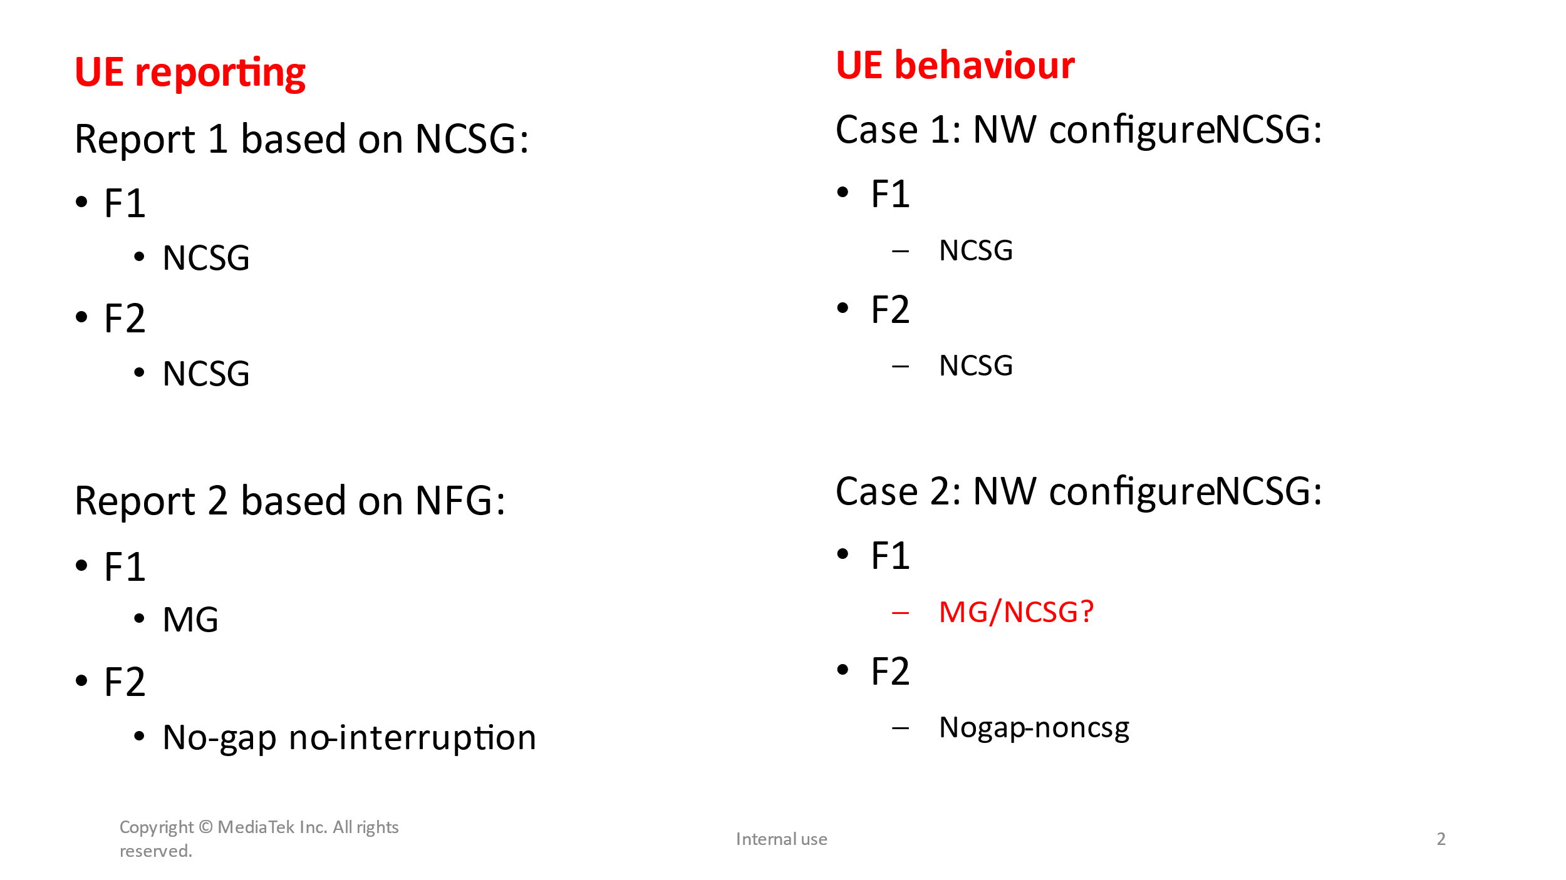

Discussion:

Tentative agreement:

## Sub-topic 4-3: Cross feature in NFG (HST)

**Issue 4-3-3: Cross feature support**

* Background (agreement)
  + - Rel-18 requirements for UE supporting NFG and inter-RAT measurements without gap do not apply for FR2-2.
* Proposals
  + Proposal 1: Whether to have Rel 18 measurements without gaps with interruptions apply for **HST**.
    - * Option 1: Yes [CMCC]
      * Option 2: No [Nokia]
* Recommended WF:
  + - For FR1 related requirements:
      * FFS
    - For FR2 related requirements:
      * FFS

Discussion:

Moderator’s note:

* For FR1 related HST requirements, no-DRX requirements are the same as legacy ones while the enhancements with DRX requirements are restricted to SMTC periodicity <=40ms, hence companies to discuss the necessity to have such two features combination due to the limit benefits.
  + - Moderator: Can we merge NFG with HST for the HST with no-DRX requirements only?
* For FR2 related HST requirements, the requirements are restricted to SMTC periodicity <=40ms, while NFG is 80ms, hence the mismatch in the requirements makes it infeasible to merge these two features for FR2.
  + - Moderator: Do we still need to consider NFG with HST for FR2?

Tentative agreement:

## Sub-topic 5-2: Inter-RAT without gaps

**Topic #5: Inter-RAT without gaps**

**Issue 5-2-1: Overlap between Effective measurement window and SMTC/SSB**

* ***Background***
  + Previous Agreements
    - For case b-2, when EMW is configured overlapped with SMTC/SSB/CSI-RS measurement with scheduling restrictions, inter-RAT LTE measurement will be dropped.
    - For case b-1 and b-2, when EMW is partially overlapped with MG (EMW periodicity < MGRP), the EMW occasion colliding physically with MG will be dropped.

* Proposals to: For case b-1 and b-2 inter-RAT LTE measurement causing scheduling restriction, when EMW periodicity is smaller than MGRP,
  + Option 1: E///, QC
    - RAN4 to update the legacy agreements as: after considering EMW dropping rule if EMW is colliding with SMTC/SSB/CSI-RS, when the remaining EMW is fully overlapping with MG, the inter-RAT meas will be performed within MG.
  + Option 1a: HW
    - RAN4 to update the legacy agreements as: after considering EMW dropping rule if EMW **outside MG** is colliding with SMTC/SSB/CSI-RS, when the remaining EMW is fully overlapping with MG, the inter-RAT meas will be performed within MG.
* Recommended WF
  + Moderator note: CRS is available all the time to the UE and the NW can avoid such corner case scenario.

Discussion:

Tentative agreement:

**Issue 5-2-2: Overlap between Effective measurement window and MG**

* ***Background***
  + Agreements
    - For case b-1 and b-2, when EMW is partially overlapped with MG (EMW periodicity < MGRP), the EMW occasion colliding physically with MG will be dropped.
    - Note: The proximity rule in Rel-17 does not apply in this case.
* Agreement for down-selection: For case b-1 and b-2 inter-RAT LTE measurement causing scheduling restriction, when EMW periodicity is larger than MGRP and all EMW are covered by measurement gaps,
  + ~~Option 1: inter-RAT LTE measurement will be dropped.~~
  + ~~Option 2: No UE behaviour is specified.~~
* Proposals to: For case b-1 and b-2 inter-RAT LTE measurement causing scheduling restriction, when EMW periodicity is larger than MGRP and all EMW are covered by measurement gaps,
  + Option 3: E///, MTK
    - apply legacy gap-based measurement requirements, i.e. RAN4 requirements should NOT be defined based on EMW.
  + Option 4: vivo, HW
    - UE measurement requirements are based on EMW-RP.
* Recommended WF
  + Discuss the options.

Discussion:

Tentative agreement:

**Issue 5-2-5: Scaling factor for case a-1: Nfreq definition**

* ***Background***
  + The principles are different between NR MO outside gap and LTE inter-frequency without MG, where all inter-frequency MOs, regardless if they are measured with or without MG, are counted in the same Nfreq.
* Proposals
  + Option 1: E///, HW
    - total number of LTE and NR MOs that are measured outside MG (same principle as LTE SA).
      * Option 1a: MTK
        + total number of inter-frequency LTE and NR MOs (same principle as LTE SA).
  + Option 2: HW
    - number of NR MOs that are measured outside MG (same principle as NR SA).
* Recommended WF
  + Discuss the options.

Discussion:

Tentative agreement: