**3GPP TSG-RAN WG4 Meeting # 112 R4-2413870**

**Maastricht, NL, August 19th – 23rd, 2024**

**Agenda item:** 5.15.3

**Source:** MediaTek inc.

**Title:** Ad-hoc minutes for [112][205] NR_MG_enh2

**Document for:** Information

# Introduction

This is the ad-hoc minutes for ad-hoc session for NR and MR-DC measurement gaps and measurements without gaps WI.

# [112][205] NR_MG_enh2

## Sub-topic 4-1: NFG - DRX related issue

**Topic #4: NeedForGap**

**Issue 4-1-2: Aligned DRX-on duration and SMTC for NFG measurements**

* Agreement
  + Interruption ratio requirement not based on DRX-on duration
  + Not define the interruption location
* Proposals
  + Option 1: ZTE
    - The interruption is not allowed at least for the small DRX-on duration. For the large DRX-on duration, we can agree that interruption is allowed but except for the last DL slot containing PDCCH in the ON duration
  + Option 2: QC
    - Interruption due to measurement without gap is allowed when UE is in DRX regardless of DRX cycle.
  + Option 1e (from issue 4-1-1): HW
    - Interruption is not allowed during DRX ON duration, if there is no SMTC occasion within a time period starting [4ms] before the starting point of the DRX ON duration and ending [4ms] after the ending point of the DRX ON duration.
  + Recommended WF
    - Interruptions are always allowed **within DRX ON duration** and it is according to Tcycle,i.
      * Consider [4ms] aligning time margin:
        + if there is no SMTC occasion within a time period starting [4ms] before the starting point of the DRX ON duration and ending [4ms] after the ending point of the DRX ON duration.

Discussion:

Nokia: We don’t need to discuss this because these comments are not contradicting

ZTE: Not sure why do we need to consider the 4ms margin outside the DRX on?

E///: No need to discuss whether interruption with a condition, the discussion should focus on when interruption is not allowed with some conditions.

Vivo: We are ok with Option1 and 3.

QC:

Ad-hoc Session chair:

* + - this issue is already covered in the next issue 4-1-1.

**Issue 4-1-1: Misalignment between DRX-on duration and SMTC for NFG measurements**

* Background (agreement):
  + - Interruption ratio requirement not based on DRX-on duration
    - Not define the interruption location
* Proposals
  + Option 1:
    - Option 1a: vivo
      * + Interruptions are always allowed **outside DRX ON duration** and it is according to Tcycle,i.
    - Option 1b: Nokia, E///
      * + Interruptions are **not allowed during** DRX ON duration.
    - Option 1c: ZTE
      * + For the case of DRX cycle **larger than 320ms**, interruptions are not allowed when DRX cycle is larger than 320ms.
    - Option 1d: ZTE
      * + For the case of DRX cycle **not larger than 320ms**, interruptions are not allowed in the DRX ON duration, excluding the time extended due to drx-inactivityTimer.
    - Option 1e: HW
      * + Interruption is not allowed during DRX ON duration, if there is **no SMTC occasion within a time period** starting [4ms] before the starting point of the DRX ON duration and ending [4ms] after the ending point of the DRX ON duration.
  + Option 2: QC
    - * Interruption due to measurement without gap is allowed when UE is in DRX regardless of DRX cycle.

|  |
| --- |
| **Session Chair:** Further discuss the two options:   * + Option 1: Nokia, E///, HW, vivo, CMCC, ZTE, Xiaomi     - Interruptions are not allowed during DRX ON duration.     - Exclude the time extended due to drx-inactivityTimer     - Consider [4ms] time margin as in option 1e.   + Option 1a: Xiaomi, CATT, ZTE, Nokia, E///, CMCC     - Interruptions are not allowed during DRX ON duration.   + Option 2: QC, Apple     - Interruption due to measurement without gap is allowed when UE is in DRX regardless of DRX cycle. |

* Recommended WF
  + Option 1: Nokia, E///, HW, vivo, CMCC, ZTE, Xiaomi
    - Interruptions are not allowed during DRX ON duration.
      * Exclude the time extended due to drx-inactivityTimer
      * Consider [4ms] time margin as in option 1e.
  + Option 1b:
    - Interruptions are not allowed during DRX ON duration [with additional UE capability].
      * Exclude the time extended due to drx-inactivityTimer
      * Consider [4ms] time margin as in option 1e.

Discussion:

Apple: there is a chance to compromise to Option 1 but we need some re-wording.

QC: We see the motivation to Option 1, and with the 4ms there is a chance for a compromise, yet we might need to have a UE capability to protect the UE.

ZTE: Due to maintenance phase, would it be fine to add a UE capability?

QC: If we get confirmation during this week then we can remove the UE capability – perhaps we can put between brackets.

CATT: we can compromise to Option1 and HW option for 4ms margin. However, we can’t agree to the new capability.

CMCC: If we support UE capability, will the RRM requirements be two set of requirements?

Tentative agreement:

* Interruptions are not allowed during DRX ON duration [with additional UE capability].
  + Exclude the time extended due to drx-inactivityTimer
  + if there is **no SMTC occasion within a time period** starting [4ms] before the starting point of the DRX ON duration and ending [4ms] after the ending point of the DRX ON duration.

**Issue 4-1-3: Interruption requirements for Tcycle,i when DRX cycle is configured and aligned with SMTC occasions**

* Proposals
  + Option 1: vivo, E///, QC
    - * For DRX, the interruption ratio is defined based on
    - Tcycle,i = max (80ms, DRX cycle) x CSSFoutside_gap,i, for DRX cycle > 320ms
    - Tcycle,i = max (80ms, SMTC period, DRX cycle) x 1.5 x CSSFoutside_gap,i, for DRX cycle ≤ 320ms
  + Recommended WF
  + For DRX, the interruption ratio is defined based on
    - Tcycle,i = DRX cycle x CSSFoutside_gap,i, for DRX cycle > 320ms
    - Tcycle,i = max (80ms, SMTC period, DRX cycle) x 1.5 x CSSFoutside_gap,i, for DRX cycle ≤ 320ms

Discussion:

Tentative agreement:

* For DRX, the interruption ratio is defined based on
  + Tcycle,i = DRX cycle x CSSFoutside_gap,i, for DRX cycle > 320ms
  + Tcycle,i = max (80ms, SMTC period, DRX cycle) x 1.5 x CSSFoutside_gap,i, for DRX cycle ≤ 320ms

**Issue 4-2-1: Interruption requirements in 8.2.2.2.19 apply also for NR-DC, EN-DC, and NE-DC**

* Background:
  + the NFG signalling is used in NR SA only, as shown below:

|  |
| --- |
| **From 38.331**:  – *NeedForGapsInfoNR*  The IE *NeedForGapsInfoNR* indicates whether measurement gap is required for the UE to perform SSB based measurements on an NR target band while NR-DC or NE-DC is not configured. |

* Proposals
  + Option 1: CMCC
    - * Yes.
        + ***except SA, it is proposed that interruption requirements in 8.2.2.2.19 apply also for EN-DC***.
        + According to RAN2 spec, R16 signalling doesn’t support NR-DC or **NE-DC**, which means they are applied to SA and **EN-DC**.
  + Option 2: Nokia, vivo, QC, MTK, HW
    - * No,
        + NFG requirements are applicable for NR SA only.

CMCC: we can further check with RAN2 colleague.

Tentative agreement

* NFG requirements are applicable for NR SA only.

**Issue 4-3-2: NFG and NCSG capabilities**

* Previous Agreements
  + No need to establish the mapping between UE’s indication for NeedForGaps and NCSG.
* Proposals
  + Option 1: vivo, MTK, HW
    - * NeedForGaps and NCSG are not expected to be enabled/configured for the same UE at the same time.
      * Option 1a: Capture in RAN2 (Nokia, HW)
      * Option 1b: Capture in RAN4, i.e., no RAN4 requirement if both are configured (Apple, HW, vivo)
  + Option 2: E///, ZTE
    - * From NW’s perspective, it’s possible to enable both NCSG and NFG reporting for the same UE at the same time.
  + Recommended WF
    - NeedForGaps and NCSG are not expected to be enabled/configured for the same UE at the same time.
      * FFS whether there is a need to send an LS to RAN2 or capture this in RAN4 spec?

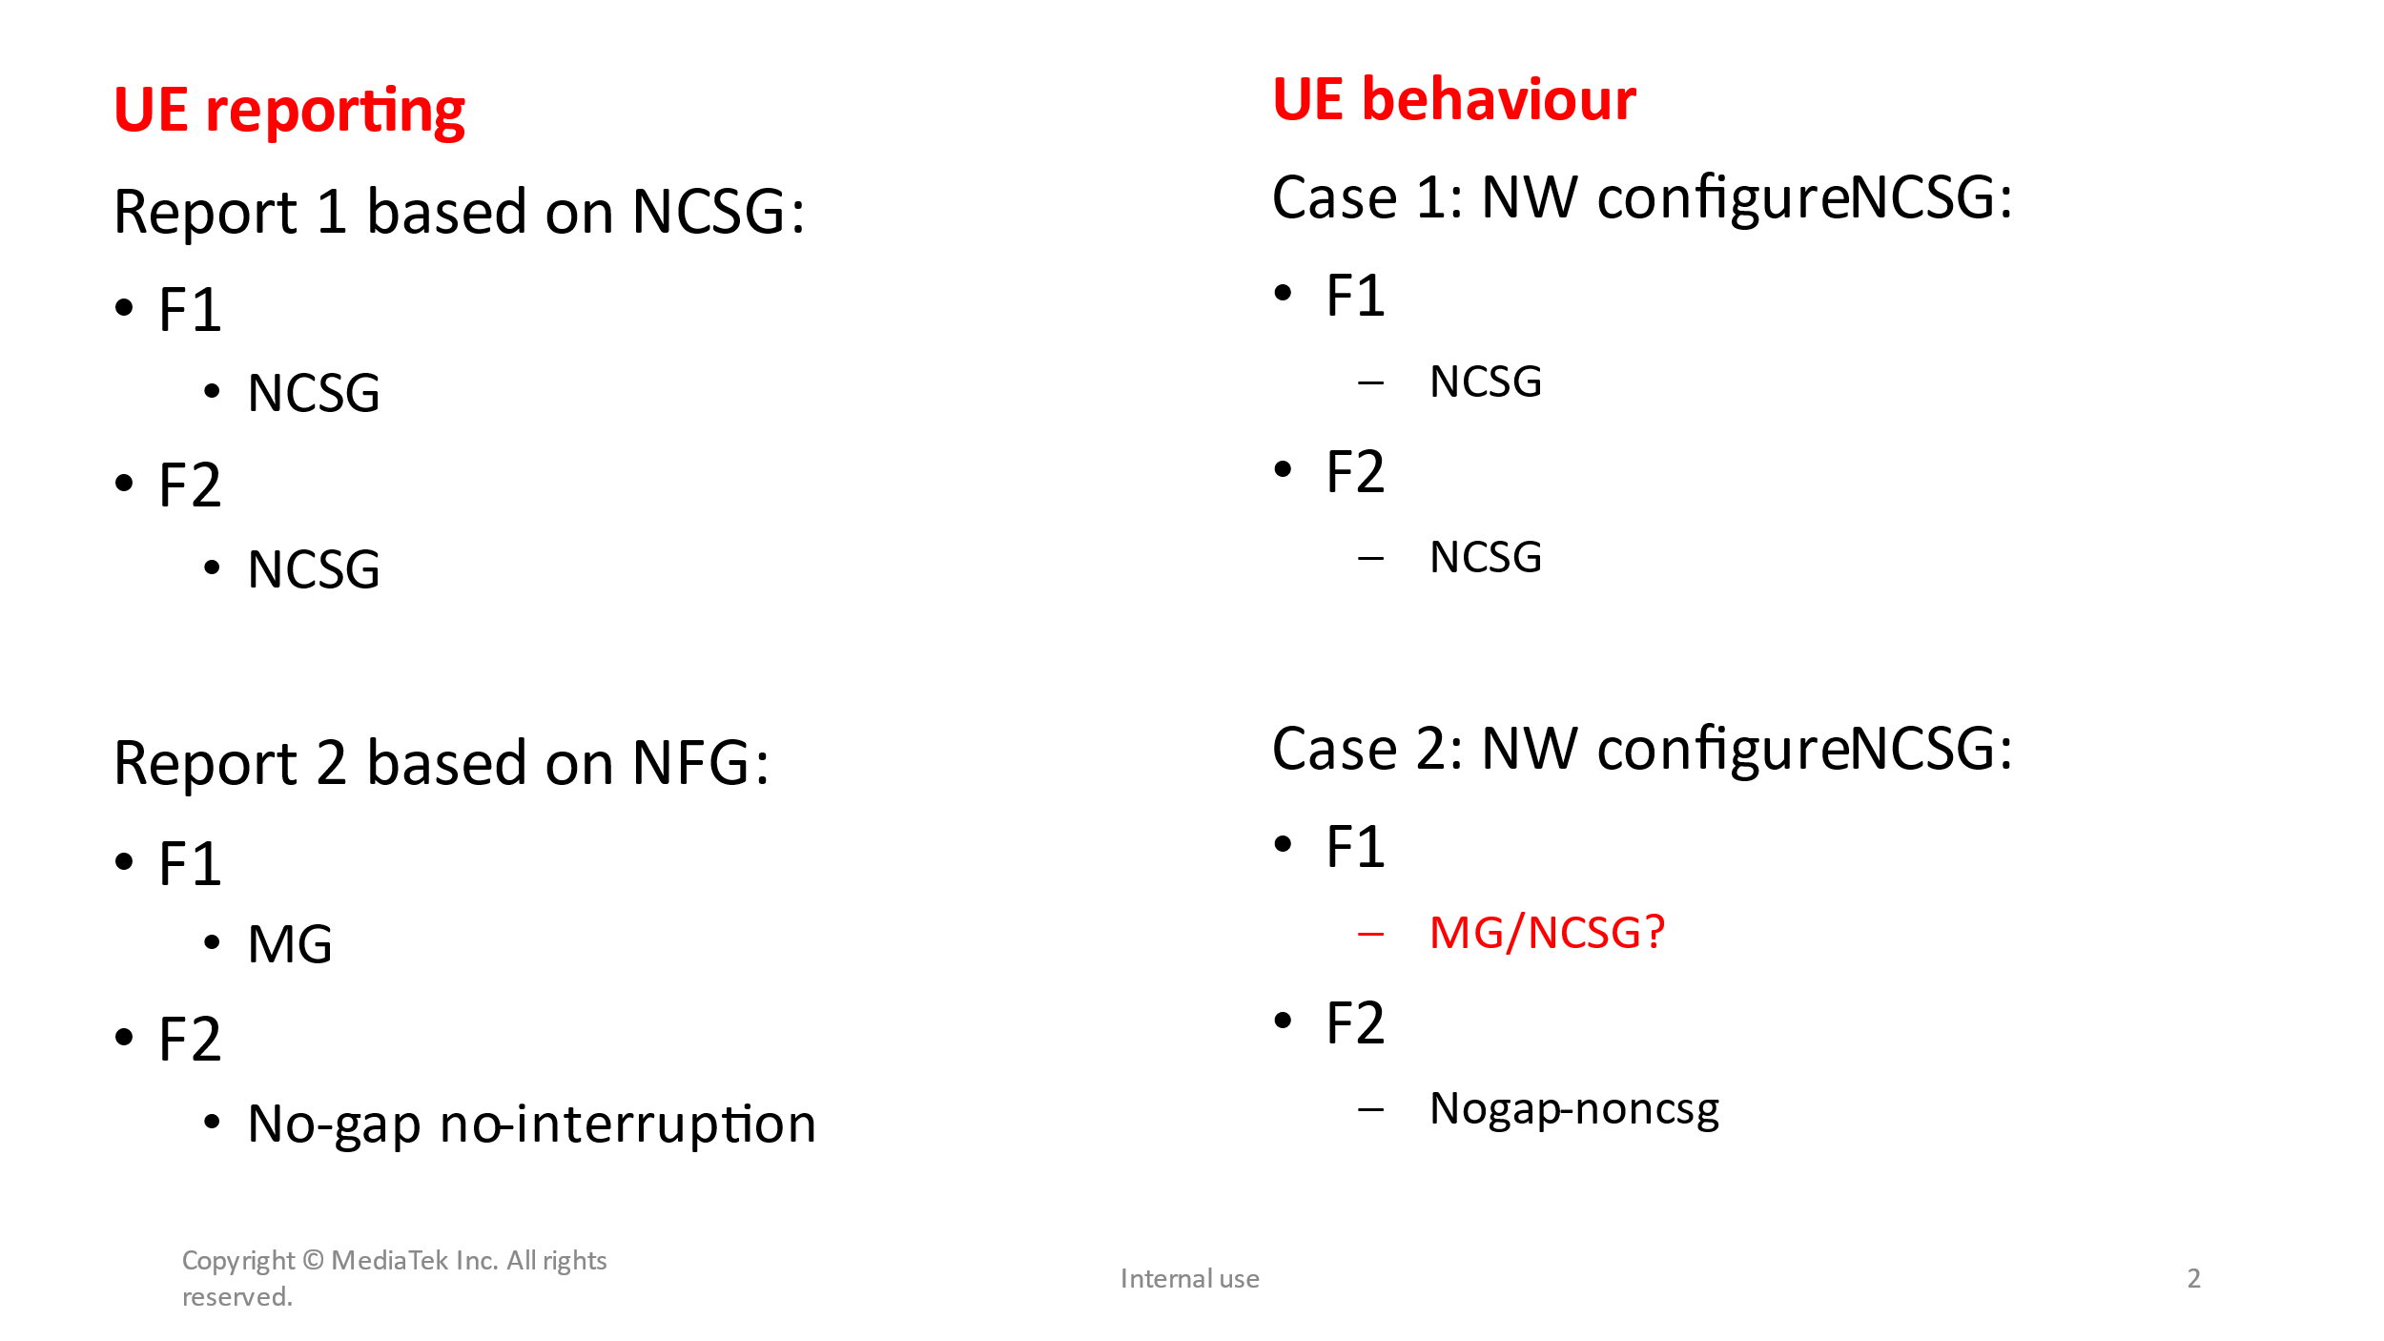

Discussion:

ZTE: why should we give such flexibility for the NW request? The UE reports to NW with NCSG for a period of time but later the UE reports NFG/MG.

HW: we don’t understand the point of this issue raised by ZTE. Why do you think the UE with R17 reporting will need a MG while with R18 the UE will need ‘no-gap’.

Nokia: We understand ZTE point of view and the benefits of such two features enabling at the same time but we also has some concern on what is the UE behaviour when the UE reports different gap level for the same frequency layer.

ZTE: understand the other companies concern on the resulting UE behaviour but the UE should just follow the NW configuration.

Tentative agreement:

* + No requirements are applied when the two features, NeedForInterruption and NCSG, are enabled/configured for the same UE at the same time.
    - The wording of NeedForInterruptionConfigNR-R18 and NeedForGapNCSG-ConfigNR-R17 to follow the signalling IE.

## Sub-topic 4-3: Cross feature in NFG (HST)

**Issue 4-3-3: Cross feature support**

* Background (agreement)
  + - Rel-18 requirements for UE supporting NFG and inter-RAT measurements without gap do not apply for FR2-2.
* Proposals
  + Proposal 1: Whether to have Rel 18 measurements without gaps with interruptions apply for **HST**.
    - * Option 1: Yes [CMCC]
      * Option 2: No [Nokia]
* Recommended WF:
  + - For FR1 related requirements:
      * FFS
    - For FR2 related requirements:
      * FFS

Discussion:

Moderator’s note:

* For FR1 related HST requirements, no-DRX requirements are the same as legacy ones while the enhancements with DRX requirements are restricted to SMTC periodicity <=40ms, hence companies to discuss the necessity to have such two features combination due to the limit benefits.
  + - Moderator: Can we merge NFG with HST for the HST with no-DRX requirements only?
* For FR2 related HST requirements, the requirements are restricted to SMTC periodicity <=40ms, while NFG is 80ms, hence the mismatch in the requirements makes it infeasible to merge these two features for FR2.
  + - Moderator: Do we still need to consider NFG with HST for FR2?

Tentative agreement:

* Rel-18 requirements for UE supporting NFG and inter-RAT measurements without gap apply for HST for **FR1**.
* Rel-18 requirements for UE supporting NFG and inter-RAT measurements without gap do **not** apply for HST for **FR2**.

## Sub-topic 5-2: Inter-RAT without gaps

**Topic #5: Inter-RAT without gaps**

**Issue 5-2-1: Overlap between Effective measurement window and SMTC/SSB**

* ***Background***
  + Previous Agreements
    - For case b-2, when EMW is configured overlapped with SMTC/SSB/CSI-RS measurement with scheduling restrictions, inter-RAT LTE measurement will be dropped.
    - For case b-1 and b-2, when EMW is partially overlapped with MG (EMW periodicity < MGRP), the EMW occasion colliding physically with MG will be dropped.

* Proposals to: For case b-1 and b-2 inter-RAT LTE measurement causing scheduling restriction, when EMW periodicity is smaller than MGRP,
  + Option 1: E///, QC
    - RAN4 to update the legacy agreements as: **after considering EMW dropping rule if EMW is colliding with SMTC/SSB/CSI-RS, when the remaining EMW is fully overlapping with MG, the inter-RAT meas will be performed within MG**.
  + Option 1a: HW
    - RAN4 to update the legacy agreements as: **after considering EMW dropping rule if EMW outside MG is colliding with SMTC/SSB/CSI-RS, when the remaining EMW is fully overlapping with MG, the inter-RAT meas will be performed within MG**.
* Recommended WF
  + Moderator note: CRS is available all the time to the UE and the NW can avoid such corner case scenario.

Discussion:

E///: the PRD reported there is an issue and we need to clarify.

Apple:

Tentative agreement:

**Issue 5-2-2: Overlap between Effective measurement window and MG**

* ***Background***
  + Agreements
    - For case b-1 and b-2, when EMW is partially overlapped with MG (EMW periodicity < MGRP), the EMW occasion colliding physically with MG will be dropped.
    - Note: The proximity rule in Rel-17 does not apply in this case.
* Agreement for down-selection: For case b-1 and b-2 inter-RAT LTE measurement causing scheduling restriction, when EMW periodicity is larger than MGRP and all EMW are covered by measurement gaps,
  + ~~Option 1: inter-RAT LTE measurement will be dropped.~~
  + ~~Option 2: No UE behaviour is specified.~~
* Proposals to: For case b-1 and b-2 inter-RAT LTE measurement causing scheduling restriction, when EMW periodicity is larger than MGRP and all EMW are covered by measurement gaps,
  + Option 3: E///, MTK
    - apply legacy gap-based measurement requirements, i.e. RAN4 requirements should NOT be defined based on EMW.
  + Option 4: vivo, HW
    - UE measurement requirements are based on EMW-RP.
* Recommended WF
  + Discuss the options.

Discussion:

Tentative agreement:

**Issue 5-2-5: Scaling factor for case a-1: Nfreq definition**

* ***Background***
  + The principles are different between NR MO outside gap and LTE inter-frequency without MG, where all inter-frequency MOs, regardless if they are measured with or without MG, are counted in the same Nfreq.
* Proposals
  + Option 1: E///, HW
    - total number of LTE and NR MOs that are measured outside MG (same principle as LTE SA).
      * Option 1a: MTK
        + total number of inter-frequency LTE and NR MOs (same principle as LTE SA).
  + Option 2: HW
    - number of NR MOs that are measured outside MG (same principle as NR SA).
* Recommended WF
  + Discuss the options.

Discussion:

Tentative agreement: