**3GPP TSG-RAN WG4 Meeting # 112 R4-24x**

**Maastricht, Netherlands, 19th – 23rd August, 2024**

**Agenda item:** 5.13.1

**Source:** Moderator (vivo)

**Title:**  Ad-hoc minutes for NR FR2 multi-Rx WI

**Document for:** Approval

# Introduction

In this meeting, there is one email thread dedicated for FR2 multi-Rx chain DL reception, i.e., [112][204] FR2_multiRx. Topic summary for the email threads [1] summarized open issues on core requirements maintenance and performance requirements maintenance in this meeting for the WI.

The following issues are to be handled in the ad-hoc session.

For Topic #1:

Issue 1-1: Measurement restriction relaxation requirements

Issue 1-3: Scheduling restriction relaxation requirements

Issue 1-4: DCI based dual TCI state switch delay for m-DCI

Issue 1-5: DCI based dual TCI state switch delay for s-DCI

Issue 1-6: Condition of multi-Rx operation for fast beam sweeping

Issue 1-7: Applicability of requirements for multi-Rx operation

Issue 1-8: MRTD for multi-Rx

For Topic #2:

Issue 2-1: 3AoAs setup 6

Issue 2-3: Test setup for dual TCI state switching for m-DCI

# Topic #1: Core requirements maintenance

### Sub-topic 1-1: Measurement restriction

**Issue 1-1: Measurement restriction relaxation requirements**

In TS38.133 v18.6.0, the measurement relaxation requirements for CSI-RS based L1 measurements are specified as follows.

For FR2-1, there is no measurement restriction allowed for UE supporting [TBD - multi-rx capability], according to the conditions described in clause 3.6.x, and the UE is required to measure both the CSI-RS for RLM and the other CSI-RS for RLM, BFD or L1-RSRP measurement, while meeting requirements in clause 8.1.3.2, provided the following conditions are met:

- Both CSI-RSs are not in any CSI-RS resource set with repetition ON, and

- [The two CSI-RS resources and both PDSCHs are overlapped on the same OFDM symbol, and]

- One CSI-RS has same QCL source as the active TCI state of one PDSCH, and the other CSI-RS has same QCL source as the active TCI state of the other PDSCH, and

- Resources of the active TCI states for the two PDSCHs have been reported as a resource group in Rel-17 group-based RSRP report.

Editor’s note: FFS how to capture UE is activated with multi-Rx operation.

The highlighted conditions need to be addressed.

* Proposals

On the condition “The two CSI-RS resources and both PDSCHs are overlapped on the same OFDM symbol”

* + Option 1: (MTK, Nokia, Ericsson, Samsung)
    - Remove the condition.
  + Option 2: (Apple)
    - Remove the condition for s-DCI, but keep the condition for m-DCI.
  + Option 3: (vivo)
    - Remove the condition.
    - Modify other condition to
      * The two CSI-RSs are QCL-ed with typeD to reference signals in a resource group in the latest Rel-17 group based beam report, and
  + Option 4: (Huawei)
    - Keep the condition.
    - Modify other conditions to
      * One CSI-RS has same QCL source as the active TCI state or default QCL assumption of one PDSCH, and the other CSI-RS has same QCL source as the active TCI state or default QCL assumption of the other PDSCH, and
      * Resources of the active TCI states or default QCL assumption for the two PDSCHs have been reported as a resource group in Rel-17 group-based RSRP report.
  + Option 5: (OPPO)
    - Modify the condition to:
      * The two CSI-RS resources are overlapped on the same OFDM symbol, where at least one of the PDSCHs is scheduled simultaneously.
  + Option 6: (ZTE)
    - Modify the condition to:
      * For s-DCI, CSI-RSs and both of the PDSCHs are on the same OFDM symbol(s), or one of the CSI-RSs and one of the PDSCHs with different QCL typeD are on the same OFDM symbol(s) when partially overlapping PDSCHs are scheduled.
      * For m-DCI, one of the PDSCH is overlapping with the two CSI-RS.

On the condition “FFS how to capture UE is activated with multi-Rx operation”

* + Option 1: (ZTE, vivo)
    - Remove the condition UE is activated with multi-Rx operation.
* Recommended WF
  + Remove the condition UE is activated with multi-Rx operation.
  + Further discuss the condition [The two CSI-RS resources and both PDSCHs are overlapped on the same OFDM symbol].

*Background:*

R4-2411780 ( MediaTek inc.)

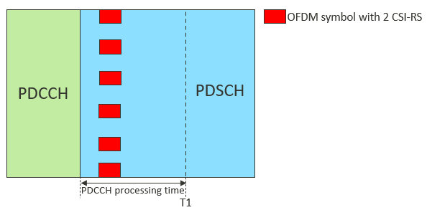

R4-2412998 (Ericsson)2

Figure 2: sDCI and mDCI based same slot scheduling

Figure 3: sDCI based cross slot scheduling

Figure 4: mDCI based cross slot scheduling

R4-2412192 ( Huawei, HiSilicon)

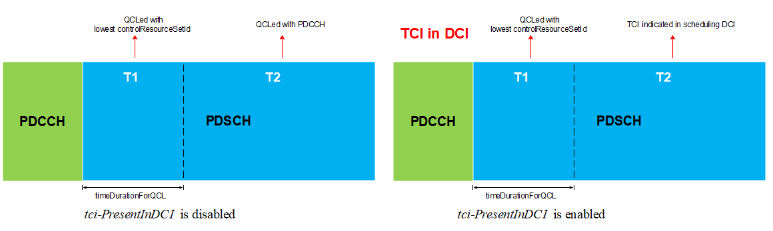

Fig.1 Rx beam for sTRP

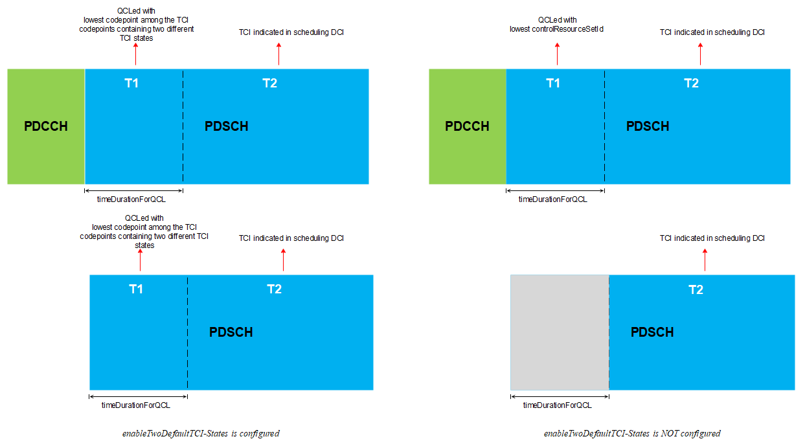

Fig.2 Rx beam for mTRP sDCI

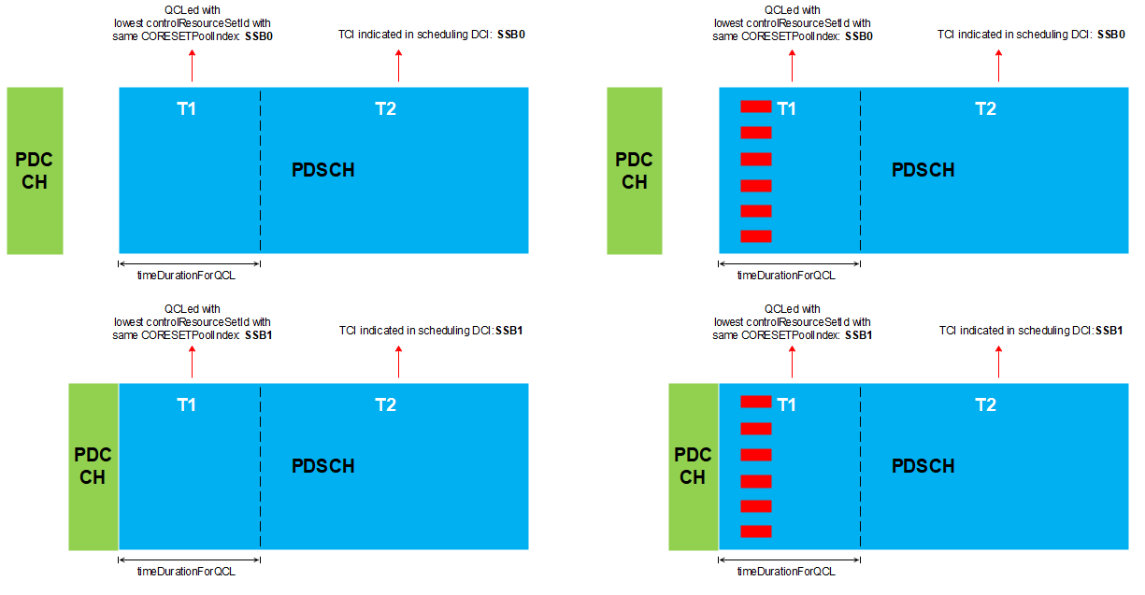

Fig.3 Rx beam for mTRP mDCI

R4-2411400 (Apple)

Discussion:

HW: Why do we need this condition? As long as CSI-RSs are from GBBR pair, UE can measure simultaneously. NW cares more on measurement accuracy, not measurement delay. We don’t need to force UE to use no optimal RX beam for measurement.

We only need to measure CSI-RS resource pair when it has same spatial filter as PDSCHs.

Nokia: Why do we need to consider PDCCH processing time?

Apple: Similar view with Huawei.

Qualcomm: We support proposal from Huawei.

Ericsson: For same slot scheduling, we don’t need the condition as we already buffered PDSCH and CSI-RS simultaneously.

MTK: UE needs to keep UE behaviour regardless of whether PDCCH is decoded or not.

MTK: focus on same slot scheduling.

QC: OFDM symbols after PDCCH symbols that are required to be received by UE in every slot with default QCL assumption as per TS 38.214.

Any concern to specify requirements for same slot scheduling only?

ZTE: We don’t agree to limit to the same slot scheduling case only.

Q1: What is the assumption of PDCCH processing time?

Option 1: 2-3 symbols

Option 2: 350us (assumption in DCI-based BWP switching)

Option 3: 1 slot

Q2: Any modification of other conditions, i.e., option 4, in addition to overlapping with PDSCHs is needed?

Q3: For s-DCI, is there any issue by removing the condition of overlapping with PDSCHs?

Q4: For m-DCI, is there any issue by removing the condition of overlapping with PDSCHs?

Case 1: active TCI state + active TCI state

Case 2: Default TCI state + Default TCI state

Case 3: Default TCI state + active TCI state

Tentative agreement

Option 1:

Case 2: Default TCI state + Default TCI state (for same slot scheduling)For same slot scheduling,

- Both CSI-RSs are not in any CSI-RS resource set with repetition ON, and

- One CSI-RS has same QCL source as the default [TCI state] QCL assumption of one PDSCH, and the other CSI-RS has same QCL source as the default QCL assumption of the other PDSCH, and

- Resources of the default QCL assumptions for the two PDSCHs have been reported as a resource group in Rel-17 group-based RSRP report.

Note: default QCL assumption is defended in TS 38.214.

Case 1: active TCI state + active TCI state (for cross slot scheduling)

For cross slot scheduling,

- Both CSI-RSs are not in any CSI-RS resource set with repetition ON, and

- The two CSI-RS resources and both PDSCHs are overlapped on the same OFDM symbol, and

- One CSI-RS has same QCL source as the default [TCI state] QCL assumption of one PDSCH, and the other CSI-RS has same QCL source as the default QCL assumption of the other PDSCH, and

- Resources of the default QCL assumptions for the two PDSCHs have been reported as a resource group in Rel-17 group-based RSRP report.

Note: default QCL assumption is defended in TS 38.214.

Option 2: Remove measurement restriction relaxation requirements for multi-Rx.

Option 3: Option 4 from Huawei. Further clarify on the wording of [default QCL assumption] and/or [PDSCH].

(Huawei, Nokia, Apple, Qualcomm, OPPO)

Q5: Is it necessary to consider the case that there is no PDSCHs are scheduled in a slot, especially when PDSCH processing time is less than one slot?

### Sub-topic 1-2: Scheduling restriction

**Issue 1-3: Scheduling restriction relaxation requirements**

In the RAN4#110 meeting, following agreement was reached and captured in the WF R4-2403560.

Agree the following and no further discussion on other proposals.

* The CSI-RS and both of the PDSCHs are on the same OFDM symbol(s), or the CSI-RS and one of the PDSCHs with different QCL typeD are on the same OFDM symbol(s) when partially overlapping PDSCHs are scheduled.
* Further check for mDCI case.

The conditions for highlighted m-DCI case need to be addressed.

* Proposals
  + Option 1: (ZTE)
    - For m-DCI, CSI-RS and both of the PDSCHs are on the same OFDM symbol(s), or the CSI-RS and one of the PDSCHs with different QCL typeD are on the same OFDM symbol(s) when partially overlapping PDSCHs are scheduled.
    - For m-DCI, even though non-overlapping PDSCHs scheduled by different TRPs, scheduling restriction relaxation is allowed provided the CSI-RS overlapping with both PDSCHs.
  + Option 2: (OPPO)
    - The two CSI-RS resources are overlapped on the same OFDM symbol, where at least one of the PDSCHs is scheduled simultaneously.
* Recommended WF
  + Further discuss and focus on m-DCI scheduling only.

Discussion:

### Sub-topic 1-3: TCI state switch

**Issue 1-4: DCI based dual TCI state switch delay for m-DCI**

* Proposals
  + Option 1: (vivo)
    - No additional requirements are needed for DCI based dual TCI state switch delay for m-DCI.
  + Option 2: (Nokia)
    - The UE can receive simultaneously TCI 1 and TCI 2 between points C and D if they have been reported as a beam pair using GBBR-17.
  + Option 3: (Ericsson)
    - For m-DCI based dual DCI state switch, TCI state switch on each coreset is independent without any restriction on the DCI reception.
    - Between point C and D, UE to receive on TCI state 0 alone, if new TCI state 0 and old TCI state 1 are not in a beam pair.
  + Option 4: (ZTE)
    - If TCI 1 and TCI 2 are in a beam pair, UE to receive on TCI 1 and TCI 2 between C and D. After D, to receive on TCI 2 and TCI 4. Between C and D, UE capable of multi-Rx can receive overlapping PDSCH 0 and PDSCH 1 simultaneously. Otherwise, UE to receive on TCI 2 alone till D. After D, UE can receive on TCI 2 and TCI 4.
* Recommended WF
  + Further discuss.
  + It is moderator’s understanding that proposals in options 2, 3 and 4 are the UE behaviour that is allowed or not precluded by RAN1 specification. However, it is not necessary to capture such UE behaviour in RAN4 specification further.

**Issue 1-5: DCI based dual TCI state switch delay for s-DCI**

* Proposals
  + Option 1: (Huawei)
    - Remove the following requirements.
      * For sDCI, If TCI state switching is from dual TCI states to single TCI state and the target TCI state is one of the source TCI states, there is no TCI state switching delay allowed, provided that UE is configured with group-based RSRP report (groupBasedBeamReporting-r17).”
* Recommended WF
  + Proponent is encouraged to offline with companies firstly.

### Sub-topic 1-4: General

**Issue 1-6: Condition of multi-Rx operation for fast beam sweeping**

In TS38.133 v18.6.0, the condition of multi-Rx operation for fast beam sweeping is specified as follows.

The UE is activated with multi-Rx operation when the UE is configured with Rel-17 group-based beam reporting

group-based beam reporting

Proposals are further provided to modify/enhance the condition.

* Proposals
  + Option 1: (MTK)
    - Add a leaving condition: If UE recently reported ‘Not valid’ for one of the RSRP for a beam pair, this means UE is allow to fallback to single panel for the later reception QCL-ed to that beam pair.
  + Option 2: (vivo)
    - Add a leaving condition: When dual TCI states are not indicated within [300] s since group-based beam reporting is configured, the UE is allowed to exit fast beam sweeping.
  + Option 3: (Xiaomi)
    - UE is configured with group-based beam reporting (GBBR) report and UE is activated with dual TCI states.
    - Leaving fast beam sweeping can be initiated by NW or UE.
  + Option 4: (OPPO)
    - Rel-17 group-based beam reporting (GBBR) is configured and activated by the network.
* Recommended WF
  + Draw conclusion in this meeting.

**Issue 1-7: Applicability of requirements for multi-Rx operation**

In TS38.133 v18.6.0, the applicability of requirements for multi-Rx operation in FR2-1 is specified as follows.

The requirements related to the support of [*reducedRxBeamNum* and 30-1] are applicable to a PCell, PSCell, or SCell, provided the UE is configured with a single serving cell (PCell, PSCell, or SCell) in FR2-1.

The requirements related to the support of [*reducedRxBeamNum*] is applicable when the network configures the UE with a CSI report containing groupBasedBeamReporting-v1710.

Proposals are further provided to modify the applicability conditions.

* Proposals
  + Option 1: (Apple)
    - Modify the 2nd applicability of requirements to:
      * The requirements related to the support of [reducedRxBeamNum] is applicable when the network has configured the UE with a CSI report containing *groupBasedBeamReporting-v1710* and the UE has not sent UAI indicating its preference of single-RX operation since it was most recently configured with such CSI reporting.
* Recommended WF
  + Further discuss.

**Issue 1-8: MRTD for multi-Rx**

In TS38.133 v18.6.0, the MRTD requirements for multi-Rx operation in FR2-1 is specified as follows.

A UE supporting [*FG 30-1 or 30-2*] shall be capable of handling at least a relative receive timing difference between slot timing of different TCI states on the same carrier at the UE receiver as shown in Table 7.6.8-3.

Table 7.6.8-3: Maximum receive timing difference requirement for UE supporting multi-RX

|  |  |
| --- | --- |
| Frequency Range | Maximum receive timing difference |
| FR2-1 | CP lengthnote 1 |
| Note 1: CP length dependency on SCS is FFS | |

The FFS part should be addressed.

* Proposals
  + Option 1: (Apple)
    - The MRTD is smaller than the CP length corresponding to MAX (SSB SCS, data SCS).
      * It is more challenging to maintain MRTD < CP length of 240kHz SCS from network deployment perspective.
* Recommended WF
  + Further discuss.

# Topic #2: Performance requirements maintenance

*Main technical topic overview. The structure can be done based on sub-agenda basis.*

### Sub-topic 2-1: AoA Setup

**Issue 2-1: 3AoAs setup 6**

In TS38.133 v18.6.0, the 3 AoAs setup 6 is specified with brackets as follows.

**A.3.15.6 Setup 6:** **3 AoAs for simultaneous reception with different QCL Type-D**

There are 3 active probes in the test and the DL signals and noise are transmitted from the three active probes.

Out of the three AoA, one AoA [(AoA1)] is aligned to a direction which is from the set of directions corresponding to the EIS spherical coverage percentile of the DUT as defined in clause 7.3.4 of TS 38.101-2 [19] for UE power class 3 and other 2 AoAs [(AoA2, AoA3)] are from the set of [qualified AoA pairs] according to the spherical coverage requirement for simultaneous reception from multiple directions as defined in clause 7.3K.3 of TS 38.101-2 for power class 3 supporting simultaneous reception from multiple directions.

The relative angular offset between the directions of the AoA pair is based on the UE’s declared [AoA separation and UE] orientation as defined in clause 7.3K.3 of TS 38.101-2 and [shall not be changed for each test iteration].

* Proposals
  + P1: (Apple)
    - [qualified AoA pairs] is replaced with “the AoA pairs, i.e., (AoA1, AoA2), that can support 2 AoA reception.
  + P2: (Ericsson)
    - Specify the AoA numbering and their description in the test set up.
  + P3: (Nokia)
    - The UE positioning shall be such that the UE passes both spherical coverage requirements.
* Recommended WF
  + Discuss if the proposals are agreeable.

### Sub-topic 2-2: Test setup

*Sub-topic description:*

*Open issues and candidate options before f2f meeting:*

**Issue 2-3: Test setup for dual TCI state switching for m-DCI**

In the last meeting, following agreements on Test case(s) for dual TCI state switching for m-DCI.

* Introduce one test case for DCI-based dual TCI state switching for m-DCI
* From [RS1, RS2] (Probe 1 and 2, no simultaneous transmission) to [RS3, RS4] (Probe 1 and 3) with 3 active probes.
  + Side conditions
    - Probe 1 & 3 shall fulfill the mRx spherical coverage EIS requirement (angular offset as declared by the UE). Note: Aligned with 2AoA selected as we agreed.
    - In addition, Probe 1 & 2 shall fulfill individually the legacy spherical coverage EIS requirement and angular offset from the legacy 2AoA table, i.e. selection is equivalent to a single pair from Setup 3
  + Signal mapping
    - RS1 & RS3 are mapped to Probe 1
    - RS2 is mapped to Probe 2
    - RS4 is mapped to Probe 3

Proposals are further provided to improve the test design.

* Proposals (Nokia)
  + P1: When three probes are used to transmit four RS, the test probe transmitting more than one RS should emulate different DL transmit beams by transmitting different RS with different power and delay. This will ensure that the UE has done a time/frequency synchronization with the target RS before switching to the target TCI state when receiving a DCI command for a TCI state switch
  + P2: In m-DCI TCI state switching test case, because support of simultaneous PDCCH reception is not mandatory for a Rel-18 UE, the TE shall send the two DCIs to switch to the target TCI states in consecutive slots n and n+1. The UE shall be able to receive the target TCI states simultaneously at slot n + 1 + *timeDurationForQCL*.
  + P3: Distinguish PDCCH and PDSCH TCI states clearly in the m-DCI TCI state switching test case. The TCI states and associated probes and SSBs should be
    - TCI states at the beginning of the test:
      * For CORESETPoolIndex 0
        + PDCCH TCI state: TCI state 0 (probe 0, SSB0)
        + PDSCH TCI states: TCI state 0 (probe 0, SSB0)
      * For CORESETPoolIndex 1
        + PDCCH TCI state: TCI state 1 (probe 1, SSB1)
        + PDSCH TCI states: TCI state 1 (probe 1, SSB1)
    - TCI states at the end of the test:
      * For CORESETPoolIndex 0
        + PDCCH TCI state: TCI state 0 (probe 0, SSB0)
        + PDSCH TCI states: TCI state 3 (probe 0, SSB3)
      * For CORESETPoolIndex 1
        + PDCCH TCI state: TCI state 1 (probe 1, SSB1)
        + PDSCH TCI states: TCI state 2 (probe 2, SSB2)
* Recommended WF
  + Further discuss the proposals.

# References

1. R4-2411798 Topic summary for [112][203] FR2_multiRx, Moderator (vivo)