**3GPP TSG- RAN4 Meeting #112R4-2413951**

**Maastricht, Netherlands, 19th – 23rd August, 2024**

|  |  |  |  |  |  |  |  |  |
| --- | --- | --- | --- | --- | --- | --- | --- | --- |
| *CR-Form-v12.3* | | | | | | | | |
| **CHANGE REQUEST** | | | | | | | | |
|  | | | | | | | | |
|  | **38.133** | **CR** | **4806** | **rev** | **1** | **Current version:** | **18.6.0** |  |
|  | | | | | | | | |
| *For* [***HELP***](http://www.3gpp.org/3G_Specs/CRs.htm#_blank)*on using this form: comprehensive instructions can be found at* [*http://www.3gpp.org/Change-Requests*](http://www.3gpp.org/Change-Requests)*.* | | | | | | | | |
|  | | | | | | | | |

|  |  |  |  |  |  |  |  |  |
| --- | --- | --- | --- | --- | --- | --- | --- | --- |
| ***Proposed change affects:*** | UICC apps |  | ME | **X** | Radio Access Network |  | Core Network |  |

|  |  |  |  |  |  |  |  |  |  |  |
| --- | --- | --- | --- | --- | --- | --- | --- | --- | --- | --- |
|  | | | | | | | | | | |
| ***Title:*** | CR on test cases for BWP operation without restriction | | | | | | | | | |
|  |  | | | | | | | | | |
| ***Source to WG:*** | vivo | | | | | | | | | |
| ***Source to TSG:*** | R4 | | | | | | | | | |
|  |  | | | | | | | | | |
| ***Work item code:*** | NR_BWP_wor-Perf | | | | |  | ***Date:*** | | | 2024-8-22 |
|  |  | | | |  | |  | | |  |
| ***Category:*** | F |  | | | | | ***Release:*** | | | Rel-18 |
|  | *Use one of the following categories:* ***F*** *(correction)* ***A*** *(mirror corresponding to a change in an earlier release)* ***B*** *(addition of feature),* ***C*** *(functional modification of feature)* ***D*** *(editorial modification)*  Detailed explanations of the above categories can be found in 3GPP [TR 21.900](http://www.3gpp.org/ftp/Specs/html-info/21900.htm). | | | | | | | | *Use one of the following releases: Rel-8 (Release 8) Rel-9 (Release 9) Rel-10 (Release 10) Rel-11 (Release 11) … Rel-17 (Release 17) Rel-18 (Release 18) Rel-19 (Release 19)  Rel-20 (Release 20)* | |
|  |  | | | | | | | | | |
| ***Reason for change:*** | | Test cases for UE supporting NCD-SSB based measurement outside active BWP (FG53-3) is not finalized. | | | | | | | | |
|  | |  | | | | | | | | |
| ***Summary of change:*** | | * Corrected configurations in the test cases. * Corrected titles of the test cases. * Removed brackets. | | | | | | | | |
|  | |  | | | | | | | | |
| ***Consequences if not approved:*** | | Test cases for UE supporting NCD-SSB based measurement outside active BWP (FG53-3) is not completed. | | | | | | | | |
|  | |  | | | | | | | | |
| ***Clauses affected:*** | | A.4.5.1.12, A.5.5.1.14, A.6.5.1.12, A.7.5.1.13 | | | | | | | | |
|  | |  | | | | | | | | |
|  | | **Y** | **N** |  | | | |  | | |
| ***Other specs*** | |  | **X** | Other core specifications | | | | TS/TR ... CR ... | | |
| ***affected:*** | | **X** |  | Test specifications | | | | TS 38.533 | | |
| ***(show related CRs)*** | |  | **X** | O&M Specifications | | | | TS/TR ... CR ... | | |
|  | |  | | | | | | | | |
| ***Other comments:*** | |  | | | | | | | | |
|  | |  | | | | | | | | |
| ***This CR's revision history:*** | |  | | | | | | | | |

<Start of Change #1>

#### A.4.5.1.12 EN-DC Radio Link Monitoring Out-of-sync Test for FR1 PSCell configured with SSB-based RLM RS in non-DRX mode for UE supporting NCD-SSB based measurement outside active BWP

##### A.4.5.1.12.1 Test Purpose and Environment

The purpose of this test is to verify that the UE properly detects the out of sync and in sync for the purpose of monitoring downlink radio link quality of the PSCell for UE supporting FG 53-3. This test will partly verify the FR1 PSCell radio link monitoring requirements in clause 8.1.

In the test, UE is configured to perform RLM on SSB, with *detectionResource* included in *RadioLinkMonitoringRS* set to SSB#0, and *purpose* set to ‘*rlf*’. Supported test configurations are shown in table A.4.5.1.12.1-1. The test parameters are given in Tables A.4.5.1.12.1-2, A.4.5.1.12.1-3, and A.4.5.1.12.1-4 below. There are two cells, Cell 1 is the E-UTRAN PCell, and Cell 2 is the PSCell, in the test. The E-UTRAN PCell setting refers to Table A.3.7.2.1-1. The test consists of three successive time periods, with time duration of T1, T2 and T3 respectively. Figure A.4.5.1.12-1 shows the variation of the downlink SNR in the active Cell 2 to emulate out-of-sync and in-sync states. Prior to the start of the time duration T1, the UE shall be fully synchronized to Cell 1 and Cell 2. The UE shall be configured for periodic CSI reporting with a reporting periodicity of 5 ms. The UE is configured to perform inter-frequency measurements using Gap Pattern ID #0 (40ms) in test 1.

Table A.4.5.1.12.1-1: Supported test configurations for FR1 PSCell for UE supporting NCD-SSB based measurement outside active BWP

|  |  |
| --- | --- |
| Configuration | Description |
| 1 | LTE FDD, NR 15 kHz SSB SCS, 10 MHz bandwidth, FDD duplex mode |
| 2 | LTE FDD, NR 15 kHz SSB SCS, 10 MHz bandwidth, TDD duplex mode |
| 3 | LTE FDD, NR 30 kHz SSB SCS, 40 MHz bandwidth, TDD duplex mode |
| 4 | LTE TDD, NR 15 kHz SSB SCS, 10 MHz bandwidth, FDD duplex mode |
| 5 | LTE TDD, NR 15 kHz SSB SCS, 10 MHz bandwidth, TDD duplex mode |
| 6 | LTE TDD, NR 30 kHz SSB SCS, 40 MHz bandwidth, TDD duplex mode |
| Note: The UE is only required to pass in one of the supported test configurations in FR1 | |

Table A.4.5.1.12.1-2: General test parameters for FR1 out-of-sync testing in non-DRX mode for UE supporting NCD-SSB based measurement outside active BWP

|  |  |  |  |  |
| --- | --- | --- | --- | --- |
| Parameter | | | Unit | Value |
|  | | |  | Test 1 |
| Active E-UTRA PCell | | |  | Cell 1 |
| E-UTRA RF Channel Number | | |  | 1 |
| Active PSCell | | |  | Cell 2 |
| RF Channel Number | | |  | 2 |
| Duplex mode | | Config 1, 4 |  | FDD |
|  | | Config 2, 3, 5, 6 |  | TDD |
| BWchannel | | Config 1, 4 | MHz | 10: NRB,c = 52 |
|  | | Config 2, 5 |  | 10: NRB,c = 52 |
|  | | Config 3, 6 |  | 20: NRB,c = 51 |
| DL initial BWP configuration | | Config 1, 2, 3, 4, 5, 6 |  | DLBWP.0.1 |
| DL dedicated BWP configuration | | Config 1, 2, 3, 4, 5, 6 |  | DLBWP.1.1 |
| UL initial BWP configuration | | Config 1, 2, 3, 4, 5, 6 |  | ULBWP.0.1 |
| UL dedicated BWP configuration | | Config 1, 2, 3, 4, 5, 6 |  | ULBWP.1.1 |
| TDD Configuration | | Config 1, 4 |  | Not Applicable |
|  | | Config 2, 5 |  | TDDConf.1.1 |
|  | | Config 3, 6 |  | TDDConf.2.1 |
| CORESET | | Config 1, 4 |  | CR.1.1 FDD |
| Reference Channel | | Config 2, 5 |  | CR.1.1 TDD |
|  | | Config 3, 6 |  | CR.2.1 TDD |
| SSB Configuration | | Config 1, 4 |  | SSB.1 FR1 |
|  | | Config 2, 5 |  | SSB.1 FR1 |
|  | | Config 3, 6 |  | SSB.2 FR1 |
| NCD-SSB Configuration | | Config 1 |  | SSB.9 FR1 |
| Config 2 | SSB.9 FR1 |
| Config 3 | SSB.10 FR1 |
| SMTC | | Config 1, 2, 4, 5 |  | SMTC.10 |
| Configuration | | Config 3, 6 |  | SMTC.10 |
| PDSCH/PDCCH | | Config 1, 2, 4, 5 |  | 15 kHz |
| subcarrier spacing | | Config 3, 6 |  | 30 kHz |
| PRACH Configuration | | Config 1, 2, 4, 5 |  | Table A.3.8.2.1-1 |
|  | | Config 3, 6 |  | Table A.3.8.2.1-1 |
| SSB index assigned as RLM RS | | |  | 0 |
| OCNG parameters | | |  | OP.1 |
| CP length | | |  | Normal |
| Correlation Matrix and Antenna Configuration | | |  | 2x2 Low |
| Out of sync | DCI format | |  | 1-0 |
| transmission parameters | Number of Control OFDM symbols | |  | 2 |
|  | Aggregation level | | CCE | 8 |
|  | Ratio of hypothetical PDCCH RE energy to average SSS RE energy | | dB | 4 |
|  | Ratio of hypothetical PDCCH DMRS energy to average SSS RE energy | | dB | 4 |
|  | DMRS precoder granularity | |  | REG bundle size |
|  | REG bundle size | |  | 6 |
| DRX | | |  | *OFF* |
| Gap pattern ID | | |  | *gp0* |
| Layer 3 filtering | | |  | *Enabled* |
| T310 timer | | | ms | *0* |
| T311 timer | | | ms | 1000 |
| N310 | | |  | 1 |
| N311 | | |  | 1 |
| CSI-RS for CSI | | Config 1, 4 |  | CSI-RS.1.1 FDD |
| reporting | | Config 2, 5 |  | CSI-RS.1.1 TDD |
|  | | Config 3, 6 |  | CSI-RS.2.1 TDD |
| CSI-RS for tracking | | Config 1, 4 |  | TRS.1.1 FDD |
|  | | Config 2, 5 |  | TRS.1.1 TDD |
|  | | Config 3, 6 |  | TRS.1.2 TDD |
| T1 | | | s | 0.2 |
| T2 | | | s | 0.48 |
| T3 | | | s | 0.48 |
| D1 | | | s | 0.44 |
| Note 1: All configurations are assigned to the UE prior to the start of time period T1.  Note 2: UE-specific PDCCH is not transmitted after T1 starts.  Note 3: E-UTRAN is in non-DRX mode under test. | | | | |

Table A.4.5.1.12.1-3: Cell specific test parameters for FR1 (Cell 2) for out-of-sync radio link monitoring tests in non-DRX mode for UE supporting NCD-SSB based measurement outside active BWP

|  |  |  |  |  |  |  |
| --- | --- | --- | --- | --- | --- | --- |
| Parameter | | Unit | Test 1 | | | |
|  | |  | T1 | | T2 | T3 |
| EPRE ratio of PDCCH DMRS to SSS | | dB | 4 | | | |
| EPRE ratio of PDCCH to PDCCH DMRS | | dB | 0 | | | |
| EPRE ratio of PBCH DMRS to SSS | | dB |  | | | |
| EPRE ratio of PBCH to PBCH DMRS | | dB |  | | | |
| EPRE ratio of PSS to SSS | | dB |  | | | |
| EPRE ratio of PDSCH DMRS to SSS | | dB | 0 | | | |
| EPRE ratio of PDSCH to PDSCH DMRS | | dB |  | | | |
| EPRE ratio of OCNG DMRS to SSS | | dB |  | | | |
| EPRE ratio of OCNG to OCNG DMRS | | dB |  | | | |
| SNR on | Config 1, 4 | dB | 1 | -7 | | -15 |
| RLM-RS | Config 2, 5 |  | 1 | -7 | | -15 |
|  | Config 3, 6 |  | 1 | -7 | | -15 |
|  | Config 1, 4 | dBm/15 kHz | -98 | | | |
|  | Config 2, 5 |  | -98 | | | |
|  | Config 3, 6 |  | -98 | | | |
|  | Config 1, 4 | dBm/SCS | -98 | | | |
|  | Config 2, 5 |  | -98 | | | |
|  | Config 3, 6 |  | -95 | | | |
| Propagation condition | |  | TDL-C 300ns 100Hz | | | |
| Note 1: OCNG shall be used such that the resources in Cell 2 are fully allocated and a constant total transmitted power spectral density is achieved for all OFDM symbols.  Note 2: The signal contains PDCCH for UEs other than the device under test as part of OCNG.  Note 3: SNR levels correspond to the signal to noise ratio over the SSS REs. | | | | | | |

Table A.4.5.1.12.1-4: Measurement gap configuration for out-of-sync tests in non-DRX mode

|  |  |
| --- | --- |
| Field | Test 1 |
|  | Value |
| gapOffset | 0 |
| Note 1: E-UTRAN PCell and PSCell are SFN-synchronous and frame boundary aligned. (Ensure that RLM RS is partially overlapped with measurement gap). | |

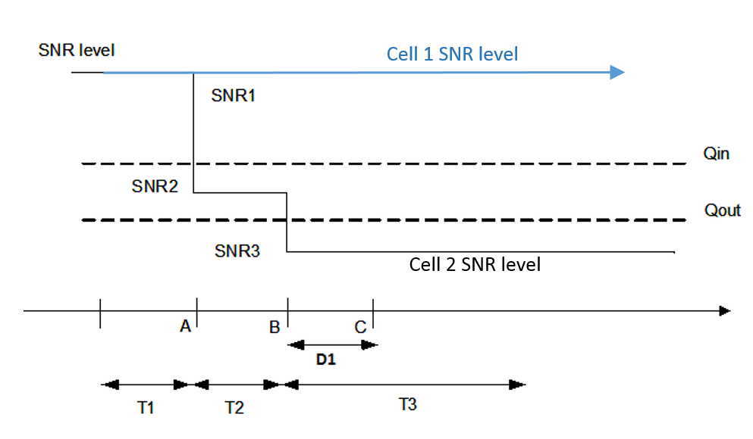

Figure A.4.5.1.12-1: SNR variation for out-of-sync testing

##### A.4.5.1.12.2 Test Requirements

The UE behaviour in each test during time durations T1, T2 and T3 shall be as follows:

During the period from time point A to time point B the UE shall transmit uplink signal at least in all uplink slots configured for CSI transmission according to the configured periodic CSI reporting.

The UE shall stop transmitting uplink signal in Cell 2 no later than time point C (D1 second after the start of the time duration T3).

The rate of correct events observed during repeated tests shall be at least 90%.

<End of Change #1>

<Start of Change #3>

#### A.5.5.1.14 EN-DC Radio Link Monitoring Out-of-sync Test for FR2 PSCell configured with SSB-based RLM RS in non-DRX mode for UE supporting NCD-SSB based measurement outside active BWP

##### A.5.5.1.14.1 Test Purpose and Environment

The purpose of this test is to verify that the UE properly detects the out of sync and in sync for the purpose of monitoring downlink radio link quality of the PSCell for UE supporting FG 53-3. This test will partly verify the FR2 radio link monitoring requirements in clause 8.1.

In the test, UE is configured to perform RLM on SSB, with *detectionResource* included in *RadioLinkMonitoringRS* set to SSB#0 and SSB#1, and *purpose* set to ‘*rlf*’. Supported test configurations are shown in table A.5.5.1.14.1-1. The test parameters are given in Tables A.5.5.1.14.1-2, A.5.5.1.14.1-3, and A. 5.5.1.x.1-4 below. There are two cells, Cell 1 is the E-UTRAN PCell, and Cell 2 is the PSCell, in the test. The E-UTRAN PCell setting refers to Table A.3.7.2.1-2. The test consists of three successive time periods, with time duration of T1, T2 and T3 respectively. Figure A.5.5.1.14.1-1 shows the variation of the downlink SNR in the active cell to emulate out-of-sync and in-sync states, and Figure A.5.5.1.14.1-2 shows the Time multiplexed downlink transmissions from each Angle of Arrival. Prior to the start of the time duration T1, the UE shall be fully synchronized to Cell 1 and Cell 2. The UE shall be configured for periodic CSI reporting with a reporting periodicity of 5 ms. UE is configured to perform inter-frequency measurements using Gap Pattern ID #0 (40ms) in test 1.

Table A.5.5.1.14.1-1: Supported test configurations for FR2 PSCell for UE supporting NCD-SSB based measurement outside active BWP

|  |  |
| --- | --- |
| Configuration | Description |
| 1 | FDD LTE PCell, NR 120 KHz SSB SCS, 100 MHz bandwidth, TDD duplex mode |
| 2 | TDD LTE PCell, NR 120 KHz SSB SCS, 100 MHz bandwidth, TDD duplex mode |
| Note: The UE is only required to pass in one of the supported test configurations in FR2 | |

Table A.5.5.1.14.1-2: General test parameters for FR2 out-of-sync testing in non-DRX mode

|  |  |  |  |  |
| --- | --- | --- | --- | --- |
| Parameter | | | Unit | Value |
| Test 1 |
| Active E-UTRA PCell | | |  | Cell 1 |
| E-UTRA RF Channel Number | | |  | 1 |
| Active PSCell | | |  | Cell 2 |
| RF Channel Number | | |  | 2 |
| Duplex mode | | Config 1, 2 |  | TDD |
| BWchannel | | Config 1, 2 |  | 100: NRB,c = 66 |
| Data RBs allocated | | Config 1, 2 |  | 24 |
| DL initial BWP configuration | | Config 1, 2 |  | DLBWP.0.1 |
| DL dedicated BWP configuration | | Config 1, 2 |  | DLBWP.1.1 |
| UL initial BWP configuration | | Config 1, 2 |  | ULBWP.0.1 |
| UL dedicated BWP configuration | | Config 1, 2 |  | ULBWP.1.1 |
| TDD Configuration | | Config 1, 2 |  | TDDConf.3.1 |
| RMSI CORESET Reference Channel | | Config 1, 2 |  | CR.3.1 TDD |
| Dedicated CORESET Reference Channel | | Config 1, 2 |  | CCR.3.4 TDD |
| SSB Configuration | | Config 1, 2 |  | SSB.1 FR2 |
| NCD-SSB Configuration | | Config 1 |  | SSB.19 FR2 |
| SMTC Configuration | | Config 1, 2 |  | SMTC pattern 1 for RedCap |
| PDSCH/PDCCH subcarrier spacing | | Config 1, 2 |  | 120 KHz |
| PRACH Configuration | | Config 1, 2 |  | Table A.3.8.3.1 |
| SSB index assigned as RLM RS | | Config 1, 2 |  | 0,1 |
| OCNG parameters | | |  | OP.5 |
| CP length | | |  | Normal |
| Out of sync transmission parameters | DCI format | |  | 1-0 |
| Number of Control OFDM symbols | |  | 2 |
| Aggregation level | | CCE | 8 |
| Ratio of hypothetical PDCCH RE energy to average SSS RE energy | | dB | 4 |
| Ratio of hypothetical PDCCH DMRS energy to average SSS RE energy | | dB | 4 |
| DMRS precoder granularity | |  | REG bundle size |
| REG bundle size | |  | 6 |
| DRX | | |  | *OFF* |
| Gap pattern ID | | |  | *gp0* |
| Layer 3 filtering | | |  | *Enabled* |
| T310 timer | | | ms | *0* |
| T311 timer | | | ms | 1000 |
| N310 | | |  | 1 |
| N311 | | |  | 1 |
| CSI-RS for CSI reporting | | Config 1, 2 |  | CSI-RS.3.1 TDD |
| reportConfigType | | |  | periodic |
| reportQuantity | | |  | cri-RI-PMI-CQI |
| CSI reporting periodicity | | | slot | 40 |
| CSI reporting offset | | | slot | 4 |
| TCI states for PDCCH/PDSCH | | |  | TCI.State.2 |
| CSI-RS for tracking | | Config 1, 2 |  | TRS.2.1 TDD |
| T1 | | | s | 0.2 |
| T2 | | | s | 9.68 |
| T3 | | | s | 9.68 |
| D1 | | | s | 9.64 |
| Note 1: All configurations are assigned to the UE prior to the start of time period T1.  Note 2: UE-specific PDCCH is not transmitted after T1 starts.  Note 3: E-UTRAN is in non-DRX mode under test. | | | | |

Table A.5.5.1.14.1-3: OTA related cell specific test parameters for FR2 (Cell 2) for out-of-sync radio link monitoring tests in non-DRX mode

|  |  |  |  |  |  |  |  |  |
| --- | --- | --- | --- | --- | --- | --- | --- | --- |
| Parameter | | Unit | Test 1 | | | | | |
|  | |  | T1 | T2 | T3 | T1 | T2 | T3 |
| AoA setup | |  | Setup 3 defined in A.3.15 | | | | | |
|  | |  | AoA1 | | | AoA2 | | |
| Assumption for UE beamsNote 5 | |  | Rough | | | Rough | | |
| EPRE ratio of PDCCH DMRS to SSS | | dB | 4 | | |  | | |
| EPRE ratio of PDCCH to PDCCH DMRS | | dB |  | | |  | | |
| EPRE ratio of PBCH DMRS to SSS | | dB |  | | |  | | |
| EPRE ratio of PBCH to PBCH DMRS | | dB |  | | |  | | |
| EPRE ratio of PSS to SSS | | dB | 0 | | | Not sent | | |
| EPRE ratio of PDSCH DMRS to SSS | | dB |  | | |  | | |
| EPRE ratio of PDSCH to PDSCH DMRS | | dB |  | | |  | | |
| EPRE ratio of OCNG DMRS to SSS | | dB |  | | |  | | |
| EPRE ratio of OCNG to OCNG DMRS | | dB |  | | |  | | |
| ssb-Index 0 SNR | Config 1, 2 | dB | 2Note 6 | -6Note 6 | -15 |  | | |
| ssb-Index 1 SNR | Config 1, 2 |  | Not sent | | | 2Note 6 | -15 | -15 |
|  | Config 1, 2 | dBm/ 15kHz | -92.1 | | | -92.1 | | |
| Time multiplexing of the downlink transmissions from each AoA | |  | Defined in Figure A.5.5.1.1.1-2 | | | | | |
| Propagation condition | |  | TDL-A 30ns 75Hz | | | TDL-A 30ns 75Hz | | |
| Note 1: OCNG shall be used such that a constant total transmitted power spectral density is achieved for all OFDM symbols.  Note 2: The signal contains PDCCH for UEs other than the device under test as part of OCNG.  Note 3: SNR levels correspond to the signal to noise ratio over the SSS REs.  Note 4: The SNR values are specified for testing a UE which supports 2RX on at least one band. For testing of a UE which supports 4RX on all bands, the SNR during T3 is A.3.6.  Note 5: Information about types of UE beam is given in B.2.1.3, and does not limit UE implementation or test system implementation  Note 6: This value allows up to 1dB degradation from applied SNR to UE baseband | | | | | | | | |

Table A.5.5.1.14.1-4: Measurement gap configuration for out-of-sync tests in non-DRX mode

|  |  |
| --- | --- |
| Field | Test 1 |
|  | Value |
| gapOffset | 0 |
| Note 1: E-UTRAN PCell and PSCell are SFN-synchronous and frame boundary aligned. (Ensure that RLM RS is partially overlapped with measurement gap). | |

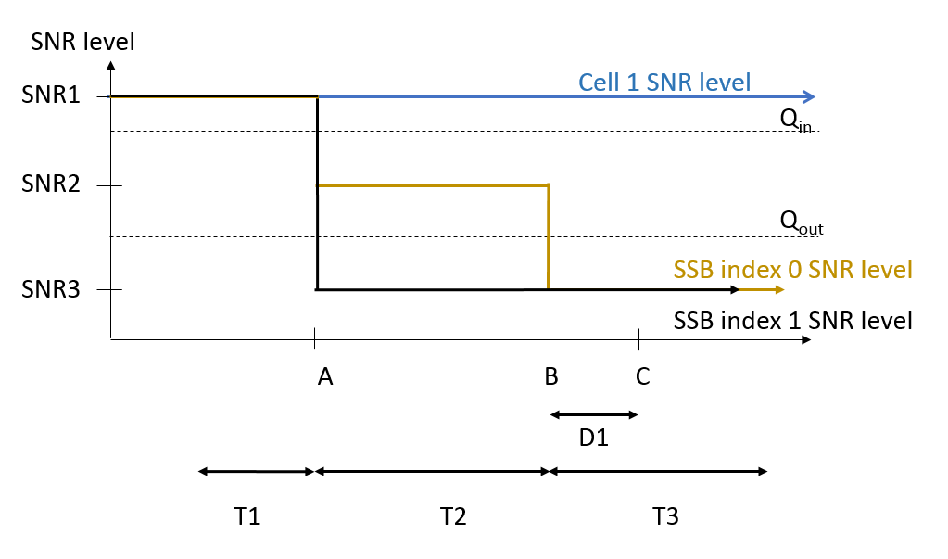

Figure A.5.5.1.14.1-1: SNR variation for out-of-sync testing



Figure A.5.5.1.14.1-2: Time multiplexed downlink transmissions

##### A.5.5.1.14.2 Test Requirements

The UE behavior in each test during time durations T1, T2 and T3 shall be as follows:

During the period from time point A to time point B the UE shall transmit uplink signal at least in all uplink slots configured for CSI transmission according to the configured periodic CSI reporting.

The UE shall stop transmitting uplink signal in Cell 2 no later than time point C (D1 second after the start of the time duration T3).

The rate of correct events observed during repeated tests shall be at least 90%.

<End of Change #3>

<Start of Change #5>

#### A.6.5.1.12 Radio Link Monitoring Out-of-sync Test for FR1 PCell configured with SSB-based RLM RS in non-DRX mode for UE supporting NCD-SSB based measurement outside active BWP

##### A.6.5.1.12.1 Test Purpose and Environment

The purpose of this test is to verify that the UE properly detects the out of sync and in sync for the purpose of monitoring downlink radio link quality of the PCell for UE supporting FG 53-3. This test will partly verify the FR1 radio link monitoring requirements in clause 8.1.

In the test, UE is configured to perform RLM on SSB, with *detectionResource* included in *RadioLinkMonitoringRS* set to SSB#0, and *purpose* set to ‘*rlf*’. Supported test configurations are shown in table A.6.5.1.12.1-1. The test parameters are given in Tables A.6.5.1.12.1-2, A.6.5.1.12.1-3, and A.6.5.1.12.1-4 below. There is one cell (Cell 1), which is the active NR cell, in the test. The test consists of three successive time periods, with time duration of T1, T2 and T3 respectively. Figure A.6.5.1.12.1-1 shows the variation of the downlink SNR in the active cell to emulate out-of-sync and in-sync states. Prior to the start of the time duration T1, the UE shall be fully synchronized to Cell 1. The UE shall be configured for periodic CSI reporting with a reporting periodicity of 5 ms. The UE is configured to perform inter-frequency measurements using Gap Pattern ID #0 (40ms) in test 1.

Table A.6.5.1.12.1-1: Supported test configurations for FR1 PCell for UE supporting FG NCD-SSB based measurement outside active BWP

|  |  |
| --- | --- |
| Configuration | Description |
| 1 | FDD, SSB SCS 15 kHz, data SCS 15 kHz, BW 10 MHz |
| 2 | TDD, SSB SCS 15 kHz, data SCS 15 kHz, BW 10 MHz |
| 3 | TDD, SSB SCS 30 kHz, data SCS 30 kHz, BW 40 MHz |
| Note: The UE is only required to pass in one of the supported test configurations in FR1 | |

Table A.6.5.1.12.1-2: General test parameters for FR1 out-of-sync testing in non-DRX mode for UE supporting NCD-SSB based measurement outside active BWP

|  |  |  |  |  |
| --- | --- | --- | --- | --- |
| Parameter | | | Unit | Value |
|  | | |  | Test 1 |
| Active PCell | | |  | Cell 1 |
| RF Channel Number | | |  | 1 |
| Duplex mode | | Config 1 |  | FDD |
| Config 2, 3 |  | TDD |
| BWchannel | | Config 1 | MHz | 10: NRB,c = 52 |
|  | | Config 2 |  | 10: NRB,c = 52 |
|  | | Config 3 |  | 20: NRB,c = 51 |
| DL initial BWP configuration | | Config 1, 2, 3 |  | DLBWP.0.1 |
| DL dedicated BWP configuration | | Config 1, 2, 3 |  | DLBWP.1.1 |
| UL initial BWP configuration | | Config 1, 2, 3 |  | ULBWP.0.1 |
| UL dedicated BWP configuration | | Config 1, 2, 3 |  | ULBWP.1.1 |
| TDD Configuration | | Config 1 |  | Not Applicable |
|  | | Config 2 |  | TDDConf.1.1 |
|  | | Config 3 |  | TDDConf.2.1 |
| RMSI CORESET Reference Channel | | Config 1 |  | CR.1.1 FDD |
|  | | Config 2 |  | CR.1.1 TDD |
|  | | Config 3 |  | CR.2.1 TDD |
| Dedicated CORESET Reference Channel | | Config 1 |  | CCR.1.3 FDD |
|  | | Config 2 |  | CCR.1.3 TDD |
|  | | Config 3 |  | CCR.2.2 TDD |
| CD-SSB Configuration | | Config 1 |  | SSB.1 FR1 |
|  | | Config 2 |  | SSB.1 FR1 |
|  | | Config 3 |  | SSB.2 FR1 |
| NCD-SSB Configuration | | Config 1 |  | SSB.9 FR1 |
| Config 2 |  | SSB.9 FR1 |
| Config 3 |  | SSB.10 FR1 |
| SMTC Configuration | | Config 1, 2 |  | SMTC.10 |
|  | | Config 3 |  | SMTC.10 |
| PDSCH/PDCCH subcarrier spacing | | Config 1, 2 |  | 15 kHz |
|  | | Config 3 |  | 30 kHz |
| PRACH Configuration | | Config 1, 2 |  | Table A.3.8.2.1-1 |
|  | | Config 3 |  | Table A.3.8.2.1-1 |
| SSB index assigned as RLM RS | | |  | 0 |
| OCNG parameters | | |  | OP.1 |
| CP length | | |  | Normal |
| Correlation Matrix and Antenna Configuration | | |  | 2x2 Low |
| Out of sync transmission parameters | DCI format | |  | 1-0 |
|  | Number of Control OFDM symbols | |  | 2 |
|  | Aggregation level | | CCE | 8 |
|  | Ratio of hypothetical PDCCH RE energy to average SSS RE energy | | dB | 4 |
|  | Ratio of hypothetical PDCCH DMRS energy to average SSS RE energy | | dB | 4 |
|  | DMRS precoder granularity | |  | REG bundle size |
|  | REG bundle size | |  | 6 |
| DRX | | |  | *OFF* |
| Gap pattern ID | | |  | *gp0* |
| Layer 3 filtering | | |  | *Enabled* |
| T310 timer | | | ms | *0* |
| T311 timer | | | ms | 1000 |
| N310 | | |  | 1 |
| N311 | | |  | 1 |
| CSI-RS configuration for CSI reporting | | Config 1 |  | CSI-RS.1.1 FDD |
|  | | Config 2 |  | CSI-RS.1.1 TDD |
|  | | Config 3 |  | CSI-RS.2.1 TDD |
| CSI-RS for tracking | | Config 1 |  | TRS.1.1 FDD |
|  | | Config 2 |  | TRS.1.1 TDD |
|  | | Config 3 |  | TRS.1.2 TDD |
| T1 | | | s | 0.2 |
| T2 | | | s | 0.48 |
| T3 | | | s | 0.48 |
| D1 | | | s | 0.44 |
| Note 1: All configurations are assigned to the UE prior to the start of time period T1.  Note 2: UE-specific PDCCH is not transmitted after T1 starts. | | | | |

Table A.6.5.1.12.1-3: Cell specific test parameters for FR1 (Cell 1) for out-of-sync radio link monitoring tests in non-DRX mode for UE supporting NCD-SSB based measurement outside active BWP

|  |  |  |  |  |  |
| --- | --- | --- | --- | --- | --- |
| Parameter | | Unit | Test 1 | | |
|  | |  | T1 | T2 | T3 |
| EPRE ratio of PDCCH DMRS to SSS | | dB | 4 | | |
| EPRE ratio of PDCCH to PDCCH DMRS | | dB | 0 | | |
| EPRE ratio of PBCH DMRS to SSS | | dB | 0 | | |
| EPRE ratio of PBCH to PBCH DMRS | | dB |  | | |
| EPRE ratio of PSS to SSS | | dB |  | | |
| EPRE ratio of PDSCH DMRS to SSS | | dB |  | | |
| EPRE ratio of PDSCH to PDSCH DMRS | | dB |  | | |
| EPRE ratio of OCNG DMRS to SSS | | dB |  | | |
| EPRE ratio of OCNG to OCNG DMRS | | dB |  | | |
| SNR on RLM-RS | Config 1 | dB | 1 | -7 | -15 |
|  | Config 2 |  | 1 | -7 | -15 |
|  | Config 3 |  | 1 | -7 | -15 |
|  | Config 1 | dBm/15kHz | -98 | | |
|  | Config 2 |  | -98 | | |
|  | Config 3 |  | -98 | | |
|  | Config 1 | dBm/SCS | -98 | | |
|  | Config 2 |  | -98 | | |
|  | Config 3 |  | -95 | | |
| Propagation condition | |  | TDL-C 300ns 100Hz | | |
| Note 1: OCNG shall be used such that the resources in Cell 1 are fully allocated and a constant total transmitted power spectral density is achieved for all OFDM symbols.  Note 2: The signal contains PDCCH for UEs other than the device under test as part of OCNG.  Note 3: SNR levels correspond to the signal to noise ratio over the SSS REs.  Note 4: The SNR in time periods T1, T2 and T3 is denoted as SNR1, SNR2 and SNR3 respectively in Figure A.6.5.1.12.1-1.  Note 5: The SNR values are specified for testing a UE which supports 2RX on at least one band. | | | | | |

Table A.6.5.1.12.1-4: Measurement gap configuration for out-of-sync tests in non-DRX mode

|  |  |
| --- | --- |
| Field | Test 1 |
|  | Value |
| gapOffset | 0 |
| Note: Ensure that RLM RS is partially overlapped with measurement gap | |

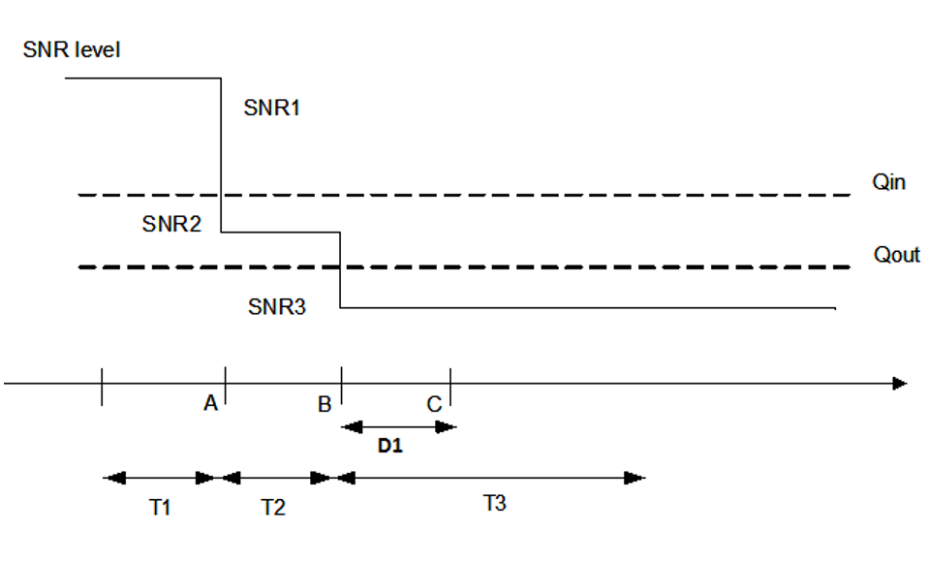

Figure A.6.5.1.12.1-1: SNR variation for out-of-sync testing

##### A.6.5.1.12.2 Test Requirements

The UE behaviour in each test during time durations T1, T2 and T3 shall be as follows:

During the period from time point A to time point B the UE shall transmit uplink signal at least in all uplink slots configured for CSI transmission according to the configured periodic CSI reporting.

The UE shall stop transmitting uplink signal no later than time point C (D1 second after the start of the time duration T3).

The rate of correct events observed during repeated tests shall be at least 90%.

<End of Change #5>

< Start of Change #7>

#### A.7.5.1.13 Radio Link Monitoring Out-of-sync Test for FR2 PCell configured with SSB-based RLM RS in non-DRX mode for UE supporting NCD-SSB based measurement outside active BWP

##### A.7.5.1.13.1 Test Purpose and Environment

The purpose of this test is to verify that the UE properly detects the out of sync and in sync for the purpose of monitoring downlink radio link quality of the PCell. This test will partly verify the FR2 radio link monitoring requirements in clause 8.1.

In the test, UE is configured to perform RLM on SSB, with *detectionResource* included in *RadioLinkMonitoringRS* set to SSB#0 and SSB#1, and *purpose* set to ‘*rlf*’. Supported test configurations are shown in table A.7.5.1.13 .1-1. The test parameters are given in Tables A.7.5.1.13 .1-2, A.7.5.1.13 .1-3, and A.7.5.1.13 .1-4 below. There is one cell (Cell 1), which is the active NR cell, in the test. The test consists of three successive time periods, with time duration of T1, T2 and T3 respectively. Figure A.7.5.1.13 .1-1 shows the variation of the downlink SNR in the active cell to emulate out-of-sync and in-sync states, and Figure A.7.5.1.13 .1-2 shows the Time multiplexed downlink transmissions from each Angle of Arrival. Prior to the start of the time duration T1, the UE shall be fully synchronized to Cell 1. The UE shall be configured for periodic CSI reporting with a reporting periodicity of 5 ms. In addition to RLM-RS radio link monitoring using SSB index 0 and SSB index 1, the UE is configured to perform inter-frequency measurements using Gap Pattern ID #0 (40ms) in test 1.

Table A.7.5.1.13 .1-1: Supported test configurations for FR2 PCell

|  |  |
| --- | --- |
| Configuration | Description |
| 1 | TDD, SSB SCS 120 KHz, data SCS 120KHz, BW 100 MHz |

Table A.7.5.1.13 .1-2: General test parameters for FR2 out-of-sync testing in non-DRX mode

|  |  |  |  |  |
| --- | --- | --- | --- | --- |
| **Parameter** | | | **Unit** | **Value** |
| **Test 1** |
| Active PCell | | |  | Cell 1 |
| RF Channel Number | | |  | 1 |
| Duplex mode | | Config 1 |  | TDD |
| BWchannel | | Config 1 |  | 100: NRB,c = 66 |
| Data RBs allocated | | Config 1 |  | 24 |
| DL initial BWP configuration | | Config 1 |  | DLBWP.0.1 |
| DL dedicated BWP configuration | | Config 1 |  | DLBWP.1.1 |
| UL initial BWP configuration | | Config 1 |  | ULBWP.0.1 |
| UL dedicated BWP configuration | | Config 1 |  | ULBWP.1.1 |
| TDD Configuration | | Config 1 |  | TDDConf.3.1 |
| RMSI CORESET Reference Channel | | Config 1 |  | CR.3.1 TDD |
| Dedicated CORESET Reference Channel | | Config 1 |  | CCR.3.4 TDD |
| CD-SSB Configuration | | Config 1 |  | SSB.1 FR2 |
| NCD-SSB Configuration | | Config 1 |  | SSB.19 FR2 |
| SMTC Configuration | | Config 1 |  | SMTC pattern 1 for RedCap |
| PDSCH/PDCCH subcarrier spacing | | Config 1 |  | 120 KHz |
| PRACH Configuration | | Config 1 |  | Table A.3.8.3.4 |
| SSB index assigned as RLM RS | | Config 1 |  | 0,1 |
| OCNG parameters | | |  | OP.5 |
| CP length | | |  | Normal |
| Out of sync transmission parameters | DCI format | |  | 1-0 |
| Number of Control OFDM symbols | |  | 2 |
| Aggregation level | | CCE | 8 |
| Ratio of hypothetical PDCCH RE energy to average SSS RE energy | | dB | 4 |
| Ratio of hypothetical PDCCH DMRS energy to average SSS RE energy | | dB | 4 |
| DMRS precoder granularity | |  | REG bundle size |
| REG bundle size | |  | 6 |
| DRX | | |  | *OFF* |
| Gap pattern ID | | |  | *gp0* |
| Layer 3 filtering | | |  | *Enabled* |
| T310 timer | | | ms | *0* |
| T311 timer | | | ms | 1000 |
| N310 | | |  | 1 |
| N311 | | |  | 1 |
| CSI-RS for CSI reporting | | Config 1 |  | CSI-RS.3.1 TDD |
| reportConfigType | | |  | periodic |
| reportQuantity | | |  | cri-RI-PMI-CQI |
| CSI reporting periodicity | | | slot | 40 |
| CSI reporting offset | | | slot | 4 |
| TCI states for PDCCH/PDSCH | | |  | TCI.State.2 |
| CSI-RS for tracking | | Config 1 |  | TRS.2.1 TDD |
| T1 | | | s | 0.2 |
| T2 | | | s | 9.68 |
| T3 | | | s | 9.68 |
| D1 | | | s | 9.64 |
| Note 1: All configurations are assigned to the UE prior to the start of time period T1.  Note 2: UE-specific PDCCH is not transmitted after T1 starts. | | | | |

Table A.7.5.1.13 .1-3: OTA related cell specific test parameters for FR2 (Cell 1) for out-of-sync radio link monitoring tests in non-DRX mode

|  |  |  |  |  |  |  |  |  |
| --- | --- | --- | --- | --- | --- | --- | --- | --- |
| Parameter | | Unit | Test 1 | | | | | |
|  | |  | T1 | T2 | T3 | T1 | T2 | T3 |
| AoA setup | |  | Setup 3 defined in A.3.15 | | | | | |
|  | |  | AoA1 | | | AoA2 | | |
| Assumption for UE beams Note 5 | |  | Rough | | | Rough | | |
| EPRE ratio of PDCCH DMRS to SSS | | dB | 4 | | | Not sent | | |
| EPRE ratio of PDCCH to PDCCH DMRS | | dB | 0 | | |  | | |
| EPRE ratio of PBCH DMRS to SSS | | dB |  | | |  | | |
| EPRE ratio of PBCH to PBCH DMRS | | dB |  | | |  | | |
| EPRE ratio of PSS to SSS | | dB |  | | |  | | |
| EPRE ratio of PDSCH DMRS to SSS | | dB |  | | |  | | |
| EPRE ratio of PDSCH to PDSCH DMRS | | dB |  | | |  | | |
| EPRE ratio of OCNG DMRS to SSS | | dB |  | | |  | | |
| EPRE ratio of OCNG to OCNG DMRS | | dB |  | | |  | | |
| ssb-Index 0 SNR | Config 1 | dB | 2Note 6 | -6Note 6 | -15 |  | | |
| ssb-Index 1 SNR | Config 1 |  | Not sent | | | 2Note 6 | -15 | -15 |
|  | Config 1 | dBm/ 15kHz | -92.1 | | | -92.1 | | |
| Time multiplexing of the downlink transmissions from each AoA | |  | Defined in Figure A.7.5.1.13 .1-2 | | | | | |
| Propagation condition | |  | TDL-A 30ns 75Hz | | | TDL-A 30ns 75Hz | | |
| Note 1: OCNG shall be used such a constant total transmitted power spectral density is achieved for all OFDM symbols.  Note 2: The signal contains PDCCH for UEs other than the device under test as part of OCNG.  Note 3: SNR levels correspond to the signal to noise ratio over the SSS REs.  Note 4: The SNR values are specified for testing a UE which supports 2RX on at least one band..  Note 5: Information about types of UE beam is given in B.2.1.3 and does not limit UE implementation or test system implementation.  Note 6: This value allows up to 1dB degradation from applied SNR to UE baseband | | | | | | | | |

Table A.7.5.1.13 .1-4: Measurement gap configuration for out-of-sync tests in non-DRX mode

|  |  |
| --- | --- |
| Field | Test 1 |
| Value |
| gapOffset | 0 |

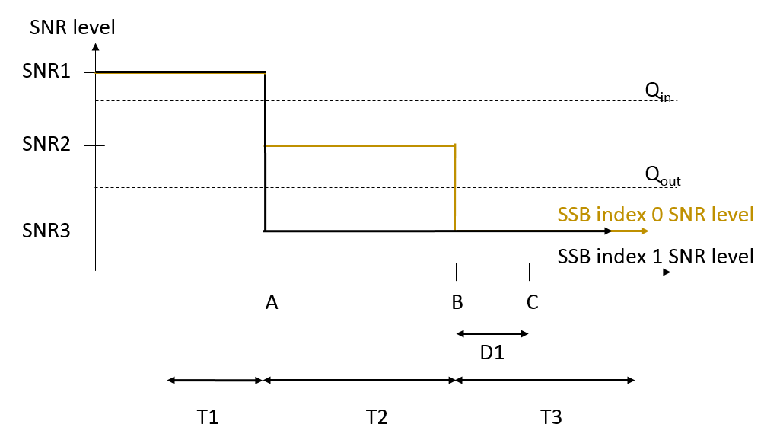

Figure A.7.5.1.13 .1-1: SNR variation for out-of-sync testing



Figure A.7.5.1.13 .1-2: Time multiplexed downlink transmissions

##### A.7.5.1.13.2 Test Requirements

The UE behavior in each test during time durations T1, T2 and T3 shall be as follows:

During the period from time point A to time point B the UE shall transmit uplink signal at least in all uplink slots configured for CSI transmission according to the configured periodic CSI reporting.

The UE shall stop transmitting uplink signal no later than time point C (D1 second after the start of the time duration T3).

The rate of correct events observed during repeated tests shall be at least 90%.

<End of Change #7>