**3GPP TSG-RAN WG4 Meeting # 112 R4-240xxxx**

**Maastricht, The Netherlands, 19 – 23 August, 2024**

**Agenda item:** 4.1

**Source:** Moderator (Huawei, HiSilicon)

**Title:** Topic summary for [112][201] Maintenance_up_to_R17

**Document for:** Information

# Introduction

This document provides summary for RRM related Tdocs submitted to the following AI

*4.5 RRM requirements [WI code]*

*4.8 Rel-15/16/17 TEI [TEI]*

Please kindly take following notes for Tdoc handling in this topic thread.

1. Open issues are based on Discussion papers.
2. Based on Chair’s guidance, all CRs in this email thread will be first handled in NWM flagging procedure which will be triggered separately.
3. Tdocs that are withdrawn or revised in the Tdocs list will not be handled in the summary document or the NWM flagging procedure.
4. Cat-A CRs will not be handled in the summary document or the NWM flagging procedure.

Recommended issues for online discussion:

Sub-topic 4-1: NCSG patterns

Sub-topic 2-1: Interruption requirements for R16 NFG

Sub-topic 1-1: MAC CE based active TCI state list update delay

Sub-topic 3-1: Applicability of tci-ActivatedConfig for SCell

Sub-topic 1-2: NR – E-UTRAN Handover Delay

# Topic #1: R15 NR

## Companies’ contributions summary

|  |  |  |
| --- | --- | --- |
| **T-doc number** | **Company** | **Proposals / Observations** |
| [**R4-2411395**](https://www.3gpp.org/ftp/TSG_RAN/WG4_Radio/TSGR4_112/Docs/R4-2411395.zip) | Apple | ***Proposal 1: It is proposed to specify the active TCI state list update delay as follows:***  ***“If the target TCI state is known, upon receiving PDSCH carrying MAC-CE for activation/deactivation of UE-specific PDSCH TCI state as defined in clause 6.1.3.14 of TS 38.321 [7] at slot n, UE shall be able to receive PDCCH, which schedules PDSCH with the new target TCI state, at the first slot that is after n+ THARQ + +TOk*(Tfirst-SSB + TSSB-proc) / NR slot length, and the UE is not expected to receive such PDCCH before that. Where THARQ, Tfirst-SSB, TSSB-proc and TOk are defined in clause 8.10.3.”*** |
| [**R4-2411952**](https://www.3gpp.org/ftp/TSG_RAN/WG4_Radio/TSGR4_112/Docs/R4-2411952.zip) | Nokia | 1. Allow UE an additional HO delay of one MIB reception attempt when the given conditions are fulfilled. 2. Define the delay requirement as part of PRACH acquisition delay in Tinterrrupt under TIU. |

## Open issues summary

### Sub-topic 1-1: MAC CE based active TCI state list update delay

* Proposals
  + Option 1 (Apple):

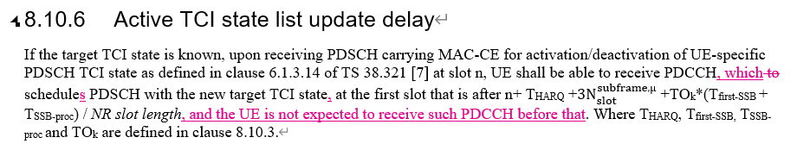

* Recommended WF
  + Discuss the option

### Sub-topic 1-2: NR – E-UTRAN Handover Delay

* Proposals
  + Option 1 (Nokia):
    - Allow UE an additional HO delay of one MIB reception attempt when the given conditions are fulfilled.
    - Define the delay requirement as part of PRACH acquisition delay in Tinterrrupt under TIU.

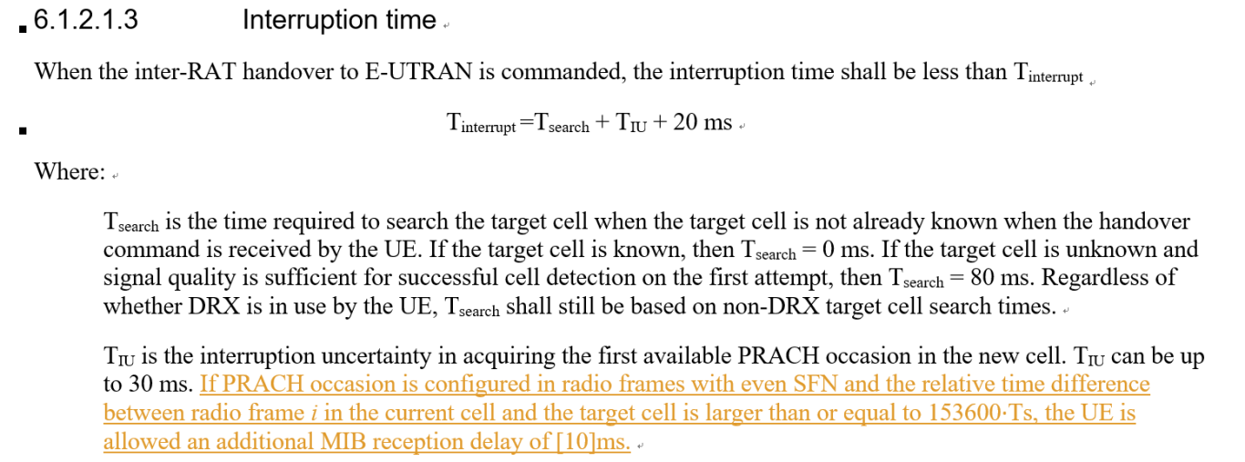

* Recommended WF
  + Discuss the option

# Topic #2: R16 NR_RRM_enh

## Companies’ contributions summary

|  |  |  |
| --- | --- | --- |
| **T-doc number** | **Company** | **Proposals / Observations** |
| [**R4-2412025**](https://www.3gpp.org/ftp/TSG_RAN/WG4_Radio/TSGR4_112/Docs/R4-2412025.zip) | Nokia | Proposal 1: Confirm tentative agreement for Scenario 1, LTE – NR inter-RAT measurement:   * 1. interRAT-NeedForGapsNR-r16=FALSE means that the UE support measurement without gaps      1. The UE may or may not cause interruption.   2. if UE causes interruptions when performing measurements without gaps:      1. Support early implementation of interRAT-NeedForInterruptionNR-r18:         1. Optional since Rel-17   Proposal 2: Confirm tentative agreement for Scenario 2, NR measurements without gaps   * 1. “no-gap” as part of NeedForGapsInfoNR-r16 means that the UE support measurement without gaps      1. The UE may or may not cause interruption.   2. if UE causes interruptions when performing measurements without gaps:      1. Support early implementation of nr-NeedForInterruptionReport-r18:         1. Optional since Rel-17   Proposal 3: Send RAN2 LS informing of the decision and requesting to take actions related to early implementation. |

## Open issues summary

### Sub-topic 2-1: Interruption requirements for R16 NFG

* Proposals
  + Option 1 (Nokia):
    - Confirm tentative agreement for Scenario 1, LTE – NR inter-RAT measurement:
      * interRAT-NeedForGapsNR-r16=FALSE means that the UE support measurement without gaps
        + The UE may or may not cause interruption.
      * if UE causes interruptions when performing measurements without gaps:
        + Support early implementation of interRAT-NeedForInterruptionNR-r18:
        + Optional since Rel-17
    - Confirm tentative agreement for Scenario 2, NR measurements without gaps
      * “no-gap” as part of NeedForGapsInfoNR-r16 means that the UE support measurement without gaps
        + The UE may or may not cause interruption.
      * if UE causes interruptions when performing measurements without gaps:
        + Support early implementation of nr-NeedForInterruptionReport-r18:

Optional since Rel-17

* + - Send RAN2 LS informing of the decision and requesting to take actions related to early implementation.
* Recommended WF
  + Agree on option 1
  + Check the LS draft in Annex of R4-2412025

# Topic #3: R17 LTE_NR_DC_enh2

## Companies’ contributions summary

|  |  |  |
| --- | --- | --- |
| **T-doc number** | **Company** | **Proposals / Observations** |
| **R4-2411961** | Nokia | Observation 1: tci-ActivatedConfig can be configured for any SCell unconditionally.  Observation 2: tci-ActvatedConfig can only be configured for a PSCell which is activated when configured.  Observation 3: tci-ActivatedConfig can be configured for a deactivated SCell and a direct activated SCell.  **Proposal 1: Update the RAN4 UE requirements capturing that tci-ActivatedConfig can be configured for a deactivated SCell and a direct activated SCell.**  **Proposal 2: If proposal 1 is not agreeable, send LS to RAN2 clarifying the RAN2 understanding of the applicability of tci-ActivatedConfig.** |

## Open issues summary

### Sub-topic 3-1: Applicability of tci-ActivatedConfig for SCell

* Proposals
  + Option 1 (Nokia):
    - Update the RAN4 UE requirements capturing that tci-ActivatedConfig can be configured for a deactivated SCell and a direct activated SCell.

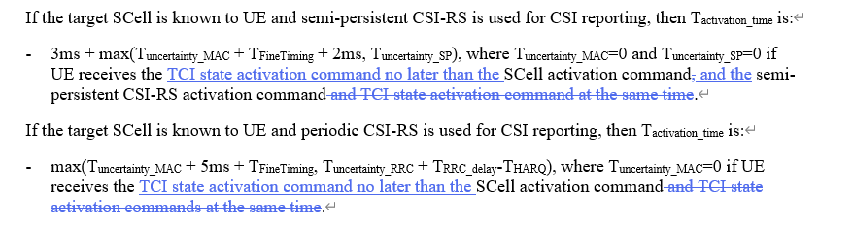

* + - If proposal 1 is not agreeable, send LS to RAN2 clarifying the RAN2 understanding of the applicability of tci-ActivatedConfig.

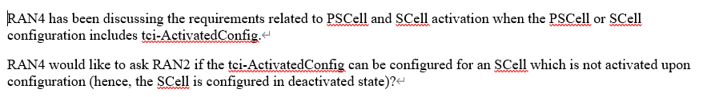

* Recommended WF
  + Discuss the option

# Topic #4: R17 NR_MG_enh

## Companies’ contributions summary

|  |  |  |
| --- | --- | --- |
| **T-doc number** | **Company** | **Proposals / Observations** |
| [**R4-2411486**](https://www.3gpp.org/ftp/TSG_RAN/WG4_Radio/TSGR4_112/Docs/R4-2411486.zip) | OPPO, CATT | **Observation 1: The two NCSG patterns in each of the following groups are the same in terms of ML and VIRP:**   * **NCSG pattern 0 and 13** * **NCSG pattern 1 and 14** * **NCSG pattern 4 and 12** * **NCSG pattern 5 and 15** * **NCSG pattern 6 and 16** * **NCSG pattern 7 and 17** * **NCSG pattern 8 and 18** * **NCSG pattern 9 and 19**   **Observation 2: When both the serving cells and measurement purpose are in FR2, and the per-UE gap (pattern #12-25) is configured, the switching time is 0.25ms rather than 0.5ms.**  **Observation 3: When both the serving cells and measurement purpose are in FR2 only, and the per-UE NCSG (pattern #12-23) is configured, VIL is defined as 1ms in current spec, which is not aligned with the principle of RF switching time for MG pattern.**  **Propose 1: VIL should be specific to NCSG patterns, i.e. VIL=1ms for NCSG pattern #0-11 and VIL=0.75ms for NCSG pattern #12-23.**  Propose 2: Support to modify VIL specific to NCSG patterns in the VIL requirements, e.g. Table 9.1.9-1 for NCSG pattern #0-11 and Table 9.1.9-2 for NCSG pattern #12-23 as shown below. |
| [**R4-2412509**](https://www.3gpp.org/ftp/TSG_RAN/WG4_Radio/TSGR4_112/Docs/R4-2412509.zip) | Ericsson | ***Observation 1: NCSG patterns’ parameters for pattern #0-11 and pattern #12-23 are the same in RAN4 spec, but they are clear from RAN2 signalling.***  ***Proposal 1: In Rel-17, RAN4 to update the NCSG patterns with a clarification.*** |
| [**R4-2412628**](https://www.3gpp.org/ftp/TSG_RAN/WG4_Radio/TSGR4_112/Docs/R4-2412628.zip) | Huawei, HiSilicon | **Proposal: Update the applicability of VIL such that it depends on the NCSG pattern rather than NCSG type (per-UE or per-FR).** |

## Open issues summary

### Sub-topic 4-1: NCSG patterns

* Proposals
  + Option 1 (OPPO, CATT, HW):
    - VIL should be specific to NCSG patterns, i.e. VIL=1ms for NCSG pattern #0-11 and VIL=0.75ms for NCSG pattern #12-23.
    - Support to modify VIL specific to NCSG patterns in the VIL requirements, e.g. Table 9.1.9-1 for NCSG pattern #0-11 and Table 9.1.9-2 for NCSG pattern #12-23 as shown below.

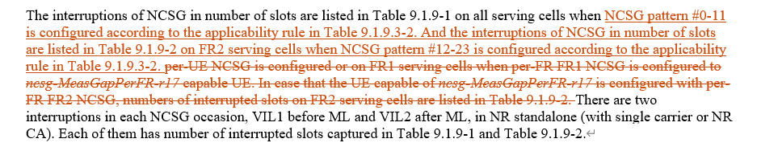

* + Option 2 (E///):
    - In Rel-17, RAN4 to update the NCSG patterns with a clarification.
* Recommended WF
  + Discuss the options

# Topic #5: R17 NR_UE_pow_sav_enh-Core

## Companies’ contributions summary

|  |  |  |
| --- | --- | --- |
| **T-doc number** | **Company** | **Proposals / Observations** |
| [**R4-2412515**](https://www.3gpp.org/ftp/TSG_RAN/WG4_Radio/TSGR4_112/Docs/R4-2412515.zip) | vivo | **Observation 1 Short DRX is only used once when there is UL/DL data during the on-duration of each DRX cycle. However, R17 UE RLM/BFD relaxation mainly focuses on the scenarios where in most DRX cycles there is no UL/DL data. UE shall not be expected in the continuous short DRX cycles for R17 RLM/BFD relaxation.**  **Observation 2 Considering the target scenario for R17 RLM/BFD relaxation are the cases when UE has no UL/DL data in most of the DRX cycles, short DRX shall only be used during transition period, and it is already clear in TS 38.133 that UE does not need to meet RRM requirements during transitions for RLM/BFD.**  **Observation 3 In case UE has continuous data in consecutive DRX cycles, it is up to gNB implementation to enable or disable RLM/BFD relaxation feature via RRC signaling.**  **Proposal 1 For R17 RLM/BFD relaxation, no further spec impact is needed.** |

## Open issues summary

### Sub-topic 5-1: Impact of RAN2 LS R2-2403995

* Proposals
  + Option 1 (vivo):
    - For R17 RLM/BFD relaxation, no further spec impact is needed (due to the received information in RAN2 LS R2-2403995)
* Recommended WF
  + Discuss the option

# Topic #6: R17 NR_RRM_enh2

## Companies’ contributions summary

|  |  |  |
| --- | --- | --- |
| **T-doc number** | **Company** | **Proposals / Observations** |
| [**R4-2412179**](https://www.3gpp.org/ftp/TSG_RAN/WG4_Radio/TSGR4_112/Docs/R4-2412179.zip) | Huawei, HiSilicon | **Observation 1: In legacy multiple SCell activation requirements as specified in section 8.3.7, it is always assumed that Cell search is not needed for an FR2 to-be-activated SCell.**  **Observation 2: Only sharing of cell search among FR1 Cells are considered in legacy requirements.**  **Observation 3: The sharing of cell search between FR1 and FR2 PUCCH SCell are not considered in existing requirements.**  **Observation 4: If introducing delay extension on both FR1 and FR2, the overall delay is even worse than separate activation commands, which makes the requirements for multiple SCell activation meaningless.**  **Proposal 1: No requirements when there is parallel to-be-activated FR1 SCell which is counted in N1.** |
| [**R4-2412184**](https://www.3gpp.org/ftp/TSG_RAN/WG4_Radio/TSGR4_112/Docs/R4-2412184.zip) | Huawei, HiSilicon | **Observation 1: The reason why sync/async is further differentiated is that NW is more possible to avoid the interruption for sync case, thus symbol level interruption is useful at least for sync case.**  **Observation 2: The number of interruption symbols is calculated by aggressive CC symbol length +30 us/victim CC symbols length, where MRTD and MTTD is not used in the calculation.**  **Proposal 1: The SRS AS interruption requirements for NR SA shall be modified as following two cases:**   * **Interruption length in symbols of victim CC when 1 SRS symbol is configured** * **Interruption length in slots of victim CC for rest of the SRS configurations** |

## Open issues summary

### Sub-topic 6-1: PUCCH SCell activation with multiple SCell

* Proposals
  + Option 1 (Huawei):
    - No requirements when there is parallel to-be-activated FR1 SCell which is counted in N1.

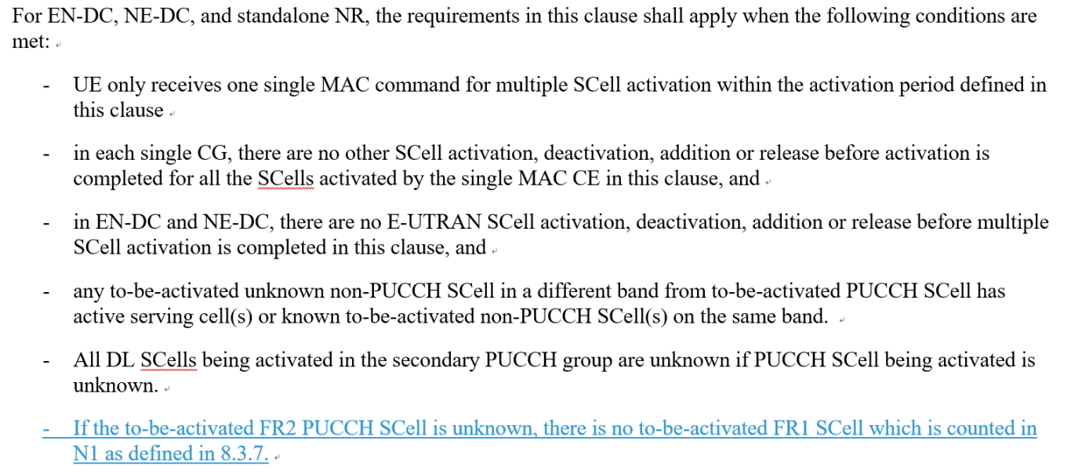

* Recommended WF
  + Discuss the option

### Sub-topic 6-2: Interruption requrirements for SRS antenna switching

* Proposals
  + Option 1 (Huawei):
    - The SRS AS interruption requirements for NR SA shall be modified as for the following two cases:
      * Interruption length in symbols of victim CC when 1 SRS symbol is configured
      * Interruption length in slots of victim CC for rest of the SRS configurations
* Recommended WF
  + Discuss the option

# Topic #7: R17 NR_SmallData_INACTIVE

## Companies’ contributions summary

|  |  |  |
| --- | --- | --- |
| **T-doc number** | **Company** | **Proposals / Observations** |
| [**R4-2412026**](https://www.3gpp.org/ftp/TSG_RAN/WG4_Radio/TSGR4_112/Docs/R4-2412026.zip) | Nokia | **Observation 1: It has been suggested to adjust the number of resource blocks in the tests to mitigate dynamic range problems for the Io values.**  **Observation 2: It has been suggested to remove noise from the Io values to mitigate the dynamic range problems.**  **Observation 3: P0 is the power level for T1, T3 and T6. P1 is the power level for T2. P2 is the power level for T4 and T5.**  **Observation 4: The number of RB’s used will be as suggested, 66 vs 24, corresponding to 95.04MHz and 34.56MHz respectively.**  **Observation 5: The dynamic range of RSRP is 27dB for all calculations, which is the same as the maximum value of Es/Noc for the tests.**  **Observation 6: The dynamic range of Io is 24dB with noise and 27dB without**  **Observation 7: The dynamic range of the Io does not depend on the number of RBs used in the test.**  **Observation 8: The number of RB’s have impact on the minimum RSRP value used, P0, for the test to stay within the Io range of -50 to -70dBm/BW, but does not have any impact on the Io dynamic range.**  **Proposal 1: RAN4 to consider the numbers presented and present a way forward for testing of SDT in FR2 given the RSRP dynamic range forced by the large in-accuracy of FR2 measurements.** |

## Open issues summary

### Sub-topic 6-1: Power levels and thresholds in SDT TCs

* Proposals
  + Option 1 (Nokia):
    - RAN4 to consider the numbers presented and present a way forward for testing of SDT in FR2 given the RSRP dynamic range forced by the large in-accuracy of FR2 measurements.

|  |  |  |  |  |  |  |
| --- | --- | --- | --- | --- | --- | --- |
|  | With Noise | | | Without Noise | | |
|  | P0 | P1 | P2 | P0 | P1 | P2 |
| FR2 SS-RSRP [dBm] | -104 | -78 | -77 | -104 | -78 | -77 |
| Es/Noc [dB] | 0 | 26 | 27 | 0 | 26 | 27 |
| BW [MHz] | 95.04 | 95.04 | 95.04 | 95.04 | 95.04 | 95.04 |
| Io [dBm/BW] | -72 | -49 | -48 | -75 | -49 | -48 |
| FR2 SS-RSRP [dBm] | -102 | -76 | -75 | -102 | -76 | -75 |
| Es/Noc [dB] | 0 | 26 | 27 | 0 | 26 | 27 |
| BW [MHz] | 34.56 | 34.56 | 34.56 | 34.56 | 34.56 | 34.56 |
| Io [dBm/BW] | -74.4 | -51.4 | -50.4 | -77.4 | -51.4 | -50.4 |

*Table 2: Io values for 66 and 24 RB's, with and without noise in the calculations.*

* Recommended WF
  + Discuss the options