**3GPP TSG-RAN WG4 Meeting #112 R4-24XXXXX**

**Maastricht, The Netherlands, 19 – 23 August, 2024**

**Agenda item:** 4.1

**Source:** Huawei, HiSilicon

**Title:** Ad-hoc minutes #1 for [112][201] Maintenance_up_to_R17

**Document for:** Approval

# Introduction

*The document provides minutes for ad-hoc session #1 for [112][201] Maintenance_up_to_R17.*

# Topic #1: Open issues

### Sub-topic 4-1: NCSG patterns

* Proposals
  + Option 1 (OPPO, CATT, HW):
    - VIL should be specific to NCSG patterns, i.e. VIL=1ms for NCSG pattern #0-11 and VIL=0.75ms for NCSG pattern #12-23.
    - Support to modify VIL specific to NCSG patterns in the VIL requirements, e.g. Table 9.1.9-1 for NCSG pattern #0-11 and Table 9.1.9-2 for NCSG pattern #12-23 as shown below.

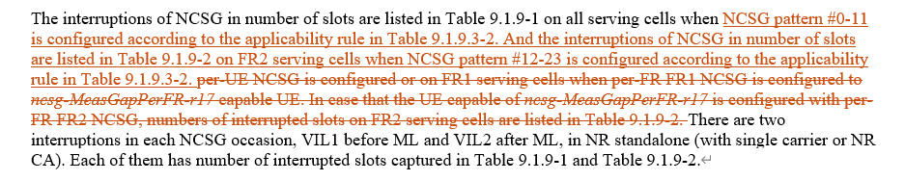

* + Option 2 (E///):
    - In Rel-17, RAN4 to update the NCSG patterns with a clarification.
* Recommended WF
  + Discuss the options

### Sub-topic 2-1: Interruption requirements for R16 NFG

* Proposals
  + Option 1 (Nokia):
    - Confirm tentative agreement for Scenario 1, LTE – NR inter-RAT measurement:
      * interRAT-NeedForGapsNR-r16=FALSE means that the UE support measurement without gaps
        + The UE may or may not cause interruption.
      * if UE causes interruptions when performing measurements without gaps:
        + Support early implementation of interRAT-NeedForInterruptionNR-r18:
        + Optional since Rel-17
    - Confirm tentative agreement for Scenario 2, NR measurements without gaps
      * “no-gap” as part of NeedForGapsInfoNR-r16 means that the UE support measurement without gaps
        + The UE may or may not cause interruption.
      * if UE causes interruptions when performing measurements without gaps:
        + Support early implementation of nr-NeedForInterruptionReport-r18:

Optional since Rel-17

* + - Send RAN2 LS informing of the decision and requesting to take actions related to early implementation.
* Recommended WF
  + Agree on option 1
  + Check the LS draft in Annex of R4-2412025

### Sub-topic 1-1: MAC CE based active TCI state list update delay

* Proposals
  + Option 1 (Apple):

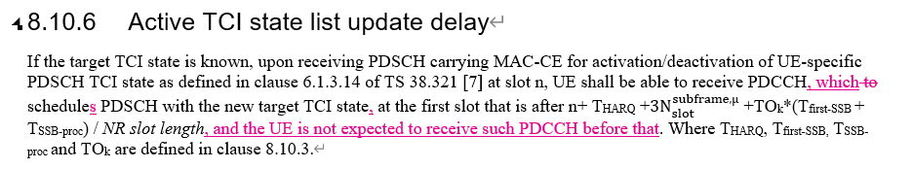

* Recommended WF
  + Discuss the option

### Sub-topic 3-1: Applicability of tci-ActivatedConfig for SCell

* Proposals
  + Option 1 (Nokia):
    - Update the RAN4 UE requirements capturing that tci-ActivatedConfig can be configured for a deactivated SCell and a direct activated SCell.

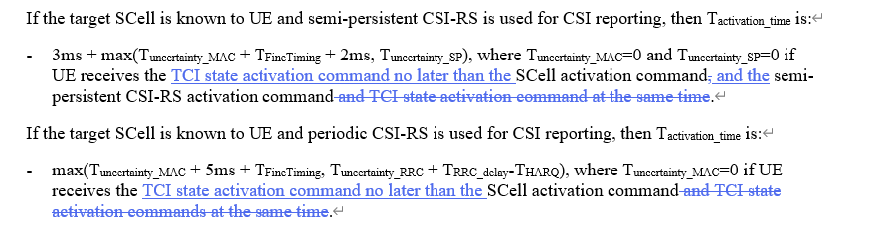

* + - If proposal 1 is not agreeable, send LS to RAN2 clarifying the RAN2 understanding of the applicability of tci-ActivatedConfig.

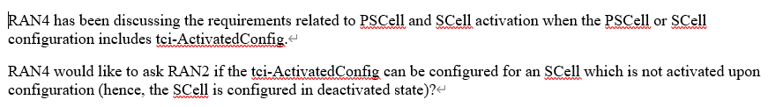

* Recommended WF
  + Discuss the option

### Sub-topic 1-2: NR – E-UTRAN Handover Delay

* Proposals
  + Option 1 (Nokia):
    - Allow UE an additional HO delay of one MIB reception attempt when the given conditions are fulfilled.
    - Define the delay requirement as part of PRACH acquisition delay in Tinterrrupt under TIU.

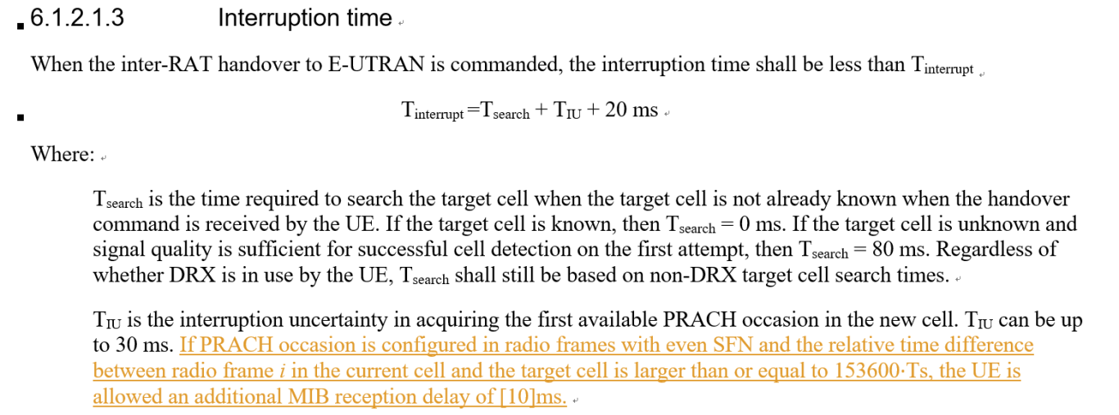

* Recommended WF
  + Discuss the option

### Sub-topic 6-1: PUCCH SCell activation with multiple SCell

* Proposals
  + Option 1 (Huawei):
    - No requirements when there is parallel to-be-activated FR1 SCell which is counted in N1.

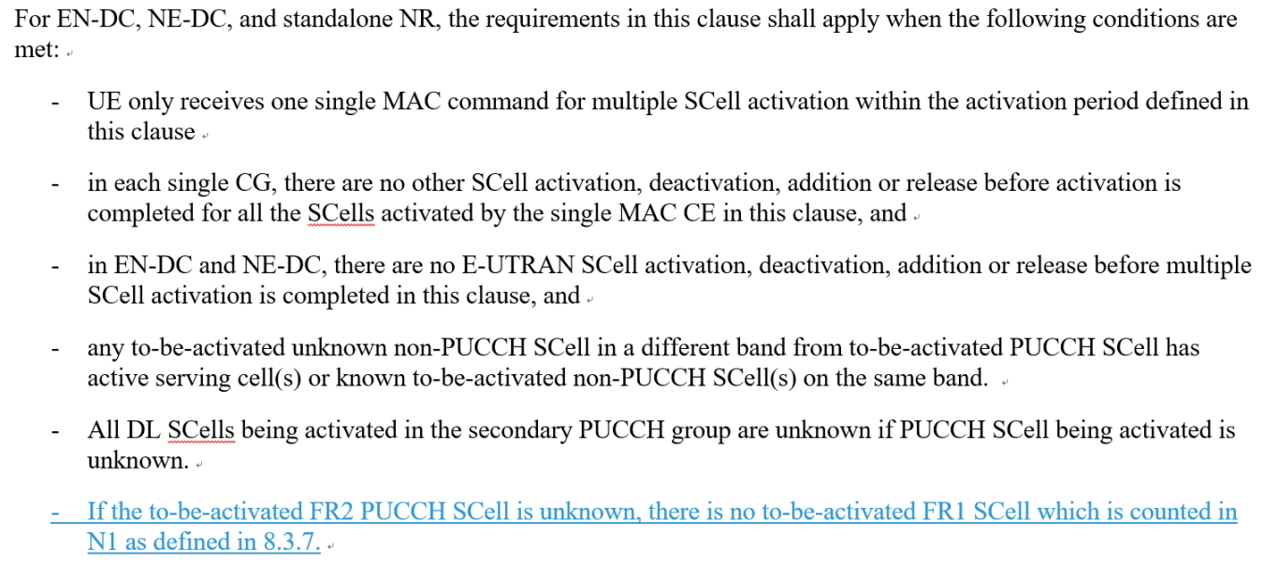

* Recommended WF
  + Discuss the option

### Sub-topic 6-2: Interruption requrirements for SRS antenna switching

* Proposals
  + Option 1 (Huawei):
    - The SRS AS interruption requirements for NR SA shall be modified as for the following two cases:
      * Interruption length in symbols of victim CC when 1 SRS symbol is configured
      * Interruption length in slots of victim CC for rest of the SRS configurations
* Recommended WF
  + Discuss the option

### Sub-topic 5-1: Impact of RAN2 LS R2-2403995 (R17 RLM/BFD relaxation)

* Proposals
  + Option 1 (vivo):
    - For R17 RLM/BFD relaxation, no further spec impact is needed (due to the received information in RAN2 LS R2-2403995)
* Recommended WF
  + Discuss the option

### Sub-topic 7-1: Power levels and thresholds in SDT TCs

* Proposals
  + Option 1 (Nokia):
    - RAN4 to consider the numbers presented and present a way forward for testing of SDT in FR2 given the RSRP dynamic range forced by the large in-accuracy of FR2 measurements.

|  |  |  |  |  |  |  |
| --- | --- | --- | --- | --- | --- | --- |
|  | With Noise | | | Without Noise | | |
|  | P0 | P1 | P2 | P0 | P1 | P2 |
| FR2 SS-RSRP [dBm] | -104 | -78 | -77 | -104 | -78 | -77 |
| Es/Noc [dB] | 0 | 26 | 27 | 0 | 26 | 27 |
| BW [MHz] | 95.04 | 95.04 | 95.04 | 95.04 | 95.04 | 95.04 |
| Io [dBm/BW] | -72 | -49 | -48 | -75 | -49 | -48 |
| FR2 SS-RSRP [dBm] | -102 | -76 | -75 | -102 | -76 | -75 |
| Es/Noc [dB] | 0 | 26 | 27 | 0 | 26 | 27 |
| BW [MHz] | 34.56 | 34.56 | 34.56 | 34.56 | 34.56 | 34.56 |
| Io [dBm/BW] | -74.4 | -51.4 | -50.4 | -77.4 | -51.4 | -50.4 |

*Table 2: Io values for 66 and 24 RB's, with and without noise in the calculations.*

* Recommended WF
  + Discuss the options