**3GPP TSG-RAN WG4 Meeting #112 R4-24XXXXX**

**Maastricht, The Netherlands, 19 – 23 August, 2024**

**Agenda item:** 4.1

**Source:** Huawei, HiSilicon

**Title:** Ad-hoc minutes #1 for [112][201] Maintenance_up_to_R17

**Document for:** Approval

# Introduction

*The document provides minutes for ad-hoc session #1 for [112][201] Maintenance_up_to_R17.*

# Topic #1: Open issues

### Sub-topic 4-1: NCSG patterns

* Proposals
  + Option 1 (OPPO, CATT, HW):
    - VIL should be specific to NCSG patterns, i.e. VIL=1ms for NCSG pattern #0-11 and VIL=0.75ms for NCSG pattern #12-23.
    - Support to modify VIL specific to NCSG patterns in the VIL requirements, e.g. Table 9.1.9-1 for NCSG pattern #0-11 and Table 9.1.9-2 for NCSG pattern #12-23 as shown below.

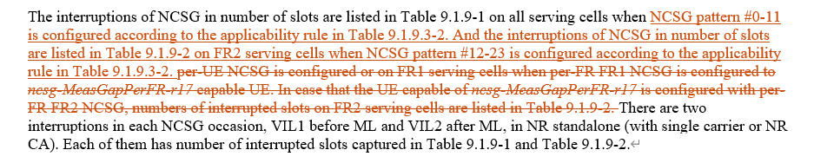

* + Option 2 (E///):
    - In Rel-17, RAN4 to update the NCSG patterns with a clarification.
* Recommended WF
  + Discuss the options

QC: opt 1 may impact mandatory NCSG patterns, Prefer no change.

MTK/Apple: OK with opt 1 after checking.

OPPO: we have CR for opt 1. The applicability of VIL does not impact mandatory NCSG patterns.

QC: need time to check.

Nokia: opt 1 will change per-UE and per-FR applicability of different NCSG patterns.

HW: pattern 12-23 can also be used as per-UE NCSG.

### Sub-topic 2-1: Interruption requirements for R16 NFG

* Proposals
  + Option 1 (Nokia):
    - Confirm tentative agreement for Scenario 1, LTE – NR inter-RAT measurement:
      * interRAT-NeedForGapsNR-r16=FALSE means that the UE support measurement without gaps
        + The UE may or may not cause interruption.
      * if UE causes interruptions when performing measurements without gaps:
        + Support early implementation of interRAT-NeedForInterruptionNR-r18:
        + Optional since Rel-17
    - Confirm tentative agreement for Scenario 2, NR measurements without gaps
      * “no-gap” as part of NeedForGapsInfoNR-r16 means that the UE support measurement without gaps
        + The UE may or may not cause interruption.
      * if UE causes interruptions when performing measurements without gaps:
        + Support early implementation of nr-NeedForInterruptionReport-r18:

Optional since Rel-17

* + - Send RAN2 LS informing of the decision and requesting to take actions related to early implementation.
* Recommended WF
  + Agree on option 1
  + Check the LS draft in Annex of R4-2412025

Nokia: close the issue based on the tentative agreement and send LS to RAN2.

Agreement:

* Confirm tentative agreement for Scenario 1, LTE – NR inter-RAT measurement:
  + interRAT-NeedForGapsNR-r16=FALSE means that the UE support measurement without gaps
    - The UE may or may not cause interruption.
  + if UE causes interruptions when performing measurements without gaps:
    - Support early implementation of interRAT-NeedForInterruptionNR-r18:
    - Optional since Rel-17
* Confirm tentative agreement for Scenario 2, NR measurements without gaps
  + “no-gap” as part of NeedForGapsInfoNR-r16 means that the UE support measurement without gaps
    - The UE may or may not cause interruption.
  + if UE causes interruptions when performing measurements without gaps:
    - Support early implementation of nr-NeedForInterruptionReport-r18:
      * Optional since Rel-17
* Send RAN2 LS informing of the decision and requesting to take actions related to early implementation.
  + Nokia will take lead on the LS drafting.

### Sub-topic 1-1: MAC CE based active TCI state list update delay

* Proposals
  + Option 1 (Apple):

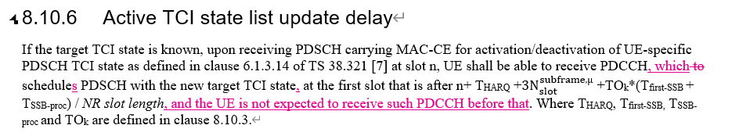

* Recommended WF
  + Discuss the option

MTK: opt 1 will change UE behaviour, now UE is not allowed to receive. We do not support the change.

Nokia: need to be careful to change R15 spec. First change makes little difference. Second change is already clear, i.e. UE is not required to receive xxxx before yyyy.

QC: agree with Nokia on R15 change. PDCCH can be received during TCI list update. The possible misalignment may not be big issue.

OPPO: first change is to clarify but we already clarified the wording before. Second change is not needed with the understanding that UE is not required to do something.

Apple: we do not have test for this. Intention is to clarify when UE should be able to receive PDSCH, but the requirements need to involve PDCCH. On PDCCH we agree with QC. Current tests are unclear. We do not think opt 1 change UE behaviour.

MTK: *not expected* is different from *not required*.

E///: not sure if the change is needed in R15 or anything is broken, open to discuss. CR from last meeting is enough.

Nokia: we can discuss the technical part and then discuss whether to change spec.

QC: requirement should be about PDSCH. PDCCH can be before. The change is limiting PDCCH.

### Sub-topic 3-1: Applicability of tci-ActivatedConfig for SCell

* Proposals
  + Option 1 (Nokia):
    - Update the RAN4 UE requirements capturing that tci-ActivatedConfig can be configured for a deactivated SCell and a direct activated SCell.

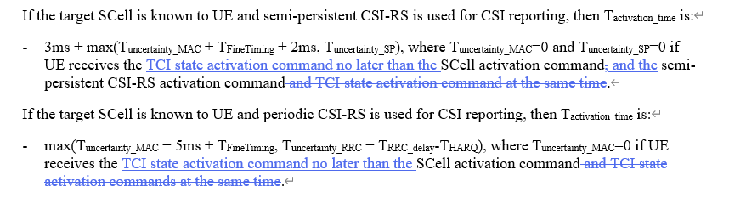

* + - If proposal 1 is not agreeable, send LS to RAN2 clarifying the RAN2 understanding of the applicability of tci-ActivatedConfig.

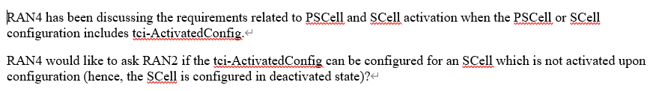

* Recommended WF
  + Discuss the option

MTK: no strong concern, some wording suggestion.

Apple: checking MAC spec, MAC CE for TCI activation, TCI ID can only point to one TCI from the candidate TCI list for PDSCH for the active BWP. There is no active BWP for deactivated SCell. It is not clear which TCI state is referred to by the TCI indication in RRC

QC: there is first active BWP for SCell. TCI state activation cannot be before SCell activation, wording needs change.

MTK: in R16 direct SCell activation, we do not have TCI state indication. In R17 RAN2 adds this signalling.

Apple: OK if we clarify the wording to make it clear that this is RRC indication.

Apple: we can add another condition where Tuncertainty is zero.

Agreement:

Update the RAN4 UE requirements capturing that tci-ActivatedConfig can be considered as a condition to have Tuncertainty_MAC = 0 for SCell activation, including normal MAC CE based and direct SCell activation.

### Sub-topic 1-2: NR – E-UTRAN Handover Delay

* Proposals
  + Option 1 (Nokia):
    - Allow UE an additional HO delay of one MIB reception attempt when the given conditions are fulfilled.
    - Define the delay requirement as part of PRACH acquisition delay in Tinterrrupt under TIU.

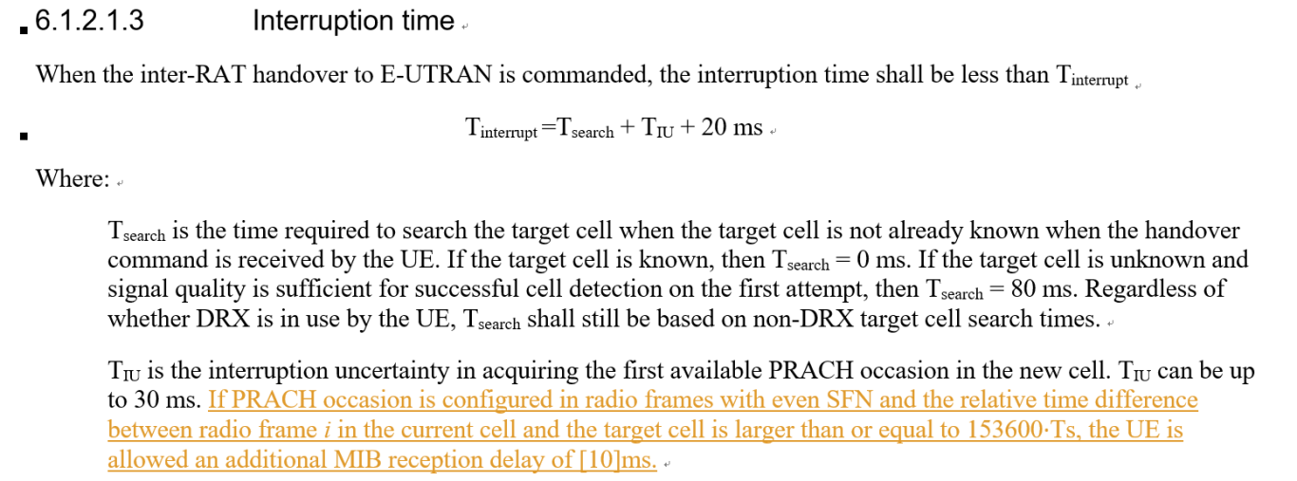

* Recommended WF
  + Discuss the option

QC: OK to define the exact delay. Proposed time does not PBCH combining. Propose 40ms.

Apple: similar as QC. We refer to CGI requirements which is 50ms. Side condition is better here, so we can further discuss.

Nokia: fine to discuss the exact number.

E///: in general fine but need to check the number. Do we need to make the change in R15?

Apple: fine to start from R16 +.

Agreement:

Define the delay requirements for MIB reading in NR – E-UTRAN Handover Delay requirement when PRACH occasions are in even frames and the time difference between source and target cell is larger than 153600 Ts.

* Exact delay value is [50ms]
* Define the requirements from R17.

### Sub-topic 6-1: PUCCH SCell activation with multiple SCell

* Proposals
  + Option 1 (Huawei):
    - No requirements when there is parallel to-be-activated FR1 SCell which is counted in N1.

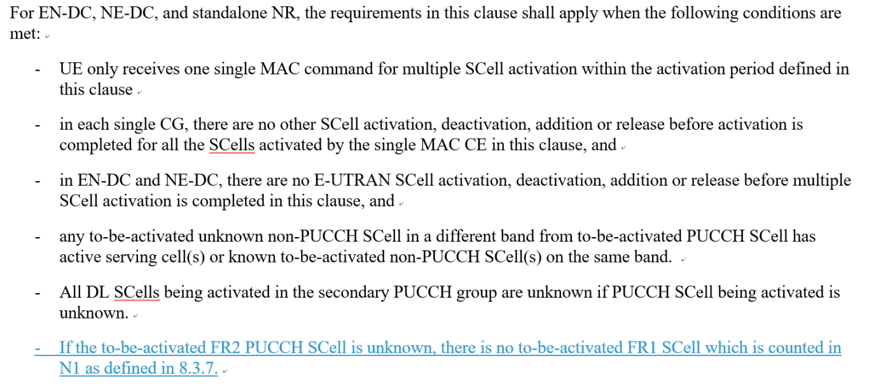

* Recommended WF
  + Discuss the option

Nokia: fine to have applicability. OK to have no requirement for unknown FR2 PUCCH SCell + unknown FR1 SCell for multiple SCell activation since we do not have requirements for unknow FR2 PUCCH SCell in multiple SCell activation. But we still miss requirements for unknown FR2 PUCCH SCell + known FR1 SCell for multiple SCell activation.

QC: prefer to have no requirements for blue or yellow. But blue one may be more relevant.

MTK: Nokia proposal already covered by the CR.

### Sub-topic 6-2: Interruption requrirements for SRS antenna switching

* Proposals
  + Option 1 (Huawei):
    - The SRS AS interruption requirements for NR SA shall be modified as for the following two cases:
      * Interruption length in symbols of victim CC when 1 SRS symbol is configured
      * Interruption length in slots of victim CC for rest of the SRS configurations
* Recommended WF
  + Discuss the option

QC: fine with the change.

Nokia: fine, prefer to use HW CR.

vivo: fine.

E///: fine

Agreement

* The SRS AS interruption requirements for NR SA shall be modified as for the following two cases:
  + Interruption length in symbols of victim CC when 1 SRS symbol is configured
  + Interruption length in slots of victim CC for rest of the SRS configurations

### Sub-topic 5-1: Impact of RAN2 LS R2-2403995 (R17 RLM/BFD relaxation)

* Proposals
  + Option 1 (vivo):
    - For R17 RLM/BFD relaxation, no further spec impact is needed (due to the received information in RAN2 LS R2-2403995)
* Recommended WF
  + Discuss the option

Nokia: *configured DRX cycle* is not clear.

E///: similar view as vivo. RAN4 spec does not differ short and long DRX, so it is not conflicting with RAN2 spec. If we make this differentiation, we may need to update many other requirements.

CATT: same as E///. This part is already considered in previous agreement

Nokia: just because of the previous agreement, we need to clarify ”configured”.

vivo: it means either long or short DRX cycle.

### Sub-topic 7-1: Power levels and thresholds in SDT TCs

* Proposals
  + Option 1 (Nokia):
    - RAN4 to consider the numbers presented and present a way forward for testing of SDT in FR2 given the RSRP dynamic range forced by the large in-accuracy of FR2 measurements.

|  |  |  |  |  |  |  |
| --- | --- | --- | --- | --- | --- | --- |
|  | With Noise | | | Without Noise | | |
|  | P0 | P1 | P2 | P0 | P1 | P2 |
| FR2 SS-RSRP [dBm] | -104 | -78 | -77 | -104 | -78 | -77 |
| Es/Noc [dB] | 0 | 26 | 27 | 0 | 26 | 27 |
| BW [MHz] | 95.04 | 95.04 | 95.04 | 95.04 | 95.04 | 95.04 |
| Io [dBm/BW] | -72 | -49 | -48 | -75 | -49 | -48 |
| FR2 SS-RSRP [dBm] | -102 | -76 | -75 | -102 | -76 | -75 |
| Es/Noc [dB] | 0 | 26 | 27 | 0 | 26 | 27 |
| BW [MHz] | 34.56 | 34.56 | 34.56 | 34.56 | 34.56 | 34.56 |
| Io [dBm/BW] | -74.4 | -51.4 | -50.4 | -77.4 | -51.4 | -50.4 |

*Table 2: Io values for 66 and 24 RB's, with and without noise in the calculations.*

* Recommended WF
  + Discuss the options