3GPP TSG-RAN4 Meeting #112 R4-2412162

Maastricht, Netherland, Aug 19th - 23th 2024
CR-Form-v12.3
CHANGE REQUEST
 | 38.133 | CR | 4756 | rev | - | Current version: | 15.26.0
For HELP on using this form: comprehensive instructions can be found at
http://www.3gpp.org/Change-Requests.

Proposed change affects: | UICC apps |  | ME | x | Radio Access Network |  | Core Network

Title: | (NR_newRAT-Perf) Correction to PRACH RMCs_R15
Source to WG: | Huawei, HiSilicon
Source to TSG: | R4
Work item code: | NR_newRAT-Perf |  |  |  |  |  | Date: |  |  | 2024-08-10
Category: | F |  |  |  |  |  | Release: |  |  | Rel-15
 | Use one of the following categories:  F (correction)  A (mirror corresponding to a change in an earlier release)  B (addition of feature),  C (functional modification of feature)  D (editorial modification)  Detailed explanations of the above categories can  be found in 3GPP TR 21.900. |  |  |  |  |  |  |  | Use one of the following releases:  Rel-8 (Release 8)  Rel-9 (Release 9)  Rel-10 (Release 10)  Rel-11 (Release 11)  …  Rel-17 (Release 17)  Rel-18 (Release 18)  Rel-19 (Release 19)  Rel-20 (Release 20)
Reason for change: |  | In RAN4#111 we have submitted R4-2408533 to correct the issue found in PRACH RMCs. The reason of change in R4-2408533 is copied below FYI. And we also have received several comments from RAN4/RAN5. The main concern in the comments was that too many test cases would be impacted by this change. We fully understand the concern from industry hence we suggest fix this issue in an alternative way, which is, changing ra-PreambleIndex in RACH-ConfigDedicated to 40. Then only CFRA TCs and BFR TCs will be impacted.  Following contents are copied from reason of change in R4-2408533:  In PRACH RMCs specified in 38.133 Annex A.3, several parameters are set as follows:  - prach-ConfigurationIndex = 102. Note that it’s not specified that whether the prach-ConfigurationIndex in RMC refers to the field in RACH-ConfigCommon (i.e. for CBRA, SI request or PDCCH order) or the field in RACH-ConfigDedicated (i.e. for HO or BFR). It should be understood as both because this field is mandatory. Which means the ROs associated to RACH-ConfigCommon and ROs assocated to RACH-ConfigDedicated are fully overlapped.  - totalNumberOfRA-Preambles = 48. This is the field in RACH-ConfigCommon because it states “Total number of preambles used for contention based and contention free random access” in comments column.  - ra-PreambleIndex = 50, This is the field in RACH-ConfigDedicated.  The allocation of preamble indices in RO associated to RACH-ConfigCommon or RACH-ConfigDedicated are shown as follows.  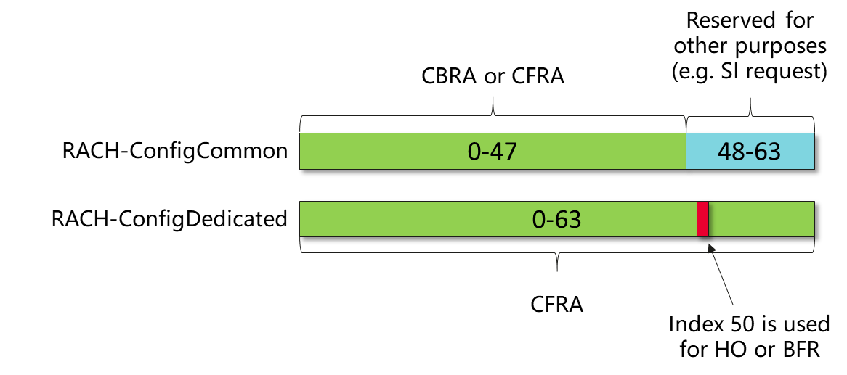  The problem with the current configuration is, the ROs corresponding to RACH-ConfigCommon and RACH-ConfigDedicated are completely overlapped. Therefore, after the UE triggers HO/BFR procedure with preamble index 50, it is not aware whether the E/T/RAPID subheader with RAPID = 50 included in received RAR MAC PDU is the response to the SI request initiated by another UE using the preambled index = 50 in RACH-ConfigCommon (i.e. a subheader with RAPID only), or is the response to its CFRA request (i.e.a subheader with RAPID and RAR) shown as follows. As a result, the UE may fail the test due to inability of reading the RAR on the bytes following the subheader.  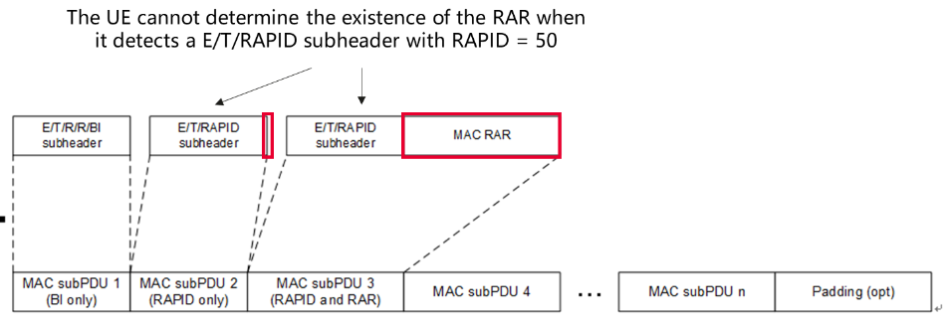
Summary of change: |  | ra-PreambleIndex is changed to 40.
Consequences if not approved: |  | Conformant UE may fail the test.
Clauses affected: |  | A.3.8.2, A.3.8.3
 |  | Y | N
Other specs |  |  | x | Other core specifications |  |  |  | TS/TR ... CR ...
affected: |  | x |  | Test specifications |  |  |  | TS38.533
(show related CRs) |  |  | x | O&M Specifications |  |  |  | TS/TR ... CR ...
Other comments:
This CR's revision history: |  | 1st revision:  Updated based on comments received.  - add missing CR no. on coversheet.

<Start of Change 1>

A.3.8.2 PRACH configurations in FR1

A.3.8.2.1 FR1 PRACH configuration 1
FR1 PRACH configuration 1 in this clause provides the typical PRACH configuration for SSB-based contention based random access in FR1.
Table A.3.8.2.1-1: Parameters for FR1 PRACH configuration 1
Field | Value | Comment
prach-ConfigurationIndex | 102 | 10ms PRACH periodicity, and other detailed configuration defined in table 6.3.3.2-2 and table 6.3.3.2-3 in TS 38.211 [6].
msg1-SubcarrierSpacing | Same as UL carrier SCS
totalNumberOfRA-Preambles | 48 | Total number of preambles used for contention based and contention free random access
numberOfRA-PreamblesGroupA | 48 | No group B.
prach-RootSequenceIndex | 0 | Logic sequence index = 0, resulting in root sequence = 1.
ssb-perRACH-OccasionAndCB-PreamblesPerSSB | oneFourth, n48 | OneFourth: 1 SSB associated with 4 RACH occasions  n48: 48 contention based preambles per SSB
msg1-FDM | One | One PRACH transmission occasions FDMed in one time instance.
rsrp-ThresholdSSB | RSRP_51 | The actual value of the threshold is -105dBm, as defined in TS 38.331 [2].
ra-ContentionResolutionTimer | sf48 | 48 sub-frames
powerRampingStep | dB2
preambleReceivedTargetPower | dBm-120
preambleTransMax | n6 | Max number of RA preamble transmission performed before declaring a failure is 6
ra-ResponseWindow | sl10 | 10 slots
zeroCorrelationZoneConfig | 11 | N-CS configuration, N_{CS} = 23
Backoff Parameter Index | 2 | 20ms, as defined in table 7.2-1 in TS 38.321 [7].
Note: For further information see clause 6.3.2 in TS 38.331 [2].

A.3.8.2.2 FR1 PRACH configuration 2
FR1 PRACH configuration 2 in this clause provides the typical PRACH configuration for SSB based non-contention based random access in FR1.
Table A.3.8.2.2-1: Parameters for FR1 PRACH configuration 2
Field | Value | Comment
prach-ConfigurationIndex | 102 | 10ms PRACH periodicity, and other detailed configuration defined in table 6.3.3.2-2 and table 6.3.3.2-3 in TS 38.211 [6].
msg1-SubcarrierSpacing | Same as UL carrier SCS
totalNumberOfRA-Preambles | 48 | Total number of preambles used for contention based and contention free random access
numberOfRA-PreamblesGroupA | 48 | No group B.
prach-RootSequenceIndex | 0 | Logic sequence index = 0, resulting in root sequence = 1.
ssb-perRACH-Occasion | oneFourth | OneFourth: 1 SSB associated with 4 RACH occasions
msg1-FDM | One | One PRACH transmission occasions FDMed in one time instance.
powerRampingStep | dB2
preambleReceivedTargetPower | dBm-120
preambleTransMax | n6 | Max number of RA preamble transmission performed before declaring a failure is 6
ra-ResponseWindow | sl10 | 10 slots
zeroCorrelationZoneConfig | 11 | N-CS configuration, N_{CS} = 23
Backoff Parameter Index | 2 | 20ms, as defined in table 7.2-1 in TS 38.321 [7].
ssb-ResourceList | ra-PreambleIndex = 40 | Associated with SSB index 0. UE doesn’t use ssb-ResourceList and BFR-SSB-Resource IEs at the same time. UE doesn’t use this field if is transmitting CFRA to convey BFR.
BFR-SSB-Resource | ra-PreambleIndex = 40 | Associated with SSB index 0. UE doesn’t use ssb-ResourceList and BFR-SSB-Resource IEs at the same time. UE uses this field only if is transmitting CFRA to convey BFR
ra-ssb-OccasionMaskIndex | 1 | PRACH occasion index 1 is allowed
rsrp-ThresholdSSB | RSRP_51 | The actual value of the threshold is -105dBm, as defined in TS 38.331 [2].
Note: For further information see clause 6.3.2 in TS 38.331 [2].

A.3.8.2.3 FR1 PRACH configuration 3
FR1 PRACH configuration 3 in this clause provides the typical PRACH configuration for CSI-RS based non-contention based random access in FR1.
Table A.3.8.2.3-1: Parameters for FR1 PRACH configuration 3
Field | Value | Comment
prach-ConfigurationIndex | 102 | 10ms PRACH periodicity, and other detailed configuration defined in table 6.3.3.2-2 and table 6.3.3.2-3 in TS 38.211 [6].
msg1-SubcarrierSpacing | Same as UL carrier SCS
totalNumberOfRA-Preambles | 48 | Total number of preambles used for contention based and contention free random access
numberOfRA-PreamblesGroupA | 48 | No group B.
prach-RootSequenceIndex | 0 | Logic sequence index = 0, resulting in root sequence = 1.
ssb-perRACH-Occasion | oneFourth | OneFourth: 1 SSB associated with 4 RACH occasions
msg1-FDM | One | One PRACH transmission occasions FDMed in one time instance.
powerRampingStep | dB2
preambleReceivedTargetPower | dBm-120
preambleTransMax | n6 | Max number of RA preamble transmission performed before declaring a failure is 6
ra-ResponseWindow | sl10 | 10 slots
zeroCorrelationZoneConfig | 11 | N-CS configuration, N_{CS} = 23
Backoff Parameter Index | 2 | 20ms, as defined in table 7.2-1 in TS 38.321 [7].
csirs-ResourceList | ra-PreambleIndex = 40 | Associated with CSI-RS configured
ra-OccasionList | 1 | RA occasions allowed corresponding to CSI-RS
rsrp-ThresholdCSI-RS | RSRP_51 | The actual value of the threshold is -105dBm, as defined in TS 38.331 [2].
Note: For further information see clause 6.3.2 in TS 38.331 [2].

A.3.8.2.4 FR1 PRACH configuration 4
FR1 PRACH configuration 4 in this clause provides the PRACH configuration for CSI-RS based non-contention based random access in FR1 to convey BFR.
Table A.3.8.2.4-1: Parameters for FR1 PRACH configuration 4
Field | Value | Comment
prach-ConfigurationIndex | 102 | 10ms PRACH periodicity, and other detailed configuration defined in table 6.3.3.2-2 and table 6.3.3.2-3 in TS 38.211 [6].
totalNumberOfRA-Preambles | 48 | Total number of preambles used for contention based and contention free random access
numberOfRA-PreamblesGroupA | 48 | No group B.
prach-RootSequenceIndex | 0 | Logic sequence index = 0, resulting in root sequence = 1.
ssb-perRACH-Occasion | oneFourth | OneFourth: 1 SSB associated with 4 RACH occasions
msg1-FDM | One | One PRACH transmission occasions FDMed in one time instance.
powerRampingStep | dB2
preambleReceivedTargetPower | dBm-120
preambleTransMax | n200 | Max number of RA preamble transmission performed before declaring a failure is 200
ra-ResponseWindow | sl1 | 1 slot
zeroCorrelationZoneConfig | 11 | N-CS configuration, N_{CS} = 93
Backoff Parameter Index | 2 | 20ms, as defined in table 7.2-1 in TS 38.321 [7].
BFR-CSIRS-Resource | ra-PreambleIndex = 40 | Associated with CSI-RS configured
ra-OccasionList | 1 | RA occasions allowed corresponding to CSI-RS
rsrp-ThresholdSSB | RSRP_51 | The actual value of the threshold is -105dBm, as defined in TS 38.331 [2].
Note: For further information see clause 6.3.2 in TS 38.331 [2].

A.3.8.3 PRACH configurations in FR2

A.3.8.3.1 FR2 PRACH configuration 1
FR2 PRACH configuration 1 in this clause provides the typical PRACH configuration for SSB-based contention based random access in FR2.
Table A.3.8.3.1-1: Parameters for FR2 PRACH configuration 1
Field | Value | Comment
prach-ConfigurationIndex | 190 | Preamble Format C2, with 10ms PRACH periodicity, and other detailed configuration defined in table 6.3.3.2-4 in TS 38.211 [6].
msg1-SubcarrierSpacing | Same as UL carrier SCS
totalNumberOfRA-Preambles | 48 | Total number of preambles used for contention based and contention free random access
numberOfRA-PreamblesGroupA | 48 | No group B.
prach-RootSequenceIndex | 0 | Logic sequence index = 0, resulting in root sequence = 1.
ssb-perRACH-OccasionAndCB-PreamblesPerSSB | oneFourth, n48 | OneFourth: 1 SSB associated with 4 RACH occasions  n48: 48 contention based preambles per SSB
msg1-FDM | One | One PRACH transmission occasions FDMed in one time instance.
rsrp-ThresholdSSB | RSRP_51 | The actual value of the threshold is -105dBm, as defined in TS 38.331 [2].
ra-ContentionResolutionTimer | sf48 | 48 sub-frames
powerRampingStep | dB2
preambleReceivedTargetPower | dBm-120
preambleTransMax | n6 | Max number of RA preamble transmission performed before declaring a failure is 6
ra-ResponseWindow | sl10 | 10 slots
zeroCorrelationZoneConfig | 11 | N-CS configuration, N_{CS} = 23
Backoff Parameter Index | 2 | 20 ms, as defined in table 7.2-1 in TS 38.321 [7].
Note: For further information see clause 6.3.2 in TS 38.331 [2].

A.3.8.3.2 FR2 PRACH configuration 2
FR2 PRACH configuration 2 in this clause provides the typical PRACH configuration for SSB based non-contention based random access in FR2.
Table A.3.8.3.2-1: Parameters for FR2 PRACH configuration 2
Field | Value | Comment
prach-ConfigurationIndex | 190 | Preamble Format C2, with 10ms PRACH periodicity, and other detailed configuration defined in table 6.3.3.2-4 in TS 38.211 [6].
msg1-SubcarrierSpacing | Same as UL carrier SCS
totalNumberOfRA-Preambles | 48 | Total number of preambles used for contention based and contention free random access
numberOfRA-PreamblesGroupA | 48 | No group B.
prach-RootSequenceIndex | 0 | Logic sequence index = 0, resulting in root sequence = 1.
ssb-perRACH-Occasion | oneFourth | OneFourth: 1 SSB associated with 4 RACH occasions
msg1-FDM | One | One PRACH transmission occasions FDMed in one time instance.
powerRampingStep | dB2
preambleReceivedTargetPower | dBm-120
preambleTransMax | n6 | Max number of RA preamble transmission performed before declaring a failure is 6
ra-ResponseWindow | sl10 | 10 slots
zeroCorrelationZoneConfig | 11 | N-CS configuration, N_{CS} = 23
Backoff Parameter Index | 2 | 20 ms, as defined in table 7.2-1 in TS 38.321 [7].
ssb-ResourceList | ra-PreambleIndex = 40 | Associated with SSB index 0. UE doesn’t use ssb-ResourceList and BFR-SSB-Resource IEs at the same time. UE doesn’t use this field if is transmitting CFRA to convey BFR.
BFR-SSB-Resource | ra-PreambleIndex = 40 | Associated with SSB index 0. UE doesn’t use ssb-ResourceList and BFR-SSB-Resource IEs at the same time. UE uses this field only if is transmitting CFRA to convey BFR
ra-ssb-OccasionMaskIndex | 1 | PRACH occasion index 1 is allowed
rsrp-ThresholdSSB | RSRP_51 | The actual value of the threshold is -105dBm, as defined in TS 38.331 [2].
Note: For further information see clause 6.3.2 in TS 38.331 [2].

A.3.8.3.3 FR2 PRACH configuration 3
FR2 PRACH configuration 3 in this clause provides the typical PRACH configuration for CSI-RS based non-contention based random access in FR2.
Table A.3.8.3.3-1: Parameters for FR2 PRACH configuration 3
Field | Value | Comment
prach-ConfigurationIndex | 190 | Preamble Format C2, with 10ms PRACH periodicity, and other detailed configuration defined in table 6.3.3.2-4 in TS 38.211 [6].
msg1-SubcarrierSpacing | Same as UL carrier SCS
totalNumberOfRA-Preambles | 48 | Total number of preambles used for contention based and contention free random acces
numberOfRA-PreamblesGroupA | 48 | No group B.
prach-RootSequenceIndex | 0 | Logic sequence index = 0, resulting in root sequence = 1.
ssb-perRACH-Occasion | oneFourth | OneFourth: 1 SSB associated with 4 RACH occasions
msg1-FDM | One | One PRACH transmission occasions FDMed in one time instance.
powerRampingStep | dB2
preambleReceivedTargetPower | dBm-120
preambleTransMax | n6 | Max number of RA preamble transmission performed before declaring a failure is 6
ra-ResponseWindow | sl10 | 10 slots
zeroCorrelationZoneConfig | 11 | N-CS configuration, N_{CS} = 23
Backoff Parameter Index | 2 | 20 ms, as defined in table 7.2-1 in TS 38.321 [7].
csirs-ResourceList | ra-PreambleIndex = 40 | Associated with CSI-RS configured
ra-OccasionList | 1 | RA occasions allowed corresponding to CSI-RS
rsrp-ThresholdCSI-RS | RSRP_51 | The actual value of the threshold is -105dBm, as defined in TS 38.331 [2].
Note: For further information see clause 6.3.2 in TS 38.331 [2].

A.3.8.3.4 FR2 PRACH configuration 4
FR2 PRACH configuration 4 in this clause provides the PRACH configuration for CSI-RS based non-contention based random access in FR2 to convey BFR.
Table A.3.8.3.4-1: Parameters for FR2 PRACH configuration 4
Field | Value | Comment
prach-ConfigurationIndex | 190 | Preamble Format C2, with 10ms PRACH periodicity, and other detailed configuration defined in table 6.3.3.2-4 in TS 38.211 [6].
msg1-SubcarrierSpacing | Same as UL carrier SCS
totalNumberOfRA-Preambles | 48 | Total number of preambles used for contention based and contention free random access
numberOfRA-PreamblesGroupA | 48 | No group B.
prach-RootSequenceIndex | 0 | Logic sequence index = 0, resulting in root sequence = 1.
ssb-perRACH-Occasion | oneFourth | OneFourth: 1 SSB associated with 4 RACH occasions
msg1-FDM | One | One PRACH transmission occasions FDMed in one time instance.
powerRampingStep | dB2
preambleReceivedTargetPower | dBm-120
preambleTransMax | n200 | Max number of RA preamble transmission performed before declaring a failure is 200.
ra-ResponseWindow | sl40 | 40 slots
zeroCorrelationZoneConfig | 11 | N-CS configuration, N_{CS} = 23
Backoff Parameter Index | 2 | 20 ms, as defined in table 7.2-1 in TS 38.321 [7].
BFR-CSIRS-Resource | ra-PreambleIndex = 40 | Associated with CSI-RS configured
ra-OccasionList | 1 | RA occasions allowed corresponding to CSI-RS
rsrp-ThresholdSSB | RSRP_51 | The actual value of the threshold is -105dBm, as defined in TS 38.331 [2].
Note: For further information see clause 6.3.2 in TS 38.331 [2].

<End of Change 1>

