**3GPP TSG-RAN WG4 Meeting #112 R4-2414310**

**Maastricht, 19th ‒ 23rd, 2024**

**Title:** WF on UE RF requirements for Rel-19 MIMO enhancement

**Agenda Item:** 8.18.4

**Source: Samsung**

**Document for:** Approval

# <Topic 1> UE RF impact

**Issue 1-1: UE RF work plan approval**

Chair: encourage companies to follow the work plan in R4-2412134.

**Issue 1-2: UE RF impact of 3Tx**

* Proposals
  + Option 1: Identified. Start with 3Tx
  + Option 2: Not yet. Wait for further progress in RAN1
* Agreement
  + RAN4 will analyse the impact of 3Tx on UE RF requirements.

**Issue 1-3: UE RF impact of asymmetric DL sTRP/UL mTRP**

* Proposals
  + Option 1: Identified (e.g., spherical coverage with a different TCI state for UL compared to DL)
  + Option 2: Not yet. Wait for further progress in RAN1
* Way forward
  + Companies are encouraged to provide clear view based on WID and RAN1 status

# <Topic 2> 3Tx

**Issue 2-1: Applicable UE types**

* Proposals
  + Option 1: Handheld UE included
  + Option 2: Non-handheld UE only
  + Option 3: Depend on condition (e.g., ULFPTx)
* Agreement
  + Both handheld and non-handheld UEs will be considered for UE RF requirements
  + FFS on whether a single set or two sets of UE RF requirements, e.g., MPR, will be specified.

**Issue 2-2: Applicable Frequency Ranges**

* Proposals
  + Option 1: FR1 only
  + Option 2: Others
* Agreement
  + Both FR1 and FR2 will be considered for potential UL mTRP requirements
  + Only FR1 is considered for 3Tx objective

**Issue 2-3: Power classes and PA configuration for 3Tx UL MIMO**

* Proposals
  + Option 1: PC3 and PC2
  + Option 2: PC1.5 only
  + Option 3: Others
* Way forward
  + Companies are encouraged to provide clear view on 3Tx power class and its PA assumptions

**Issue 2-5: Non ULFPTx mode**

* Proposals
  + Option 1: 3-layer with precoding matrix of $W=\frac{1}{\sqrt{3}}\left[\begin{matrix}1 & 0 & 0 \\ 0 & 1 & 0 \\ 0 & 0 & 1\end{matrix}\right]$.
  + Option 2: Others
* Agreement
  + 3-layer with precoding matrix of $W=\frac{1}{\sqrt{3}}\left[\begin{matrix}1 & 0 & 0 \\ 0 & 1 & 0 \\ 0 & 0 & 1\end{matrix}\right]$.

**Issue 2-6: ULFPTx mode 0**

* Proposals
  + Option 1: Add both 1-layer and 2-layer for 3Tx with

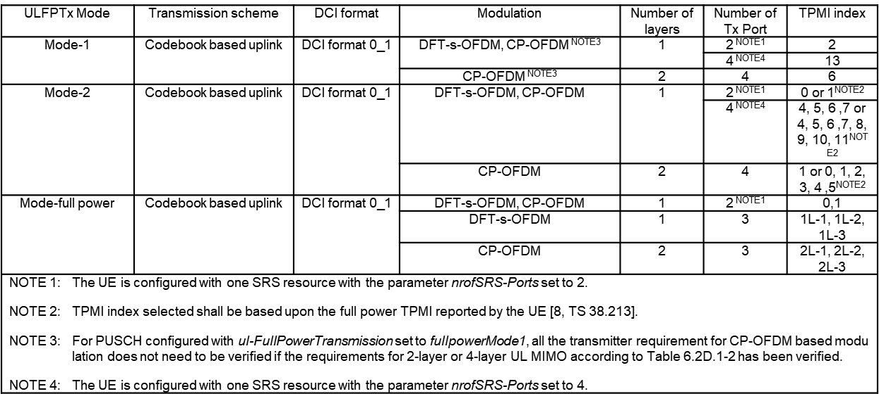

* + Option 2: Add 1-layer for 3Tx with $W=\frac{1}{\sqrt{3}}\left[\begin{aligned}1 \\ 0 \\ 0\end{aligned}\right],\frac{1}{\sqrt{3}}\left[\begin{aligned}0 \\ 1 \\ 0\end{aligned}\right],\frac{1}{\sqrt{3}}\left[\begin{aligned}0 \\ 0 \\ 1\end{aligned}\right]$
* Tentative agreement
  + Take 1-layer as baseline
  + Further discuss whether 2-layer is needed

# <Topic 3> FR2 enhancement

**Issue 3-1: FFS FR2 UL enhancement scenario, companies to check**

* Proposals
  + Option 1: UL TCI-state differs from DL TCI-state
  + Other options not precluded