3GPP TSG-RAN WG4 Meeting #112 R4-2413028

Maastricht, Netherlands, 19th – 23rd August, 2024

**Source:** Huawei, HiSilicon

**Title: Discussion on PC1.5 for intra-band CA**

**Agenda Item:** 8.1.1.1.1

**Document for:** Approval

# 1 Introduction

A WF [1] was agreed in RAN4#111. The captured open issues are duplicated below, for which we share our views in the sequal.

## PCMAX,C

**Proposals:**

* + Proposal 1: Define PCMAX,c limitation for each component carrier considering PC1.5 UE architecture of intra-band UL CA. (LGE)
* For dualPA-architecture
  + PCMAX,C limitation for each component carrier is 26dBm
* For TxD (dualTx)
  + PCMAX,CC1 =
  + PCMAX,CC2 =
  + Proposal 2: Changes to TS 38.101-1 for dual-PA architecture, inset new equation for PCMAX,*c* (Ericsson, more details refer to R4-2407721)

**Way forward**: FFS in future meetings

## 2.5 PCMAX

**Proposals:**

* + Option 1: (Skyworks)
  + MOP for 2Tx architectures (TxD w/wo UL MIMO) is: *29* dBm
  + MOP for Dual-PA architectures (one PA/CC, 2LO) is:

*PCmax= 29 + 10*log(1/2*(1+Min(LCRB1*SCS1,LCRB2*SCS2)/Max(LCRB1*SCS1,LCRB2*SCS2)))* dBm

* + Option 2: (Skyworks)

MPR for Dual-PA architectures (one PA/CC, 2LO) is modified by: *10*log(1/2*(1+Min(LCRB1*SCS1,LCRB2*SCS2)/Max(LCRB1*SCS1,LCRB2*SCS2)))* dB

* + Option 3: (Captured in last meeting’s WF)

For R19 PC1.5 intra-band non-contiguous /contiguous ULCA with two 26dBm PAs and one PA per CC, the PCMAX is modified as follows to account for RB BW imbalances

PCmax=10*log(10^(26/10) + 10^((26-10*log(LCRB1*SCS1/(LCRB2*SCS2)))/10))

* + Option 4: For UEs indicating dualPA-Architecture (Architecture #1) the total configured output power PCMAX for the band combination is given by clause 6.2A.4.1.3 for inter-band CA in the current version of 38.101-1, the same applies for TxD (Ericsson)

**Way forward**: FFS in future meetings

# 2 Discussion

In the current specification, regarding the configured transmitted power requirements for both intra-band contiguous and non-contiguous CA, the MPR/A-MPR is defined relative to the max CA power (PPowerClass, CA) set by the CA power class.

For example, for intra-band contiguous CA:

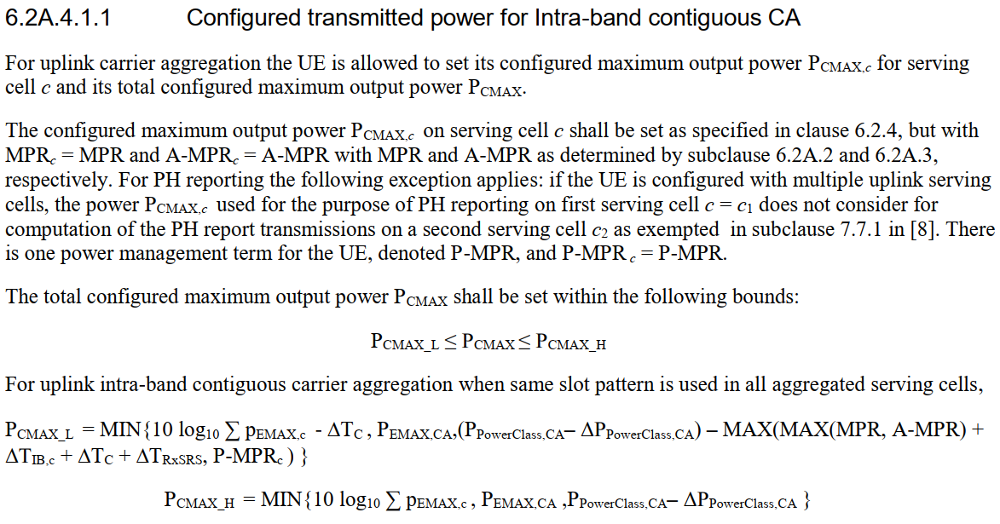

Therefore, it’s assumed that the max CA power (23dBm for PC3 and 26dBm for PC2) can always be achieved under equal PSD condition when MPR=0.

**Observation 1: As specified in the configured transmitted power clauses, the PC3/PC2 MPR/A-MPR requirements for intra-band CA are defined relative to the max CA power (PPowerClass, CA) set by the CA power class, which assumes that PCMAX can always achieve 23dBm or 26dBm if MPR and A-MPR=0.**

For PC1.5, under equal-PSD condition, the total power of 29dBm is achievable for 2Tx TxD, but not for the dualPA architecture. This is even without considering the usual factors that would require MPR, such as ACLR, SEM, EVM, etc.

**Observation 2: Under equal-PSD condition, the dualPA architecture cannot deliver 29dBm for PC1.5 if the two CCs are scheduled with unequal transmission bandwidths.**

Based on the above analysis, we think option 1 for issue 2.5 in the WF [1] is reasonable.

**Proposal 1: Support option 1 for PCMAX in the WF [1], i.e. for the total CA power**



For the max power per CC (PCMAX,C), the current specification requires that the same MPR/A-MPR for CA applies to each CC. This is highlighted below.

The configured maximum output power PCMAX,*c* on serving cell *c* shall be set as specified in clause 6.2.4, but with MPR*c* = MPR and A-MPR*c* = A-MPR with MPR and A-MPR as determined by subclause 6.2A.2 and 6.2A.3, respectively. For PH reporting the following exception applies: if the UE is configured with multiple uplink serving cells, the power PCMAX,*c* used for the purpose of PH reporting on first serving cell *c* = *c*1 does not consider for computation of the PH report transmissions on a second serving cell *c*2 as exempted in subclause 7.7.1 in [8]. There is one power management term for the UE, denoted P-MPR, and P-MPR *c* = P-MPR.

**Observation 3: As specified in the configured transmitted power clauses, the same MPR/A-MPR is applied to each CC. Effectively, this implies that the total CA power after back-off is:**

$$\frac{p_{cmax, ca}}{{mpr}_{ca}}=\frac{p_{cmax,c1}}{{mpr}_{ca}}+\frac{p_{cmax,c2}}{{mpr}_{ca}}$$

Since the two CCs share the total power, the max power per CC can be readily obtained under the equal-PSD condition.

**Proposal 2: For max power per CC, PCMAX,c can be expressed as follows, regardless of the PA architecture:**





# 3 Conclusion

In this paper, we have shared our views on the open issues for PC1.5 intra-band UL CA. The following observations and proposals are made:

**Observation 1: As specified in the configured transmitted power clauses, the PC3/PC2 MPR/A-MPR requirements for intra-band CA are defined relative to the max CA power (PPowerClass, CA) set by the CA power class, which assumes that PCMAX can always achieve 23dBm or 26dBm if MPR and A-MPR=0.**

**Observation 2: Under equal-PSD condition, the dualPA architecture cannot deliver 29dBm for PC1.5 if the two CCs are scheduled with unequal transmission bandwidths.**

**Proposal 1: Support option 1 for PCMAX in the WF [1], i.e. for the total CA power**



**Observation 3: As specified in the configured transmitted power clauses, the same MPR/A-MPR is applied to each CC. Effectively, this implies that the total CA power after back-off is:**

$$\frac{p_{cmax, ca}}{{mpr}_{ca}}=\frac{p_{cmax,c1}}{{mpr}_{ca}}+\frac{p_{cmax,c2}}{{mpr}_{ca}}$$

**Proposal 2: For max power per CC, PCMAX,c can be expressed as follows, regardless of the PA architecture:**





# References

1. R4-2410750 WF on higher power UE, Samsung, RAN4#111
2. RP-240828 New WID: UE RF enhancements for NR FR1/FR2 and EN-DC, Phase 4, RAN4 chair (Huawei), RAN#103