**3GPP TSG-RAN WG4 Meeting #112 R4-2412819**

**Maastricht, Netherlands, 19-23 Aug, 2024**

**Agenda item:** 8.1.3

**Source:** Moderator (Samsung)

**Title:** Topic summary for [112][117] NR_ENDC_RF_Ph4_part2

**Document for:** Information

# Introduction

This email thread focuses on,

* High power UE (HPUE) for CA in terrestrial network (TN) (AI 8.1.1.1)

# Topic #1: High power UE (HPUE) for CA in terrestrial network (TN)

*Main technical topic overview. The structure can be done based on sub-agenda basis.*

## Companies’ contributions summary

|  |  |  |
| --- | --- | --- |
| **TDoc** | **Title** | **Source** |
| [**R4-2411168**](https://www.3gpp.org/ftp/TSG_RAN/WG4_Radio/TSGR4_112/Docs/R4-2411168.zip) | MPR for PC1.5 intra-band contiguous UL CA | Apple |
| [**R4-2411169**](https://www.3gpp.org/ftp/TSG_RAN/WG4_Radio/TSGR4_112/Docs/R4-2411169.zip) | Rel-19 HPUE for inter-band UL CA/EN-DC with 2Tx or 3Tx | Apple |
| [**R4-2411170**](https://www.3gpp.org/ftp/TSG_RAN/WG4_Radio/TSGR4_112/Docs/R4-2411170.zip) | On Rel-19 increasing UE transmission high power limit | Apple |
| [**R4-2411302**](https://www.3gpp.org/ftp/TSG_RAN/WG4_Radio/TSGR4_112/Docs/R4-2411302.zip) | On equal PSD vs equal power spectral regrowth | Skyworks Solutions Inc. |
| [**R4-2411315**](https://www.3gpp.org/ftp/TSG_RAN/WG4_Radio/TSGR4_112/Docs/R4-2411315.zip) | Views on HPUE intra-band CA | Samsung |
| [**R4-2411316**](https://www.3gpp.org/ftp/TSG_RAN/WG4_Radio/TSGR4_112/Docs/R4-2411316.zip) | Views on HPUE inter-band CA with 2Tx or 3Tx | Samsung |
| [**R4-2411317**](https://www.3gpp.org/ftp/TSG_RAN/WG4_Radio/TSGR4_112/Docs/R4-2411317.zip) | Views on Increasing higher power limit feature | Samsung |
| [**R4-2411595**](https://www.3gpp.org/ftp/TSG_RAN/WG4_Radio/TSGR4_112/Docs/R4-2411595.zip) | Discussion on PC1.5 TDD intra-band CA | Xiaomi |
| [**R4-2411596**](https://www.3gpp.org/ftp/TSG_RAN/WG4_Radio/TSGR4_112/Docs/R4-2411596.zip) | Discussion on PC1.5 UE for two band NR inter-band uplink CA | Xiaomi |
| [**R4-2411597**](https://www.3gpp.org/ftp/TSG_RAN/WG4_Radio/TSGR4_112/Docs/R4-2411597.zip) | Discussion on increasing high power limit for inter-band CA DC with 2Tx and or 3Tx | Xiaomi |
| [**R4-2411646**](https://www.3gpp.org/ftp/TSG_RAN/WG4_Radio/TSGR4_112/Docs/R4-2411646.zip) | On PC1.5 intra-band contiguous ULCA with 2Tx | Skyworks Solutions Inc. |
| [**R4-2411648**](https://www.3gpp.org/ftp/TSG_RAN/WG4_Radio/TSGR4_112/Docs/R4-2411648.zip) | High power UE RF requirements for intra-band CA in TN | Meta Ireland |
| [**R4-2411649**](https://www.3gpp.org/ftp/TSG_RAN/WG4_Radio/TSGR4_112/Docs/R4-2411649.zip) | High power inter-band CA/DC UE RF requirements including 2Tx/3Tx within 2 bands | Meta Ireland |
| [**R4-2411672**](https://www.3gpp.org/ftp/TSG_RAN/WG4_Radio/TSGR4_112/Docs/R4-2411672.zip) | Framework for intra-band UL CA with PC1.5 | Ericsson |
| R4-2411673 | On the higher power limit with PC1.5 band capability | Ericsson |
| [**R4-2411869**](https://www.3gpp.org/ftp/TSG_RAN/WG4_Radio/TSGR4_112/Docs/R4-2411869.zip) | HPUE for inter-band UL CA and EN-DC | LG Electronics |
| [**R4-2411870**](https://www.3gpp.org/ftp/TSG_RAN/WG4_Radio/TSGR4_112/Docs/R4-2411870.zip) | HPUE for increasing high power limit | LG Electronics |
| [**R4-2411880**](https://www.3gpp.org/ftp/TSG_RAN/WG4_Radio/TSGR4_112/Docs/R4-2411880.zip) | Further discussion on R19 Increasing UE transmission power limit | ZTE Corporation, Sanechips |
| [**R4-2411881**](https://www.3gpp.org/ftp/TSG_RAN/WG4_Radio/TSGR4_112/Docs/R4-2411881.zip) | Further discussion on R19 2Tx/3Tx PC2/1.5 Inter-band NR CA/ENDC | ZTE Corporation, Sanechips |
| [**R4-2411882**](https://www.3gpp.org/ftp/TSG_RAN/WG4_Radio/TSGR4_112/Docs/R4-2411882.zip) | Further discussion on R19 PC1.5 Intra-band UL CA | ZTE Corporation, Sanechips |
| [**R4-2412007**](https://www.3gpp.org/ftp/TSG_RAN/WG4_Radio/TSGR4_112/Docs/R4-2412007.zip) | UE RF Enh 4: On necessity of additional MSD requirement for HPUE | Nokia |
| [**R4-2412008**](https://www.3gpp.org/ftp/TSG_RAN/WG4_Radio/TSGR4_112/Docs/R4-2412008.zip) | UE RF Enh 4: Increasing UE transmission power | Nokia |
| [**R4-2412024**](https://www.3gpp.org/ftp/TSG_RAN/WG4_Radio/TSGR4_112/Docs/R4-2412024.zip) | HPUE for intra-band UL CA | LG Electronics Finland |
| [**R4-2412073**](https://www.3gpp.org/ftp/TSG_RAN/WG4_Radio/TSGR4_112/Docs/R4-2412073.zip) | Further discussion on HPUE for intra-band contiguous and non-contiguous CA | vivo |
| [**R4-2412092**](https://www.3gpp.org/ftp/TSG_RAN/WG4_Radio/TSGR4_112/Docs/R4-2412092.zip) | Discussion on UL inter-band UL CA or DC with 2Tx or 3Tx | vivo |
| [**R4-2412093**](https://www.3gpp.org/ftp/TSG_RAN/WG4_Radio/TSGR4_112/Docs/R4-2412093.zip) | Discussion on increasing transmission high power limit for CA HPUE | vivo |
| [**R4-2412264**](https://www.3gpp.org/ftp/TSG_RAN/WG4_Radio/TSGR4_112/Docs/R4-2412264.zip) | Discussion on SAR solutions for new Rel-19 inter-band EN-DC HPUE scenarios | CHTTL |
| [**R4-2412277**](https://www.3gpp.org/ftp/TSG_RAN/WG4_Radio/TSGR4_112/Docs/R4-2412277.zip) | On PC1.5 intra-band non-contiguous ULCA with dualPA | Skyworks Solutions Inc. |
| [**R4-2412349**](https://www.3gpp.org/ftp/TSG_RAN/WG4_Radio/TSGR4_112/Docs/R4-2412349.zip) | R19 MPR for PC1.5 contiguous CA | OPPO |
| [**R4-2412350**](https://www.3gpp.org/ftp/TSG_RAN/WG4_Radio/TSGR4_112/Docs/R4-2412350.zip) | R19 MPR for PC1.5 NC CA | OPPO |
| [**R4-2412432**](https://www.3gpp.org/ftp/TSG_RAN/WG4_Radio/TSGR4_112/Docs/R4-2412432.zip) | Views on SAR Solution | China Telecom |
| [**R4-2412619**](https://www.3gpp.org/ftp/TSG_RAN/WG4_Radio/TSGR4_112/Docs/R4-2412619.zip) | MSD for HPUE | Qualcomm France |
| [**R4-2412675**](https://www.3gpp.org/ftp/TSG_RAN/WG4_Radio/TSGR4_112/Docs/R4-2412675.zip) | Discussion on MSD rules and UE types for HPUE CA | NTT DOCOMO, INC. |
| [**R4-2413028**](https://www.3gpp.org/ftp/TSG_RAN/WG4_Radio/TSGR4_112/Docs/R4-2413028.zip) | Discussion on PC1.5 for intra-band CA | Huawei, HiSilicon |
| [**R4-2413029**](https://www.3gpp.org/ftp/TSG_RAN/WG4_Radio/TSGR4_112/Docs/R4-2413029.zip) | Discussion on Increasing UE transmission high power limit | Huawei, HiSilicon |
| [**R4-2413225**](https://www.3gpp.org/ftp/TSG_RAN/WG4_Radio/TSGR4_112/Docs/R4-2413225.zip) | On wider applicability of higherPowerLimit-r17 | Qualcomm Incorporated |
| [**R4-2413400**](https://www.3gpp.org/ftp/TSG_RAN/WG4_Radio/TSGR4_112/Docs/R4-2413400.zip) | RF requirements for HPUE for CA terrestrial networks | Qualcomm Technologies Int |

## Open issues summary

*Before Meeting, moderators shall summarize list of open issues, candidate options and possible WF (if applicable) based on companies’ contributions.*

* + 1. Sub-topic 1-1: PC1.5 Intra-band ULCA

#### **Issue 1.2.1-1: MPR evaluation methodology and assumption**

Proposals：

* + **Proposal 1: (Skyworks) on MRP studies**
* MPR and NS_04 A-MPR studies for PC1.5 contiguous intra-band ULCA focusses on 2Tx architecture and should account for reasonable PSD imbalance (<6dB?)
* PC1.5 contiguous intra-band ULCA based on dualPA architecture is not specified in R19 as it does not allow UL MIMO and has power limitations such that it rarely delivers better performance than PC2 based on the same two 26dBm PAs.
* MPR studies for PC1.5 non-contiguous intra-band ULCA focuses on dualPA architecture as it avoids limitations in total BW and gap size, should account for reasonable PSD imbalance (<6dB?), and the power limitation to 26dBm per CC should be captured in the PCmax or MPR equations and account for RB BW imbalance.
* PC1.5 non-contiguous intra-band ULCA based on 2Tx architecture is not specified in R19 as it does not allow support for the example n77(2A) configurations.
* FFS what behavior is allowed for the UE when the PSD imbalance get too high to guarantee emissions (both related to MPR and A-MPR).
  + **Proposal 2: (Skyworks) on MPR evaluation parameters**
* Post PA loss: 4dB, Antenna isolation: 10dB for smartphone and 20dB for FWA
* PA calibration for DFT-s-OFDM QPSK 20MHz 100RB0 allocation:
* 30dB ACLR at 26dBm for the “23dBm” PA used in 2Tx PC2
* 31dB ACLR at 29dBm for the “26dBm” PA used in 2Tx PC1.5
* Measuring back-off needed for SEM and ACLR (for QPSK), EVM for higher order modulations
* Equal PSD power sharing as a starting point but companies are encouraged to also evaluate with 6dB PSD imbalance.
* Both DFT-s-OFDM and CP-OFDM waveforms starting with QPSK
* When the same allocation is used in each CC the waveforms should be uncorrelated (different data)
* Waveforms used in each Tx Path should see TxD processing to have some level of correlation (worst case)
* Emissions are calculated based on the mathematical sum of each path under the assumed coupling.
* Both actual back-off and back-off difference between PC2 and PC1.5 may be reported.
  + **Proposal 3: (Apple) on MPR derivation methodology**

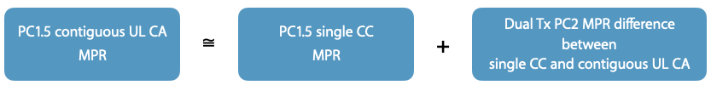

* + **Proposal 4: (Meta) on MPR simulation assumption**
* The proposed MPR simulation assumptions in Table 1 &2, RAN4 can derive the detail MPR requirements for PC1.5 intra-band CA UE.

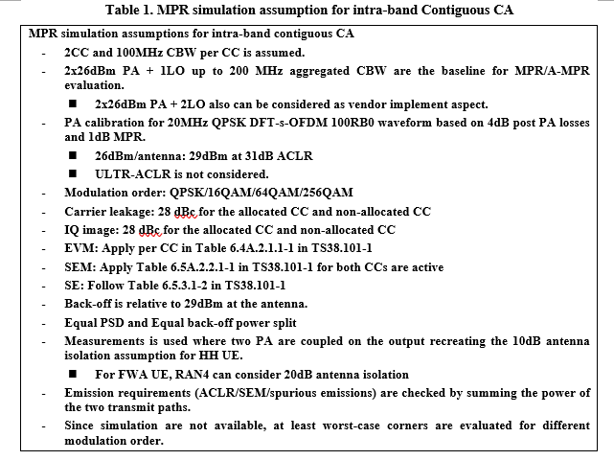

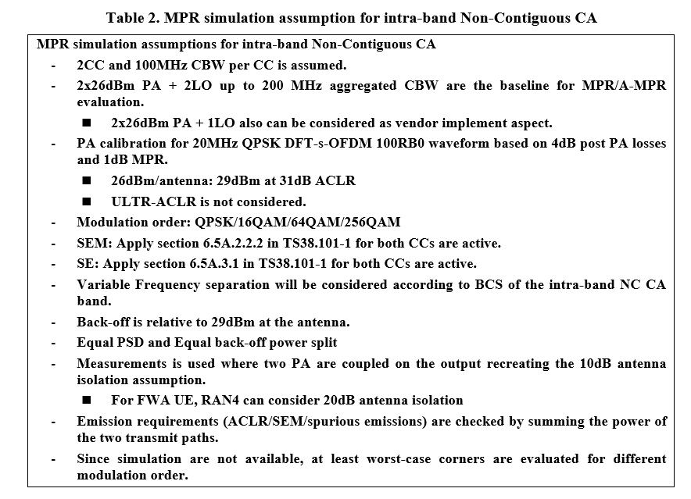

* + **Proposal 5: (LGE) on PSD assumption and MPR derivation methodology**
* For dualPA-Architecture of PC1.5 intra-band non-contiguous UL CA, consider different PSD when LCRB1 is different from LCRB2.
* For TxD-Architecture of PC1.5 intra-band contiguous UL CA, consider same PSD when LCRB1 is different from LCRB2.
* Study possibility to avoid MPR simulations and analysis for each CA output power combination through intoducing MA,delta value (MA,total= MA + MA,delta) ,which is used to offset the reference MPR requirement to new CA output power levels and PA combinations.
  + **Proposal 5: (vivo) on PSD assumption and MRP simulation parameters**

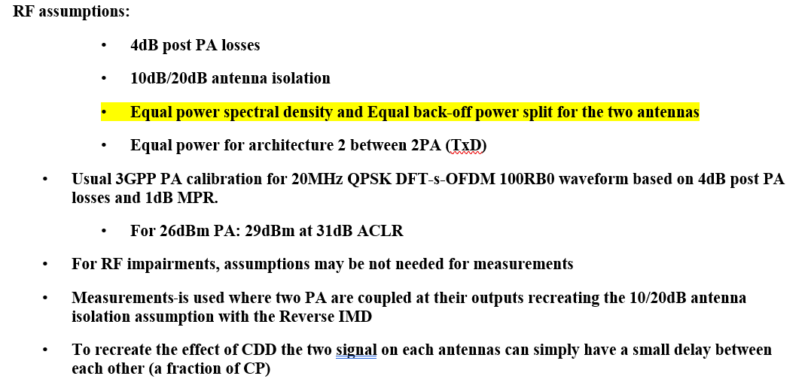

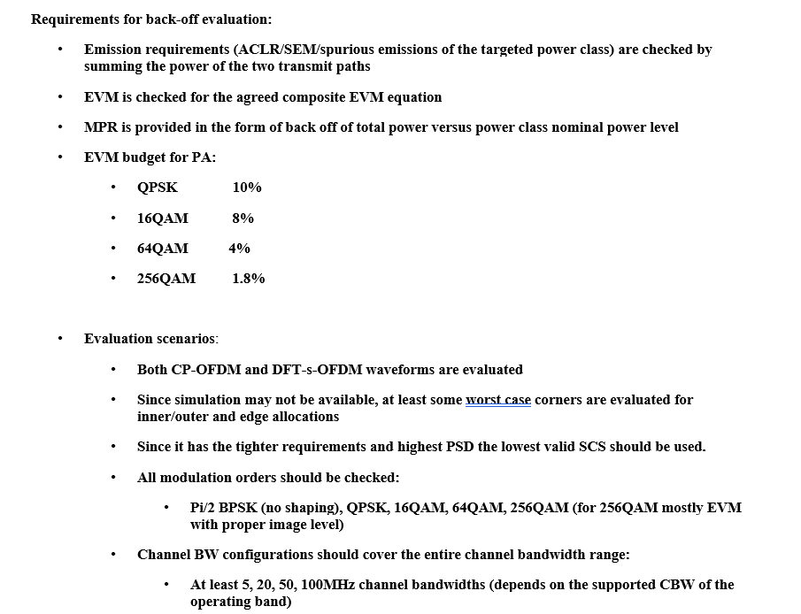

* + **Proposal 6: (Ericsson)**
* For intra-band non-contiguous CA with PC1.5 supported by a dual PA architecture (Architecture #1), the MPRc for serving cells c are equal, MPRc = MPR with MPR the reduction of the total UE power.
* for UEs indicating dualPA-Architecture (Architecture #1) for a non-contiguous intra-band combination with PC1.5 capability, the MPR specified for the total power also covers unequal UL PSD and RB bandwidths across CCs.
* Recommended WF

(*Moderator: Check and modify online*)

* + MPR and NS_04 A-MPR studies for PC1.5 contiguous intra-band ULCA focusses on TxD architecture and should account for reasonable PSD imbalance (<[6]dB?)
  + PC1.5 contiguous intra-band ULCA based on dualPA architecture is not specified in R19 as it does not allow UL MIMO and has power limitations such that it rarely delivers better performance than PC2 based on the same two 26dBm PAs.
  + MPR studies for PC1.5 non-contiguous intra-band ULCA focuses on dualPA architecture as it avoids limitations in total BW and gap size, should account for reasonable PSD imbalance (<[6]dB?)
  + PC1.5 non-contiguous intra-band ULCA based on TxD architecture is not specified in R19 as it does not allow support for the example n77(2A) configurations.
  + FFS what behavior is allowed for the UE when the PSD imbalance get too high to guarantee emissions (both related to MPR and A-MPR).
  + Still assume MPRc=MPR
  + Check online which methodology is used to derive MPR requirements. Measurement? Simulation? Mathematical calculation? Then align the evaluation parameters (if measurement and/or simulation are adopted)

#### **Issue 1.2.1-2: PCMAX,C**

Proposals：

* **For dualPA-architecture****,** 
  + PCMAX,C limitation for each component carrier is 26dBm (Skyworks, Samsung, Ericsson, ZTE, Huawei, LGE, Xiaomi)
  + No restriction (vivo)
  + (Huawei)

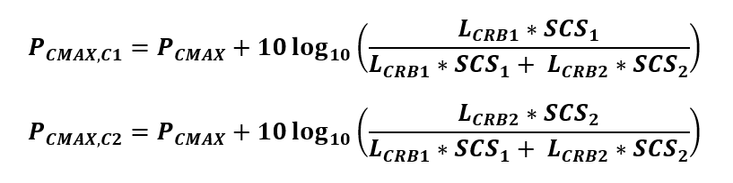

* **For TxD (dualTx),**
  + PCMAX,CC1 = (LGE)

PCMAX,CC2 =

* + No change of current spec (Xiaomi, ZTE, Samsung, vivo, Skyworks, Ericsson)
  + (Huawei)



* Recommended WF
  + TBD

#### **Issue 1.2.1-3: PCMAX**

* + Option 1: (Melta)
  + MOP for 2Tx architectures (TxD w/wo UL MIMO) is: *29* dBm
  + MOP for Dual-PA architectures (one PA/CC, 2LO) is:

*PCmax= 29 + 10*log(1/2*(1+Min(LCRB1*SCS1,LCRB2*SCS2)/Max(LCRB1*SCS1,LCRB2*SCS2)))* dBm

* + Option 2: (Huawei)
 $$P_{CMAX}=\left\{\begin{aligned}29 dBm for 2Tx TxD \\ \\ 26+10\log_{10}\left(1+\frac{\min{(L_{CRB1}*{SCS}_{1}, L_{CRB2}*{SCS}_{2})}}{max⁡(L_{CRB1}*{SCS}_{1}, L_{CRB2}*{SCS}_{2})}\right) for dualPA-architecture\end{aligned}\right.$$

 + Option 3: No change of current spec (Ericsson, LGE, Xiaomi)
  + Option 4: 29dBm for TxD (ZTE)
* Recommended WF
  + For TxD, no change of current spec
  + For dualPA-Architecture, TBD

#### **Issue 1.2.1-4: Further description on the architectures for PC1.5 NC ULCA**

Proposal：(Skyworks)

|  |  |  |  |  |  |  |
| --- | --- | --- | --- | --- | --- | --- |
| ***Architecture*** | ***Implementation*** | ***Indicated***  ***capability*** | ***UL MIMO***  ***support*** | ***Power limitation*** | ***Support of 1CC PC1.5 fallback*** | ***Separation BW limitations*** |
| *#1* | *2x26 dBm PA + 2 LO with 100MHz BW* | *dualPA-Architecture* | *No* | *Each carrier is limited to 26dBm* | *Requires LO switching and thus interruption* | *No limitations other than the currently defined largest separation BW of 600MHz* |
| *#2* | *2x26 dBm PA + 1 LO with 200MHz BW* | *TxD and/or UL MIMO* | *Yes* | *One carrier can reach 29dBm* | *Can support without any switching* | *Max separation BW of 200MHz, Gap size <aggregated BW* |

* + Option 1: Agree
  + Option 2: Not agree, and further refine/modify
* Recommended WF

(Moderator remove the “power limitation” column as it can be covered in Issue 1.2.1-2, the column can be added back if agreement reached for Issue 1.2.1-2, and a note is added to clarify the WID scope)

|  |  |  |  |  |  |
| --- | --- | --- | --- | --- | --- |
| ***Architecture*** | ***Implementation*** | ***Indicated***  ***capability*** | ***UL MIMO***  ***support*** | ***Support of 1CC PC1.5 fallback*** | ***Separation BW limitations*** |
| *#1* | *2x26 dBm PA + 2 LO with 100MHz BW* | *dualPA-Architecture* | *No* | *Requires LO switching and thus interruption* | *No limitations other than the currently defined largest separation BW of 600MHz* |
| *#2* | *2x26 dBm PA + 1 LO with 200MHz BW* | *TxD and/or UL MIMO* | *Yes* | *Can support without any switching* | *Max separation BW of 200MHz, Gap size <aggregated BW* |
| *Note: PC1.5 NC ULCA+UL MIMO is out of WI scope* | | | | | |

* + 1. Sub-topic 1-2: 2-band PC2/PC1.5 inter-band NR-CA/EN-DC with 2Tx or 3Tx

#### **Issue 1.2.2-1: Configuration**

Proposals：

* + Proposal 1: RAN4 to decide whether PC2 FDD bands would be considered in PC1.5 inter-band UL CA/EN-DC at the early phase of the work item. If RAN4 decides to consider PC2 FDD bands in PC1.5 inter-band UL CA/EN-DC configurations, a few exemplary band combinations would be required for companies to exercise the MSD analysis. (Apple)
  + Proposal 2: In the Rel-19 UE RF enhancement WI except PC1.5 FDD+FDD band combinations, RAN4 can focus on general RF requirements for high power inter-band CA/DC UE. (Meta)
* Recommended WF
  + TBD

#### **Issue 1.2.2-2: Spec organization**

Proposal：(Meta)

* + RAN4 can consider the above general RF requirements in TS38.101-1 for PC 1.5/PC2 inter-band CA including 2Tx/3Tx UE. Similar approach will be applied to inter-band EN-DC including 2Tx/3Tx UE in TS38.101-3.
    - suffix A (2Tx/3Tx CA without MIMO)
    - suffix H (3Tx w/ UL-MIMO)
    - suffix L (3Tx w/Tx Diversity)
* Recommended WF
  + Adopt same way as in Rel-18

#### **Issue 1.2.2-3:** **3UL CC with 3Tx**

Proposal：

* + Proposal 1: For PC1.5 inter-band UL CA/EN-DC, limit the UL configuration to one CC only in each of the UL bands to avoid RAN4 workload upsurge on the already busy and demanding objectives of this work item. (Apple)
  + Based on the above UE architecture analysis, RAN4 can support the two example CA band combinations without uplink MIMO in Rel-19. (Meta, details refer to R4-2411649)
  + 3UL CC of CA_nXA-nY(2A) should be excluded from 3Tx scenario (ZTE)
  + Do not discuss 3UL CC with 3Tx since it is out of WI scope. Any up scoping would belong to RAN level discussion. (vivo)

Recommended WF

* + Don not consider 3ULCC with 3Tx scenarios (such as CA_nXA-nY(2A) and CA_ nXA-nYB) considering there is no input from operators, the demanding objectives of this WI and the incomplete lower order power class
    1. Sub-topic 1-3: Increasing UE transmission power

#### **Issue 1.2.3-1:** **The methodology for Rel-19**

Proposal：

* + Proposal 1: The UE capability IEs to support increasing UE transmission high power limit for inter-band UL CA and EN-DC as defined in Rel-17, i.e., higherPowerLimit-R17 and higherPowerLimtMRDC-R17, are also applicable for any other UL power compositions with different power classes between the two UL bands. (Apple)
  + Option 2: Define Rel-19 capability of higher power limit for inter-band CA and inter-band EN-DC and Consider new duty cycle solution if Rel-19 capability of higher power limit is adopted. (LGE)
  + Option 3: For R19 increasing UE transmission power limit, to use the following existing R17/R18 methodologies: (ZTE, Samsung, Qualcomm, Nokia)
    - Use the higherPowerLimit-R17 and higherPowerLimtMRDC-R17 capability
    - No new power class is introduced
  + Option 4: To increase the transmission power limit, consider directly replacing the limit (PPowerClass,CA) set by the CA power class with the sum of the power limit per band (10 log10 ∑ pPowerClass,c) in PCMAX_H or both PCMAX_H and PCMAX_L. (Huawei)
* Recommended WF
  + Use higherPowerLimit-R17 and higherPowerLimtMRDC-R17 capability
  + No new power class is introduced

#### **Issue 1.2.3-2:** **The scenarios to be considered in Rel-19**

*(For information, the following scenarios are defined in Rel-17/18)*

|  |  |  |  |  |
| --- | --- | --- | --- | --- |
| **Indicated PC for A-B**  **(2Tx in total)** | **PC for band A of A-B** | **PC for band B of A-B** | **From which release increasing high power limit feature supported** | **Note** |
| PC2 | PC3(FDD or TDD) | PC2(TDD) | Support from Rel-17 | One CC per band |
| PC3 | PC5(NRU band) | PC3(FDD or TDD) | Support from Rel-18 | One CC per band;  One CC on band B, 2CC on band A(NRU band) |

Proposals：

* + Proposal 1: (Apple)

Use the UL power compositions in the table below to define 2UL IMD MSD requirements for the corresponding new UL configurations to support “increasing UE transmission high power limit” feature.

|  |  |  |
| --- | --- | --- |
| Power Class | UL Configuration | UL Power for 2UL IMD MSD |
| PC2 | PC2 FDD + PC5 TDD | 20dBm + 20dBm |
| PC2 | PC2 FDD + PC3 TDD | 23dBm + 23dBm |
| PC2 | PC2 FDD + PC3 FDD | 23dBm + 23dBm |
| PC1.5 | PC1.5 TDD + PC5 TDD | N/A |
| PC1.5 | PC1.5 TDD + PC3 TDD | N/A |
| PC1.5 | PC1.5 TDD + PC3 FDD | 27.8dBm + 23dBm |
| PC1.5 | PC1.5 TDD + PC2 TDD | N/A |
| PC1.5 | PC1.5 TDD + PC2 FDD | 26dBm + 26dBm |

* + Proposal 2: (Samsung)
* For 2Tx, higher power limit feature is enabled for any specified inter-band band combination.
  + - “Specified” here intends for the existing combos and the ones to be added into MOP table in future
* For 3Tx, the following scenarios may could be considered for NR-CA/EN-DC.

|  |  |  |  |  |
| --- | --- | --- | --- | --- |
| **Indicated PC for A-B**  **(3Tx in total)** | **PC for band A of A-B**  **(1Tx)** | **PC for band B of A-B**  **(2Tx)** | **The total power**  **(dBm)** | **Note** |
| PC2 | PC3 | PC2 | 27.8 | -One CC per band  -One CC in band A, 2CC on band B (if this scenario would be introduced for 3Tx) |
| PC1.5 | PC3 | PC1.5 | 30.0 | -One CC per band; For FWA only  -One CC in band A, 2CC on band B (if this scenario would be introduced for 3Tx); For FWA only |

* + Proposal 3: (Xiaomi)

The following power class configuration could be considered in Rel 19 for UE increasing high power limit.

* PC3 (TDD/FDD) +PC1.5 indicating PC1.5 with 3Tx
* PC2 (TDD with TxD) +PC3 (TDD/FDD) indicating PC2 with 3Tx
  + Proposal 4: (Meta)

To support the accumulative power increases of inter-band CA/DC band combinations UE, RAN4 can investigate how to apply the actual increased UE transmit power based on the above CA/DC power combinations with the existing power classes in Rel-19.

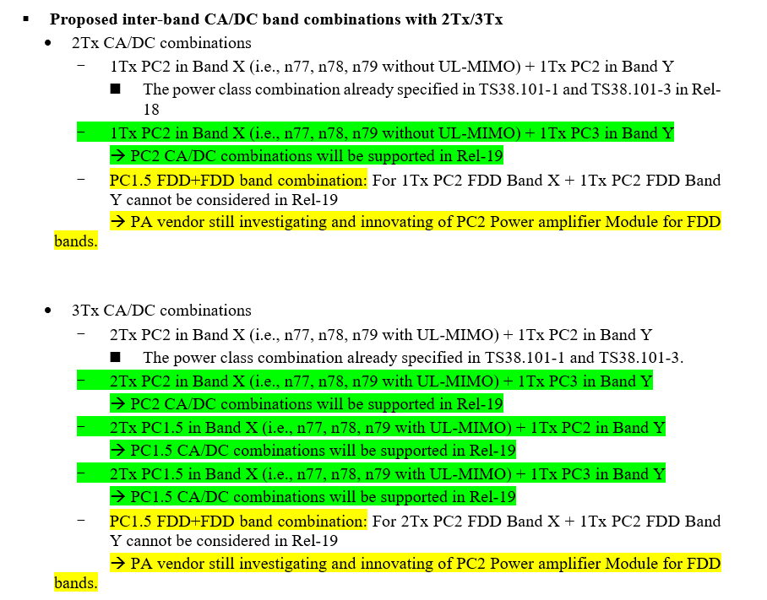

* + Proposal 5: (LGE)
* Decide which inter-band CA combinations are applicable in Rel-19 from lists in Table 2-1.

Table 2-1: A list of applicable inter-band CA scenarios for increasing UE transmission power limit

|  |  |  |  |  |
| --- | --- | --- | --- | --- |
| **CA power class** | **Power class configuration**  **Band A + Band B** | | **2Tx** | **3Tx** |
| PC2 | PC2 TDD | PC3 TDD | R18 | R18 |
| PC3 FDD | R18 | R18 |
| PC2 FDD | PC3 TDD | R19 ? | R19 ? |
| PC3 FDD | R19 ? | R19 ? |
| PC1.5 | PC1.5 TDD | PC3 TDD | N/A | R19 ? |
| PC3 FDD | N/A | R18 |
| PC2 TDD | N/A | R19 ? |
| PC2 FDD | N/A | R19 ? |

* Decide which inter-band EN-DC combinations are applicable in Rel-19 from lists in Table 2-2.

Table 2-2: A list of applicable inter-band CA scenarios for increasing UE transmission power limit

|  |  |  |  |  |
| --- | --- | --- | --- | --- |
| **CA power class** | **Power class configuration**  **Band A(E-UTRA) + Band B(NR)** | | **2Tx** | **3Tx** |
| PC2 | PC3 TDD | PC2 TDD | R18 | R18 |
| PC3 FDD | PC2 TDD | R18 | R18 |
| PC2 FDD | R19 ? | R19 ? |
| PC2 TDD | PC3 TDD | R19 ? | R19 ? |
| PC1.5 | PC3 TDD | PC1.5 TDD | N/A | R19 ? |
| PC3 FDD | N/A | R19 ? |
| PC2 TDD | N/A | R19 ? |
| PC2 FDD | N/A | R19 ? |

* + Proposal 6 (ZTE)
* To consider the following additional eligible PC2 2Tx inter-band NR CA and ENDC to enable increasing higher power limit in Rel-19:
  + - Inter-band with intra-band UL contiguous CA in one of the NR band
* To consider the following additional eligible HPUE 3Tx inter-band NR CA and ENDC with up to 3CC in UL bands to enable increasing higher power limit in Rel-19:
  + - PC2 band combination of PC3+PC2
    - PC1.5 band combination of PC3+PC1.5
    - PC1.5 band combination of PC2+PC1.5

Note: Only PC3 is considered for LTE FDD in EN-DC

Note: For 3UL CC, only inter-band with intra-band UL contiguous CA in one of the NR band is considered.

* + Proposal 7 (Nokia)

Choose Proposal 3 [1] as a WF

* higherPowerLimit-r17 is enabled for any standardized inter-band band combination. Cases where there is concern about exceeding local regulation are treated separately as exceptions.
* RAN4 to rely on network operators (carriers) to identify if local regulatory limits are exceeded when higherPowerLimit-r17 is enabled for their band combination.
* RAN4 to evaluate best method to identify corner case UL CA configuration (band combination + power class aggregation) where higherPowerLimit-r17 may NOT be used due to local regulation. Options:
  + - Set up an NS case
    - Rely on PEMAX,CA, the value indicated by p-NR-FR1 or by p-UE-FR1
    - Maintain an exception list in 38.101-x for UL CA configurations where higherPowerLimit-r17 may NOT be used
* Remove references to power class or TR duplexing type from sections of the standard that enable use of higherPowerLimit-r17
  + Proposal 8 (vivo)
* Consider PC3+PC2 and PC3+PC1.5 for 3Tx as scenarios for increasing power limit Rel-19.
* Consider to add some restrictions of UE type such as FWA only in case the total Tx power limit beyond PC1.5**.**
* No need to discuss relationship with power boosting since already have agreements.
  + Proposal 9 (NTT Docomo)
* Both FWA and handheld UE can support PC1.5 CA/DC with increasing UE high power limit feature in Rel-19 if there are no technical issues.
  + Proposal 10 (Huawei)
* Consider the following list of scenarios for increasing UE transmission power limit as shown in Table 1 below.
* Increasing the total Tx power limit beyond PC1.5 is only for FWA UEs, not for handheld UEs.

Table 1: A list of applicable scenarios for increasing UE transmission power limit

|  |  |  |  |  |  |
| --- | --- | --- | --- | --- | --- |
| **CA power class** | **Power class configuration**  **Band A + Band B** | | **Power limit increase (dB)** | **2Tx** | **3Tx** |
| PC3 | PC3 | PC5 | 1.8 | Completed in R18 | N/A |
| PC2 | PC2 | PC3 | 1.8 | Completed in R17 | R19 |
| PC5 | 1.0 | R19 | R19 |
| PC1.5 | PC1.5 | PC2 | 1.8 | N/A | R19 |
| PC3 | 1.0 | N/A | R19 |
| PC5 | 0.5 | N/A | R19 |

* + Proposal 11 (Qualcomm)
* For Rel-19, enable use of higherPowerLimit-r17 as the default case rather than the exception.
* RAN4 discusses applicability of higherPowerLimit-r17 to basic inter-band ULCA configurations with single CC per band before addressing mixed inter- + intra- combinations.
* For Rel-19, the basic inter-band configurations (with no intra-band component) is enabled for all power class aggregations that are introduced into the standard. Exceptions can be accommodated on a case-by-case basis.
* Recommended WF

*(Moderator: Companies views are quite diverse, check during online if the following can be a compromise)*

* For both 2Tx and 3Tx, *higherPowerLimit-R17*/*higherPowerLimtMRDC-R17* is enabled for any specified inter-band band combination
  + - “Specified” here intends for the existing combos and the ones to be added into MOP table in future
* Increasing the total Tx power limit beyond 29dBm is only for FWA UEs, not for handheld UEs
  + 1. Sub-topic 1-4: General aspects

#### **Issue 1.2.4-1: MSD rules**

Proposals：

* + Proposal 1: (Samsung)
* RAN4 to clarify that MSD general rule discussion is within the WI scope, just the specific MSD values are left for corresponding basket WIDs to evaluate.
* For all types of MSD, RAN4 defines only the default power class inter-band CA and intra-band CA MSD requirements, and the new HPUE MSD requirements are no longer specified in the TS. The legacy agreed HPUE MSD test points are not impacted and are kept in the TS.
  + Proposal 2: (Xiaomi)
* If the supported maximum power class of the constituted band are not changed in the higher power class case for the same band combination, no new MSD case is needed compared to the existing MSD requirement in the spec when defining the harmonic, harmonic mixing and cross isolation requirements.
* A discussion is needed on whether we can agree that for a given band combination, not to reconsider additional IMD MSD requirements for higher total power class on the basis that the MSD requirement has already been defined for the same power class configuration in lower total power class.
  + Proposal 3: (Nokia)
* WID objectives preclude band combination specific MSD discussions but allow generic MSD discussion applicable to all band combinations.
* When new PC1.5 NR TDD intra-band UL contiguous and non-contiguous CA with 2Tx configuration is introduced no additional MSD test points are specified.
* When new PC1.5 UE for two band NR inter-band uplink CA with 2Tx and/or 3Tx for handheld and FWA, and PC1.5 and PC2 for two band EN-DC with 2Tx and/or 3Tx for handheld and FWA is introduced no additional MSD test points are specified.
* Framework for those new configurations which are not covered by proposals in this paper can be discussed in relevant basket WI separately unless there is a consensus to have common WF in this meeting for all HPUE power classes no matter if it is single band, CA or DC.
  + Proposal 4: (vivo)

There are some basic options for MSD derivation for HPUE BC:

* + - Re-Calculate the MSD requirements.
    - Using High Power + Default power class requirements
    - Using Default Power + Default power class requirements
  + Proposal 5: (Qualcomm)
* Instead of going directly into “PC3 MSD only” approach, companies should first consider if some simplifications e.g. by specifying just single set of requirements for HPUE FDD band combinations and/or by using some equations to derive PC2/PC1.5 MSD from respective PC3 MSD would help to bring the MSD specification framework back on track.
  + Proposal 6: (NTT docomo)

Introduce new guidelines for MSD requirements due to IM. Below are the key points.

* The default is the MSD requirement for PC3 CA/DC.
* Regarding test points for HPUE CA/DC;
  + - if there are in the default MSD requirements, they will be reused.
    - if there are not in the default MSD requirements, new test points are added to other tables.
* Regarding MSD values for HPUE CA/DC, it can be calculated using default MSD value for PC3 and new parameter.
* Regarding power configuration for test;
  + - for PC2 CA/DC, assuming both of the transmitters shall be set min(+23 dBm, PCMAX_L,f,c).
    - for PC1.5 CA/DC, assuming both of the transmitters shall be set min(+26 dBm, PCMAX_L,f,c).
  + Proposal 7: (CHTTL)
* Regarding the HPUE for inter-band CA/EN-DC in Rel.19, suggest to focus on the SAR solutions according to the WID at this stage.
* Recommended WF
  + It is common understanding in RAN4 that MSD general rule discussion is within the WI scope, just the specific MSD values are left for corresponding basket WIDs to evaluate.
  + FFS the MSD rules

#### **Issue 1.2.4-2: Duty cycle solution for SAR compliance**

Proposals：

* + Proposal 1: Do not introduce ΔPPowerClass related specifications changes for PC1.5 inter-band UL CA/EN-DC with 2Tx or 3Tx configuration. (Apple)
  + Proposal 2: 3GPP duty-cycle solution is not specified for any scenarios of this WI. (Samsung)
  + Proposal 3: (Xiaomi)
* If follow the similar approach as current spec, for PC1.5 UE for two band NR inter-band uplink CA with 2Tx and/or 3Tx, the existing SAR mitigation solution for PC1.5 with 3Tx in Ts 38.101-1 could be reused. For PC1.5 inter-band EN-DC with 2Tx and 3Tx case, the duty cycle approach could be defined based on the existing dutycycle approach for PC2 case with some small changes as shown in the following table 2 for TDD+TDD case and FDD+TDD case.
* A unify approach on SAR solution for all possible HP UE scenarios can be considered. The detail approach could be discussed further. For example, only P-MPR is considered (i.e., Duty-cycle solution is not considered), or SAR solution just relies on per single band manner.
  + Proposal 4: (Meta)
* RAN4 can reuse the max uplink duty cycle limitation of the single carrier SAR solution for PC 1.5 intra-band contiguous CA combinations UE.
* RAN4 can reuse the max uplink duty cycle limitation of the single carrier SAR solution for PC 1.5 intra-band non-contiguous CA combinations UE.
  + Proposal 5: (LGE)
* Modify the existing PC2 duty cycle solution if PC2 FDD/TDD + PC2 TDD with 2Tx is introduced.
* For PC3 E-UTRA FDD + PC3/PC2 NR FDD, consider A new capability, for example, maxUplinkDutyCycle-interBandENDC-FDD-PC2 which comprises of maxUplinkDutyCycle-FDD-EN-DC1 and maxUplinkDutyCycle-FDD-EN-DC2
* For PC2 E-UTRA TDD + PC3 NR TDD, consider New duty cycle solution considering the possible E-UTRA TDD uplink-downlink configurations and the percentage of maximum E-UTRA/NR uplink transmission
* For PC2 E-UTRA TDD + PC2 NR TDD, considere New duty cycle solution considering the possible E-UTRA TDD uplink-downlink configurations and the percentage of maximum E-UTRA/NR uplink transmission
* For PC3 E-UTRA FDD + PC3/PC2 NR FDD (UL-MIMO or Tx diversity), consider a new capability, for example, maxUplinkDutyCycle-interBandENDC-FDD-PC2 which comprises of maxUplinkDutyCycle-FDD-EN-DC1 and maxUplinkDutyCycle-FDD-EN-DC2
* For PC2 E-UTRA TDD + PC3 NR TDD (UL-MIMO or Tx diversity), consider New duty cycle solution considering the possible E-UTRA TDD uplink-downlink configurations and the percentage of maximum E-UTRA/NR uplink transmission
* For PC3 E-UTRA FDD/TDD + PC1.5 NR TDD (UL-MIMO or Tx diversity), consider New duty cycle solution considering the possible E-UTRA TDD uplink-downlink configurations and the percentage of maximum E-UTRA/NR uplink transmission
* For PC2 E-UTRA TDD + PC2/PC1.5 NR TDD (UL-MIMO or Tx diversity), consider New duty cycle solution considering the possible E-UTRA TDD uplink-downlink configurations and the percentage of maximum E-UTRA/NR uplink transmission
  + Proposal 6: (ZTE)
* Duty-cycle solution should be considered for limited scenarios of PC2/PC1.5 NR inter-band UL CA.
  + - Only consider P-MPR scheme for the band combination including PC2 FDD band, i.e. FDD+FDD, FDD+TDD
    - Except P-MPR, duty cycle scheme is applied to the band combination including pure TDD bands, i.e. TDD+TDD
* For duty cycle based SAR solution, reuse the PC1.5 single CC capability for PC1.5 TDD UL intra-band contiguous and non-contiguous CA
  + Proposal 7: (vivo)
* For PC1.5 of intra-band CA, the default threshold is 25% when maxUplinkDutyCycle-PC2-FR1 is absent, if 0.5* maxUplinkDutyCycle-PC2-FR1 is exceeded, power reduction is expected.
* To compatible with PC2 of inter-band CA, for PC1.5 of inter-band CA, there is no default threshold when maxUplinkDutyCycle-interBandCA-PC2 is absent, if maxUplinkDutyCycle-PC2-FR1 is reported and 0.5* maxUplinkDutyCycle-PC2-FR1 is exceeded, power reduction is expected.
* To compatible with PC2 of inter-band EN-DC(TDD+TDD), for PC1.5 of Inter-band EN-DC(TDD+TDD) , the default threshold is 15% when maxUplinkDutyCycle-interBandENDC-TDD-PC2-r16 is absent, if 0.5*maxUplinkDutyCycle-interBandENDC-TDD-PC2-r16 is exceeded, power reduction is expected.
* For PC2 of inter-band EN-DC(FDD+FDD), on LTE side, there are two threshold 40% and 70% is hardcoded. On NR side, UE will report two thresholds: maxUplinkDutyCycle-FDD-FDD-EN-DC1 and maxUplinkDutyCycle-FDD-FDD-EN-DC2.
  + Proposal 8: (CHTTL)
* Regarding the SAR solutions for LTE FDD + NR TDD with 1Tx PC3 + 2Tx PC1.5 configuration
  + - At least the method that reusing PC2 LTE FDD + NR TDD signalling with 0.5 scaling is considered
    - The UE-implementation based methods (i.e. P-MPR) is still applied by default
* Regarding the SAR solutions for LTE FDD + NR FDD 2Tx/3Tx configurations
  + - The UE-implementation based methods (i.e. P-MPR) is applied by default
    - RAN4 to discuss whether other solutions (ex: duty cycle method) can be considered
  + Proposal 9: (China Telecom)
* For PC2 two band EN-DC with 2Tx and/or 3Tx, the legacy duty-cycle solution in 38.101-3 and corresponding capability and signalling shall be reused.
* For PC1.5 HPUE for intra/inter-band CA, the general SAR solution framework and the threshold of average percentage of uplink symbols should both refer to PC2 UE for CA and PC1.5 UE for single CC.
* For PC1.5 HPUE for intra/inter-band CA, if power class of one or both of the bands within the band combination is power class 1.5, the default value of maxDutyNR,x/y should be 25%.
* Start with taking half of PC2 default duty-cycle threshold and 0.5*PC2capability as new trigger condition of SAR solution for PC1.5 of FDD+TDD/TDD+TDD.
* Recommended WF
  + TBD