3GPP TSG-RAN WG2 Meeting #127 R2-240xxxx
Maastricht, Netherlands, Aug 19th – 23rd, 2024

Agenda item: 8.8.4
Source: Apple
Title: [Offline 307] [R19 NR NTN] service area information (Apple)
WID/SID: NR_NTN_Ph3-Core
Document for: Discussion and Decision

Introduction

This is to handle the following offline.
[AT127][307][R19 NR NTN] service area information (Apple)
Scope: Continue the discussion on the options to provide service area information: SIB20 vs MBSBroadcastConfiguration in MCCH
Intended outcome: report of offline discussion
Deadline for companies' feedback: Thursday 2024-08-22 20:00
Deadline for rapporteur's summary (in R2-2407619): Friday 2024-08-23 08:00

Discussions
#1: Observation from Online discussion (Tuesday)
From online discussion, we observed the following comments on two approaches, i.e., using SIB20 or MBSBroadcastConfiguration in MCCH to provide service area information for a broadcast session.
 | Pros | Cons
SIB20 | UE power saving from skipping monitoring MCCH if UE is not inside intended service area of its interested broadcast service. | 1) Signaling design is not clear to companies  2) How to support association for location dependent services.
MCCH | Simple signaling design | UE needs to always monitor MCCH to keep it up-to-date.

#2: Expected UE behavior when UE is not in any intended service area of its interested broadcast services
The understanding from SIB20 approach proponents is UE does not need to (re)acquire up-to-date MCCH when UE is not inside any intended service area of its interested broadcast services.
Question 1: Do companies share the understanding of expected UE behavior when UE is not in any intended service area of its interested broadcast interested broadcast services, UE does not need to (re)acquire up-to-date MCCH.
Company | Yes/No | Comments
TCL | Yes | To support the association for location dependent services, it is preferable to consider associating a service area or a cell level service area with MBS session information within SIB20.
vivo | Comments | There may be some broadcast services that the UE is interested in are provided without related intended service area. Then the UE cannot just simply determine not to acquire the MCCH based on the UE location and the intended service area (i.e. the UE should acquire the latest MCCH to check if there is any service that the UE is interested in is provided in the current cell). Thus, for user experience, UE should (re)acquire up-to-date MCCH.  Maybe RAN2 has to discuss whether the service associated with the intended area can be provided together with the service not associated with the intended area.
THALES | Yes
Qualcomm | Yes
Continental Automotive | Yes
ITRI | Comments | Regardless of the intended service area of MBS services, UE needs to obtain info of the modification of the MBS session provided in the neighbouring cell from up-to-date MCCH.  UE could determine whether to acquire the updated MCCH by receiving MCCH change notification, e.g., according to the LSB in the 2-bit bitmap of MCCH change notification which may indicate neighbouring cell information modification.
InterDigital | Yes | If UE has an interested service, the UE acquires an MCCH message at the cell and UE won’t need to re-acquire the MCCH message until MCCH modification is indicated (i.e. UE doesn’t need to continuously monitor MCCH.)

#3: Signaling example to provision the mapping between intended service areas and broadcast services
The following two figures show our understanding on the signaling design in to approaches.
1) Assumption 1: For location dependent services, one cell may provide multiple sets of configurations (e.g., g-RNTI, MRB configuration, MTCH configuration) for one single TMGI.
TS 23.274:

6.2.3 Location dependent MBS service
A location dependent MBS is identified by MBS Session ID, and provided in several MBS service areas. The location dependent MBS service enables distribution of different content data to different MBS service areas. The same MBS Session ID is used but a different Area Session ID is used for each MBS service area.
2) Assumption 2: It is assumed a common service area pool is provided somewhere. And service area ID is used to do the association.
With those understanding, below are the possible signaling structures to provision the mapping between one broadcast session (either it is location dependent service, or normal broadcast service).
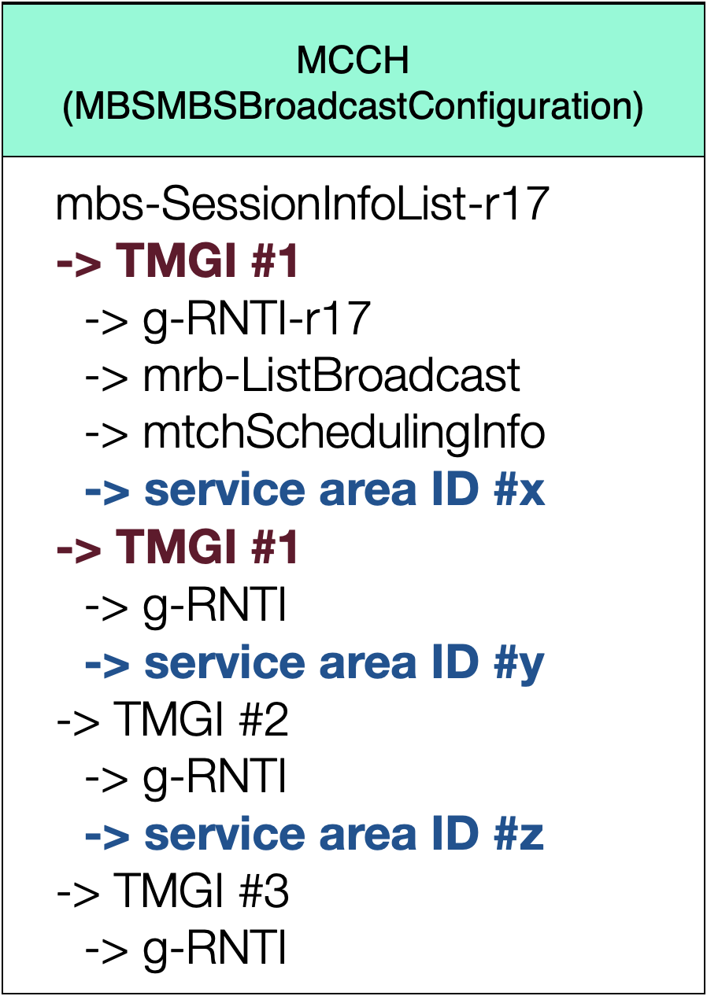
Fig. 1 – MCCH provisioning broadcast session and service area mapping
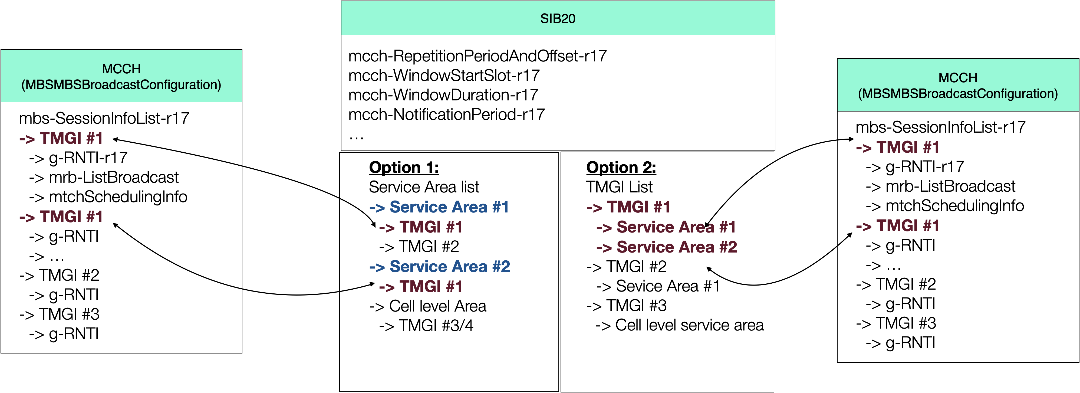
Fig. 2 – SIB20 provisioning broadcast session and service area mapping
Possible variants on configurations for SIB20 to provide the association between two lists in SIB20/MCCH:
1) For multiple entries associated with one single TMGI, association is done based on the entry order in two lists (as shown in Fig. 2).
2) Index can be used
3) Other solutions: TMGI + g-RNTI in SIB20

Question 2: Comments on signaling example above and possible down-selection.
- Approach 1: SIB20
- Approach 2: MCCH
Company | Approach 1/2 | Comments
TCL | Approach 1 | Allow skipping monitoring MCCH if UE outside of the intended service area
vivo | Approach 2 | For Approach 1, there might be SIB20 and MCCH update mismatch issues (i.e. the modification period of MCCH message and SIB20 is different). For example, when NW adds TMGI#1 which UE is interested in, NW should inform MCCH change notification. Under this use case, it is not suitable for UE to determine whether a new TMGI#1 is provided based on the intended service area info of TMGI#1 in SIB20. Assuming MCCH modification period is sf=2 and the SIB modification period sf=8 respectively. This means that NW cannot update timely SIB20 to provide the intended area info of new TMGI#1, which makes UE consider that TMGI#1 is not provided in NW (without reading MCCH). As a result, it will miss the interested broadcast service for a while. There may be an argument that NW can update MCCH message and SIB20 with the same modification period, e.g., based on modification period with sf2. However, on the one hand, this will restrict NW implementation. On the other hand, this will bring transmission delay of broadcast service TMGI#1.  For Approach 2, the intended area info of a broadcast service should be put outside of the MBS-SessionInfoList IE as the current signaling structure of MBS-SessionInfoList IE cannot be extended.  The signaling example of Approach 2 can be as following:  MBSBroadcastConfiguration-r17  -> mbs-SessionInfoList-r17  -> serviceareaofTMGI list-r19  ->> service area info of TMGI #1  ->> service area info of TMGI #2  ….  ->> service area info of TMGI #N  The mbs-SessionInfoList-r17 and serviceareaofTMGI list-r19 should have the same number of entries and has one-one mapping.
THALES | See comment | Preference for Approach 1 since it enables the UE only to monitor if there are/are not Broadcast service in NTN area. But no opposition to Approach 2 that is more cleaner if intended service area is limited to MBS Broadcast. FFS if a new SIB is introduce if service area had to be broadcasted for another purpose.
Qualcomm | Approach 1 | Also better not to add overheads in MCCH.
Continental Automotive | Approach 1 with comments | Enable UE to save power by skipping monitoring MCCH, if UE is not inside intended service area of its interested broadcast service.
ITRI | No strong preference | No strong preference.
InterDigital | Approach 1 | It’s better in terms of MCCH overhead.

