3GPP TSG-RAN WG2 Meeting #127 R2-240xxxx

Maastricht, Netherlands, 19th – 23rd August, 2024

**Agenda item: 7.25.1**

**Source: Samsung**

**Title: Report of [AT127][024][ATG] Clarification on SCS for Timing Advance reporting**

**WID/SID: NR_ATG**

**Document for: Discussion and Decision**

# Introduction

This is the e-mail discussion for the following:

* [AT127][024][ATG] Clarification on SCS for Timing Advance Reporting (Samsung)

Scope:

* + - Agree on an approach (if any) and produce agreeable CRs.

     Deadline:

* + - Before any online session (yet to be scheduled)

# Background

For the meeting we have three contributions discussing the issue of the SCS for the Timing Advance Report:

[R2-2406604](https://www.3gpp.org/ftp/tsg_ran/WG2_RL2/TSGR2_127/Docs/R2-2406604.zip) Clarification of offsetThresholdTA-r18 for NR ATG Huawei, HiSilicon, CMCC CR Rel-18 38.331 18.2.0 4882 - F NR_ATG-Core

[R2-2407380](https://www.3gpp.org/ftp/tsg_ran/WG2_RL2/TSGR2_127/Docs/R2-2407380.zip) Discussion on ATG ZTE Corporation, Sanechips discussion Rel-18 NR_ATG-Core

[R2-2407530](https://www.3gpp.org/ftp/tsg_ran/WG2_RL2/TSGR2_127/Docs/R2-2407530.zip) Clarifications for ATG timing advance reporting procedures Samsung discussion Rel-18 NR_ATG-Core

The issues covered in the above papers can be divided in two issues on; 1) SCS applied for offset threshold and 2) SCS applied in Timing Advance Field for ATG in Timing Advance Report MAC CE.

## SCS applied for offsetThresholdTA

The offset threshold TA is configured to trigger the Timing Advance report. In ATG, this is configured using symbols, which means that the absolute length in time would be dependent on the SCS.

---------------- 38.331 ----------------

– TAR-Config

The IE *TAR-Config* is used to configure Timing Advance reporting in non-terrestrial networks and ATG network.

***TAR-Config* information element**

-- ASN1START

-- TAG-TAR-CONFIG-START

. . . OMITTED . . .

TAR-Config-r18 ::= SEQUENCE {

offsetThresholdTA-r18 INTEGER (1..56) OPTIONAL, -- Need R

timingAdvanceSR-r18 ENUMERATED {enabled} OPTIONAL, -- Need R

...

}

-- TAG-TAR-CONFIG-STOP

-- ASN1STOP

|  |
| --- |
| ***TAR-Config* field descriptions** |
| ***offsetThresholdTA***  Offset for TA reporting as specified in TS 38.321 [3]. Network only configures this parameter for MCG. For ATG, network only configures offsetThresholdTA-r18, which is in unit of symbols. |
| ***timingAdvanceSR***  Used to configure whether a Timing Advance report may trigger a Scheduling Request as specified in TS 38.321 [3]. |

---------------- 38.331 ----------------

The issue is that if there is a BWP switch where the SCS changes, then the offset threshold in absolute time could be interpreted to change. For instance if UE switches from BWP#1 with 15 kHz SCS to BWP#2 with 30 kHz SCS, then the offset threshold TA in absolute time would divided by 30/15=2. This may for instance trigger mistakenly trigger a Timing Advance Report when the BWP is switched. This can be seen in Figure 1.

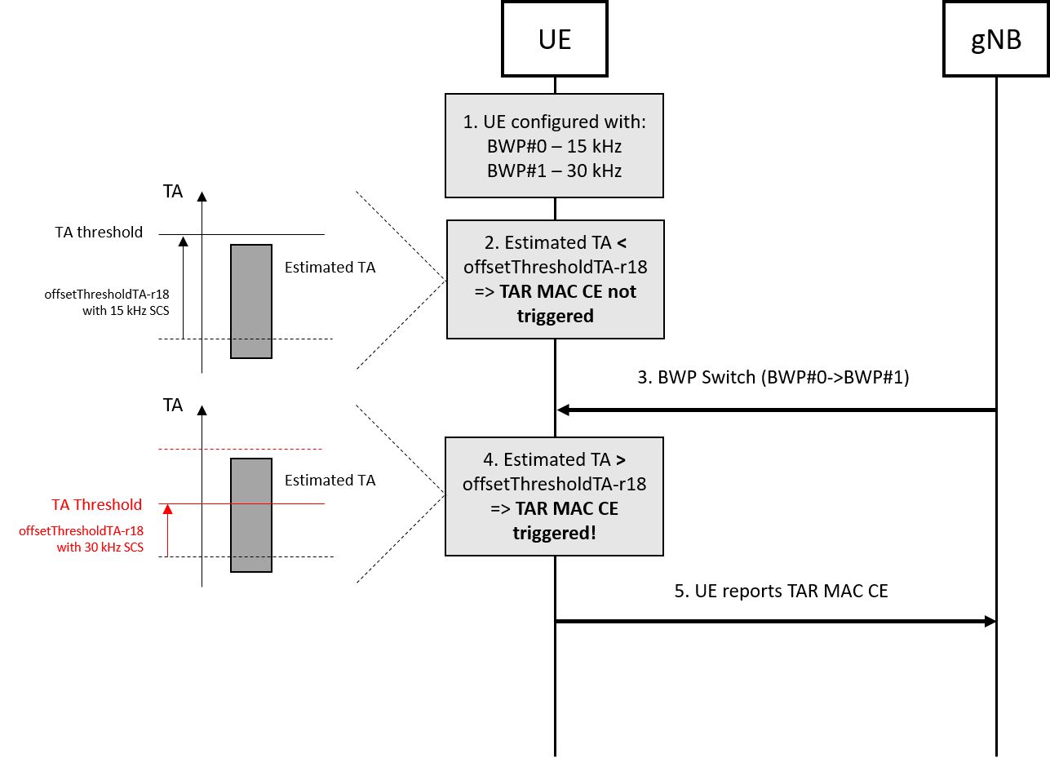

Figure 1.

In R2-2406604, it is suggested to clarify that the SCS applied is the SCS of the active BWP when the field is configured.

In R2-2407380, is it suggested to clarify that the UE always applies 30 kHz SCS.

In R2-2407530, the following 4 options are suggested: 1) UE applies 15 kHz SCS, 2) the SCS of initial BWP is applied, 3) SCS of the active BWP when the UE is configured is applied and 4) the SCS of active BWP is applied.

## SCS for Timing Advance Field in TAR MAC CE

The first issue is that the wording “currently configured” is not sufficiently clear as the UE may technically be configured with multiple BWPs with different SCSes.

---------------- 38.321 ----------------

6.1.3.56 Timing Advance Report MAC CE

The Timing Advance Report MAC CE is identified by MAC subheader with LCID as specified in Table 6.2.1-2. It has a fixed size and consists of two octets defined as follows (Figure 6.1.3.56-1):

- R: Reserved bit, set to 0;

- Timing Advance: Except for ATG in FR1, the Timing Advance field indicates the least integer number of slots, using subcarrier spacing of 15 kHz, greater than or equal to the Timing Advance value (see TS 38.211 [8], clause 4.3.1).

For ATG in FR1, the Timing Advance field indicates the least integer number of symbols greater than or equal to the Timing Advance value (see TS 38.211 [8], clause 4.3.1). The symbol duration is based on the subcarriers spacing the UE is currently configured with. In this release of the specification, only 15 kHz and 30 kHz SCS are applicable and only values 1 … 56 are used.

The length of the field is 14 bits.

---------------- 38.321 ----------------

The second issue that is discussed in paper R2-2407380 is that if a BWP switch occurs where SCS#1 is changed to SCS#2 after a TAR MAC CE is triggered. In this case there may be an issue where by the UE may report a TAR MAC CE with the Timing Advance field using SCS#1 in another BWP with SCS#2. This will confuse the network.

# Way forward

After offline discussions with other companies, there seems to be an agreement that the issues as described in the contributions are valid and that some type of correction is needed.

Based on further discussions, it seems that an acceptable outcome would be to agree to fix the issue of offsetThresholdTA by clarifying that the UE applies the SCS of active BWP when the UE is configured with Timing Advance Reporting.

**Q1: For clarifying the applied SCS for ATG offsetThresholdTA, SCS is assumed to be based on the SCS of the active BWP when the UE is configured with Timing Advance reporting? (In other words agree CR R2-2406604)**

|  |  |  |
| --- | --- | --- |
| Company | Yes/No | Comment (or other way forward) |
|  |  |  |

**P1: (TBD based on discussion)**

**Q2: Any Comment on CR R2-2406604.**

|  |  |
| --- | --- |
| Company | Comment (or other way forward) |
|  |  |

**P2: (TBD based on discussion)**

Based on further offline discussion, it seems that for the SCS to apply for Timing Advance field in the Timing Advance MAC CE, it seems that a small clarification can be accepted. This fix would be that the UE applies the SCS in currently configured active BWP. The clarification that seems acceptable is the following:

---------------- 38.321 example ----------------

6.1.3.56 Timing Advance Report MAC CE

The Timing Advance Report MAC CE is identified by MAC subheader with LCID as specified in Table 6.2.1-2. It has a fixed size and consists of two octets defined as follows (Figure 6.1.3.56-1):

- R: Reserved bit, set to 0;

- Timing Advance: Except for ATG in FR1, the Timing Advance field indicates the least integer number of slots, using subcarrier spacing of 15 kHz, greater than or equal to the Timing Advance value (see TS 38.211 [8], clause 4.3.1).

For ATG in FR1, the Timing Advance field indicates the least integer number of symbols greater than or equal to the Timing Advance value (see TS 38.211 [8], clause 4.3.1). The symbol duration is based on the subcarriers spacing of the active BWP the UE is currently configured with. In this release of the specification, only 15 kHz and 30 kHz SCS are applicable and only values 1 … 56 are used.

The length of the field is 14 bits.

---------------- 38.321 example ----------------

**Q3: For clarifying the applied SCS for Timing Advance field in TAR MAC CE, SCS is assumed to be based on the SCS of the active BWP?**

|  |  |  |
| --- | --- | --- |
| Company | Yes/No | Comment (or other way forward) |
|  |  |  |

**P3: (TBD based on discussion)**

**Q4: Comments on the 38.321 Text proposal?**

|  |  |
| --- | --- |
| Company | Comment (or other way forward) |
|  |  |

**P4: (TBD based on discussion)**

For the issue that is mentioned in R2-2407380, where the TAR MAC CE is triggered on a BWP with SCS#1 and then the BWP is switched and is then reported in a BWP with SCS#2, this may be seen to be a corner case that a network may be able to handle.

**Q5: TAR MAC CE reporting in another BWP than it was triggered in (as mention in R2-2407380) is considered a corner case that can be handled by network implementation?**

|  |  |  |
| --- | --- | --- |
| Company | Yes/No | Comment (or other way forward) |
|  |  |  |

**P5: (TBD based on discussion)**

# Conclusion

In this contribution we discussed issues related to ATG Timing advance reporting.

**P1: (TBD based on discussion)**

**P2: (TBD based on discussion)**

**P3: (TBD based on discussion)**

**P4: (TBD based on discussion)**

**P5: (TBD based on discussion)**