**3GPP TSG RAN WG1 #118 draft-R1-2407318**

**Maastricht, NL, August 19th – 23rd, 2024**

**Source: Moderator (Fujitsu)**

**Title: FL summary 1 of Measurements related enhancements for LTM**

**Agenda Item: 9.1.1**

**Document for: Information**

# Introduction

This contribution is a Feature Lead (FL) summary for A.I. 9.9.1: Maintenance on Further NR Mobility Enhancements.

# Plan for Online discussion

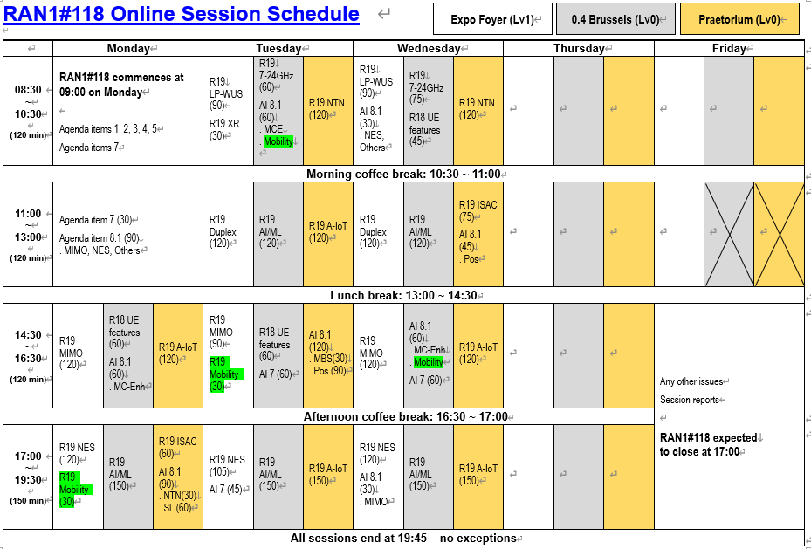

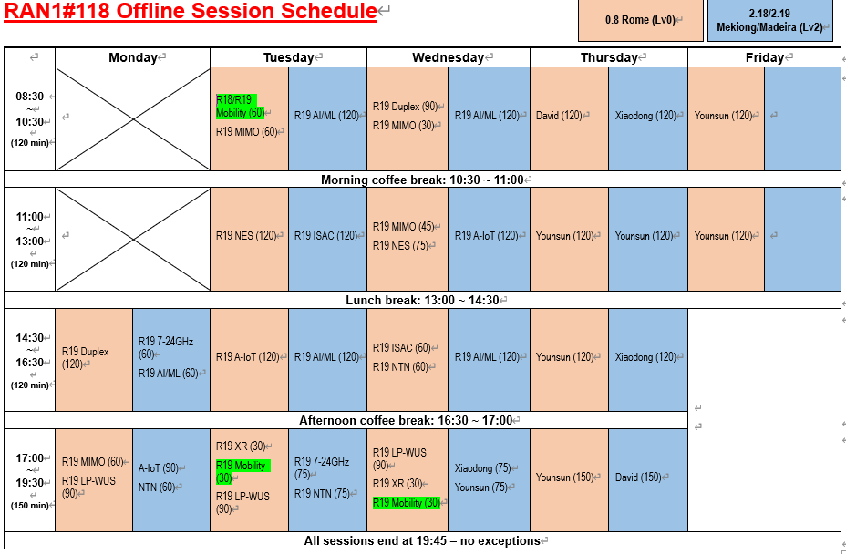

##### [Proposals for Tuesday Online]

##### [Proposals for Wednesday Online]

##### [Proposals for Thursday Online]

##### [Proposals for Friday Online]

# Contact people

|  |  |  |
| --- | --- | --- |
| Name | Company | Email address |
| Yosuke Akimoto | Fujitsu (FL) | akimoto.yosuke@fujitsu.com |
| Taewoo Lee | Fujitsu | lee.taewoo@fujitsu.com |
| Paul Marinier | InterDigital | paul.marinier@interdigital.com |
|  |  |  |
|  |  |  |
|  |  |  |

# List of Contributions

## Contributions under AI 9.9 and 9.9.1

|  |  |  |
| --- | --- | --- |
| [**R1-2406860**](https://www.3gpp.org/ftp/TSG_RAN/WG1_RL1/TSGR1_118/Docs/R1-2406860.zip) | Work plan for Rel-19 Further NR Mobility Enhancements | Apple, China Telecom |

|  |  |  |
| --- | --- | --- |
| [**R1-2405859**](https://www.3gpp.org/ftp/TSG_RAN/WG1_RL1/TSGR1_118/Docs/R1-2405859.zip) | Measurements related enhancements for LTM | Huawei, HiSilicon |
| [**R1-2405924**](https://www.3gpp.org/ftp/TSG_RAN/WG1_RL1/TSGR1_118/Docs/R1-2405924.zip) | Discussion on measurements related enhancements for LTM | Spreadtrum Communications |
| [**R1-2406001**](https://www.3gpp.org/ftp/TSG_RAN/WG1_RL1/TSGR1_118/Docs/R1-2406001.zip) | Discussion on measurements related enhancements for LTM | CMCC |
| [**R1-2406032**](https://www.3gpp.org/ftp/TSG_RAN/WG1_RL1/TSGR1_118/Docs/R1-2406032.zip) | Discussion on measurements related enhancements for LTM | ZTE Corporation, Sanechips |
| [**R1-2406063**](https://www.3gpp.org/ftp/TSG_RAN/WG1_RL1/TSGR1_118/Docs/R1-2406063.zip) | Discussion on measurements related enhancements for LTM | LG Electronics |
| [**R1-2406200**](https://www.3gpp.org/ftp/TSG_RAN/WG1_RL1/TSGR1_118/Docs/R1-2406200.zip) | Views on measurements related enhancements for LTM | vivo |
| [**R1-2406264**](https://www.3gpp.org/ftp/TSG_RAN/WG1_RL1/TSGR1_118/Docs/R1-2406264.zip) | Discussions on measurement enhancement for LTM | OPPO |
| [**R1-2406303**](https://www.3gpp.org/ftp/TSG_RAN/WG1_RL1/TSGR1_118/Docs/R1-2406303.zip) | Measurements related enhancements for LTM | Xiaomi |
| [**R1-2406386**](https://www.3gpp.org/ftp/TSG_RAN/WG1_RL1/TSGR1_118/Docs/R1-2406386.zip) | Discussion on measurements related enhancements for LTM | CATT |
| [**R1-2406432**](https://www.3gpp.org/ftp/TSG_RAN/WG1_RL1/TSGR1_118/Docs/R1-2406432.zip) | Measurements enhancements for LTM | TCL |
| [**R1-2406458**](https://www.3gpp.org/ftp/TSG_RAN/WG1_RL1/TSGR1_118/Docs/R1-2406458.zip) | Measurements related enhancements for LTM | InterDigital, Inc. |
| [**R1-2406486**](https://www.3gpp.org/ftp/TSG_RAN/WG1_RL1/TSGR1_118/Docs/R1-2406486.zip) | Measurements related enhancements for LTM | Sony |
| [**R1-2406525**](https://www.3gpp.org/ftp/TSG_RAN/WG1_RL1/TSGR1_118/Docs/R1-2406525.zip) | Measurements related enhancements for LTM | Lenovo |
| [**R1-2406527**](https://www.3gpp.org/ftp/TSG_RAN/WG1_RL1/TSGR1_118/Docs/R1-2406527.zip) | Discussion on measurements related enhancements for LTM | Fujitsu |
| [**R1-2406668**](https://www.3gpp.org/ftp/TSG_RAN/WG1_RL1/TSGR1_118/Docs/R1-2406668.zip) | Views on Rel-19 measurement related enhancements for LTM | Samsung |
| [**R1-2406697**](https://www.3gpp.org/ftp/TSG_RAN/WG1_RL1/TSGR1_118/Docs/R1-2406697.zip) | Discussion on measurements related enhancements for LTM | NEC |
| [**R1-2406737**](https://www.3gpp.org/ftp/TSG_RAN/WG1_RL1/TSGR1_118/Docs/R1-2406737.zip) | Discussion on NR mobility ehnancement based on CSI-RS measurements | ETRI |
| [**R1-2406769**](https://www.3gpp.org/ftp/TSG_RAN/WG1_RL1/TSGR1_118/Docs/R1-2406769.zip) | LTM measurements related enhancements | MediaTek Inc. |
| [**R1-2406791**](https://www.3gpp.org/ftp/TSG_RAN/WG1_RL1/TSGR1_118/Docs/R1-2406791.zip) | Measurement related enhancements for LTM | Nokia |
| [**R1-2406861**](https://www.3gpp.org/ftp/TSG_RAN/WG1_RL1/TSGR1_118/Docs/R1-2406861.zip) | Measurements enhancements for LTM | Apple |
| [**R1-2406947**](https://www.3gpp.org/ftp/TSG_RAN/WG1_RL1/TSGR1_118/Docs/R1-2406947.zip) | Discussion on measurement related enhancements for LTM | NTT DOCOMO, INC. |
| [**R1-2406966**](https://www.3gpp.org/ftp/TSG_RAN/WG1_RL1/TSGR1_118/Docs/R1-2406966.zip) | Discussion on measurement related enhancements for LTM | KDDI Corporation |
| [**R1-2407047**](https://www.3gpp.org/ftp/TSG_RAN/WG1_RL1/TSGR1_118/Docs/R1-2407047.zip) | Measurement related enhancement for LTM | Qualcomm Incorporated |
| [**R1-2407053**](https://www.3gpp.org/ftp/TSG_RAN/WG1_RL1/TSGR1_118/Docs/R1-2407053.zip) | Discussion on measurements related enhancements for LTM | Sharp |
| [**R1-2407115**](https://www.3gpp.org/ftp/TSG_RAN/WG1_RL1/TSGR1_118/Docs/R1-2407115.zip) | Discussion on measurements related enhancements for LTM | Google |
| [**R1-2407146**](https://www.3gpp.org/ftp/TSG_RAN/WG1_RL1/TSGR1_118/Docs/R1-2407146.zip) | Measurement related enhancements for LTM | Ericsson |

# Discussion

## L1 measurement based on CSI-RS

### [High] Measurement quantity

##### [Summary of contributions]

**Introduction of L1-RSRP based on CSI-RS**

* No concern was raised in the contributions

**Introduction of L1-SINR: based on CSI-RS**

* It is proposed by many companies while concern was raised. The situation is similar to that in Rel-18: the companies view is split to almost half vs half.
* Reasons for support
  + SINR is supported for L3. Thus, similar function is needed/helpful
  + Interference measurement is important for inter-frequency mobility
  + Interference measurement is based on CSI-RS, thus easy to support in Rel-19 given the support of CSI-RS.
  + To address the concern on complexity, only CMR can be used for simplicity
* Reasons for not support
  + Complicated measurement at UE side on both CMR and IMR
  + The benefits need to be identified
  + Instantaneous signal quality and interference may not accurately predict fast changing channels and interference situation
  + Signaling overhead due to RS resource and resource set for interference measurement need to be considered
  + Additional workload in RAN4 to evaluate and define the requirement on L1-SINR based on supported RS.

##### [FL Observation]

Given the discussion above, it is intuitive to support L1-RSRP measurement based on CSI-RS because L1-RSRP is the key functionality of Rel-18 LTM. For L1-SINR, further discussion would be needed to better understand the benefit over specification impact, UE complexity and overhead caused by configuring many RSs including interference measurement.

##### [FL Proposal 1-1-v1]

* Support L1-RSRP measurement based on CSI-RS.
* FFS: Support L1-SINR measurement based on CSI-RS.

##### [Comments to FL Proposal 1-1-v1]

|  |  |  |
| --- | --- | --- |
| Company | Comment | FL reply |
| Fujitsu | L1-SINR is beneficial to measure interference for the case of inter-frequency LTM. Anyhow, we support FL’s proposal to study further about the benefits of L1-SINR. |  |
| InterDigital | Fine with FL proposal |  |

### [High] Support of intra- and inter frequency measurement

##### [Summary of contributions]

**Support of intra-frequency CSI-RS based L1-measurement**

* A few companies explicitly proposed it
* No concern was raised

**Support of inter-frequency for CSI-RS based measurement**

* Explicitly mentioned & suggested by a lot of companies
  + It is highly possible for UE to handover from one cell to another cell based on inter-frequency measurement
  + Two companies mentioned that the detailed definition is up to RAN4, while there is a proposal related to measurement gap

##### [FL Observation]

Considering the companies’ view and Rel-18 design, FL agrees that it is straightforward to support both intra- and inter-frequency L1-measurement based on CSI-RS. For L1-SINR, the introduction can be discussed under section 5.1.1, and hence FL would suggest putting FFS at this moment. However, it is noted here that it is SINR measurement is helpful for inter-frequency (pointed out by DOCOMO).

For the definition of intra- and inter-frequency, FL suggestion is to take the same approach as in Rel-18: leave the details to RAN4. This means RAN1 will have no further discussion on this aspect.

##### [FL Proposal 1-2-v1]

* Support intra- and inter-frequency L1-RSRP measurement based on CSI-RS.
* Support intra- and inter-frequency L1-SINR measurement based on CSI-RS, if L1-SINR is supported.
* The detailed definition of intra- and inter-frequency CSI-RS based L1 measurement is up to RAN4.

##### [Comments to FL Proposal 1-2-v1]

|  |  |  |
| --- | --- | --- |
| Company | Comment | FL reply |
| Fujitsu | Fine with FL proposals. For inter-frequency L1 measurement case, SINR plays an important role to obtain the accurate channel state. |  |
| InterDigital | Fine with FL proposals |  |

### [High] Configuration of CSI-RS

##### [Summary of contributions]

**Explicit configuration**

* It is proposed to support explicit configuration of CSI-RS for LTM measurement per candidate cell rather than Rel-17 ICBM based solution because Rel-17 ICBM mechanism is too restrictive e.g. in terms of RTD.

**Parameters in the configuration**

* Only a few companies mentioned the necessary parameters for CSI-RS based measurement.
  + For inter-frequency CSI-RS measurement, Point A configuration, SCS, center frequency and SFN offset needs to be included
  + The CSI-RS configuration parameters (e.g., port, density, periodicity, bandwidth, etc) in legacy CSI framework should be directly reused
  + One company mentioned “repetition” is needed while one company mentioned “repetition” should be off in LTM configuration for event triggered reporting.

**RRC Structure**

* A lot of companies discussed where the CSI-RS configuration is included in the current LTM RRC structure.
  + The existing SSB measurement configuration framework can be reused for CSI-RS
    - CSI-RS configuration is located under candidate cell configuration
    - Introduce NZP CSI-RS resource set in LTM-CSI-SSB-ResrouceSet as in Rel-18
    - CandidateTCI-States in Rel-18 has already included the CSI-RS configuration. This can be reused for L1-measurement as well.
  + It needs further discussion whether how to handle the RSs with different types (i.e. SSB, CSI-RS) in a resource set
    - multiple NZP CSI-RS of multiple candidate cells are configured within a resource set.
    - According to RAN2 working assumption

##### [FL Observation]

It is important to clarify that the target of the standardization work for CSI-RS measurement in Rel-19 even though it is not clearly captured in the WID: FL’s understanding is that the target of Rel-19 is not to mimic the CSI-RS transmission from candidate cell as if it is transmitted from the serving cell as in Rel-17 ICBM. Therefore, FL would like to suggest to make this aspect clear.

For the details of configuration parameter and RRC structure, FL suggestion is to take the same approach in Rel-18: The detailed configuration parameter will be discussed after the rapporteur’s proposal for RRC parameters is ready. And the RRC structure is up to RAN2. This leads to no FL proposal in this meeting for this aspect. Companies are encouraged to further assess the RRC parameters and structure to configure CSI-RS for L1 measurement in the future meetings.

##### [FL Proposal 1-3-v1]

* Explicit configuration of CSI-RS per candidate cell for L1-measurement is introduced

##### [Comments to FL Proposal 1-3-v1]

|  |  |  |
| --- | --- | --- |
| Company | Comment | FL reply |
| Fujitsu | Fine with the FL proposal. Furthermore, RAN1 to study further how to configure the measurement RS explicitly. |  |
| InterDigital | Fine with FL proposal. |  |

### [Mid] Second level details for the next meeting

##### [Summary of contributions]

**Transmission of CSI-RS in time domain, i.e. periodicity**

* Majority view seems to support at least periodic CSI-RS for L1-measurement
  + TRS in Rel-18 LTM is periodically transmitted
  + Semi-persistent and aperiodic CSI-RSs require additional coordination between the source and candidate cells due to their dynamic nature.
* Meanwhile, a couple of companies see the necessity to support semi-persistent and aperiodic CSI-RS transmission as well
  + Semi-persistent and aperiodic CSI-RS allow the candidate cells to suspend the CSI-RS when unnecessary while periodic assumes always-on CSI-RS
  + According to the current mechanism, trigger of aperiodic/semi-persistent CSI-RS is indicated from the serving cell while the transmission of CSI-RS is controlled by each candidate cell
    - Then, it may impact RAN3 specification to coordinate transmit/suspend timing of the CSI-RS for LTM measurement. If the timing is not aligned, the transmitted CSI-RS from candidate cell may be missed by the UT
  + If the coordination between serving cell and candidate cell is necessary, the coordination might be more complicated for inter-CU scenario

**Type of CSI-RS**

* Many companies have proposed the necessary types of CSI-RS for L1-measurement
  + CSI-RS for beam management: This is deemed as a natural extension of intra-cell beam management
  + CSI-RS for mobility: This CSI-RS has already been available for L3 measurement and can be reused
  + CSI-RS for tracking: This CSI-RS has already available in Rel-18 (though this is an optional feature)
  + CSI-RS for CSI: The motivation of this CSI-RS is CSI acquisition before cell switch rather than L1 measurement
  + CSI-IM: This CSI-RS is needed if interference measurement is necessary. It depends on how the interference measurement is defined for L1-SINR (if supported)
* It is observed by one company that the overhead of CSI-RS may increase the overhead. It is desired to reuse the CSI-RS, which originally transmitted at the candidate cell, to reduce the overhead by CSI-RS transmission. (Nokia)

**Signaling overhead**

* It is pointed out that a larger set of CSI-RSs could be configured compared to SSBs from each candidate cell, with each CSI-RS configuration containing more information, resulting in signaling overhead. (Nokia) – solution(s) to reduce the overhead may be needed.

**Procedure for CSI-RS measurement**

* Three companies mentioned that the UE needs to monitor SSB, which is a QCL source RS of a CSI-RS, before starting CSI-RS measurement for synchronization purpose (i.e. timing detection of the candidate cell). (vivo, Lenovo, Samsung)

**UE Capability issue**

* How to count the active CSI-RS ports (LG)

##### [FL Observation]

For the periodicity of CSI-RS, it seems that the support of periodic transmission would be agreeable. However, considering the concern raised by the companies, FL believes that it would be more important to have a common understanding on the issues behind CSI-RS periodicity, i.e. always-on CSI-RS from candidate cell should be assumed? Necessity/possibility of coordination of CSI-RS transmission timing between serving cell and candidate cells? And hence, FL suggestion is to discuss this issue as a package at the next meeting rather than agreeing one piece of the proposal (i.e. periodic).

For Type of CSI-RS, FL thinks that it would be important to reuse the existing CSI-RS transmitted for other purpose as much as possible. Otherwise, many types of CSI-RS would be transmitted from candidate cells resulting in the overhead and inter-cell interference. Companies are encouraged to review the proposals taking into account this aspect. In this sense, FL suggestion is coming back at the next meeting.

On the UE capability issue, FL suggestion is to come back this after the overall picture of CSI-RS L1 measurement becomes clear.

##### [FL Proposal 1-4-v1]

* Companies are encouraged to further study the following issues on CSI-RS based L1-measurement
  + Periodicity of the CSI-RS transmitted from candidate cells, i.e. periodic, aperiodic and/or semi-persistent
  + Type of CSI-RS supported for L1-measurement, i.e. CSI-RS for beam management, CSI-RS for mobility, TRS, CSI-RS for CSI and CSI-IM
  + The overhead caused by multiple types of CSI-RS transmitted from candidate cells, and the potential solutions
  + Necessary RAN1 procedure and spec impact of DL synchronization with candidate cell(s) before CSI-RS based L1 measurement is performed

##### [Comments to FL Proposal 1-4-v1]

|  |  |  |
| --- | --- | --- |
| Company | Comment | FL reply |
| Fujitsu | Periodic CSI-RS transmission is simple to implement while its low resource usage efficiency and possibility to occur interference are major drawback. We need to further study how to support semi-persistent and aperiodic CSI-RS for LTM. |  |
| InterDigital | For the third sub-bullet, it is not only because of multiple “types” of CSI-RS but also there would be more CSI-RS resources to configure compared to SSB. Suggest to simplify to “the overhead caused by multiple CSI-RS transmitted from candidate cells”. |  |

## gNB scheduled reporting

### [High] CSI-RS based L1-measurement report on gNB scheduled reporting

##### [Summary of contributions]

**Support of CSI-RS based L1 measurement for gNB scheduled reporting**

* Support of CSI-RS based L1 measurement for gNB scheduled reporting, which is specified in Rel-18, have been proposed by a lot of companies
* It is also proposed that and the same mechanism as in Rel-18 can be the baseline
  + *L* cells x *M* beams, where *L* and *M* are configurable
  + RS index (SSBRI in Rel-18), which needs to be extended to CSI-RS, i.e. CRI
  + 7-bit absolute value and 4-bit differential value
  + Periodic report on PUCCH, semi-persistent report on PUCCH/PUSCH, and aperiodic report on PUSCH
  + *SpCellInclusion* mechanism for the gNB to make a quick and fair comparison on beam quality of multiple cells
  + L1-SINR should also be conveyed by gNB scheduled reporting, if supported
* Additional mechanisms were also proposed.
  + CRI selection can be done by two-step; cell quality first resource quality second manner.
  + Reduction of UL resource overhead and/or unnecessary measurement at UE side caused by the introduction of CSI-RS

##### [FL Observation]

Many companies see the necessity to extend the gNB scheduled reporting specified in Rel-18 to convey CSI-RS based L1 measurement results. FL believes this is a natural extension because gNB scheduled reporting is still useful depending on the scheduler strategy. FL also agrees that

##### [FL Proposal 2-1-v1]

* CSI-RS based L1-RSRP report is supported for gNB scheduled reporting
* CSI-RS based L1-SINR report is supported for gNB scheduled reporting, if L1-SINR is supported
* The container and format for gNB scheduled reporting defined in Rel-18 is the baseline for CSI-RS based L1-measurement report by gNB scheduled reporting
* FFS:
  + Additional rule for CSI-RS resource selection to be reported
  + Means to reduce UL resource overhead and/or unnecessary measurement at UE side caused by the introduction of CSI-RS

##### [Comments to FL Proposal 2-1-v1]

|  |  |  |
| --- | --- | --- |
| Company | Comment | FL reply |
| Fujitsu | Fine with the proposal. For the report container and report format, we can leverage that of Rel-18. |  |
| InterDigital | Fine with the proposal. |  |
|  |  |  |
|  |  |  |

### [Low] Second level details for the next meeting

##### [Summary of the contributions]

**Filtering**

* It is not necessary to introduce time and spatial domain filtering for CSI-RS based L1 measurement because it can be done at gNB side
* One company proposed to use the same mechanism as Rel-18: no filtering

**Support of mTRP**

* Support group based beam report for LTM CSI report to enable the multi-TRP operation after switch to the new serving cell.

**Report priority**

* SSB based LTM report should be prioritized over CSI-RS when collision happens

##### [FL observation]

FL thinks there would be not many issues to support CSI-RS based L1-measurement report by gNB scheduled reporting because baseline framework has been available. However, it is proposed to encourage interested companies to further check if something important is missed.

Regarding the filtering, FL confirms that there is no demand to introduce it because the filtering operation can be done at the gNB side as discussed in Rel-18. For mTRP, this proposal is dropped in Rel-18 due to the lack of time. FL wonders if mTRP is an essential functionality for CSI-RS reporting or not. For report priority, FL thinks it depends on how the report configuration is defined. As long as the same mechanism in Rel-18 is used, there would be no ambiguity on the reporting because the report config ID would be different. FL suggestion is to come back after all the configuration issues have been concluded.

##### [FL Proposal 2-2-v1]

* Filtering for CSI-RS based L1-measurement results reported by gNB scheduled reporting is up to UE implementation
* Companies are encouraged to further study the following issues on CSI-RS based L1-measurement report by gNB scheduled reporting
  + Support of mTRP for (SSB-based and/or) CSI-RS based L1-measurement report
  + Priority for the report carrying CSI-RS based L1-measurement results

*FL note: This proposal is not so important as our discussion can be continued even without this proposal.*

##### [Comments to FL Proposal 2-2-v1]

|  |  |  |
| --- | --- | --- |
| Company | Comment | FL reply |
| Fujitsu | In Rel-18 LTM, the filtering process is performed at gNB side with oneshot measurement result from UE. If the filtering is adopted for CSI-RS, it may have large standardization efforts on top of Rel-18 reporting. Based on this reason, we support to leave the filtering to UE implementation. |  |
| InterDigital | Fine with the proposal |  |

## Event triggered reporting

### [High] Report container

##### [Summary of contributions]

The following 4 options for the report container are observed:

* **Option 1: MAC CE – Supported by vivo, Fujitsu, MediaTek, DOCOMO, Ericsson** 
  + Pros: Support variable and high payload size. No specific procedure required (i.e. use PUSCH when available and use SR to request PUSCH resource otherwise). Reliability (with HARQ)
  + Cons: Latency to schedule PUSCH (note: some companies think the latency is almost same as UCI based solution)
* **Option 2: UCI with mode A and/or B, as defined for Rel-19 BM event triggered reporting – Supported by LG, Xiaomi, CATT, Sony, Samsung, Apple, Qualcomm**
  + Pros: Promptness/lower latency, unified design with Rel-19 UE initiated reporting for BM
  + Cons: Fixed size. Resource waste by reserved resource (note, some company think mode A can achieve the same mechanism as MAC CE, so resource waste wouldn’t be a problem),. Less reliability (without HARQ)
* **Option 3: support both Option 1 and 2 – Supported by Huawei, ZTE, IDC, Lenovo, Google** 
  + MAC CE or UCI can be configured by the network
* **Option 4: No down-selection at this RAN1 meeting**
  + RAN1 should clarify with RAN2 which working group should make the decision on the reporting container (Nokia)
  + The decision to use MAC CE or UCI to convey measurement reports is made by RAN2. (Ericsson)
  + Wait for the progress of Rel-19 BM event triggered reporting (Qualcomm)

Please note that it was not easy to provide pros/cons analysis as companies’ understanding is different, i.e. a drawback mentioned by opponent is not a drawback for a proponent.

It is noted that the details mentioned in each contribution, e.g. how to request the UL resources etc., are omitted to focus on the important aspects.

##### [FL Observation]

FL’s view is that RAN2 should make the final decision because this objective is led by RAN2. Also, an overlapping discussion with RAN2 would be expected because RAN2 has already put this issue on the table, even though they may not have extensively discussed this issue yet. FL is not favor in of option 3 at this moment because it will increase the number of options to achieve the same goal. This is a final resort.

For progress, FL would like to suggest the following steps in this meeting:

* 1st step: Discuss the pros and cons for each option focusing on the difference between beam management and LTM, and Rel-18 LTM (UCI based) and Rel-19 LTM from RAN1 point of view (which will be the justification to introduce a different solution, MAC CE), and summarize the result as an observation
  + Avoid the same discussion in Rel-19 MIMO BM and RAN2
* 2nd step: Capture the observation in case where down-selection in August meeting is not successful.
* 3rd step: Perform the down selection, if deemed possible. Send an LS to RAN2 and RAN (cc?) as necessary.

##### [FL Proposal 3-1-v1]

* Observation
  + For the report container of UE triggered reporting, the following difference between beam management and LTM, and Rel-18 LTM (UCI based) and Rel-19 LTM are observed
    - Reliability
      * The impact when the report is missed is bigger than legacy BM and Rel-18 LTM
    - Report with variable size
      * Different content would be reported for the different situation by UE
      * For Rel-19 LTM, a greater number of RSs/Cells needs to be handled due to CSI-RS and inter-frequency support.
    - Reporting delay
      * Delay requirement on the reporting delay for LTM is severer than BM ? or the same ?
    - *FL note: overhead requirement should be the same or similar for LTM and BM, as well as for Rel-18 and Rel-19*
* Proposal
  + From RAN1 point of view, [MAC CE/UCI/Both MAC CE and UCI] is/are recommended for event triggered reporting for LTM
  + [RAN1 to send an LS to RAN2 and cc RAN, which the observation and/or agreement are included, as necessary]

##### [Comments to FL Proposal 3-1-v1]

|  |  |  |
| --- | --- | --- |
| Company | Comment | FL reply |
| Fujitsu | We prefer MAC CE as a report container for Event-triggered report. The MAC CE can correspond to flexible report size, and no need to reserve the resources to transmit the results. Although UEI BM already defined the mechanism to carry the report with UCI, it is designed for intra-cell and thus it requires enhancement to apply in the case of inter-frequency scenario. |  |
| InterDigital | From our perspective, Option 3 is not a “final resort in case we cannot agree” but provides significant benefit. Not all events have same requirements for latency vs flexibility. Events configured for intra-frequency cell switch require low latency, thus UCI-based is better for these (also no concern for inter-frequency for that case). Other events do not require such low latency but benefit from flexibility, thus MAC CE is better for these. |  |

### [High] Report quantity

##### [Summary of contributions]

* Not many companies mentioned about the report quantity for event triggered reporting, but the companies’ views in the available contributions are almost aligned
  + Support L1-RSRP based on SSB, L1-RSRP based on CSI-RS and L1-SINR based on CSI-RS as a reporting quantity.
  + It is pointed out that RAN2 has already agreed to support event-based reporting for both SSB and CSI-RS based measurements.

##### [FL Observation]

FL thinks the proposal on the quantity is stable except L1-SINR.

##### [FL Proposal 3-2-v1]

* SSB based L1-RSRP measurements is supported for event triggered reporting
* CSI-RS based L1-RSRP measurements is supported for event triggered reporting
* FFS: CSI-RS based L1-SINR measurements is supported for event triggered reporting, if L1-SINR is supported

##### [Comments to FL Proposal 3-2-v1]

|  |  |  |
| --- | --- | --- |
| Company | Comment | FL reply |
| Fujitsu | Similar to our comments for the report quantity of the gNB scheduled, the L1-SINR is also needed for the event triggered reporting in order to measure interference. |  |
| InterDigital | Fine with FL proposal |  |

### [Low] Report format and contents

##### [Summary of contributions]

A couple of companies proposed to reuse the format for gNB scheduled reporting defined in Rel-18

* This is because the motivation of event triggered reporting is to reduce the report overhead. Optimization of the report contents (i.e. reduce the contents/give additional information) is not so important
* This implies that SSBRI(CRI), *L* cells x *M* beams, 7-bit absolute value + 4-bit differential value, SpCellInclusion are used for reporting.

The following contents are proposed to be additionally included in the report

* Identification of event that triggers the report

The following aspect has the dependency on the event

* Which cell(s)/beam(s) are included in the report? – only the beam(s)/cell(s) satisfying the event can be reported
  + This might result in candididate cell only report or serving cell only report depending on the event.
* Whether SpCell report is (always) included, especially when the serving cell beam is included in the event definition

Who will take the lead?

* RAN1 can lead if the container is UCI
* RAN2 can lead if the container is MAC CE

Dependency on the container discussion

* Container should be decided first – the report size can be flexible if MAC CE is used. This would ease addition/removal of the report contents.

##### [FL Observation]

From FL point of view, there would be a dependency on the container discussion. More concretely, if the payload size varies depending on the event (i.e. the beams satisfying the event can be reported), the MAC CE would be a more appropriate container. FL believes such linkage may brock the progress of the discussion, which is not good.

Given this assessment, FL would like to suggest deprioritizing the detailed discussion on the format and contents until the container discussion is settle down. In this meeting, high level observation would be sufficient to encourage the companies’ input in the next meeting.

##### [FL Proposal 3-3-v1]

* Observation
  + The discussion on the contents and the format for event triggered reporting can be commenced after the report container is decided.
  + The following aspects are considered for the report contents and format applied to event triggered reporting
    - Whether the existing format for gNB scheduled reporting in Rel-18 can be the starting point or not
      * RS/cell identifier, i.e. SSBRI or CRI
      * L cells x M beams where L and M can be configured
      * 7-bit absolute value + 4-bit differential value for measurement results
    - Whether the cell(s)/beam(s) satisfying the event can be reported or not
    - Whether the event identifier that triggers the reporting is included in the report or not
    - Whether the report contents depend on the event or not, e.g.
      * The measurement result(s) for serving cell is always included

##### [Comments to FL Proposal 3-3-v1]

|  |  |  |
| --- | --- | --- |
| Company | Comment | FL reply |
| Fujitsu | We are fine with deferring discussion until the report container is decided. |  |
| InterDigital | It would be useful to understand the requirements for the report contents for the different types of events as this could influence the decision on the report container. |  |

### [High] Event definition and evaluation

##### [Summary of contributions]

**LTM events agreed in RAN2**  
- Event LTM2: Beam of serving cell becomes worse than absolute threshold;  
- Event LTM3: Beam of candidate cell becomes amount of offset better than beam of serving cell;  
- Event LTM4: Beam of candidate cell becomes better than absolute threshold;  
- Event LTM5: Beam of serving cell becomes worse than absolute threshold1 AND Beam of candidate cell becomes better than another absolute threshold2.

**Event definition**

* The following proposals are made for event definition
  + The definition of LTM event should be left to RAN2 for decision.
  + Confirm the RAN2 agreements on the event: Support Event LTM2, LTM3, LTM4 and LTM5
  + Support of new events

**UE behavior after event condition is met**

* RAN1 to study whether and how periodic reporting is supported after an event to report is met.
  + Supporting early DL/UL synchronization and then cell switch decisions based on the reports may require periodic reports once the event to report is met so that the network becomes aware of any changes in the quality of the measurements.

**Event evaluation**

* Quantity
  + It is suggested that L1-RSRP is enough for event detection
* TCI state framework, whether Rel-15/16 TCI state framework is supported or not (Nokia)
  + Supporting LTM does not put any constraint to use any specific TCI state framework in the serving cell.
    - Serving cell beam determination for events LTM2, LTM3, and LTM4, is to be defined for both Rel-15/16 and Rel-17 unified TCI state frameworks.
* RS identification for serving cell
  + Option. 1: Derived from QCL (type-D) RS of the indicated (joint/DL) TCI state for the serving cell
  + Option. 2: Derived from QCL RS or SSB QCLed with the QCL RS of the indicated (joint/DL) TCI state for the serving cell
    - QCL RS or SSB is configured by the network
  + Option. 3: Measurement RS is explicitly configured
  + Option. 4: Derived from QCL RSs of activated TCI states with the best quality, or SSB which is QCLed with the QCL RSs of activated TCI states with the best quality.
  + Option. 5: For a serving cell supporting Rel-15/16 TCI state framework, the TCI state activated for the PDCCH transmitted over the CORESET associated with a monitored search space with the lowest *controlResourceSetId* is used to determine the quality of the serving cell beam for event evaluation.
  + The QCL RS could be SSB, TRS or CSI-RS
  + FFS for mTRP and ICBM
* RS identification for candidate cell
  + The RS is Explicitly configured
    - Selection criteria need to be studied to shortlist the candidate RSs from the configured measurement RS set
    - UE may have a limited UE capability to perform the evaluation simultaneously
  + The RS is configured in a resource set, which is associated with the candidate cell
  + Both SSB and CSI-RS can be configured as measurement RS
  + The RS configuration should be the same framework as in Rel-18
* Type of RS configured for candidate cell
  + The type (SSB, CSI-RS) of RS should be same for serving cell and candidate cell, which is the working assumption in RAN2
  + NW can configure an LTM CSI resource set including SSB(s) and CSI-RS(s) across configured LTM candidate cell(s)
  + It is proposed that RAN1 study is needed for this aspect
* Start/stop condition of the report
  + whether/how to support cell-level event(s) and their triggering condition(s)
  + In order to improve robustness and reliability of switching decision, L1 measurement reporting is triggered only if beam level measurement result satisfies entering condition N times within TTT, where
    - Entering condition can be continuously or discontinuously met N times within TTT.
    - FFS: LTM event(s) counting corresponds to the same candidate cell(s).
    - From the perspective of reporting overhead, L1 measurement reporting is stopped only if the number of times L1 measurement result being reported is larger than or equal to M, where the minimize value of M can be 1.
  + Specify measurement value thresholds for the start or stop of event triggered L1 measurement reporting.

##### [FL Observation]

For event definition, FL has no intention to discuss in RAN1 as this issue is fully overlapped with RAN2 work unless explicitly requested.

For the UE behavior after the condition of the event is met, i.e. whether periodic report is possible or not, FL thinks the difficulty depends on the report container. Thus, it would be better to wait until the container discussion is settle down.

For event evaluation, FL also see the overlap with the work in RAN2, which should be avoided for the better workload control. FL would like to suggest the following issues at this meeting for the better coordination with RAN2.

* **Issue 1: Necessity to support both Rel-15/16 TCI state framework and Rel-17 unified TCI state framework operated in serving cell**
* **Issue 2: RS identification for serving cell**
* **Issue 3: RS identification for candidate cell**

For issue 1, FL’s understanding is that the LTM beam indication mechanism is designed based on Rel-17 unified TCI framework only, i.e. Rel-15/16 TCI state framework was precluded in Rel-18. The problem here is that the serving cell and target cell do not need to operate Rel-17 unified TCI framework for the intra-cell beam management (due to the absence of linkage between candidate TCI state and serving cell TCI state) even when Rel-18 LTM is operated. If we continue to use this “relaxed” mechanism in Rel-19, it would be more appropriate to specify the rule to identify the serving cell RS for event evaluation based on Rel-15/16 TCI state framework. FL believes this issue should be good to conclude in this meeting.

For issue 2, FL understands that this is an open issue in RAN2. It is not clear if RAN2 is willing to proceed the discussion, but it is obvious that RAN1 is more expertized on this matter. The principle of Option 2 is based on the Rel-18 UEI report, and the applying the same approach would be helpful to reduce the implementation. Options 3 and 4 is that the serving cell evaluation is not necessarily to be the current beam for cell switch decision, e.g. LTM2 and LTM3, which is the major difference between LTM and BM. Option 5 can be considered when Rel-15/16 TCI state framework is supported.

For issue 3, according to the contributions submitted to this meeting, all the companies think the RS is explicitly configured. The next question is the RRC structure to convey the RS configuration, but it can be discussed in the next meeting, if necessary, considering the discussion status in RAN2.

##### [FL Proposal 3-4-v1]

* For the identification of the serving cell RS for event evaluation,
  + Both Rel-15/16 TCI state framework and Rel-17 unified TCI state framework are supported for intra-cell beam management
  + The following options are further studied in RAN1, where different options could apply to different LTM event
    - Option. 1: Derived from QCL (type-D) RS of the indicated joint/DL TCI state for the serving cell
    - Option. 2: Derived from QCL RS or SSB QCLed with the QCL RS of the indicated joint/DL TCI state for the serving cell
      * QCL RS or SSB is configured by the network
    - Option. 3: Measurement RS is explicitly configured
    - Option. 4: Derived from QCL RSs of activated TCI states with the best quality, or SSB which is QCLed with the QCL RSs of activated TCI states with the best quality.
    - Option. 5: For a serving cell supporting Rel-15/16 TCI state framework, derived from the TCI state activated for the PDCCH transmitted over the CORESET associated with a monitored search space with the lowest *controlResourceSetId*
    - FFS for mTRP and Rel-17 ICBM
* The RSs of the candidate cell(s) for event evaluation are explicitly configured

*FL note: yellow shadow part would require some discussion.*

##### [Comments to FL Proposal 3-4-v1]

|  |  |  |
| --- | --- | --- |
| Company | Comment | FL reply |
| Fujitsu | We are fine to keep the potential options at this stage.  We prefer to Option2. According to RAN2 assumption, same RS type will be used for serving cell and candidate cell and thus SSB QCLed with the QCL RS of the indicated joint/DL TCI state should be included. |  |
| InterDigital | Fine with the FL proposal |  |

### [Low] Second level details for the next meeting

##### [Summary of contributions]

**Avoiding the duplicated discussion with RAN2**

* It is proposed that the event triggered L1 measurement reporting in RAN1 can start after RAN#105 based on RAN1 MIMO and RAN2 mobility enhancement progress to avoid repetitive discussions and seek a unified design

**Necessity of specified filtering for event evaluation**

* filtering can be UE implementation
  + Report will be delayed due to filtering operation. Thus, filtering is not preferable
  + The same benefit can be achieved by TTT and or event evaluation. Additional filtering(s) of the measured L1-RSRP(s) may not be needed if appropriate event evaluation mechanisms are specified
    - RAN1 should start the discussion after checking the details of TTT and event evaluation defined in RAN2.
* Specific L1 filtering is necessary
  + Simulation result is provided in Ericsson’s Tdoc
  + Network configurability is important to control/avoid the ping-pong
  + Cell level and beam level filtering can be introduced
  + Potential solution 1: a first order IIR network configurable filter like the one used for L3 filtering.
  + Potential solution 2: if within a time window (which is configurable), the number of same Event occurs greater than or equal to a configurable number M, LTM beam report is triggered

**Configuration**

* Common configuration of CSI-RS used for LTM
  + Support a unified CSI-RS design for network-controlled and event-triggered LTM in Rel-19, e.g. CSI-RS configuration, CSI-RS type, time domain behavior and measurement quantity to simplify the specification
* Relationship between event and report
  + Multiple event triggered reporting configurations may be provisioned to cover different scenarios (e.g., measurements from different sets of RSs/candidate cells in each configuration), but different reporting configurations may be suitable at different times depending on the UE location and use case.
* Necessity of dynamic activation/deactivation of the event triggered reporting
  + Support low-latency activation/deactivation of RRC-configured event-triggered reporting for LTM

**Other aspects**

* Report destination: whether report is transmitted to the serving cell or directly to candidate cell(s)
  + FL view: Considering the commonality with Rel-18 gNB scheduled report and the potential spec impact, we view is that report to serving cell should be the baseline
* Coexistence
  + among of the events: whether/how to simultaneously or individually configure or enable the LTM event(s)
  + gNB scheduled reporting and event triggered reporting: one potential spec impact is the priority rule. However, there would be the dependency on the report container.

##### [FL Observation]

Firstly, FL fully agree that the coordination with RAN1 MIMO and RAN2 is important to avoid the duplicated discussion. On the other hand, we shouldn’t wait for their progress not to waste the allocated time in RAN1. As a compromise, FL would like to provide the observations to give a guidance for the next meeting.

Regarding the filtering, FL agrees that this is a kind of duplicated work in RAN2 and RAN1 as RAN2 will work on event evaluation including TTT, which will help to avoid occurrence of the ping-pong issue, even though RAN2 has mentioned that filtering is the RAN1 issue. To move forward, FL would like to suggest delaying the start of RAN1 discussion until RAN2 finishes their work event evaluation including TTT.

Configuration aspect: Regarding the common configuration for CSI-RS, FL believes other companies see the similar issue and the discussion is held under 5.1.4. Regarding the relationship between event and report, FL thinks this is a configuration details and RAN2 is also looking at this issue. Since this objective is RAN2 lead, FL preference is to let RAN2 to discuss and RAN1 discussion can be triggered from RAN2. Finally, for the necessity of dynamic activation/deactivation of the event triggered reporting, this is the similar issue with measurement RS/cell update discussed in section 5.5.1. FL suggestion is to commence the discussion after the flamework discussion of event triggered reporting is settle down.

For other aspects above, FL thinks the discussion can be started after the overall picture of event triggered reporting becomes clear.

Overall, FL would like to suggest an observation on filtering for the next meeting.

##### [FL Proposal 3-5-v1]

* Observation
  + The necessity of specific filtering operation for event triggered reporting depends on how the event evaluation including TTT is defined in RAN2
    - RAN1 work will be started after RAN2 defines the event evaluation
  + The following aspects can be considered for the filtering operation
    - Cell level and/or beam level filtering
    - A first order IIR network configurable filter and/or FIR filter with configurable window length
    - UE implementation

##### [Comments to FL Proposal 3-5-v1]

|  |  |  |
| --- | --- | --- |
| Company | Comment | FL reply |
| Fujitsu | The report from UE for the event-triggered reporting might be more important than that of the gNB scheduled reporting, since the report also implies the channel state change due to the conditions of the event, and thus the serving cell may determine the cell switch based on the ‘oneshot’ report by the event-triggered. In this sense, we need to have different approach of the filtering method to the event-triggered reporting. Since RAN2 is discussing about TTT, we don’t prefer the duplicated filtering at both RAN1 and RAN2 that it might be over-optimized. |  |
| InterDigital | Fine with FL proposal |  |

## Beam Management based on CSI-RS

### [Low] Candidate TCI states activation and indication based on CSI-RS

##### [Summary of the contributions]

The following views are provided in the contributions to support CSI-RS based beam management

* For cell switch command, the indicated TCI state for target cell can include a CSI-RS as QCL source RS.
* CSI-RS for beam management can be additionally supported as QCL source RS in TCI state.
* Rel-18 candidate TCI state configuration provides support for CSI-RS-based TCI activation and indication.
* For CSI-RS based beam management, TCI state activation of a candidate cell is received before the reception of beam indication of the candidate cell
* The beam management using CSI-RS in Rel-19 LTM should be supported by updating the restriction of QCL RS on the candidate TCI states described in TS38.213

Also, additional mechanisms for beam indication are proposed as follows:

* Retention of activated candidate TCI states after cell switch, which requires the linkage between candidate TCI states and BM TCI states (Nokia)
* UE autonomous TCI states activation – this is associated with event triggered reporting (Ericsson)

##### [FL observation]

FL understanding is that the support of CSI-RS based beam management can be achieved by using Rel-18 RRC parameters because *LTM-TCI-Info-r18* is designed to provide full set of CSI-RS configurations. Companies’ view is that the necessary configuration (e.g. CSI-RS for BM) can be provided based on this. This aspect can be provided as an observation.

The additional mechanisms are discussed under section 5.5.1 as they are not clearly described in the WID and they are single company proposal at this moment.

##### [FL Proposal 4-1-v1]

* Observation
  + Rel-18 RRC can provide sufficient parameters to enable CSI-RS based candidate TCI-state activation and beam indication
  + RAN1 to further discuss how to configure QCL source RS in candidate TCI state for CSI-RS based beam management

##### [Comments to FL Proposal 4-1-v1]

|  |  |  |
| --- | --- | --- |
| Company | Comment | FL reply |
| Fujitsu | We think the issue is not clear on this topic because only a few companies raised the issue. So, we are fine to defer the discussion in future meeting to formulate the issue. |  |
| InterDigital | Fine with FL proposal |  |
|  |  |  |

## Other necessary enhancements

### [Mid] Identification of necessary enhancements in Rel-19

##### [Summary of contributions]

The following items are categorized as “other necessary enhancements” because the schemes are not clearly captured in the WID. This means that nothing is precluded at this stage. However, only essential feature should be specified under this description.

The proposed items under this category are summarized as follows:

**Item 1: CSI acquisition for candidate cell be before cell switch (many companies)**

* Justification
  + In Rel-18, the gNB cannot obtain CSI of the target cell before cell switch command, which causes performance degradation or delay to schedule PDSCH with appropriate MCS.
  + In addition, it is not easy to predict the MCS for PDCCH
  + Simulation results are provided by ZTE
  + 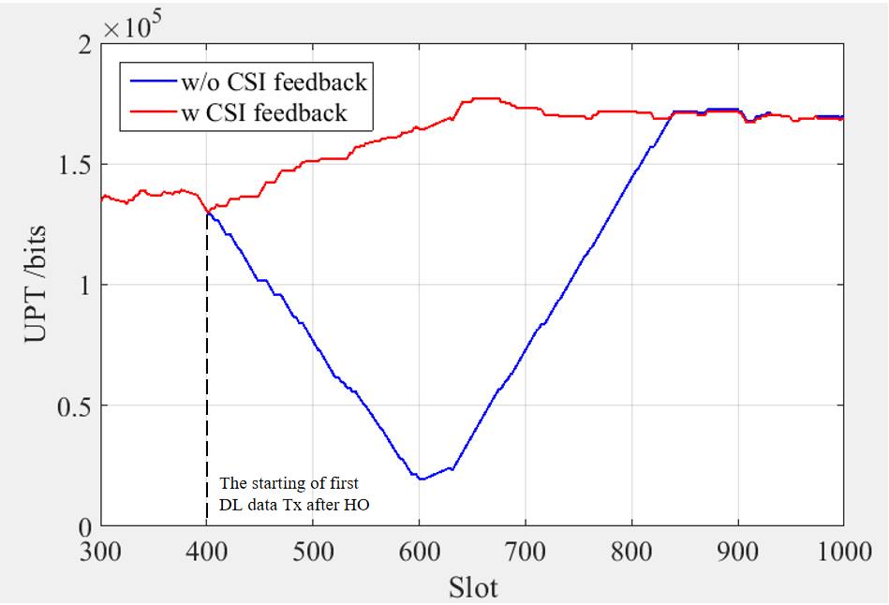
* Potential solution/spec impact
  + At least aperiodic CSI (RI/PMI/CQI) report based on L1 measurement on CSI-RS of candidate cell before cell switch could be supported in Rel-19 LTM
  + Support reporting of CRI, CQI, PMI and RI for a Type I codebook for a candidate cell
  + Do not support the P3 procedure, i.e., measurements on a CSI-RS resource set with repetition on, before the LTM cell switch.
  + Mechanisms to report the CSI information to the relevant candidate cells.
* Concern to introduce this functionality
  + power consumption, gain, UE complexity

**Item 2: Dynamic update of measurement RS or candidate cells to perform L1-measurement (many companies)**

* Justification
  + Reduction of UE measurement overhead to monitor periodic CSI-RS
  + When a UE moves around in a FR2 cell, using RRC signal to update the measurement resource introduces a large latency and eventually leads to LTM Cell switch failure.
* Potential solution/spec impact
  + Dynamically indicating CSI-RS resource(s) or candidate cell(s) to be measured or start to measure only after a certain condition is satisfied or after the reception of measurement indication from the network side.
    - This mechanism is applicable to both gNB configured CSI report and Event-triggered L1 measurement reporting
* Concern to introduce this functionality
  + gNB complexity to manage/send the update indication

**Item 3: Enhancement on TRS in candidate TCI states to enable faster tracking (vivo, DOCOMO, Fujitsu)**

* Justification
  + Faster TRS acquisition, i.e. less interruption time in which throughput is decreased
  + Unnecessary TRS transmission before CSC
* Potential solution/spec impact
  + Aperiodic TRS resource(s) that is the QCL source RS of the indicated TCI state can be triggered by cell switch command
  + Start TRS tracking after the reception of cell switch command
* Concern to introduce this functionality
  + Not identified yet

**Item 4: UL-based measurement (vivo)**

* Justification
  + DL measurement causes a large delay and requires a high computation capability on UE, especially when the number of candidate cells for L1 measurement is large.
* Potential solution/spec impact
  + UL-based measurement by SRS
    - No impact for intra-frequency case
* Concern to introduce this functionality
  + RAN3 impact to exchange the received SRS
  + Coordination of SRS resources, especially when asynchronous case
  + Handling of SRS overhead

**Item 5: Early DL beam management (ETRI)**

* Justification
  + For effective early beam management, both CSI-RS-based downlink beam management and SRS-based uplink beam management should be introduced.
* Potential solution/spec impact
  + Not clear yet
* Concern to introduce this functionality
  + FL view: the overall LTM procedure should be discussed in RAN2 first

**Item 6: Retention of activated candidate TCI states after cell switch (Nokia)**

* Justification
  + In Rel-18, the explicit linkage between a candidate TCI state and the TCI state used for serving cell BM, as well as the retention of activated candidate TCI states, was not supported to ensure flexibility for the network.
* Potential solution/spec impact
  + Indicate whether the UE should assume an explicit linkage between candidate TCI states and BM TCI states of certain candidate cells as part of the LTM configuration.
    - The linkage specifies that candidate TCI states are selected from the candidate cell’s TCI state pool used for BM, with matching configurations (TCI state ID, qcl-Typ1, qcl-Type2, referenceSignal).
  + Upon cell switch to a candidate cell with linkage between candidate TCI states and BM TCI states, the UE should retain activated candidate TCI states.
* Concern to introduce this functionality
  + Constraint to introduce the linkage, which RAN1 couldn’t reach consensus.
  + FL view: In Rel-18, no consensus was achieved (mainly due to the lack of time).

**Item 7: TA acquisition based on CSI-RS (Nokia)**

* Justification
  + Current RACH procedure for LTM is based on SSB. Meanwhile, this can be extended to CSI-RS based operation. However, CSI-RS-based preamble transmission may enable the configuration of narrow beam transmission (by the UE) and reception (at the corresponding candidate cell) for preamble transmission/reception. Similarly, narrow beam and/or larger bandwidth CSI-RS transmission may impact the derivation of Rx timing difference measurements.
* Potential solution/spec impact
  + Not clear yet – proponent requests RAN1 study whether CSI-RS-based RACH procedures and/or CSI-RS-based UE-based TA acquisition should be supported for LTM.
* Concern to introduce this functionality
  + Not clear yet

**Item 8: Autonomous TCI state activation by event triggered report (Ericsson)**

* Justification
  + Reduce the delay caused by TCI-state activation
* Potential solution/spec impact
  + After sending an event-triggered LTM measurement report, the UE will activate the candidate TCI states that are associated with the reference signals in the measurement report.
  + For each measurement target, the UE includes a flag that indicates if the corresponding candidate TCI states are activated.
* Concern to introduce this functionality
  + Not clear yet

##### [FL Observation]

Even though there are a lot of proposal under “other necessary enhancements” in this meeting, FL thinks the only essential feature(s) should be introduced to avoid unnecessary options. Considering this is the very first meeting for Rel-19 LTM, FL would like to encourage the interested companies to assess the potential items until the next meeting.

##### [FL Proposal 5-1-v1]

* The following items are further studied in RAN1 for the potential necessary enhancements in Rel-19 LTM
  + Item 1: CSI acquisition for candidate cell be before cell switch
  + Item 2: Dynamic update of measurement RS or candidate cells to perform L1-measurement
  + Item 3: Enhancement on TRS in candidate TCI states to enable faster tracking
  + Item 4: UL-based measurement
  + Item 5: Early DL beam management
  + Item 6: Retention of activated candidate TCI states after cell switch
  + Item 7: TA acquisition based on CSI-RS
  + Item 8: Autonomous TCI state activation by event triggered report

##### [Comments to FL Proposal 5-1-v1]

|  |  |  |
| --- | --- | --- |
| Company | Comment | FL reply |
| Fujitsu | For the consideration of the aims of the LTM to the reduce the latency, we think the CSI acquisition and the TRS tracking are needed in Rel-19. |  |
| InterDigital | Fine with FL proposal |  |

## LS

### [Paused] LS to RAN2,3 and 4

Paused at this moment