3GPP TSG-CT3 Meeting #135 C3-243382

Hyderabad, India, 27 - 31 May, 2024
CR-Form-v12.2
CHANGE REQUEST
 | 29.514 | CR | 0645 | rev | - | Current version: | 18.5.0
For HELP on using this form: comprehensive instructions can be found at
http://www.3gpp.org/Change-Requests.

Proposed change affects: | UICC apps |  | ME |  | Radio Access Network |  | Core Network | X

Title: | Corrections to TSC user plane node information reporting
Source to WG: | Intel
Source to TSG: | CT3
Work item code: | DetNet |  |  |  |  |  | Date: |  |  | 2024-05-28
Category: | F |  |  |  |  |  | Release: |  |  | Rel-18
 | Use one of the following categories:  F (correction)  A (mirror corresponding to a change in an earlier release)  B (addition of feature),  C (functional modification of feature)  D (editorial modification)  Detailed explanations of the above categories can  be found in 3GPP TR 21.900. |  |  |  |  |  |  |  | Use one of the following releases:  Rel-8 (Release 8)  Rel-9 (Release 9)  Rel-10 (Release 10)  Rel-11 (Release 11)  …  Rel-16 (Release 16)  Rel-17 (Release 17)  Rel-18 (Release 18)  Rel-19 (Release 19)
Reason for change: |  | According to TS 29.512 clause 5.6.2.41 the MTU size for IPv4 and IPv6 is provided by the SMF within the TsnBridgeInfo type:  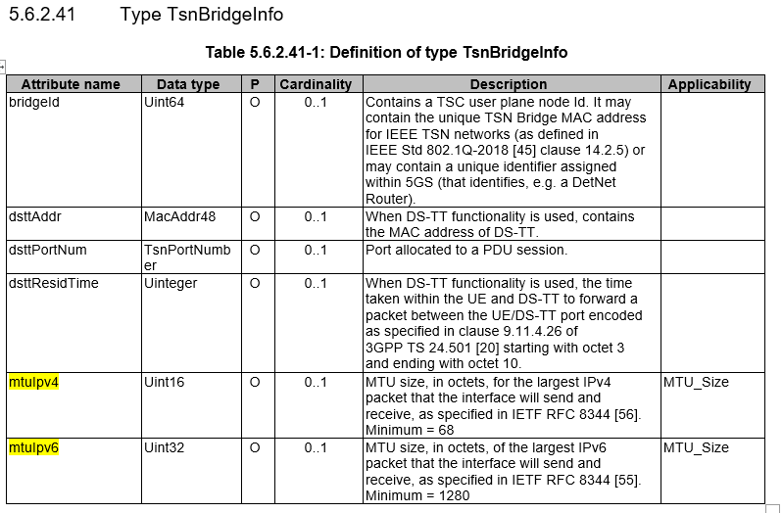  Accordingly, this CR proposes to clarify that the MTU size is included in the "tsnBridgeInfo" attribute as received from the SMF when the PCF provides the TSC user plane node information within PduSessionTsnBridge data type to the TSCTSF.
Summary of change: |  | Clarify that the MTU size is included in the "tsnBridgeInfo" attribute as received from the SMF.
Consequences if not approved: |  | Inconsistent specification.
Clauses affected: |  | 4.2.5.16
 |  | Y | N
Other specs |  |  | X | Other core specifications |  |  |  | TS/TR ... CR ...
affected: |  |  | X | Test specifications |  |  |  | TS/TR ... CR ...
(show related CRs) |  |  | X | O&M Specifications |  |  |  | TS/TR ... CR ...
Other comments: |  | This CR does not introduce any changes to the Open API.
This CR's revision history: |  | Rev1  - Keep the MTU_Size feature  - Clarify that the MTU size is included in the "tsnBridgeInfo" attribute as received from the SMF

* * * First Change * * * *

4.2.5.16 Notification about TSC user plane node Information, no Individual Application Session Context exists
During PDU session establishment of a PDU session enabling Time Sensitive Communications, Time Synchronization and Deterministic Networking, the PCF may receive from the SMF TSC user plane node information as specified in clauses 4.2.2.19 and 4.2.3.23 of 3GPP TS 29.512 [8].
If the "TimeSensitiveNetworking" or "TimeSensitiveCommunication" feature is supported and if the PCF becomes aware that TSC user plane node information for an external network (e.g. TSN) is available, but there is no "Individual Application Session Context" resource bound to the SM Policy Association updated with TSC user plane node related information, the PCF shall inform the NF service consumer (i.e. TSN AF or TSCTSF) about the detection of a TSC user plane node information in the context of a PDU session by sending a notification request:
- to the request URI locally configured in the PCF for the NF service consumer; or
- if the request URI for the TSCTSF is not locally configured in the PCF, to the notification URI registered by the TSCTSF in the NRF as default notification subscription for time sensitive communication, time synchronization and deterministic networking notifications, and retrieved from NRF by the PCF using the discovery service, as specified in 3GPP TS 29.510[27] for the PDU session DNN/S-NSSAI.
NOTE 1: PCF configuration of TSN AF needs to ensure that the notification is addressed to a TSN AF that connects to the same external network the UPF/NW-TT connects to. How it is achieved is implementation specific. It can be based e.g. on dedicated DNN/S-NSSAI combinations or on the received TSC user plane node information.
NOTE 2: It is assumed that there is only one TSCTSF for a given DNN/S-NSSAI in this release of the specification.
Figure 4.2.5.16-1 illustrates the notification about TSC user plane node information when there is no Individual Application Session Context bound to the SM Policy Association.

Figure 4.2.5.16-1: Notification about TSC user plane node Information, no AF session context exists
When the PCF determines that the AF application session context does not exist for the SM Policy Association that detected new port information and a notification URI for the NF service consumer can be determined, the PCF shall invoke the Npcf_PolicyAuthorization_Notify service operation by sending the HTTP POST request (as shown in figure 4.2.5.16-1, step 1) using the notification URI locally configured in the PCF or, retrieved from NRF, and appending the "new-bridge" segment path at the end of the URI, to trigger the NF service consumer (i.e. TSN AF or TSCTSF) to request the creation of an Individual Application Session Context resource to handle the TSC user plane node detected in the context of a PDU session, configuring ports and TSC user plane node management information, and providing the corresponding TSCAI input containers and TSC traffic QoS related data (see clauses 4.2.2.2, 4.2.2.24, 4.2.2.25 and 4.2.2.31).
The PCF shall provide in the body of the HTTP POST request the "PduSessionTsnBridge" data type including TSC user plane node information as follows:
- the "tsnBridgeInfo" attribute as received from the SMF;
- when DS-TT and/or NW-TT functionality is used, the "tsnPortManContDstt" attribute and/or "tsnPortManContNwtts" attribute as received from the SMF, if available;
- in case of Deterministic Networking, for the device side port, and if the "MTU_Size" feature is supported, the MTU size for IPv4 and the MTU size for IPv6 encoded in the "mtuIpv4" and "mtuIpv6" attributes respectively within the "tsnBridgeInfo" attribute as received from the SMF, if available; and
- when the "TimeSensitiveCommunication" feature is supported and for a PDU session of IP type, the UE IPv4 address within the "ueIpv4Addr" attribute or the UE IPv6 prefix within the "ueIpv6AddrPrefix", the DNN within the "dnn" attribute, the S-NSSAI within the "snssai" attribute and, if available, the domain identity within the "ipDomain" attribute if UE IPv4 address is provided.
NOTE 3: In the case of IP overlapping, the DNN, S-NSSAI and domain identity, if available, are required for session binding in the PCF. Domain identity applies as defined in clause 4.2.2.2.
Upon the reception of the HTTP POST request from the PCF, the NF service consumer shall acknowledge that request.
With the received information, the NF service consumer (i.e. TSN AF or TSCTSF) shall immediately trigger the creation of an Individual Application Session Context resource to handle in this association the configuration of the new TSC user plane node in the context of this PDU session, as described in clauses 4.2.2.2, 4.2.2.24, 4.2.2.25 and 4.2.2.31.
NOTE 4: For the time synchronization service, the subscription to UE availability for time-synchronization service can occur after the PDU Session establishment has been completed in 5GS. Similarly, for the AF session with required QoS, the indication of the required QoS and TSC Assistance Container information can occur after the completion of the PDU session establishment. In such cases, the PCF sends the notification to the TSCTSF about the detection of a TSC user plane node information during PDU session establishment, and the TSCTSF could defer the creation of the related "Individual Application Session Context" till the reception of the subscription to UE availability for time synchronization or the AF session with required QoS occurs, as specified in 3GPP TS 29.513[7].
The NF service consumer (i.e. TSN AF or TSCTSF) may use the received TSC user plane node information and/or the received DS-TT port management information container and/or NW-TT port management information containers and the local configuration to construct the DS-TT port and or NW-TT port management information required to interwork with the external network.
* * * End Change * * * *

