3GPP TSG-SA5 Meeting #157 S5-246187
Hyderabad, India, 14 - 18 October 2024
CR-Form-v12.1
CHANGE REQUEST
 | 28.312 | CR | 0249 | rev | 1 | Current version: | 17.7.0
For HELP on using this form: comprehensive instructions can be found at
http://www.3gpp.org/Change-Requests.

Proposed change affects: | UICC apps |  | ME |  | Radio Access Network | x | Core Network | x

Title: | Rel-17 CR TS 28.312 intent definition clarification
Source to WG: | Nokia, Nokia Shanghai Bell
Source to TSG: | S5
Work item code: | TEI17 |  |  |  |  |  | Date: |  |  | 2024-10-03
Category: | F |  |  |  |  |  | Release: |  |  | Rel-17
 | Use one of the following categories:  F (correction)  A (mirror corresponding to a change in an earlier release)  B (addition of feature),  C (functional modification of feature)  D (editorial modification)  Detailed explanations of the above categories can  be found in 3GPP TR 21.900. |  |  |  |  |  |  |  | Use one of the following releases:  Rel-8 (Release 8)  Rel-9 (Release 9)  Rel-10 (Release 10)  Rel-11 (Release 11)  …  Rel-15 (Release 15)  Rel-16 (Release 16)  Rel-17 (Release 17)  Rel-18 (Release 18)
Reason for change: |  | Support for intent definition clarification
Summary of change: |  | Current document talks about the ‘desired state’ a lot. That should also be reflected in the definition.
Consequences if not approved: |  | There is a mismatch between the intent description and rest of the document
Clauses affected: |  | 4.1.1
 |  | Y | N
Other specs |  |  | x | Other core specifications |  |  |  | TS/TR ... CR ...
affected: |  |  | x | Test specifications |  |  |  | TS/TR ... CR ...
(show related CRs) |  |  | x | O&M Specifications |  |  |  | TS/TR ... CR ...
Other comments:
This CR's revision history:

1st Change

4 Concepts and Background

4.1 Intent concept

4.1.1 Introduction
An intent specifies the expectations including requirements, goals and constraints for a specific service or network management workflow. In short, an intent is a statement towards a desired/wanted state of a system. The intent may provide information on particular objective and possibly some related details. Following are some general concepts for intent:
- An intent is typically understandable by humans, and also needs to be interpreted by the machine without any ambiguity.
- An intent focuses more on describing the "What" needs to be achieved but less on "How" that outcomes should be achieved, The intent expresses the metrics that need to be achieved and not how to achieve them. This not only relieves the burden of the consumer knowing implementation details but also leaves room to allow the producer to explore alternative options and find optimal solutions. Intent describes the properties that allows a satisfactory outcome.
- The expectations expressed by an intent is agnostic to the underlying system implementation, technology and infrastructure. Area can be used as managed object in the expectations expressed by an intent to achieve system implementation, technology and infrastructure agnostic.
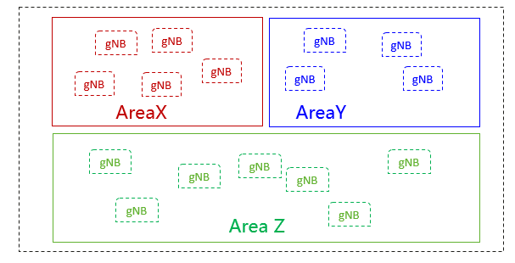
Figure 4.1.1-1
- An intent needs to be quantifiable from network data so that the fulfilment result can be measured and evaluated.
Intent can be categorized based on different user types or different management scenario types.

End of Changes

