**3GPP TSG-SA5 Meeting #157 *S5-246121***

Hyderabad, India, 14 - 18 October 2024

**Source: Rakuten Mobile, Ericsson**

**Title: Add details for termination of a NF deployment instance**

**Document for: Approval**

**Agenda Item: 6.19.6**

# 1 Decision/action requested

***For approval***

# 2 References

[1] 3GPP TR 28.869: “Study on cloud aspects of management and orchestration”.

# 3 Rationale

Fixed the XYZ reference point name and added more details for termination of a NF deployment instance.

# 4 Detailed proposal

It is proposed to make the following changes to TR 28.869 [1].

|  |
| --- |
| **1st change** |

### 5.2.5 Use case #5: Termination of a NF deployment instance

#### 5.2.5.1 Description

In this use case the 3GPP management system interacts with an orchestration and management entity for termination of a NF deployment instance.

A deployed NF deployment instance can be terminated by the 3GPP management system. To terminate a NF deployment instance there is the need to request the termination of the NF deployment instance from the orchestration and management entity.

The 3GPP management system needs to be able to request an orchestration and management entity to terminate a NF deployment instance.

|  |
| --- |
| **2nd change** |

#### 5.2.5.2 Potential requirements

**REQ-LCM-TERMINATE-1** The deployment management reference point should have the capability enabling the 3GPP management system to request termination of a NF deployment instance.

**REQ-LCM-TERMINATE-2** The deployment management reference point should have the capability enabling the orchestration and management entity to inform the 3GPP management system of the result of the request for termination of a NF deployment instance.

|  |
| --- |
| **3rd change** |

##### 5.2.5.3.1 Use of deployment management reference point

In this solution the 3GPP management system interacts with an orchestration and management system using the deployment management reference point as described in clause 5.2.1.3, for termination of a NF deployment instance.

Figure 5.2.5.3.1-1 depicts a high-level view of proposed procedure for termination of a NF deployment instance.

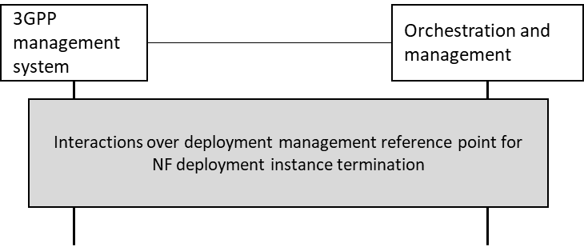

Figure 5.2.5.3.1-1: High level procedure for NF deployment instance termination

The 3GPP management system requests termination of a NF deployment instance from an orchestration and management entity for LCM of NF deployment instances over deployment management reference point, and receives the result of the request for termination of the NF deployment instance from the orchestration and management entity.

Annex F provides an example scenario using interactions with orchestration and management entity for termination of NF deployment instances. If the orchestration and management entity is ETSI NFV MANO, the interactions over deployment management reference point are as specified in clause 7.12 of 28.531 [7].

|  |
| --- |
| **End of changes** |