**3GPP TSG-SA5 Meeting #157 *S5-246119d1***

Hyderabad, India, 14 - 18 October 2024

**Source:** **China Mobile, NTT DOCOMO**

**Title: pCR Add Evaluation of solutions for Cloud-native VNF policy management**

**Document for: Approval**

**Agenda Item: 6.19.6**

# 1 Decision/action requested

***In this box give a very clear / short /concise statement of what is wanted.***

# 2 References

1. 3GPP TR 28.869 v1.0.1 Study on cloud aspects of management and orchestration.

# 3 Rationale

The contribution proposes to add evaluation of solutions for Cloud-native VNF policy management.

# 4 Detailed proposal

It proposes to make the following changes to TR 28.869 [1].

|  |
| --- |
| **1st Change** |

# 5 Use cases, potential requirements, and potential solutions

## 5.1 Use of VNF generic OAM functions

Editor's Note: This clause describes the use cases, issues, requirements, and solutions related to WT-1.

### 5.1.2 Use case #2：Cloud-native VNF policy management

#### 5.1.2.1 Description

3GPP TS 28.555 [12] specifies the concepts, requirements and use cases for network policy management in 5G networks. It is suitable for use cases where 3GPP and MANO interact for policy management (see the policy categories in ETSI GR NFV-IFA 023 [13] Table 6.2.2-1 for details) and lacks support for the cloud native VNFs.

The 3GPP management system needs to implement policy management for cloud-native VNFs, which might be implemented by a Microservice-based architecture. This architecture can split a single application into multiple small services, each of them can run independently. However, it will also bring many challenges, such as a large number of services will have complex dependencies, resulting in complex deployment. In this case, policy management is needed to help improve efficiency.

#### 5.1.2.2 Potential requirements

**REQ-policy-1** The 3GPP management system should have the capability to manage policies for the cloud-native VNFs.

**REQ-policy-2** The reference point between 3GPP management system and external OAM entity should support the capability enabling the 3GPP management system to interact with external (non-3GPP) policy management entities to perform the policy management for cloud-native VNF.

#### 5.1.2.3 Potential solutions

##### 5.1.2.3.1 Policy Agent

As shown in figure 5.1.2.3.1-1, this solution introduces a platform entity that interacts with 3GPP management system for policy management of cloud-native VNFs via a new PaaS reference point.

This solution proposes using the Policy Agent function defined in ETSI GS NFV-IFA 049 [2], which can interact with the VNF generic OAM function, other PaaS Service, and VNFs for assisting on the execution and decision-making of policies.

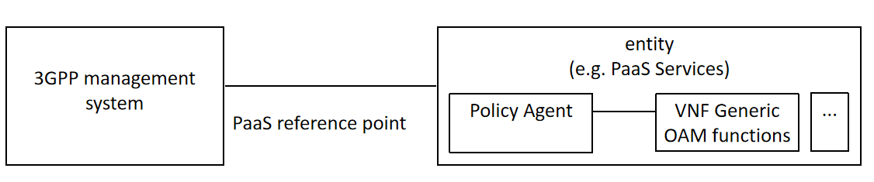

Figure 5.1.2.3.1-1: Potential solution for Cloud-native VNF policy management using the Policy Agent

The solution improves the efficiency in handling policies associated to various entities by interacting with VNF generic OAM functions and other PaaS Services, and enables the 3GPP management system having the capability to manage policies for the cloud-native VNFs with or without interaction with NFV-MANO functions.

The present solution addresses the potential requirement REQ-policy-1 and REQ-policy-2.

#### 5.1.2.4 Evaluation of solutions

The potential solution supports the capability to perform policy management for cloud-native VNFs. It introduces a PaaS reference point and a related platform entity. The advantages of this solution are:

- The Policy Agent enables decoupling the execution and decision-making of policies from the policy enforcement, enabling such an agent to be reusable for executing diverse kinds of policies, e.g., associated to cloud-native VNF or to other management functions.

- The Policy Agent can be associated to cloud-native VNF both as a common function, i.e., associated to the policy of multiple cloud-native VNF, or dedicated function, i.e., associated to a single cloud-native VNF.

The new platform entity resides outside the 3GPP management system, and the solution is compatible, without introducing any major impact, to the 3GPP management system framework. Therefore, the potential solution provided in clause 5.1.2.3.1 is a feasible solution.

The relationship of VNF Generic OAM functions and MnS Provisioning for cloud-native VNF policy management will be investigated during the normative phase.

Editor’s Note: to update the terminology used in this section upon consensus

|  |
| --- |
| **End of Changes** |