**3GPP TSG-SA5 Meeting #157 *S5-246093***

**Hyderabad, India, 14-18 October 2024**

**Source: Huawei**

**Title: pCR TR 28.874 Add plan management solution for NTN scenarios**

**Document for: Approval**

**Agenda Item: 6.19.15**

# 1 Decision/action requested

***The group is asked to discuss and agree on the proposal.***

# 2 References

[1] 3GPP TR 28.874: Study on management aspects of NTN – Phase 2

# 3 Rationale

This contribution proposes to add potential solutions for following use cases:

5.1.1 Use case #1: Connections between RAN node on-board satellite and CN (regenerative mode)

5.1.2 Use case #2: Associations between SectorEquipmentFunction on-board satellite and the RAN nodes (gNB/eNB) on ground (transparent mode)

5.2.1 Use case #1: NTN neighbour cell management

5.2.2 Use case #2: NTN Tracking area management

5.4.1 Use case #1: UE-Satellite-UE Communication via UPFs on-board the satellites

5.5.1 Use case #1: Connectivity between non-terrestrial network node and security gateway

# 4 Detailed proposal

This document proposes the following changes in TR 28.874 [1]

|  |
| --- |
| **1st Change** |

#### 5.1.1.3.X Potential solution #<x>: Pre-configuration based on single time window

To avoid adding time window for each IOC (e.g., EP_NgC, EP_N2, EP_RP_EPS, NRCellCU, NRCellDU), the pre-configuration can be done based on signle time window which covers all MOIs that are valid/activated during this time window.

Following is one example to illustrate valid instances for different time windows.

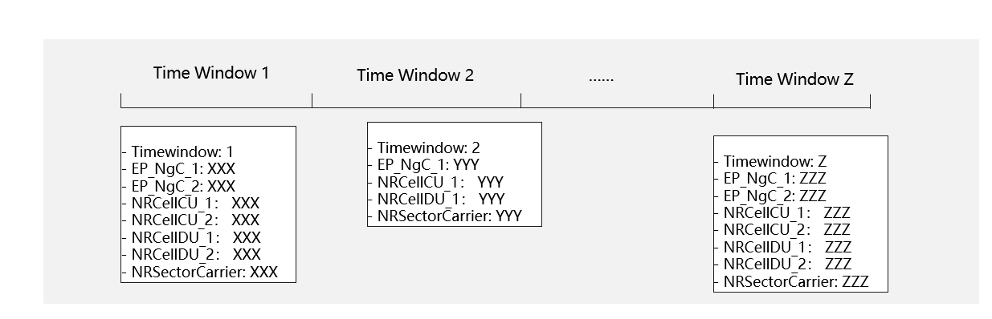

**Figure 5.1.1.3.x-1: Example to illustrate valid instances for different time windows.**

In this use case, instances of EP_NgC, EP_N2, EP_RP_EPS, NRCellCU, NRCellDU can be configured into different time windows. A new IOC may be introduced to capture configurations as under certain time window.

|  |
| --- |
| **Next Change** |

#### 5.1.2.3.y Potential solution #<y>: Pre-configuration based on single time window

The solution for NTN pre-configuration based on single time window can refer to description in clause 5.1.1.3.X.

In this use case, different instances of NRSectorCarrier can be configured as valid for different time windows.

|  |
| --- |
| **Next Change** |

#### 5.2.1.3.z Potential solution #<z>: Pre-configuration based on single time window

The solution for NTN pre-configuration based on single time window can refer to description in clause 5.1.1.3.X.

In this use case, different instances of NRSectorCarrier can be configured as valid for different time windows.

|  |
| --- |
| **Next Change** |

#### 5.2.2.3.a Potential solution #<a>: Pre-configuration based on single time window

The solution for NTN pre-configuration based on single time window can refer to description in clause 5.1.1.3.X.

In this use case, different instances of NRSectorCarrier can be configured as valid for different time windows.

|  |
| --- |
| **Next Change** |

#### 5.4.1.3.c Potential solution #<c>: Pre-configuration based on single time window

The solution for NTN pre-configuration based on single time window can refer to description in clause 5.1.1.3.X.

In this use case, different instances of NRSectorCarrier can be configured as valid for different time windows.

|  |
| --- |
| **Next Change** |

#### 5.5.1.3.b Potential solution #<b>: Pre-configuration based on single time window

The solution for NTN pre-configuration based on single time window can refer to description in clause 5.1.1.3.X.

In this use case, different instances of NRSectorCarrier can be configured as valid for different time windows.

|  |
| --- |
| **End of changes** |