3GPP TSG-SA WG4 Meeting #128 S4-241014

South Korea, Jeju, 20 – 24 May 2024

Source: Nokia Corporation
Title: [FS_5G_RTP_Ph2] Sol KI#8: RTP retransmission aware PDU Set handling
Agenda item: 10.8
Document for: Agreement

Introduction
In the RTC SWG telco on May 6, the key issue #8 on RTP retransmission for supporting XR services in 5G was described in S4aR240035. An introduction to RTP retransmission payload format and its usage in WebRTC was provided in S4aR240032.
One aspect proposed to study within KI#8 is:
- If and how awareness of RTP retransmission can benefit PDU Set based QoS handling in the network.
This contribution describes how awareness of RTP retransmission can benefit PDU Set based QoS handling and proposes a solution for achieving RTP retransmission awareness in the 5G network.

Proposal
A solution to KI#8 is proposed for incorporation into TR 26.822.

======================= CHANGE 1 (all new) =============================

6.X Solution #X: RTP retransmission aware PDU Set handling

6.X.1 Key Issue mapping
This solution addresses the key issue #8.

6.X.2 Description

RTP retransmission is negotiated and configured end-to-end between the sender and the receiver. However, currently, there is no mechanism to indicate to the 5G network whether RTP retransmission is performed and, if yes, how it is configured.

When PDU Set based handling is used, this may lead to suboptimal operation since the 5G network cannot configure the network operations like buffering, scheduling, packet discarding in a way that would benefit from awareness of RTP retransmission. For example, in case of momentary congestion, the RAN could have a higher preference for discarding packets from applications that use retransmission considering that the discarded packets will be retransmitted by the application hopefully within a non-congested period (and assuming that the packet is still found in the sender application buffer).
In this solution, the sender indicates to the network that it has successfully negotiated the use of RTP retransmission with the receiver, and thus retransmissions can take place during the session. The indication can be sent via control plane signalling e.g. in the Protocol Description signalled by the AF.

Differentiated configuration of PDU Set QoS parameters

According to RFC 4588, original packets and retransmission packets are carried in different RTP streams, either in the same RTP session or in different RTP sessions. When PDU Set handling is used, PDU Set QoS parameters can be set for each RTP stream by the AF.

PDU Set QoS parameters applied to retransmission streams can benefit from differentiated configuration. For example, the retransmission stream may be assigned a shorter PDU Set Delay Budget (PSDB) so that it becomes more likely that the retransmitted packets reach the receiver before the playout deadline of the media unit they are associated to.
NOTE: It is assumed that the retransmitted PDUs and original PDUs are placed in PDU Sets mapped to different QoS flows such that different PDU Set QoS parameters can be applied.

Modified PDU Set marking for retransmitted PDUs

When PDU Set handling is used, RTP senders can insert the RTP HE for PDU Set marking (defined in TS 26.552 clause 4.2) to outgoing RTP packets in order to add the PDU Set Information. However, for retransmitted PDUs, some of the data fields present in the RTP HE for PDU Set marking may not be necessary.

The two optional fields in the RTP HE for PDU Set marking are the PDU Set Size (PSSize) and the Number of PDUs in the PDU Set (NPDS).

PSSize is intended to be used by the RAN for allocation of scheduling resources efficiently to PDU Sets. Until a retransmitted PDU is delivered, most or all of the other original PDUs in a PDU Set will have been transmitted. Therefore, a retransmitted PDU does not need to be marked with PSSize, since this information would no longer provide any benefit to the network.

NPDS is intended to be used by the UPF to correct the PSSize calculation, in case a NAT64/NAT46 conversion has occurred in the network path changing the IP header size and thus invalidated the PSSize calculated at the sender. Thus, NPDS is similarly not necessary once all or most of the original PDUs in a PDU Set have been transmitted.

Among the mandatory fields, the PDU Sequence Number within a PDU Set (PSN) is not necessary for a retransmitted PDU since this information would not provide a correct ordering information in case of a retransmitted PDU.

The End of Data Burst (D) field is maintained since a data burst may contain PDUs from both the original and the retransmission stream and the last PDU of a data burst may correspond to a retransmitted PDU.

The PDU Set Sequence Number (PSSN) is maintained since this field allows the network to identify to which PDU Set a retransmitted PDU belongs and thus allows the network to determine whether the entire PDU Set (including the retransmitted PDU) can be delivered on time. For example, the network may estimate the delivery time for the retransmitted PDU and determine whether the transmission time for the entire PDU Set is still within the PSDB. If not, there might be no point of delivering the retransmitted PDU since the playout deadline will likely be missed.

The PDU Set Importance (PSI) field is maintained since retransmitted PDUs may also be subjected to PSI-based packet discarding in case of congestion. However, for differentiated handling of retransmitted PDUs, it could be beneficial to also indicate in the RTP HE whether the marked PDU is a retransmitted PDU. For example, if the network receives two PDUs with the same PSI value and one of them is a retransmitted PDU, that one may be considered to have higher importance and be treated more favorably in terms of resource allocation and scheduling.

NOTE: Lonely PDUs may also benefit from a more compact RTP HE for PDU Set marking since parts of the RTP HE for PDU Set marking defined in TS 26.522 such as PSSN, PSN, PSSize and NPDS may not be useful for the network in case of lonely PDUs.

An example implementation of the modified RTP HE for PDU Set marking for retransmitted PDUs is shown in Figure A. The flag indicating that the marked PDU is a retransmitted one is denoted by “X”.

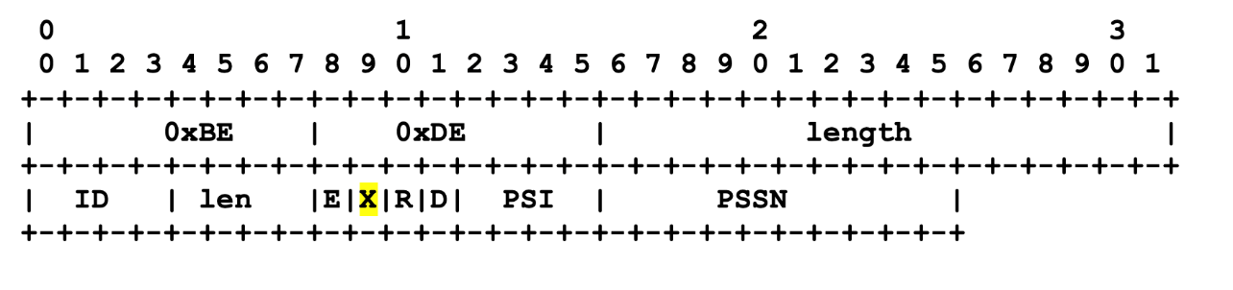
Figure A. Modified RTP HE for PDU Set marking for retransmitted PDUs.

Editor’s Note: This solution requires coordination with SA2 and RAN2.

