3GPP TSG-S4 Meeting # 128 S4-240925
Jeju, Korea, May 20th - 24th, 2024
CR-Form-v12.2
CHANGE REQUEST
 | 26.510 | CR |  | rev |  | Current version: | 1.2.3
For HELP on using this form: comprehensive instructions can be found at
http://www.3gpp.org/Change-Requests.

Proposed change affects: | UICC apps |  | ME | X | Radio Access Network |  | Core Network | X

Title: | pCR on Updates to Dynamic Policy client API
Source to WG: | Qualcomm Inc.
Source to TSG: | S4
Work item code: | 5GMS_Pro_Ph2 |  |  |  |  |  | Date: |  |  | 14th May 2024
Category: | B |  |  |  |  |  | Release: |  |  | Rel-18
 | Use one of the following categories:  F (correction)  A (mirror corresponding to a change in an earlier release)  B (addition of feature),  C (functional modification of feature)  D (editorial modification)  Detailed explanations of the above categories can  be found in 3GPP TR 21.900. |  |  |  |  |  |  |  | Use one of the following releases:  Rel-8 (Release 8)  Rel-9 (Release 9)  Rel-10 (Release 10)  Rel-11 (Release 11)  …  Rel-16 (Release 16)  Rel-17 (Release 17)  Rel-18 (Release 18)  Rel-19 (Release 19)
Reason for change: |  | The client API for the dynamic policy is not properly specified. The activation and usage of the BDT should be part of the dynamic policy activation over that API.
Summary of change: |  | integration of BDT in the dynamic policy client API.
Consequences if not approved:
Clauses affected: |  | 10.2.2.1, 10.3
 |  | Y | N
Other specs |  |  | x | Other core specifications |  |  |  | TS/TR ... CR ...
affected: |  |  | x | Test specifications |  |  |  | TS/TR ... CR ...
(show related CRs) |  |  | x | O&M Specifications |  |  |  | TS/TR ... CR ...
Other comments:
This CR's revision history:

Background
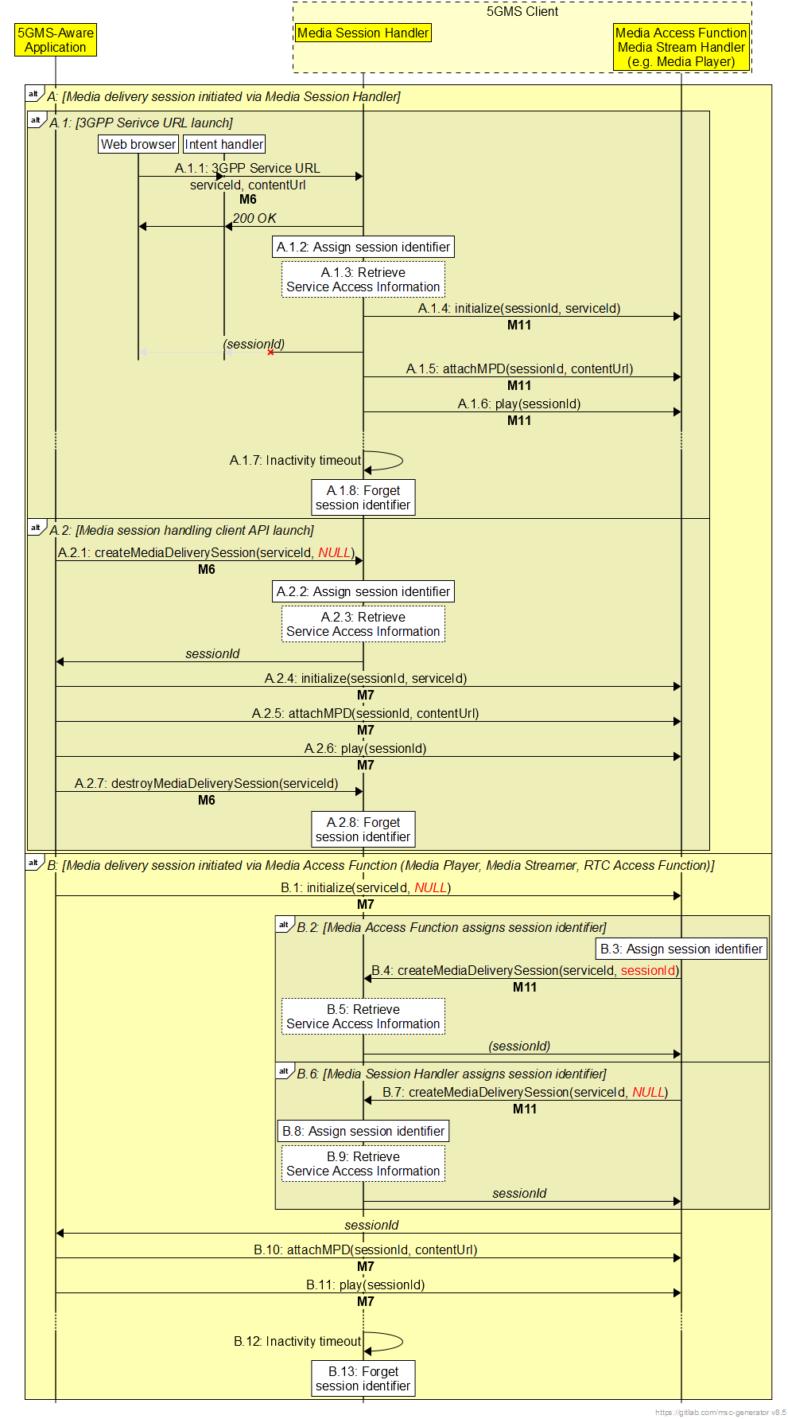

First Change

10.2.2.1 Creating a media delivery session

A 3GPP Service URL (see clause 6) may be used to implicitly trigger the creation of a new media delivery session with the Media Session Handler.
The Media Session Handler also offers the explicit createMediaDeliverySession() method, which is used to create a new media delivery session in the Media Session Handler.
The input parameters of the method are specified in table 10.2.2.1-1:
Table 10.2.2.1-1: Input parameters for createMediaDeliverySession() method
Name | Type | O | Description
serviceId | string | M | The external service identifier (see table 8.2.3.1-1) of the Provisioning Session that this media delivery session pertains to.
sessionId | string | O | A media delivery session identifier nominated by the method invoker.  If omitted, the Media Session Handler shall assign a media delivery session identifier.
domainName | string | M | The Fully-Qualified Domain Name (FQDN) of the Media AS endpoint supporting the media delivery session at reference point M4.
accessToken | string | O | An access token that the Media Session Handler presents to the Media AF to authorise invocation of media session handling operations at reference point M5.

Upon success, if the sessionId parameter was omitted, the Media Session Handler shall allocate a media delivery session identifier to uniquely identify the media delivery session in the Media Delivery System.
The return value of the method is specified in table 10.2.2.1-2.
Table 10.2.2.1-2: Return value for createMediaDeliverySession() method
Type | Description
string | The media delivery session identifier assigned by the Media AF.

2nd Change

10.3 Dynamic Policy client API

10.3.1 Dynamic Policy methods

10.3.1.1 Retrieve Background Data Transfer information
The getBDTInfo() method is used to retrieve information about the next Background Data Transfer opportunity window at one of the Service Operation Points that are available in the context of a particular media delivery session.
The input parameters of the method are specified in tables 10.3.1.1-1.
Table 10.3.1.1-1: Input parameters for getBDTInfo() method
Name | Type | Description
sessionId | string | The media delivery session identifier (as specified in clause 7.3.2) of an initialised media delivery session in the Media Session Handler.
serviceOperationPointReference | string | The external reference identifier of a Service Operation Point that uniquely identifies a Policy Template within the context of sessionId.

The return value of the method is specified in table 10.3.1.2-1.
Table 10.3.1.2-1: Return value for getBDTInfo() method
Type | Description
object | Information about a Background Data Transfer opportunity.  The object shall contain the time window start and end times and the maximum allowed data volume in bytes.

10.3.1.2 Activate Dynamic Policy
The activatePolicy() method is employed to request the application of a dynamic policy that is configured at the Media Session Handler to a media delivery session. The scope of the dynamic policy is all application flows that match the application identifier or Media AS domain name declared when the media delivery session was created (see table 10.2.2.1 1). The application may also provide the estimated transfer volume if the media delivery session is expected to be within the bounds of a Background DataTransfer time window. The Media Session Handler conveys the request to the Media AF and provides the corresponding response to the invoker of the method. The input parameters of the method are specified in table 10.3.1.2-1.
Table 10.3.1.2-1: Input parameters for activatePolicy() method
Name | Type | Optionality | Description
sessionId | string | M | The media delivery session identifier (as specified in clause 7.3.2) of an initialised media delivery session in the Media Session Handler.
serviceOperationPointReference | string | M | The external reference identifier of a Service Operation Point that uniquely identifies a Policy Template within the context of sessionId.
estimatedTransferVolume | integer | C | The estimated volume of data to be transferred, expressed in bytes.  Minimum value 1 byte.  Required to be populated when the Policy Template corresponding to the referenced Service Operation Point declares a Background Data Transfer policy.

The return value of the method is specified in table 10.3.1.2-2.
Table 10.3.1.2-2: Return value for activatePolicy() method
Type |  | Description
object
 | recommendedDownlinkBitRate | The recommended downlink bit rate for the requested Service Operation Point.
 | recommendedUplinkBitRate | The recommended uplink bit rate for the requested Service Operation Point.
 | backgroundDataTransferActivated | Indicates whether Background Data Transfer has been successfully activated for the media delivery session for the duration of the indicated time window.

Table 10.3.2-2 provides a list of general notification events exposed by the Media Session Handler.
Table 10.3.2-2: Notification Events relating to Dynamic Policies
Event | Definition | Payload
POLICY_ACTIVATED | Triggered when a new Dynamic Policy is successfully activated for the media delivery session. | Media delivery session identifier,  Recommended downlink bit rate,  Recommended uplink bit rate.
POLICY_DEACTIVATED | Triggered when the Dynamic Policy for this media delivery session is deactivated. | Media delivery session identifier.
BACKGROUND_DATA_TRANSFER_OPPORTUNITY | Triggered when a new Background Data Transfer opportunity window opens. | Media delivery session identifier,  Service Operation Point reference,  Opportunity windows start date–time,  Opportunity windows end date–time,  Data volume quota,  Maximum uplink bit rate,  Maximum downlink bit rate.

Table 10.3.3-3 provides a list of general error events exposed by the Media Session Handler.
Table 10.3.2-3: Error Events relating to Dynamic Policies
Status | Definition | Payload
ERROR_INVALID_‌SERVICE_‌OPERATION_‌POINT | Triggered when the provided Service Operation Point reference is not valid for the media delivery session. | Media delivery session identifier,  Service Operation Point reference.
ERROR_UNAUTHORISED | Triggered when the application is not authorised to instantiate a dynamic policy for the provided Service Operation Point reference. | Media delivery session identifier,  Service Operation Point reference.
ERROR_BACKGROUND_DATA_TRANSFER | Triggered when there is an error during a Background Data Transfer, for example if it is cancelled before the end of the advertised opportunity window. | Media delivery session identifier,  Error reason.

