3GPP TSG-RAN WG4 Meeting #111 R4-241XXX
Fukuoka City, Fukuoka, Japan, 20th – 24th May, 2024

Agenda item: 7.19.4
Source: Moderator (Samsung)
Title: Ad-hoc minutes for [111][328] NR_MIMO_evo_DL_UL_demod
Document for: Aprroval

Discussion
For BS side
Issue 2-1-1: Minimum requirements for tests need to be defined for Rel-18 DMRS
- Proposals
  - Option 1: Use the new simulation results to define requirements for BS Demodulation of Rel-18 DMRS (Nokia, Ericsson, Samsung)
  - Option 2: Reuse legacy value to define requirements for BS Demodulation of Rel-18 DMRS. (Huawei, Samsung as compromise)
- Recommended WF
  - Is Option 2 agreeable?

For UE side
Issue 1-2-1: Test metric of TypeII-CJT-r18 codebook
- Proposals
  - Option 1: 1.8 for both 2Rx and 4Rx case (Nokia, Ericsson)
  - Option 2: 2.3 for both 2Rx and 4Rx case (Samsung)
  - Option 3: 1.6 for both 2Rx and 4Rx case (Huawei)
  - Option 4: 1.7 for 2Rx case, 1.6 for 4Rx case (MTK)
- Recommended WF
  - Based on companies simulation results, is Option 1 agreeable?
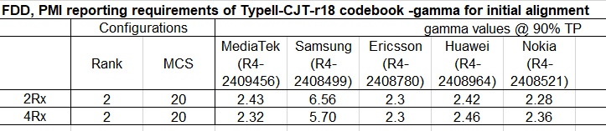

Issue 1-1-2: Test metric of TypeII-Doppler-r18 codebook
- Proposals
For FR1 TDD:
  - Option 1: 4.0 for 2Rx case, and 3.5 for 4Rx case. (Ericsson)
  - Option 2: 3.6 for 2Rx case, and 5.6 for 4Rx case. (Samsung)
  - Option 3: 1.15 for both 2Rx and 4Rx (Huawei)
  - Option 4: 4.2 for 2Rx case, and 3.9 for 4Rx case. (MTK)
- Recommended WF
  - Based on the latest simulation results, is there any possible to define 2.7 for TDD case?
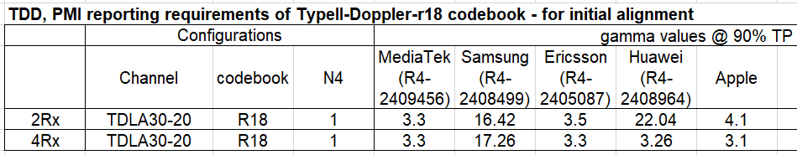

Issue 1-1-3: Test setup for FR1 FDD case of TypeII-Doppler-r18 codebook
- Proposals
  - Option 1: Propose to use only 2 first allocated PDSCH slots, like in TDD, to improve prediction accuracy (MTK)
- Recommended WF
  - More discussion needed

Issue 1-1-2: Test metric of TypeII-Doppler-r18 codebook
- Proposals
For FR1 FDD:
  - Option 1: 1.9 for 2Rx case, and 2.0 for 4Rx case (Apple)
  - Option 2: 2.0 for both 2Rx and 4Rx (Ericsson)
  - Option 3: 2.4 for 2Rx case, and 3.4 for 4Rx case. (Samsung)
  - Option 4: 1.15 for both 2Rx and 4Rx (Huawei)
  - Option 5: 1.4 for 2Rx, and 1.6 for 4Rx, if keep current configuration (MTK)
- Recommended WF
  - Based on the latest simulation results, is there any possible to define 1.8 for TDD case?
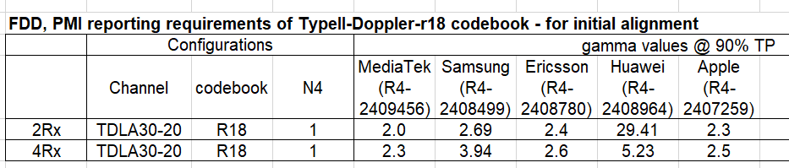

Issue 1-1-7: explicitly define for clarification what “equal probability of each applicable i₁, i₂ combination”
- Background: we have below agreement on RAN4#110 meeting
Agreement:
- Explicitly define random precoding frequency domain granularities as random i₁ with wideband granularity and random i₂ with subband granularity with ‘typeII-Doppler-r18’ and ‘typeII-CJT-r18’ codebook.
- Proposals
  - Option 1: clarify granularity more clearly as below (MTK)
PDSCH & PDSCH DMRS Precoding configuration for random Precoding |  | Single Panel Type I, Random precoder selection updated per slot, with equal probability of each applicable i1, i2 combination  (i1 with wideband granularity and i2 with subband granularity)

- Recommended WF
  - Is Option 1 agreeable?

Issue 1-1-4: Timing mismatch between the prediction reference and precoder usage in PDSCH transmission
- Proposals
  - Option 1: RAN4 to send LS to RAN1 to request update to specification with extended delta parameter options. (Nokia, MTK)
  - Option 2: No need to send LS to RAN1 and RAN2 as the timing mismatch problem between the prediction reference and precoder usage in PDSCH transmission could be solved. (Samsung)
- Observation: Configure the maximum δ value and maximum N4 value could benefit for solving the timing mismatch problem between the prediction reference and precoder usage in PDSCH transmission.
- Observation: RAN1 has already discussed the higher δ value options in RAN1#110bis-e, RAN1#111 and RAN1#112 meetings. The δ value options are narrowed down from {0, 1, 2, 3, 4, 5, 6, 8} to {0, 1, 2} through rounds of discussions.
- Recommended WF
  - More discussion needed

draft CRs and CRs
Draft CR number | Source | Proposals / Observations
R4-2407260  Return to | Apple | DraftCR for Applicability of requirements for MIMO Evo
R4-2407261  Return to | Apple | DraftCR for FRCs for rank 4 requirements with eDMRS
R4-2407756  revised | Nokia | Draft CR for 38.101-4 on PMI req for typeI-CJT-r18 for FR1 FDD
R4-2408500  revised | Samsung | Draft CR on combinations of channel model parameters (Table B.2.2-1: Channel model parameters for FR1)
R4-2408502  revised | Samsung | Big CR for UE demodulation and CSI requirements for Rel-18 MIMO in 38.101-4
R4-2408965  revised | Huawei, HiSilicon | Draft CR on PMI reporting requirements of typeII-doppler-r18 for FR1 (TS38.101-4, Rel-18)
R4-2407137  revised | Nokia | [NR_MIMO_evo_DL_UL-Perf] Draft CR for TS 38.141-1 on PUSCH manufacturer declaration and test applicabilty
R4-2408966  revised | Huawei, HiSilicon | BigCR for BS conformance testing for Rel-18 MIMO (TS38.141-1, Rel-18)
R4-2408967  revised | Huawei, HiSilicon | Draft CR on performance requirements for PUSCH with enhanced DMRS (TS38.141-2, Rel-18)
R4-2409479  revised | Samsung | Draft CR on PUSCH performance requirements with enhanced DMRS in 38.104
R4-2409480  revised | Samsung | Big CR for BS demodulation requirements for Rel-18 MIMO in 38.104

