3GPP TSG-RAN WG4 Meeting # 111 TDoc R4-24xxxxx
Fukuoka, Japan, May 20 – May 24, 2024

Title: LS on delta parameter options extension for predicted PMI
Response to:
Release: Rel-18
Work Item: NR_MIMO_evo_DL_UL-Perf

Source: RAN WG4
To: RAN WG1
Cc: RAN WG2

Contact person: Hannu Vesala, hannu.vesala@mediatek.com

Send any reply LS to: 3GPP Liaisons Coordinator, mailto:3GPPLiaison@etsi.org

Attachments:

1 Overall description
Within the Release 18 work item on NR MIMO evolution (NR_MIMO_evo_DL_UL), RAN4 has studied possible test configurations for Enhanced Type II codebook for predicted PMI. RAN4 has agreed test configurations in RAN4#110-bis meeting in April 2024 and corresponding timing diagrams are shown in Figure 1 and Figure 2.
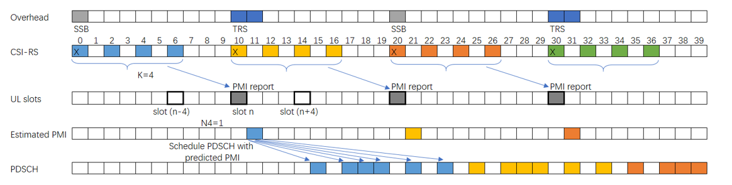
Figure 1: RAN4 agreed FDD test timing.
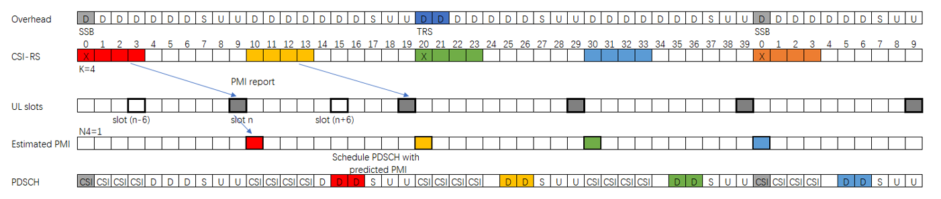
Figure 2: RAN4 agreed TDD test timing.
Based on RAN4’s evaluation, RAN4 observes that delta parameter used to UE PMI prediction timing (“Estimated PMI” in Figures) defined in RAN1 (TS38.214) and RAN2 (TS38.331) cannot match actual precoder usage timing for PDSCH due to limited options {m0, n0, n1, n2}.
typeII-Doppler-r18 SEQUENCE {
n1-n2-codebookSubsetRestriction-r18 CBSR-r18,
paramCombination-Doppler-r18 INTEGER (1..9),
td-dd-config-r18 TD-DD-Config-r18,
numberOfPMI-SubbandsPerCQI-Subband-r18 INTEGER(1..2),
predictionDelay-r18 ENUMERATED {m0,n0,n1,n2 },
typeII-RI-Restriction-r18 BIT STRING (SIZE (4))

predictionDelay
Prediction delay for Doppler and Doppler port selection codebooks see TS 38.214 [19], Clause 5.2.1.4. The first value m0 means that the first slot for which the CSI corresponds to is the slot where the CSI reference resource is located at.
For the other three candidate values (n0, n1, n2), then the first slot for which the CSI corresponds to is given by l= n+delta, where delta can take on values of 0, 1, 2 and n the slot in which CSI is reported.

RAN4 sees a mismatch causing suboptimal UE performance of predicted PMI. Therefore, RAN4 would like to inform RAN1 that to improve UE performance by solving timing mismatch and to allow network higher configuration flexibility, extending delta parameter options with larger values could be considered.

2 Actions
To RAN WG1
ACTION:
RAN4 kindly request RAN1 to take the above RAN4 evaluations into account.

3 Dates of next RAN WG 4 meetings
TSG RAN WG4 Meeting #112 19th – 23rd Aug. 2024 Maastricht, Netherlands
TSG RAN WG4 Meeting #112-bis 14th – 18th Oct. 2024 TBC, China

