3GPP TSG-RAN WG4 Meeting # 111 R4-240xxxx
Fukuoka, Japan, May 20 - 24, 2024

Agenda item: 10.14.5
Source: Moderator (Huawei)
Title: Topic summary for [111][314] NR_LPWUS
Document for: Information

Introduction
This contribution summarizes the documents that are submitted to agenda 10.14.3 for RAN4#111 and it concentrates on the following aspect.
- Topic #1: On BS RF requirements for LP-WUS/WUR

Topic #1: On the BS RF requirement for LP-WUS

Companies’ contributions summary
T-doc number | Company | Proposals / Observations
R4-2407440 | Nokia | Proposal 1: To decide on the applicable BS types after the applicable frequency range and bands for LP-WUS have been decided.  Proposal 2: To consider the power degradation of RBs other than LP-WUS signal within the carrier after the number of LP-WUS RBs have been decided in RAN1.  Proposal 3: To allow BS manufacturer to declare the supported LP-WUS power boosting level in the manufacturer declarations for BS supporting LP-WUS operation, and the power boosting levels allowed to be declared by BS manufacturer can be further discussed.
R4-2407547 | CATT | Observation 1: For NB-IoT, the power dynamic range is roughly equal to the EPRE ratio between NB-IoT and NR.  Observation 2: Due to a larger occupancy of bandwidth, the power dynamic range of LP-WUS varies with NR channel bandwidth for a given EPRE ratio between LP-WUS and NR signal.  Proposal 1: RAN4 to specify requirements of EPRE ratio between LP-WUS and NR signals instead of power dynamic range.  Proposal 2: RAN4 not to set a restriction on applicable BS types for LP-WUS.  Observation 3: Significant power degradation is observed for some configurations representing by (EPRE ratio, channel bandwidth).  Proposal 3: RAN4 to consider a power degradation limit, e.g., 2dB, for validating a configuration for LP-WUS representing by (EPRE ratio, channel bandwidth).  Proposal 4: BS power boosting requirements should be satisfied by a BS supporting LP-WUS.
R4-2407653 | Huawei, HiSilicon | Proposal 1: Similar definition of power boosting as that for NB_IoT should be adopted for LP-WUS.  Observation 1: Power boosting of LP-WUS could have big impact on small CBW.  Proposal 2: FFS whether LP-WUS power boosting, if supported, should be only considered for larger CBWs, e.g. >20MHz.  Proposal 3: Consider BS type 1-C as applicable type to further discuss of LP-WUS power boosting. FFS other BS types.  Proposal 4: Manufacturer declaration should be considered at least in the conformance test spec if LP-WUS power boosting is supported. FFS whether 3dB as minimum requirement is feasible in conjunction with consideration of supported CBWs. FFS whether cap should be considered for sake of less impact on legacy NR coverage.  Proposal 5: Besides dynamic range requirement, not all transmitter requirements should be specified for the scenario where LP-WUS in embedded in a NR carrier. FFS which Tx requirements should be considered for LP-WUS.  Proposal 6: Unwanted emissions requirements of SEM and spurious emissions should be considered for transmitted signal with LP-WUS and NR in the same carrier.  Proposal 7: FFS whether transmitted signal quality requirements should be defined for LP-WUS, at least for the EVM requirement.
R4-2407895 | Samsung | Observation 1: It is necessary for UE to obtain the power level difference between LP-SS and SSB from the base station to support RRM measurement offloading from MR to LR for UE serving cell.  Proposal 1: power boosting feature can be declaration based as long as there are schemes for UE to obtain the power level difference between LP-SS and SSB. The detailed schemes can be further studied.
R4-2407956 | CMCC | Proposal 1: All the BS types should be supported by LP-WUS.  Proposal 2: it’s suggested to also define multi-band requirements at gNB side for LP-WUS.  Proposal 3: reducing NR signal PSD to some large extent is not allowed. RAN4 should take the affected NR PSD factor into considering when determining final power boosting value.  Proposal 4: considering the benefits that power boosting could improve the WUS signal coverage, power boosting could be supported with at least 3dB boosting level.  Proposal 5: for power boosting larger than 3dB, BS manufacturer could declare boosting level for LP-WUS.
R4-2408112 | vivo | Proposal 1: RAN4 should discuss how to link current RE power control dynamic range in TS 38.104 to this new concept, whether the up value in TS 38.104 Table 6.3.2.2-1 can be applied.  Proposal 2: RAN4 should focus on FR1 licensed bands for BS RF requirements.  Proposal 3: Before concluding the feasibility of 5MHz CBW, BS power boosting discussion could focus on BS CBW ≥10MHz.  Proposal 4: RAN4 can consider different power boosting level for different BS CBW.
R4-2408365 | ZTE | Proposal 1: Keep current concept of LP-WUS dynamic range/power boosting for later discussion: The LP-WUS RB power dynamic range (or LP-WUS power boosting) is the difference between the average power of LP-WUS REs (which occupy certain REs within a NR transmission bandwidth configuration and the average power over all REs (from both LP-WUS and the NR carrier containing the LP-WUS REs).  Proposal 2: Set the LP-WUS power boosting a complete manufacture declaration feature, including whether supporting LP-WUS power boosting and the supported boosting level.  Proposal 3: RAN4 needs to discuss which type of BS is able to support LP-WUS with some level of power boosting.
R4-2409099 | Ericsson | Observation 1: 3 dB power boosting is possible if CP-OFDM symbol used for LP-WUS generation is QPSK modulation.  Observation 2: 3 dB power boosting is applied to BS type 1-C, 1-H and 1-O.  Observation 3: No test model for power boosting is defined for FR2 and power boosting capability cannot be assumed for FR2 BS.  Proposal 1: Limit the power boosting for LP-WUS to 3 dB for BS type 1-C, 1-H and 1-O.  Proposal 2: RAN4 confirm the power saving gain of WUR for FR2 before starting work on FR2.  Proposal 3: RAN4 should allow dynamic range requirements based on existing specification for OOK-1 waveform.  Proposal 4: The power boosting of the LP-WUS is up to manufacture declaration.

Open issues summary

Sub-topic 1-1 On dynamic range for LP-WUS
Issue 1-1: Manufacture declaration on LP-WUS
- Proposals
  - Option 1: Set the LP-WUS power boosting a complete manufacture declaration feature, including whether supporting LP-WUS power boosting and the supported boosting level. (Nokia, ZTE)
  - Option 2: Minimum power boosting level in core specification together with manufacturer declaration in the conformance test specification. (Huawei)
  - Option 3: Manufacturer declaration with minimum power boosting level [3] dB. (CMCC)
  - Option 4: Others.

- Recommended WF
  - TBA

Issue 1-2: Concept of LP-WUS dynamic range/power boosting
- Proposals
  - Option 1: Stick with the one in RAN4#110bis approved WF R4-2406140. (ZTE, Huawei)
    - The LP-WUS RB power dynamic range (or LP-WUS power boosting) is the difference between the average power of LP-WUS REs (which occupy certain REs within a NR transmission bandwidth configuration and the average power over all REs (from both LP-WUS and the NR carrier containing the LP-WUS REs).
  - Option 2: Define EPRE ratio between LP-WUS and NR signals instead of power dynamic range. (CATT)
Moderator: Followings are reproduced from R4-2407547 for information
Mathematically, suppose the number of PRBs is N_{RB} for the whole NR carrier, of which N_{LP_RB} is occupied by LP-WUS, and further let’s denote β_{EPRE} as the energy per RE for none LP-WUS REs, and β_{EPRE_LP} is the energy per RE for LP-WUS REs, then the power dynamic range for LP-WUS δ_{LP} can be expressed as the following equation:
$δ_{LP}=\frac{N_{RB}∙β_{EPRE_{LP}}/β_{EPRE}}{N_{LP_RB}∙β_{EPRE_LP}/β_{EPRE}+{(N}_{RB}-N_{LP_RB})}$=$\frac{N_{RB}∙α}{N_{LP_RB}∙α+{(N}_{RB}-N_{LP_RB})}$
Where α is the ratio of energy per RE between LP-WUS and none LP-WUS signals.
  - Option 3: Others.

- Recommended WF
  - TBA

Issue 1-3: Whether to preclude small CBW for consideration of LP-WUS power boosting
- Proposals
  - Proposal 1: Consider a power degradation limit, e.g., 2dB, for validating a configuration for LP-WUS representing by (EPRE ratio, channel bandwidth). (CATT)
Moderator: Followings are reproduced from R4-2407547 for information
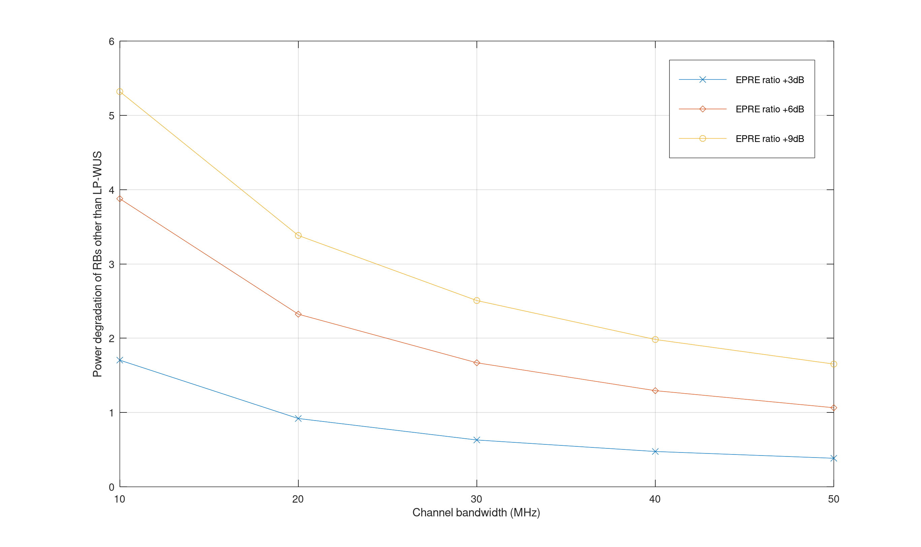
Fig: power degradation of RBs other than LP-WUS signal
  - Proposal 2: Only consider LP-WUS power boosting for CBWs larger than 20MHz. (Huawei)
Moderator: Followings are reproduced from R4-2407653 for information
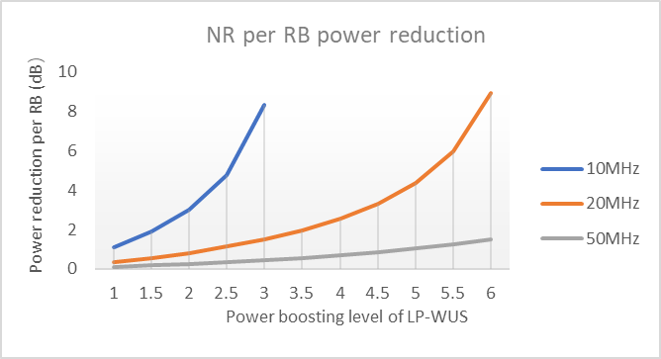
Figure: Power reduction for NR vs power boosting of LP-WUS RBs for different CBWs
(all WUS RB are transmitting)

  - Proposal 3: Focus on CBWs >= 10MHz and different power boosting values can be considered for different CBW. (vivo)

- Recommended WF
  - TBA

Issue 1-4: On applicable BS type for LP-WUS
- Proposals
  - Proposal 1: Not to set restriction on applicable BS types to support LP-WUS. (CATT, CMCC)
  - Proposal 2: To decide on the applicable BS types after the applicable frequency range and bands for LP-WUS have been decided. (Nokia)
  - Proposal 3: Consider BS type 1-C as applicable type to further discuss of LP-WUS power boosting. FFS other BS types. (Huawei)
  - Proposal 4: Depend on power boosting level for certain BS type. (ZTE)
    - If power boosting is limited to 3 dB, all BS type 1-C, 1-H and 1-O can be considered. (Ericsson)

- Recommended WF
  - Check if type 1-C can be applicable type to further discuss LP-WUS power boosting, FFS other BS types.

Issue 1-5: On minimum value for LP-WUS power boosting
- Proposals
  - Option 1: Use 3dB as minimum requirement (CMCC)
    - It should be considered in conjunction with the supported CBWs. (Huawei)
  - Option 2: Others.
- Recommended WF
  - TBA

Issue 1-6: Whether a cap for LP-WUS power boosting should be considered
- Proposals
  - Option 1: Yes, because impact on legacy NR coverage should be considered. (Huawei, CMCC, [CATT, Nokia])
    - Option 1-1: Limit to 3dB for BS type 1-C, 1-H and 1-O. (Ericsson)
    - Option 1-2: FFS on the value in conjunction with the supported CBWs. (Huawei)
  - Option 2: Others.
- Recommended WF
  - TBA

Sub-topic 1-2 Other considerations apart from dynamic range for LP-WUS
Issue 1-7: Requirements other than dynamic range
- Proposals
  - Proposal 1: Unwanted emissions requirements of SEM and spurious emissions should be considered for transmitted signal with LP-WUS and NR in the same carrier. (Huawei)
  - Proposal 2: FFS whether transmitted signal quality requirements should be defined for LP-WUS, at least for the EVM requirement. (Huawei)
  - Proposal 3: Multi-band requirements at gNB side for LP-WUS. (CMCC)

- Recommended WF
  - Discuss whether other Tx requirements should be defined for LP-WUS operation other than dynamic range requirement. If needed, FFS on the necessary requirements.

Issue 1-8: Whether UE needs to know BS power boosting information for RRM measurement
- Proposals
  - Option 1: UE needs to obtain the power level difference between LP-SS and SSB. (Samsung)
    - To support RRM measurement offloading from MR to LR for UE serving cell.
  - Option 2: Others.

- Recommended WF
  - Before discussion of the details of options, check whether the issue should be discussed in RF session or RRM session firstly.

Issue 1-9: Whether to consider FR2 for LP-WUS
- Proposals
  - Option 1: RAN4 should focus on FR1 licensed bands for BS RF requirements. (vivo)
  - Option 2: RAN4 confirm the power saving gain of WUR for FR2 before starting work on FR2. (Ericsson)
    - No test model for power boosting is defined for FR2 and power boosting capability cannot be assumed for FR2 BS.
  - Option 3: Others.

- Recommended WF
  - Check if Option 1 can be acceptable.

