3GPP TSG-RAN WG4 Meeting#111 R4-2409955
Fukuoka City, Fukuoka , Japan, 20th – 24th May, 2024
Agenda item: 10.2.4
Source: ZTE Corporation
Title: Way Forward for [111][311] NR_BS_RF
Document for: Approval

WF for U6GHz EIRP mask
Issue 2-1 The applicability of frequency range within band n104
Agreement:
- Option 1: 6425-7075MHz
Issue 2-2 The naming for this requirement
Agreement:
- OTA spatial emission
Issue 2-3 Which sub-clause to capture the requirement
Agreement:
- Use the new clause 9.9 to capture the requirement

Issue 2-4 The applicable BS types to fulfill the Expected EIRP requirements
Agreement:
- BS type 1-H and BS type 1-O

Issue 2-5 The coordinate system for Expected EIRP requirement
Agreement:

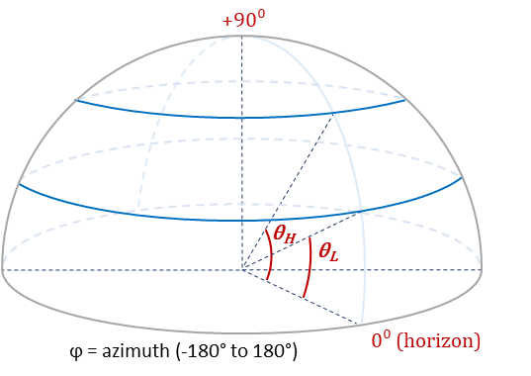

Issue 2-6 Mechanical tilts related
Agreement:
- NOTE 2: The requirement shall apply to all supported mechanical tilts.

Agreement:

Table 2.2.2-1: [CAR] declarations
Parameter | Description
Θ_{min} | Minimum angle along θ axis
θ_{max} | Maximum angle along θ axis
ϕ_{min} | Minimum angle along ϕ axis
ϕ_{max} | Maximum angle along ϕ axis
- NOTE 1: further discuss the definition of Θ_{min} θ_{max} ϕ_{min} ϕ_{max}
- NOTE 2: reusing the existing declaration is not precluded.

Issue 2-7 Expected EIRP calculation in discrete spatial sampling grid
Agreement:
- P$\left(θ_{L} , θ_{H}\right)=\frac{π}{2MN\left(sinθ_{H}-sinθ_{L}\right)}\sum_{n=n_{L}}^{n_{H}}{\sum_{m=1}^{M}{P1\left(θ_{n},φ_{m}\right) cos\left(θ_{n}\right)}} , where P1 is measured as EIRP$
- M is the number of sampling points in the azimuth range;
- [N is the number of sampling points over upper hemisphere in the elevation range ]
- $n_{L}$ is the lowest elevation sampling angles within the $\left(θ_{L} , θ_{H}\right)$ bounding range
- $n_{H}$ is the highest elevation sampling angles within the $\left(θ_{L} , θ_{H}\right)$ bounding range]
- $\sum_{m=1}^{M}{EIRP\left(θ_{n},φ_{m}\right) }$ is to produce the global sum over the whole azimuth ranges for EIRP above the horizon in a given bin.
Note: the 1st equation should be carefully reviewed by companies.

Issue 2-12 draft CRs

9.9 OTA spatial emission

9.9.1 General
OTA spatial emission requirements are defined to set upper limits on radiated power in specific directions.

9.9.2 Protection of FSS UL
This requirement shall be applied to BS operating in band n104 to protect FSS (Earth-to-space) satellite receiver.

9.9.2.1 Minimum requirement for BS type 1-H and BS type 1-O
For BS type 1-H and BS type 1-O operating in band n104, the Expected EIRP (EEIRP) in the frequency range 6425 – 7075 MHz , shall not exceed the values specified in table 9.9.2.1-1.
EEIRP is defined as the average value of the EIRP, with the averaging being performed
over azimuth angles from −180° to +180 ° and over the specified elevation angle range [θ_{L} ≤ θ < θ_{H}] in table 9.9.2-1

Table 9.9.2.1-1: EEIRP limits as function of elevation above horison
Elevation angular range  [θ_{L} ≤ θ < θ_{H}] (Degrees) | EEIRP limit  (dBm/MHz)
0<θ<5 | 27
5<θ<10 | 23
10<θ<15 | 19
15<θ<20 | 18
20<θ<30 | 16
30<θ<60 | 15
60<θ<90 | 15
Note 2: The requirement shall apply to all supported mechanical tilts.

Figure 9.9.2.1-1: Definitions of [θ_{L} and θ_{H}] angles.

Open issue for U6GHz EIRP mask and OTA testing
Issue 2-8 Expected EIRP sampling grid for average EIRP
- Recommended for further discussion:
  - Need further discussions
Issue 2-9 Other related with conformance testing declaration and RF channels
- Recommended for further discussion:
  - The following issues to be considered:
- the number of mechanical down-tilt and its corresponding angular coverage range;
- For each angular coverage range, the number of beams for conformance testing and its corresponding weighting factor;
- To balance the number for beams for conformance testing/complexity and test accuracy;
- The impacts of potential factors (measurement sampling grid for summation error etc) on EIRP accuracy.
- Other issues are not precluded.
Issue 2-10 Other related with RF channels
- Recommended for further discussion:
  - Need further discussions

Issue 2-11 Other related with confidence intervals
- Recommended for further discussion:
  - Need further discussions

Issue 3-1: Co-location reference antenna
- Recommended for further discussion
  - Further discuss the wideband antennas and check its possibility of translation between reference co-location antenna and wideband antenna;
  - Further discuss coupling loss between two AAS BS especially for FR1 high bands;
  - Other issues are not precluded.

