3GPP TSG-RAN WG4 Meeting # 111 R4-240xxxx
Fukuoka, Japan, 20th – 24th May 2024

Agenda item: 7.5.5
Source: Intel Corporation
Title: WF on NR_MG_enh2_part2
Document for: Approval

Topic #1 and #2: Core part maintenance

Summary of discussions

Sub-topic 1-1 DRX
Issue 1-1-1: Misalignment between DRX-on duration and SMTC for NFG measurements
- Proposals
  - Option 1:
    - Option 1a: Interruptions are always allowed outside DRX ON duration and it is according to Tcycle,i.
    - Option 1b: Interruptions are not allowed during DRX ON duration.
    - Option 1c: Interruptions are not allowed when DRX cycle is larger than 320ms.
    - Option 1d: Interruptions are not allowed in the DRX ON duration, excluding the time extended due to drx-inactivityTimer.
  - Option 2: Interruptions are allowed under the conditions of issues 1-1-2, 1-1-3, 1-1-4.

Issue 1-1-3: Aligned DRX-on duration and SMTC for NFG measurements
- Proposals
  - Option 1: Interruption is always allowed, and it is according to Tcycle,i.
  - Option 2: interruption is always allowed but except for the last DL slot containing PDCCH in the ON duration.
- Agreement
  - Interruption ratio requirement not based on DRX-on duration
  - Not define the interruption location

Issue 1-1-6a: Interruption requirements for Tcycle,i when DRX cycle is configured
- Proposals
  - Option 1: For DRX, the interruption ratio is defined based on
    - Tcycle,i = max (80ms, DRX cycle) x CSSFoutside_gap,i, for DRX cycle > 320ms
    - Tcycle,i = max (80ms, SMTC period, DRX cycle) x 1.5 x CSSFoutside_gap,i, for DRX cycle ≤ 320ms
  - Option 2:
    - Tcycle,i = DRXcycle, DRXcycle >320ms.
    - Tcycle,i = max (80ms, SMTCi, DRXcycle) , DRXcycle <=320ms

Sub-topic 1-2 MRDC interruption requirements
Issue 1-2-1: Interruption requirements in 8.2.2.2.19 apply also for NR-DC, EN-DC, and NE-DC
- Background:
  - the NFG signalling is used in NR SA only, as shown below:
From 38.331:

– NeedForGapsInfoNR
The IE NeedForGapsInfoNR indicates whether measurement gap is required for the UE to perform SSB based measurements on an NR target band while NR-DC or NE-DC is not configured.

- Proposals
  - Option 1: Yes. Interruption requirements in 8.2.2.2.19 shall also apply for NR-DC, EN-DC, and NE-DC considering that operations in one cell group do not impact operations on another cell group.
    - Option 1a: Same interruption requirement defined at 7.8.2.22 in 36.133 and 8.2.2.2.19 in 38.133 are applied for each cell group for UE perform NR measurement without gap with interruption.
      - 7.8.2.22 in 36.133 and 8.2.2.2.19 in 38.133 is applied for MCG and SCG, respectively in EN-DC,
      - 7.8.2.22 in 36.133 and 8.2.2.2.19 in 38.133 is applied for SCG and MCG, respectively in NE-DC,
      - 8.2.2.2.19 in 38.133 is applied for both MCG and SCG in NR-DC.
  - Option 2: NFG requirements are applicable for NR SA only.
    - Option 2a: deprioritize MR_DC for NFG in objective 2 of the WI.

Sub-topic 1-3 Others in NFG
Issue 1-3-1: further clarification on the measurement and interruption spec about gap/BWP configurations
- Proposals
  - Option 1a: Clarify in the spec that [no gap with interruption] requirements only apply when gap is not configured, or gap is fully non-overlapped with SMTC on any carriers which are measured with interruption.
  - Option 1b: Capture in the specification the agreement from RAN4#106 that intra-frequency measurements without gaps don’t cause interruption when target SSB is completely contained withing the active BWP of the UE.
  - Option 2: Do not clarify.

Issue 1-3-2: NFG and NCSG capabilities
- Previous Agreements
  - No need to establish the mapping between UE’s indication for NeedForGaps and NCSG.
- Proposals
  - Option 1: NeedForGaps and NCSG are not expected to be enabled for the same UE at the same time.
  - Option 2: Allow to enable both R17 and R18 reporting.

Issue 1-3-3: Cross feature support
- Proposals
  - Proposal 1: Rel 18 measurements without gaps with interruptions do not apply for HST.
  - Proposal 2: Rel 18 measurements without gaps with interruptions do not apply for operation above 52.6 GHz.

Sub-topic 1-4 UE capabilities
Issue 1-4-1: Relations between nr-NeedForGap-Reporting-r16 and nr-NeedForInterruptionReport-r18 and UE behaviours
- Agreements
  - No relations between nr-NeedForGap-Reporting-r16 and nr-NeedForInterruptionReport-r18. RAN4 not to further discuss the issue.
- Previous agreements
Issue 1-1-2: Scenario 2, NR measurements without gaps
Tentative agreements
- “no-gap” as part of NeedForGapsInfoNR-r16=FALSE means that the UE support measurement without gaps
  - The UE may or may not cause interruption.
- if UE causes interruptions when performing measurements without gaps:
  - Support early implementation of Rel-18 NeedForInterruption:
    - Optional since R17
  - FFS the UE behavior if the Rel-18 UE does not support NeedForInterruptionNR-r18
Proposals
Option 1: A Rel-18 UE indicating support of nr-NeedForGap-Reporting-r16 shall also indicate support of nr-NeedForInterruptionReport-r18.
Option 2: When a Rel-18 UE only supports Rel-16 NFG capability but not supports Rel-18 NFI capability, the UE’s behaviour is the same as Rel-16 UE.
Option 2a: When a Rel-18 UE supports both Rel-16 NFG and Rel-18 NFI capabilities, but NW doesn’t configure Rel-18 needForInterruptionConfigNR, the UE’s behaviour is the same as Rel-16 UE.
Option 3: A Rel-18 UE indicating support of interRAT-NeedForGapsNR-r16 shall also indicate if interruptions are needed.
No new RRM test cases are defined for a Rel-18 UE supporting signalling above.

Sub-topic 2-1 Scheduling restriction
Issue 2-1-1: Scheduling restriction for case b-1
- Proposals
  - Option 1 : No scheduling restriction is applied for UE indicate nogap-noncsg for inter-RAT EUTRAN measurement without gap.
Issue 2-1-2: Scheduling restrictions and UE capability reporting
- Proposals
  - Proposal 1a: For Cases b-1 and/or b-2: When the UE require NO scheduling restriction for a specific carrier:
    - the UE shall report to the NW that the UE can measure a given/specific carrier frequency of inter-RAT EUTRAN without gap and without interruption;
    - the UE shall not report EMW (i.e. the UE can measure with at any reference signal occasion).
  - Proposal 1b: For Cases b-1 and/or b-2: When the UE require scheduling restriction for a specific carrier:
    - the UE reports to the NW that the UE can measure a given/specific carrier frequency of inter-RAT EUTRAN without gap and without interruption,
    - also, the UE shall report the support of effective measurement window (EMW) for inter-RAT EUTRAN capability (i.e. the UE can measure and cause scheduling restrictions only within the EMW occasions).
  - Proposal 1c: For Cases b-1 and/or b-2: When the UE reports for inter-RAT EUTRAN measurements without gap and without interruption and the UE doesn’t support EMW capability, the UE shall report NCSG, or gaps.
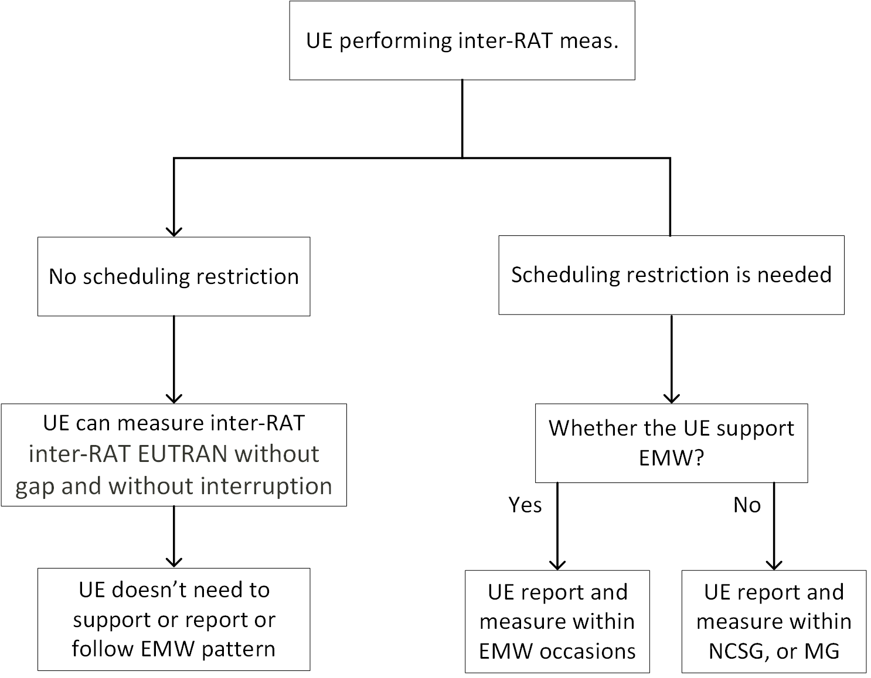
Figure 1: Illustration of Option 1, UE behaviour for measuring inter-RAT EUTRAN without gaps and without interruption.

Sub-topic 2-2 Measurement reporting period requirements
Issue 2-2-1: Overlap between Effective measurement window and SMTC/SSB
- Background
  - Previous Agreements
    - For case b-2, when EMW is configured overlapped with SMTC/SSB/CSI-RS measurement with scheduling restrictions, inter-RAT LTE measurement will be dropped.
    - For case b-1 and b-2, when EMW is partially overlapped with MG (EMW periodicity < MGRP), the EMW occasion colliding physically with MG will be dropped.
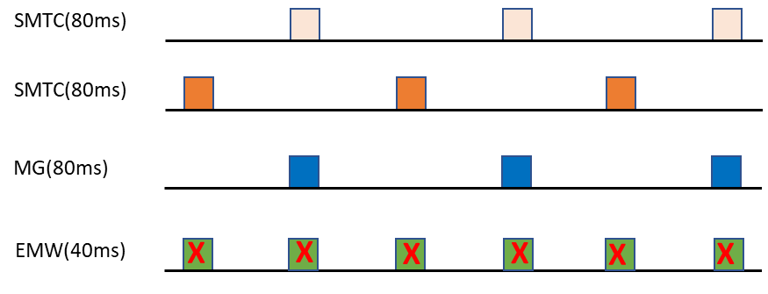
- Proposals to: For case b-1 and b-2 inter-RAT LTE measurement causing scheduling restriction, when EMW periodicity is smaller than MGRP,
  - Option 1: RAN4 to update the legacy agreements as: after considering EMW dropping rule if EMW is colliding with SMTC/SSB/CSI-RS, when the remaining EMW is fully overlapping with MG, the inter-RAT meas will be performed within MG.
  - Option 2: RAN4 to update the legacy agreements as: after considering EMW dropping rule if EMW is colliding with SMTC/SSB/CSI-RS, when the remaining EMW is fully overlapping with MG, the inter-RAT measurements will be left to UE implementation (i.e. no requirements defined for this corner case).

Issue 2-2-1a: Overlap between Effective measurement window and MG
- Background
  - Agreements
    - For case b-1 and b-2, when EMW is partially overlapped with MG (EMW periodicity < MGRP), the EMW occasion colliding physically with MG will be dropped.
    - Note: The proximity rule in Rel-17 does not apply in this case.
- Proposals to: For case b-1 and b-2 inter-RAT LTE measurement causing scheduling restriction, when EMW periodicity is larger than MGRP and all EMW are covered by measurement gaps,
  - Option 1: inter-RAT LTE measurement will be dropped.
  - Option 2: No UE behaviour is specified.
  - Option 3: apply legacy gap-based measurement requirements, i.e. RAN4 requirements should NOT be defined based on EMW.
  - Option 4: UE measurement requirements are based on EMW-RP.

Issue 2-2-2: Tinter1 for EMW configuratios:
Table 2
EMW Pattern Id | EMW Length (EMWL, ms) | EMW Repetition Period  (EMWRP, ms) | Minimum available time for inter-RAT measurements during 480 ms period  (T_{inter1}, ms)
2 | 2 | 40 | [24]
3 | 2 | 80 | [12]

- Proposals
  - Option 1: Update the Tinter1 for EMW pattern 2/3 to 60/30ms.
EMW Pattern Id | EMW Length (EMWL, ms) | EMW Repetition Period  (EMWRP, ms) | Minimum available time for inter-RAT measurements during 480 ms period  (T_{inter1}, ms)
2 | 2 | 40 | [60]
3 | 2 | 80 | [30]
  - Option 2: When determining UE requirements using Tinter1 for EMW pattern IDs 2, 3, 4, 5, Tinter1 = 60 for gap pattern IDs 2, 4, and Tinter1 = 30 for gap pattern IDs 3 and 5 shall be used.
  - Option 3: When determining UE requirements using Tinter1 for EMW IDs 2 and 3, Tinter1 = 60 for EMW ID 2 and Tinter1 = 30 for EMW ID 3 shall be used if EMW dropping rule is not applied specified in clause X. Otherwise, Tinter1 specified in table 2 is applied.

Issue 2-2-4: Tinter1 without EMW configuration
- Proposals
  - Option 1: Define Tinter1 without EMW configuration as 60ms (based on EMW pattern 0).
  - Option 2: For UE can perform inter-RAT LTE measurement without gap and does not require a scheduling restrictions, Tinter1 = 60ms is applied for the inter-RAT LTE measurement without gap.

Issue 2-2-3: Scaling factor for case a-1: Nfreq definition
- Background
  - The principles are different between NR MO outside gap and LTE inter-frequency without MG, where all inter-frequency MOs, regardless if they are measured with or without MG, are counted in the same Nfreq.
- Proposals
  - Option 1: number of NR MOs that are measured outside MG (same principle as NR SA).
  - Option 2: total number of LTE and NR MOs (same principle as LTE SA).
    - Option 2a: total number of inter-frequency LTE and NR MOs (same principle as LTE SA).

Sub-topic 2-3 UE capabilities
Issue 2-3-1: case a-1: The issue with UE capability interRAT-NeedForIntrNR-r18
- Proposals
  - Option 1: Interruptions due to interRAT NR measurements without gaps must be explicitly allowed by the network (via SIB or other means). Send LS to RAN2.
  - Option 2: Do not change current interRAT-NeedforIntrNR-r18 capability design. Not to make reporting of interRAT-NeedForIntrNR-r18 based on NW control. Do not further discuss how to report UE capability interRAT-NeedForIntrNR-r18.
  - Option 3: interRAT-NeedForIntrNR-r18 capability is based on network request. Send LS to RAN2.

Issue 2-3-1a: Relations between interRAT-NeedForGaps-r16 and interRAT-NeedForIntrNR-r18 and UE behaviours
- Agreements
  - No relations between nr-NeedForGap-Reporting-r16 and nr-NeedForInterruptionReport-r18. RAN4 not to further discuss the issue.Previous agreements
  - Issue 1-1-1: Scenario 1, LTE – NR inter-RAT measurement
  - Tentative agreements
  - interRAT-NeedForGaps-r16=FALSE means that the UE support measurement without gaps
  - The UE may or may not cause interruption.
  - if UE causes interruptions when performing measurements without gaps:
  - Support early implementation of Rel-18 NeedForInterruption:
  - Optional since R17
  - FFS mandatory report of the UE capability R18 interRAT-NeedForIntrNR-r18 from Rel-18 UE if the UE reports interRAT-NeedForGaps-r16=FALSE
  - FFS the UE behavior if the Rel-18 UE does not support interRAT-NeedForIntrNR-r18
Proposals
Option 1: A Rel-18 UE indicating support of interRAT-NeedForGapsNR-r16 shall also indicate support of interRAT-NeedForInterruptionNR-r18.
Option 2: When a Rel-18 UE only supports Rel-16 NFG capability but not supports Rel-18 NFI capability, the UE’s behaviour is the same as Rel-16 UE.
Option 2a: When a Rel-18 UE supports both Rel-16 NFG and Rel-18 NFI capabilities, but NW doesn’t configure Rel-18 needForInterruptionConfigNR, the UE’s behaviour is the same as Rel-16 UE.
Option 3: A Rel-18 UE indicating support of interRAT-NeedForGapsNR-r16 shall also indicate if interruptions are needed.
No new RRM test cases are defined for a Rel-18 UE supporting signalling above.
Recommended WF

Issue 2-3-2: Additional UE capability for scheduling restriction of case a-1
- Agreement:
  - Introduce an E-UTRA FG x-z for scheduling restriction due to mixed numerology.

Issue 2-3-3: Remove FG32-4 from prerequisite feature groups for FG 32-7.
- Agreement:
  - Not Remove FG32-4 from prerequisite feature groups for FG 32-7

Issue 2-3-4: Update FG 32-5 description.
- Agreement:
  - Support of inter-RAT EUTRAN measurements without gap when CRS is completely contained within UE’s active DL BWP.

Issue 2-3-5: Update FG 32-4 description.
- Agreement:
  - this issue is closed.

Issue 2-3-8: Feature list tables for inter-RAT measurements without gap
- Agreements
  - For UE support 32-4, no scheduling restriction is needed due to mix-numerology for CRS fully non-overlapping with UE’s active BWP
  - FFS whether to add a FG for scheduling restriction for FG x-y

- Agreed feature list:
Table 1: Rel-18 NR UE features for NR_MG_enh2 WI.
Index | Feature group | Components | Prerequisite feature groups | Need for the gNB to know if the feature is supported | Applicable to the capability signalling exchange between UEs (V2X WI only)”. | Consequence if the feature is not supported by the UE | Type | Need of FDD/TDD diff | Need of FR1/FR2 diff | Capability interpretation for mixture of FDD/TDD and/or FR1/FR2 | Note | Mandatory/Optional
32-1 | Concurrent gaps with Pre-MG in a FR | Support of multiple per-UE (or per-FR) measurement gap patterns with at least one per-UE (or per-FR) Pre-MG. Details in Clause [9.1.x.2] of TS 38.133. | 19-3-x and 19-2  x = 1 or 2 | Yes | No | UE behaviour is undefined if the network configures concurrent MGs where at least one of the gaps is a Pre-MG | Per UE | No | No | N.A |  | Optional with capability signalling
32-2 | Support for dynamic collisions | Support RRM requirements for handling dynamic collisions between a Pre-MG and another measurement gap or Pre-MG. | 32-1 | Yes | No | UE is not expected to meet RRM requirements for dynamic collisions | Per UE | No | No | N.A |  | Optional with capability signalling
32-3 | Concurrent gaps with NCSG in a FR | Support of multiple per-UE (or per-FR) measurement gap patterns with at least one per-UE (or per-FR) NCSG. Details in clause [9.1.y.2] of TS 38.133. | 19-1 and 19-2 | Yes | No | UE behaviour is undefined if the network configures concurrent MGs where at least one of the gaps is a NCSG | Per UE | No | No | N.A |  | Optional with capability signalling
32-4 | Inter-RAT EUTRAN measurements without gap and outside active DL BWP | Support inter-RAT EUTRAN measurements outside active DL BWP for nogap-noncsg | 19-1b | Yes | NA | UE does not meet the requirements of inter-RAT EUTRAN measurements without gap in TS 38.133 and the UE behavior is unknown to network | Per UE | No | No | N.A |  | Optional with capability signalling
32-5 | Inter-RAT EUTRAN measurement without gap and within active DL BWP | Support of inter-RAT EUTRAN measurements without gap when CRS is completely contained within UE’s active DL BWP |  | Yes | No | Measurement gap will be needed for inter-RAT EUTRAN measurements | Per UE | No | FR1 only | N.A |  | Optional with capability signalling
32-6 | Effective measurement window for inter-RAT EUTRAN measurements | Support configuration of effective measurement window for inter-RAT EUTRAN measurements, including offset, duration and periodicity. | 32-4 or 32-5 | Yes | No | UE is not allowed to cause scheduling restriction defined in TS 38.133 for 32-4 or 32-5 | Per UE | No | No | N.A | - A bitmap for 6 effective measurement window (EMW) patterns defined in TS 38.133.  - #0 and #1 are mandatory, if UE supports EMW feature.  Other patterns are optional  Note: If UE supports 32-4 or 32-5 and UE requires scheduling restriction, UE should support this FG | Optional with capability signalling
32-7 | Simultaneous reception of NR data and EUTRAN CRS with different numerology | Support concurrent inter-RAT measurement on EUTRAN cell in non-DSS with CRS and PDCCH or PDSCH reception from the serving cell with a different numerology | 32-4 or 32-5 | Yes | No | scheduling restriction is applicable | Per UE | No | FR1 only | N.A |  | Optional with capability signalling

Table 2: Rel-18 LTE UE features for NR_MG_enh2 WI.
Index | Feature group | Components | Prerequisite feature groups | Need for the gNB to know if the feature is supported | Applicable to the capability signalling exchange between UEs (V2X WI only)”. | Consequence if the feature is not supported by the UE | Type | Need of FDD/TDD diff | Need of FR1/FR2 diff | Capability interpretation for mixture of FDD/TDD and/or FR1/FR2 | Note | Mandatory/Optional
x-y | interRAT-NeedForInterruptionNR-r18 | Support of inter-RAT NR measurements without gap with or without interruption when the interRAT-NeedForGapsNR-r16 is false.  Note: This feature already has a defined UE capability: ‘interRAT-NeedForInterruptionNR-r18’. The intention of adding this FG is only keep consistency between 38.822 and 36.306. | interRAT-NeedForGapsNR-r16 | Yes | NA | The UE does not support inter-RAT NR measurements without gap with or without interruption for performing inter-RAT NR measurement without gap | [Per target band per BC]  Note: the same granularity as interRAT-NeedForGapsNR-r16 | No | No | NA | Candidate value: “{no-gap-with-interruption, no-gap-no-interruption}” | Optional with capability signalling
x-z | Simultaneous reception of EUTRAN data and NR SSB with different numerology | Support concurrent SSB-based inter-RAT measurement on NR cell and PDCCH or PDSCH reception from the serving cell with a different numerology | x-y | Yes | NA | scheduling restriction is applicable | Per UE | No | FR1 only | NA |  | Optional with capability signalling

Topic #3: Performance part requirements for measurements without gap

Summary of discussions
Up to this meeting, all agreed using scenarios for inter-RAT NR/LTE measurements without gap can summarized as:
- the inter-RAT NR measurements without gap in Rel18 includes the two scenarios below.
  - Case a-1: UE performing the measurements without gap in NR carriers as there is vacant RF chains for UE measurements
- the inter-RAT LTE measurements without gap in Rel18 includes the two scenarios below.
  - Case b-1: UE performing the measurements without gap in LTE carriers as there is vacant RF chains for UE measurements
  - Case b-2: LTE CRS are fully contained within UE’s active BWP

Configurations for test cases
Issue 2-1-1: Configuration for Intra-frequency measurements test cases:
- Agreement
  - Define the test case where the serving cell SSB is outside of UE’s active BWP by
  - Configuring CSI-RS for RLM
  - Note: In RAN4’s understanding, RAN5 can follow the legacy applicability of the Rel-15 intra-frequency with gap TC

Issue 2-1-2: Test cases with DRX
- Agreement
  - Do not introduce test cases with DRX configured for NFG and inter-RAT measurements.

Test cases list and responsibilities

NFG
Test list agreed
No. # | Item of core requirements | Type of test cases | FR of serving cell | SMTC | MG | DRX | Subclause | Responsibility
NFG1 | Event triggered reporting and interruptions | Intra-frequency measurements without gap config and non-DRX  Note: The testability needs to be checked before introducing the test case | FR1 | 20ms | No | No | A.6.6.1.X | Nokia
NFG2 |  | Intra-frequency measurements with gap configuration and non-DRX configuration  The test purpose: UE is not allowed to cause interruption outside MG when SMTC partially overlaps with gap | FR2 | 20ms | gap is configured  Note: UE can skip corresponding Rel-15 TC | No | A.7.6.1.X | Intel
NFG3 |  | Inter-frequency measurements without gap and without DRX | All in FR1 | 20ms | No | No | A.6.6.1.X | QC
NFG4 |  | Inter-frequency measurements without gap config but without DRX  Note: The testability needs to be checked before introducing the test case | All in FR1 | 160ms | No | No | A.7.6.1.X | HW
NFG5 | Event triggered reporting [without interruption] | Inter-frequency measurements without gap with non-DRX | All in FR1 | 20ms | No | No | A.6.6.1.X | Ericsson
NFG6 |  | Inter-frequency measurements without gap with non-DRX | All in FR2 | 20ms | No | No | A.7.6.1.X | CATT
NFG7 |  | Intra-frequency measurements without gap with non-DRX | FR1 | 20ms | No | No | A.6.6.1.X | CMCC
NFG8 |  | Intra-frequency measurements without gap with non-DRX | FR2 | 20ms | No | No | A.7.6.1.X | MTK

- Agreements
  - No TC among NFG5 to NFG8 will be merged.

Inter-RAT
Test list agreed
No. | Item of core requirements | Type of test cases | FR of serving cell | EMW | MG | DRX | Subclause | Responsibility
IR1 | Event triggered reporting and nogp-noncsg | Inter-RAT EUTRAN measurements case b-1 without MG without interruption and no DRX configuration  Note: UE follows EMW | NR FR1 | [Yes] | No | No | A.6.6.3.X | CATT
[IR2] | Event triggered reporting and nogp-noncsg | Inter-RAT EUTRAN measurements case b-1 with MG but no DRX configuration  Note: UE is configured with MG and has no scheduling restrictions outside MG | NR FR1 | TBD | [Pattern TBD] | No | A.6.6.3.X | xiaomi
IR3 | Event triggered reporting [without interruption] | Inter-RAT EUTRAN measurements case b-2 without MG or DRX configuration | NR FR1 | [Yes] | No | No | A.6.6.3.X | CMCC
IR4 | Event triggered reporting | Inter-RAT NR measurements case a-1 with MG | NR FR1 | No EMW config | [Pattern TBD] | No | A.8.4.2.X | HW
IR5 | Event triggered reporting and interruptions | Inter-RAT NR measurements case a-1 with MG | NR FR1 | No EMW config | [Pattern TBD] | No | A.8.4.2.X | Nokia

