3GPP TSG-RAN WG4 Meeting#111 R4-240xxxxx
Fukuoka City, Fukuoka , Japan, 20th – 24th May, 2024
Agenda item: 7.16.9
Source: Moderator (ZTE)
Title: Topic summary for [111][120] NR_NTN_enh_UERF_R18
Document for: Information

Introduction
Briefly introduce background, the scope of this email discussion (e.g. list of treated agenda items) and provide some guidelines for email discussion if necessary.
List of candidate target of email discussion for 1st round and 2nd round
- 1st round: TBA
- 2nd round: TBA
It is appreciated that the delegates for this topic put their contact information in the table below.

Note:
- Please add your contact information in above table once you make comments on this email thread.
- If multiple delegates from the same company make comments on single email thread, please add you name as suffix after company name when make comments i.e. Company A (XX, XX)

Topic #1: NTN UE Tx RF requirement

Companies’ contributions summary
T-doc number | Company | Proposals / Observations
R4-2407462 | Qualcomm Incorporated | Draft CR for R4-2405085 to add OFF-axis AMPR  NTN VSAT class NTN VSAT type Type description  Fixed VSAT 1 Fixed VSAT communicating with GSO and LEO with mechanical steering antenna.  2^{X} Fixed VSAT communicating with GSO and LEO with electronic steering antenna.  3 Fixed VSAT communicating with LEO only with electronic steering antenna.  Mobile VSAT 4 Mobile VSAT communicating with GSO with mechanical steering antenna.  5^{X} Mobile VSAT communicating with GSO with electronic steering antenna.  Note 1: The NTN VSAT types are assuming NTN VSAT has only one antenna beam towards one satellite at a given time in this release.  Note X: UE may need power reduction for meeting OFF-axis EIRP requirement defined in clause 9.2.2. Value is implementation dependent
R4-2408698 | Ericsson | NTN enhancement - NTN UE Tx requirements  Proposal1: Clarify that the number of VSAT simultaneously transmitting N shall be declared by the VSAT manufacturer.  Observation1: P_{rated,UE} was replaced with TRP_{max} (NTN VSAT maximum TRP specified in sub-clause 9.2.1) in the endorsed draft CR R4-2406602 [5], removing any ambiguity on the definition of P_{rated,UE}.  Proposal2: Remove the word “uncoordinated” from the additional Off-axis EIRP density requirements for protection of fixed services (sub-clause 9.2.2.3.3).  Proposal3: Do not introduce NS in specified bands n512, n511 and n510 but re-consider NS when a new NTN Ka-band will be specified.  Observation2: The antenna pointing accuracy requirements for band n512 needs to be re-organized and reworded to reflect correctly ETSI Harmonized Standards.
R4-2408700 | Ericsson, Thales | NTN enhancement: draft CR to TS 38.101-5 NTN Ka-band - additional Tx updates to the running CR - subclause 9.6
R4-2408701 | Ericsson | NTN enhancement: draft CR to TS 38.101-5 NTN Ka-band - additional Tx updates to the running CR
R4-2409044 | Samsung | On NTN UE RF Tx requirements  Observation 1: The Tx EIRP on different directions from a parabolic antenna on mechanical tilting platform can be assumed at same level in beam peak direction and other elevation angle direction. The parabolic antenna on mechanical steering platform will always use its ‘beam peak direction’ to all supported elevation directions.  Observation 2: The Tx EIRP on different directions from a phase array antenna on electronic steering platform will be different. More specifically, the EIRP of a phase array antenna electronically steered to a lower elevation angle will be lower than the beam peak direction due to two major factors: 1) The gain difference due to electronic beam steering; 2) The additional power reduction due to off-axis eirp exceedance.  Proposal 1: For measurement metric for min peak EIRP for Type 1/4 VSAT (mechanical steering antenna), the min peak EIRP can be verified for the beam peak direction, assuming the rotating motors can be cover all declared elevation angles.  - If the rotating motors cannot cover all declared elevation angles (e.g. hybrid steering), the min peak EIRP should be verified for the spherical grid between the declared supported lowest elevation angles, like a electronic steering type VSAT.  Proposal 2: For measurement metric for min peak EIRP for Type 2/3/5 VSAT (electronic steering antenna), the min peak EIRP should be verified for the spherical grid between the declared supported lowest elevation angles (as shown in Figure 1-3).  Figure 1-3 Measurement grid for min peak EIRP of a phase array VSAT  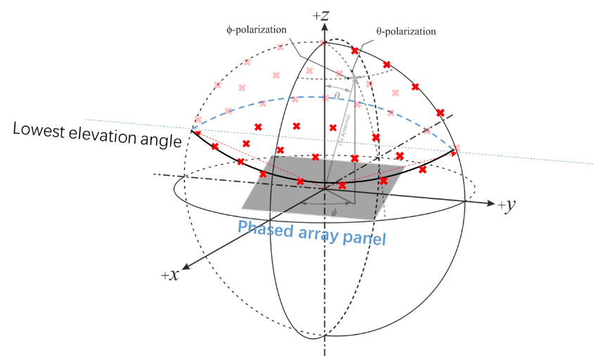  Proposal 3: All types of VSAT should declare its lowest supported elevation angle.  - For Type 1/4, it can be derived from its capability from the associated rotating motors/platforms.  - For Type 2/3/5, this can be derived from its beam steering capacity.  - For hybrid, it should first declare its VSAT type as agreed, and the lowest elevation angle can be derived from its mechanical and/or beam steering capabilities.  Proposal 4: RAN4 to define this declared lowest elevation angle shall be at most [60-deg].  Proposal 5: RAN4 to state clearly in spec that max EIRP and off-axis EIRP requirements CANNOT be relaxed if RAN4 is going to agree on a value (e.g. 43dBm) larger than 35dBm for Type 2/3/5 VSAT.
R4-2409047 | Samsung | draft CR for TS 38.101-5 Chapter 9.2.1
R4-2409325 | Huawei, HiSilicon | Draft CR for 38.101-5 to clarify the polarization charactertistic for general Tx requirements
R4-2409329 | Huawei, HiSilicon | Discussion on Tx requirement for Ka band NTN UE  Observation 1: In Rel-18, RAN4 only assumed a normalized antenna gain pattern for NTN VSAT which is not relative to specific antenna gain.  Observation 2: The maximum EIRP 76.2dBm can guarantee the current coexistence outcomes, no matter how vendors trade-off the antenna gain and maximum TRP.  Observation 3: There is no coexistence issue with 43dBm TRP for previous ACLR evaluation under the condition that the maximum EIRP 76.2 is not changed.  Proposal 1: To specify 43dBm TRP for Ka band NTN VSAT type 2, 3, 5.  Proposal 2: To specify “upper hemispherical coverage grid” as term for the definition.  Proposal 3: To consider the following as upper hemispherical coverage grid for Ka band NTN VSAT. Additionally, Horizontal coverage range ϕ and Vertical coverage range θ can be declared by manufacturers.  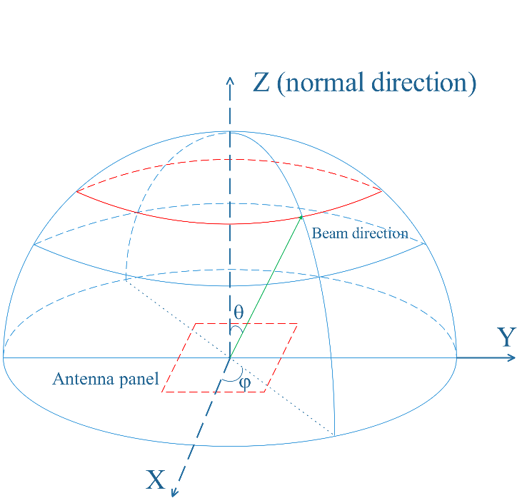  Proposal 4: RAN4 can further discuss the following two options by leveraging the EIRP scaling factor for narrow RB allocation.  Option 1: It’s allowed to scale the EIRP based on the allocated narrower RBs.  9.2.3 Configured transmitted power  The NTN VSAT can configure its maximum output power. The configured NTN VSAT maximum output power P_{CMAX,f,c} for carrier f of a serving cell c is defined as that available to the reference point of a given transmitter branch that corresponds to the reference point of the higher-layer filtered RSRP measurement as specified in TS 38.215 [11].  The configured NTN VSAT maximum output power P_{CMAX,f,c} for carrier f of a serving cell c shall be set such that the corresponding measured peak EIRP P_{UMAX,f,c} is within the following bounds  (P_{UEType} – Scaling factor) - T_{EIRP}≤ P_{UMAX,f,c} ≤ EIRP_{max} + T_{EIRP}  with P_{UEType} is the NTN VSAT minimum peak EIRP as specified in sub-clause 9.2.1, EIRP_{max} is the applicable maximum EIRP as specified in sub-clause 9.2.1 and T_{EIRP} is equal to 3.4 dB. The requirement is verified with the test metric of EIRP (Link=TX beam peak direction, Meas=Link angle).  Scaling factor is allowed for the EIRP reduction when L_{CRB} is configured less than/equal to 66 RBs for 60kHz SCS or 32 RBs for 120kHz SCS. The scaling factor should be calculated below.  Scaling factor = 10log10((L_{CRB} x SCS)/(66*60kHz))  while the corresponding measured total radiated power P_{TMAX,f,c} is bounded by the maximum TRP limit TRP_{MAX} for NTN VSAT defined in sub-clause 9.2.1:  P_{TMAX,f,c} ≤ TRP_{MAX} + T_{TRP}  where, T_{TRP} is specified as 3 dB. The P_{TMAX,f,c} requirement is verified with the test metrics of TRP (Link=TX beam peak direction, Meas=TRP grid) in beam locked mode.  Option 2: It’s allowed to additionally reduce the EIRP to meet OFF-axis EIRP requirements for NTN VSAT type 2 and 5.  9.2.3 Configured transmitted power  The NTN VSAT can configure its maximum output power. The configured NTN VSAT maximum output power P_{CMAX,f,c} for carrier f of a serving cell c is defined as that available to the reference point of a given transmitter branch that corresponds to the reference point of the higher-layer filtered RSRP measurement as specified in TS 38.215 [11].  The configured NTN VSAT maximum output power P_{CMAX,f,c} for carrier f of a serving cell c shall be set such that the corresponding measured peak EIRP P_{UMAX,f,c} is within the following bounds  (P_{UEType} – A_Reduction) - T_{EIRP}≤ P_{UMAX,f,c} ≤ EIRP_{max} + T_{EIRP}  with P_{UEType} is the NTN VSAT minimum peak EIRP as specified in sub-clause 9.2.1, EIRP_{max} is the applicable maximum EIRP as specified in sub-clause 9.2.1 and T_{EIRP} is equal to 3.4 dB. The requirement is verified with the test metric of EIRP (Link=TX beam peak direction, Meas=Link angle).  A_Reduction is allowed for the additional EIRP reduction to meet regional OFF-axis EIRP requirements for NTN VSAT type 2 and 5, when L_{CRB} is configured less than/equal to 66 RBs for 60kHz SCS or 32 RBs for 120kHz SCS. The A_Reduction should be calculated below.  A_Reduction = 10log10((L_{CRB} x SCS)/(66*60kHz))  while the corresponding measured total radiated power P_{TMAX,f,c} is bounded by the maximum TRP limit TRP_{MAX} for NTN VSAT defined in sub-clause 9.2.1:  P_{TMAX,f,c} ≤ TRP_{MAX} + T_{TRP}  where, T_{TRP} is specified as 3 dB. The P_{TMAX,f,c} requirement is verified with the test metrics of TRP (Link=TX beam peak direction, Meas=TRP grid) in beam locked mode.
R4-2409331 | Huawei, HiSilicon | CR for TR 38.863 to introduce some technical background for R18 NTN VSAT UE Tx requirements
R4-2409616 | ZTE Corporation, Sanechips | Further discussion on Tx RF requirements for NTN in Ka-band  Proposal 1: use the 43dBm as maximum TRP value for type 2 and 3 and type 5 if there are no coexistence problems identified.  Proposal 2: the TRPmax refer to the measured TRP for VSAT instead of rated TRP power.  Proposal 3: no need to further discuss the frequency boundary for SEM and SE for VSAT.
R4-2409758 | THALES, Ericsson | Tx Corrections to TS 38.101-5
R4-2409777 | THALES | Corrections to EIRPmax in TS 38.101-5
R4-2409327 | Huawei, HiSilicon | Draft CR for 38.101-5 to introduce NS for regional regulatory requirements
R4-2409328 | Huawei, HiSilicon | Discussion on how to organize the regulation requirements for Ka band

Open issues summary
Before e-Meeting, moderators shall summarize list of open issues, candidate options and possible WF (if applicable) based on companies’ contributions.

Sub-topic 1 Tx requirement
Sub-topic description:
Open issues and candidate options before e-meeting:
Issue 1-1: Maximum TRP
- Option 1: 43dBm for type 2, 3 and type 5 [Huawei, ZTE]
- Option 2: 43dBm for type 2, 3 and type 5 if max EIRP and off-axis EIRP requirements CANNOT be relaxed [Samsung]
- Recommended for further discussion:
  - Need further discussions, Option 2 seems to be agreeable.

Issue 1-2: Power backoff for type 2 and type 5 with phase array to meet OFF-axis requirement for GSO orbit
- Option 1: add the NOTE in the VSAT class table [Qualcomm]
- Option 2: add the scaling factor in the low boundary of Configured transmitted power [Huawei]
- Option 3: add the reduction factor in the low boundary of configured transmitted power [Huawei]
- Recommended for further discussion:
  - Need further discussions
  - Offline agreement for power backoff for VSAT type 2 and 5 to meet the OFF-axis requirement reached last RAN4 meeting.
  - For type 2 an type 5, the power reduction for OFF-axis EIRP requirement might be needed and the exact value is left for the implementation;

Issue 1-3: TRPmax
- Proposal 1: the TRPmax refer to the measured TRP for VSAT instead of rated TRP power. [ZTE]
- Proposal 2: NTN VSAT maximum TRP specified in sub-clause 9.2.1. [Ericsson]
- Recommended for further discussion:
  - Need further discussions

Issue 1-4: Number of VSAT simultaneously transmitting, N
- Proposal1: Clarify that the number of VSAT simultaneously transmitting N shall be declared by the VSAT manufacturer. [Ericsson]
- Recommended WF:
  - Proposal 1 is agreeable.

Issue 1-5: the clarification of “uncoordinated” from the additional Off-axis EIRP density requirements for protection of fixed services (sub-clause 9.2.2.3.3)
- Proposal1: remove the uncoordinated in the specification [Ericsson]
- Recommended for further discussion::
  - Need further discussions
Issue 1-6: NS value for FR2 NTN bands
- Proposal 1: do not introduce NS in specified bands n512, n511 and n510 but re-consider NS when a new NTN Ka-band will be specified [Ericsson]
- Proposal 2: To introduce NS values for FCC/ETSI regulatory requirements in Ka band by leveraging the existing IE additionalSpectrumEmission. [Huawei]
Network Signalling label | Requirements (clause) | Applicable Satellite orbit scenario | NR satellite Band | Channel bandwidth (MHz)
NS_200N | General requirements except for additional regional regulatory requirements | GSO and LEO | n512, n511, n510 | 50, 100, 200, 400
NS_201N | Clause 9.2.2.3  Clause 9.5.3.2  Clause 9.5.3.3  Clause 9.6.1.1  Clause 9.6.1.2  Clause 10.8 | GSO | n512 | 50, 100, 200, 400
NS_202N | Clause 9.5.3.2  Clause 9.5.3.3  Clause 9.6.1.1 | LEO | n512 | 50, 100, 200, 400
NS_203N | Clause 9.2.2.2  Clause 9.5.2.2.2  Clause 9.6.2 | GSO | n511, n510 | 50, 100, 200, 400
NS_204N | Clause 9.5.2.2.2 | LEO | n511, n510 | 50, 100, 200, 400

NR satellite band | Value of additionalSpectrumEmission
 | 0 | 1 | 2 | 3 | 4 | 5 | 6 | 7
n512 | NS_200N | NS_201N | NS_202N
n511 | NS_200N | NS_203N | NS_204N
n510 | NS_200N | NS_203N | NS_204N
NOTE: additionalSpectrumEmission corresponds to an information element of the same name defined in clause 6.3.2 of 3GPP TS 38.331 [8].

- Recommended WF:
  - Need further discussions.

Issue 1-7: Beam steering range and test direction to fulfill minimum EIRP requirement.
- Proposal 1: For measurement metric for min peak EIRP for Type 1/4 VSAT (mechanical steering antenna), the min peak EIRP can be verified for the beam peak direction, assuming the rotating motors can be cover all declared elevation angles. [Samsung]
- If the rotating motors cannot cover all declared elevation angles (e.g. hybrid steering), the min peak EIRP should be verified for the spherical grid between the declared supported lowest elevation angles, like a electronic steering type VSAT.
- Proposal 2: For measurement metric for min peak EIRP for Type 2/3/5 VSAT (electronic steering antenna), the min peak EIRP should be verified for the spherical grid between the declared supported lowest elevation angles (as shown in Figure 1-3). [Samsung]
- Figure 1-3 Measurement grid for min peak EIRP of a phase array VSAT
- 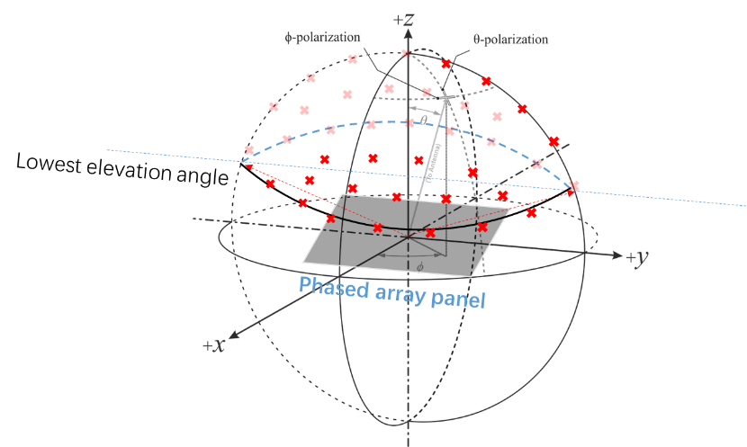

- Proposal 3: All types of VSAT should declare its lowest supported elevation angle. [Samsung]
- For Type 1/4, it can be derived from its capability from the associated rotating motors/platforms.
- For Type 2/3/5, this can be derived from its beam steering capacity.
- For hybrid, it should first declare its VSAT type as agreed, and the lowest elevation angle can be derived from its mechanical and/or beam steering capabilities.
- Proposal 4: RAN4 to define this declared lowest elevation angle shall be at most [60-deg]. [Samsung]
- Proposal 5: To specify “upper hemispherical coverage grid” as term for the definition. [Huawei]
- Proposal 6: To consider the following as upper hemispherical coverage grid for Ka band NTN VSAT. Additionally, Horizontal coverage range and Vertical coverage range can be declared by manufacturers. [Huawei]
- Recommended for further discussion:
  - NTN VSAT need to declare its supported lowest elevation angle from transmitter perspective regardless of mechanical steering antenna or electronic steering antenna or hybrid.
  - Within the declared supported elevation range or beam steering range, the minimum EIRP requirement should be fulfilled at Tx beam peak direction of any steered beam.
  - Further discuss whether lowest elevation angle shall be at most [60-deg]
Issue 1-8: On-axis cross polarization isolation requirements VS Pointing accuracy requirements in clause 9.6.1
- Proposal 1: To consider the following modifications for clause 9.6.1 from TS 38.101-5. [Huawei]

9.6.1 Minimum requirement for Mobile VSAT
The applicant shall declare the peak pointing accuracy (δφ) and the associated statistical basis.
The antenna shall maintain the declared peak pointing accuracy (δφ), such that the off-axis EIRP emission density pattern projected onto the geostationary arc remains within the mask specified in clauses 9.2.2.2 and 9.2.2.3 when shifted by an angle of ±(δφ°), taking into account the following factors [EN 303 978]:
- the worst case operational environmental conditions;
- maximum ESOMP dynamics; and
- the range of latitude, longitude and altitude relative to the satellite orbital position.

[For circularly polarized ESOMPs, the applicant shall declare the voltage axial ratio.]

- Recommended for further discussion:
  - Need further discussion.

Topic #1: NTN UE Rx RF requirement

Companies’ contributions summary
T-doc number | Company | Proposals / Observations
R4-2408699 | Ericsson | NTN enhancement - NTN UE Rx requirements  Proposal: Align the maximum input power requirement for VSAT types 1, 2 and 3.  Proposal: To specify ACS test parameters, RAN4 should consider the following alternatives:  - Alt1: Re-evaluate the maximum input power considering adjacent TN networks.  - Alt2: For the NTN Ka-band only, specify only one case for ACS test parameters with an interferer level equal to the agreed VSAT maximum input power, the corresponding degradation of the wanted signal might need further discussion.
R4-2408702 | Ericsson | NTN enhancement: draft CR to TS 38.101-5 NTN Ka-band - additional Rx updates to the running CR
R4-2409045 | Samsung | On NTN UE RF Rx requirements  Proposal 1: For measurement metric for EIS_{REFSENS} for Type 1/4 VSAT (mechanical steering antenna), the EIS_{REFSENS} can be verified for the beam peak direction, assuming the rotating motors can be cover all declared elevation angles.  - If the rotating motors cannot cover all declared elevation angles (e.g. hybrid steering), the EIS_{REFSENS} should be verified for the spherical grid between the declared supported lowest elevation angles, like a electronic steering type VSAT.  Proposal 2: For measurement metric for EIS_{REFSENS} for Type 2/3/5 VSAT (electronic steering antenna), the EIS_{REFSENS} should be verified for the spherical grid between the declared supported lowest elevation angles (as shown in Figure 1-3).  Figure 1-3 Measurement grid for EIS_{REFSENS} of a phase array VSAT  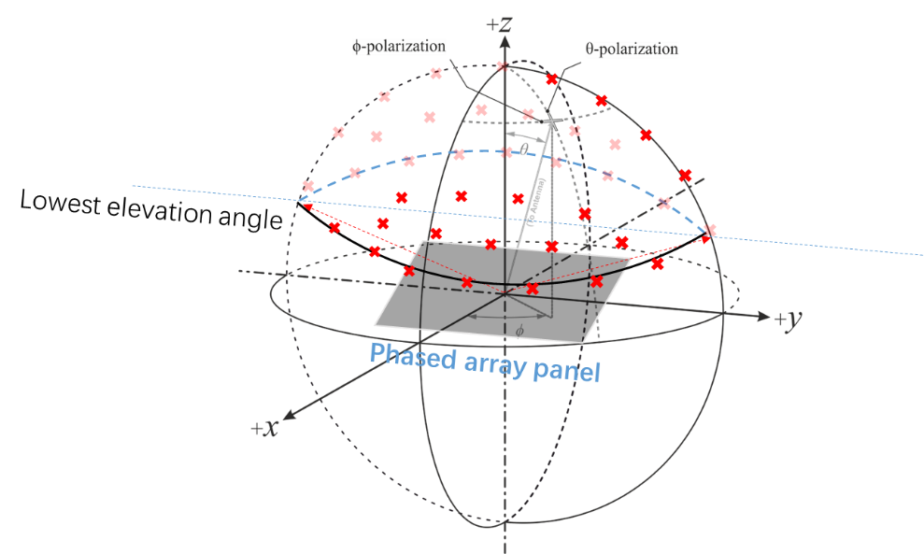  Proposal 3: All types of VSAT should declare its lowest supported elevation angle.  - For Type 1/4, it can be derived from its capability from the associated rotating motors/platforms.  - For Type 2/3/5, this can be derived from its beam steering capacity.  - For hybrid, it should first declare its VSAT type as agreed, and the lowest elevation angle can be derived from its mechanical and/or beam steering capabilities.  Proposal 4: RAN4 to define this declared lowest elevation angle shall be at most [60-deg].  Observation 3: The Maximum input power was defined as BW agnostic and it considered the SAN in the best condition (i.e. clear sky, VSAT at SAN nadir) in channel. However, the P_interference should consider the maximum input power level as from the aggressor from adjacent channel, which possibly would include NTN-TN case is different to the maximum input power level.  Proposal 5: Propose NOT to use maximum input power level as the interfernce power level for ACS testing configuration.  Proposal 6: Propose to define the P_interference as REFSENS+[29.5] and P_wanted as REFSENS+[6] from the REFSENS and ACS values, assuming SNR as -1 and IM as 2.5, for ACS test configuration. These values can be updated based on assumption change accordingly.
R4-2409048 | Samsung | draft CR for TS 38.101-5 Chapter 10.3
R4-2409326 | Huawei, HiSilicon | Draft CR for 38.101-5 to introduce clause 10.1~10.3
R4-2409330 | Huawei, HiSilicon | Discussion on Rx requirement for Ka band NTN UE  Observation 1: the minimum EIS requirements specified in current spec cannot reflect the real performance of the NTN VSAT as different antenna apertures lead to different EIS requirements.  Proposal 1: To consider declaration methodology for the NTN VSAT EIS requirements with the following changes.  10.3.2 Minimum requirement  The throughput shall be ≥ 95 % of the maximum throughput of the reference measurement channels as [specified in Annexes A.2.3.2 and A.3.3.2 (with one sided dynamic OCNG Pattern OP.1 FDD for the DL-signal as described in Annex A.5.2.1) with peak reference sensitivity specified in Table 10.3.2-1. And EIS_{REFSENS_50M} declared by the vendor is an integer value in the range specified in Table 10.3.2-2 for different types of NTN VSAT]. The requirement is verified with the test metric of EIS (Link=RX beam peak direction, Meas=Link Angle).  Table 10.3.2-1: OTA reference sensitivity requirement for NTN VSAT  NTN VSAT channel bandwidth (MHz) UL/DL RB allocation OTA reference sensitivity level, EIS_{REFSENS} (dBm)  50, 100, 200, 400 Full RB allocation N_{RB} as specified in clause 5.3.2 EIS_{REFSENS_50MHz} + 10log₁₀(N_{RB} x SCS x 12 / factor) (NOTE 1)  NOTE 1: The “factor” represents the normalized factor to scale EIS for different (Channel bandwidth, SCS) configurations. The value of factor is 66 RBs x 60 kHz SCS x 12, i.e. 47520 kHz.  Table 10.3.2-2: The range of EIS_{REFSENS_50MHz} declared by vendor per NTN VSAT  Operating band NTN VSAT class NTN VSAT type The range of EIS_{REFSENS_50MHz} (dBm)  n512, n511 Fixed VSAT 1, 2 ≤ -122  3 ≤ -115.6  n512, n511, n510 Mobile VSAT 4, 5 ≤ -122  Proposal 2: it’s proposed to specify -101dBm as OTA maximum input level for (type 3 UE) fixed VSAT supporting LEO only with electronical steering antenna.  Proposal 3: it’s proposed to define 64QAM for maximum input level tests.  Observation 2: The maximum Limit of power flux-density at the Earth’s surface from space stations in the ITU Radio Regulations is -105dBw/m²/MHz in 17.7GHz ~ 21.2GHz where the frequency bands are shared with equal rights with the fixed or mobile service.  Proposal 4: -105 dBw/m²/MHz limit of power flux density can be used to derive the maximum interference level.  Proposal 5: it’s proposed to specify ACS test configuration below.  Rx Parameter Units Channel bandwidth  50 MHz 100 MHz 200 MHz 400 MHz  Power in Transmission Bandwidth Configuration dBm EIS_{REFSENS_50M} + 6 dB + 10log₁₀(N_{RB} x SCS x 12 / factor)  P_{Interferer} for band n512, n511, n510 dBm Max((EIS_{REFSENS_50M} + 28.7), -104.07) + 10log₁₀(N_{RB} x SCS x 12 / factor)  BW_{Interferer} MHz 50 100 200 400  F_{Interferer} (offset) MHz 50 / -50 NOTE 3 100 / -100 NOTE 3 200 / -200 NOTE 3 400 / -400 NOTE 3  NOTE 1: The interferer consists of the Reference measurement channel specified in Annex A.3.2 with one sided dynamic OCNG Pattern as described in Annex A.3.2 and set-up according to Annex C.  NOTE 2: EIS_{REFSENS_50M} declared by the vendor is an integer value in the range specified in Table 10.3.2-2 for different types of NTN VSAT.  NOTE 3: The absolute value of the interferer offset F_{Interferer} (offset) shall be further adjusted to (CEIL(|F_{Interferer}(offset)|/SCS) + 0.5)*SCS MHz with SCS the sub-carrier spacing of the wanted signal in MHz. Wanted and interferer signal have same SCS.  [NOTE 4: The transmitter shall be set to same as the P_{UMAX,f,c} as defined in clause 6.2.4, with uplink configuration specified in Clause 10.3.]  NOTE 5: The “factor” represents the normalized factor to scale wanted signal and interference level for different (Channel bandwidth, SCS) configurations. The value of factor is 66 RBs x 60 kHz SCS x 12, i.e. 47520 kHz.
R4-2409332 | Huawei, HiSilicon | CR for TR 38.863 to introduce some technical background for R18 NTN VSAT UE Rx requirements
R4-2409617 | ZTE Corporation, Sanechips | Further discussion on Rx RF requirements for NTN in Ka-band  Proposal 1:  - For the type 3, to specify the maximum input power as -101dBm for all channel bandwidth and applicable modulation order as 64QAM  - For the type 1,2,4,5, to specify the maximum input power as -109.6Bm for all channel bandwidth and applicable modulation order as 16QAM and [64QAM]  Proposal 2: to define the ACS requirement for VSAT as following without Case 2 ACS requirement defined:  Table 7.5-1: Adjacent channel selectivity  Operating band Units Adjacent channel selectivity / Channel bandwidth  50 MHz 100 MHz 200 MHz 400 MHz  n512, n511, n510 dB 25 25 25 25  Table 7.5-2: Test parameters for adjacent channel selectivity, Case 1  Rx Parameter Units Channel bandwidth  50 MHz 100 MHz 200 MHz 400 MHz  Power in Transmission Bandwidth Configuration dBm REFSENS + 14 dB  P_{Interferer} for band n512, n511, n510 dBm REFSENS + 37.5 dB REFSENS +37.5 dB REFSENS +37.5 dB REFSENS +37.5 dB  BW_{Interferer} MHz 50 100 200 400  F_{Interferer} (offset) MHz 50 / -50 NOTE 3 100 / -100 NOTE 3 200 / -200 NOTE 3 400 / -400 NOTE 3  NOTE 1: The interferer consists of the Reference measurement channel specified in Annex A.3.2 with one sided dynamic OCNG Pattern as described in Annex A.3.2 and set-up according to Annex C.  NOTE 2: The REFSENS power level is specified in Clause 7.3.2, which are applicable to different UE power classes.  NOTE 3: The absolute value of the interferer offset F_{Interferer} (offset) shall be further adjusted to (CEIL(|F_{Interferer}|/SCS) + 0.5)*SCS MHz with SCS the sub-carrier spacing of the wanted signal in MHz. Wanted and interferer signal have same SCS.
R4-2409618 | ZTE Corporation, Sanechips | Draft CR to TS 38.101-5 Clause 10.4, 10.6, 10.8 and Annex

Open issues summary
Before e-Meeting, moderators shall summarize list of open issues, candidate options and possible WF (if applicable) based on companies’ contributions.

Sub-topic 2 Rx requirement
Sub-topic description:
Open issues and candidate options before e-meeting:.
Issue 2-1 Minimum EIS requirement
- Proposal 1: [Huawei]
  - Proposal 1: To consider declaration methodology for the NTN VSAT EIS requirements with the following changes.

10.3.2 Minimum requirement
The throughput shall be ≥ 95 % of the maximum throughput of the reference measurement channels as [specified in Annexes A.2.3.2 and A.3.3.2 (with one sided dynamic OCNG Pattern OP.1 FDD for the DL-signal as described in Annex A.5.2.1) with peak reference sensitivity specified in Table 10.3.2-1. And EIS_{REFSENS_50M} declared by the vendor is an integer value in the range specified in Table 10.3.2-2 for different types of NTN VSAT]. The requirement is verified with the test metric of EIS (Link=RX beam peak direction, Meas=Link Angle).
Table 10.3.2-1: OTA reference sensitivity requirement for NTN VSAT
NTN VSAT channel bandwidth (MHz) | UL/DL RB allocation | OTA reference sensitivity level, EIS_{REFSENS}  (dBm)
50, 100, 200, 400 | Full RB allocation N_{RB} as specified in clause 5.3.2 | EIS_{REFSENS_50MHz} + 10log₁₀(N_{RB} x SCS x 12 / factor)  (NOTE 1)
NOTE 1: The “factor” represents the normalized factor to scale EIS for different (Channel bandwidth, SCS) configurations. The value of factor is 66 RBs x 60 kHz SCS x 12, i.e. 47520 kHz.

Table 10.3.2-2: The range of EIS_{REFSENS_50MHz} declared by vendor per NTN VSAT
Operating band | NTN VSAT class | NTN VSAT type | The range of EIS_{REFSENS_50MHz}  (dBm)
n512, n511 | Fixed VSAT | 1, 2 | ≤ -122
 |  | 3 | ≤ -115.6
n512, n511, n510 | Mobile VSAT | 4, 5 | ≤ -122

- Recommended for further discussion:
  - Need further discussions,

Issue 2-2: Maximum input power
- Proposal: Align the maximum input power requirement for VSAT types 1, 2 and 3. [Ericsson]
- Proposal 2: it’s proposed to specify -101dBm as OTA maximum input level for (type 3 UE) fixed VSAT supporting LEO only with electronical steering antenna. [Huawei]
- Proposal 3: it’s proposed to define 64QAM for maximum input level tests. [Huawei]
- Proposal 3: [ZTE]
- For the type 3, to specify the maximum input power as -101dBm for all channel bandwidth and applicable modulation order as 64QAM
- For the type 1,2,4,5, to specify the maximum input power as -109.6Bm for all channel bandwidth and applicable modulation order as 16QAM and [64QAM]
- Recommended for further discussion:
  - For type 1/2/3,
- Option 2: -101dBm as maximum input power with 64QAM
  - For type 4/5:
- Option 1: -109.6dBm with 16QAM and [64QAM ] for type 1/2/4/5.
  - For MCS for 64QAM
- Please check the MCS in R4-2409618.

Issue 2-3: ACS
- Proposal 1: To specify ACS test parameters, RAN4 should consider the following alternatives: [Ericsson]
- Alt1: Re-evaluate the maximum input power considering adjacent TN networks.
- Alt2: For the NTN Ka-band only, specify only one case for ACS test parameters with an interferer level equal to the agreed VSAT maximum input power, the corresponding degradation of the wanted signal might need further discussion.
- Proposal 2: Propose NOT to use maximum input power level as the interfernce power level for ACS testing configuration. [Samsung]
- Proposal 3: Propose to define the P_interference as REFSENS+[29.5] and P_wanted as REFSENS+[6] from the REFSENS and ACS values, assuming SNR as -1 and IM as 2.5, for ACS test configuration. These values can be updated based on assumption change accordingly. [Samsung]
- Proposal 4: to define the ACS requirement for VSAT as following without Case 2 ACS requirement defined: [ZTE]
Table 7.5-1: Adjacent channel selectivity
Operating band | Units | Adjacent channel selectivity / Channel bandwidth
 |  | 50  MHz | 100  MHz | 200  MHz | 400  MHz
n512, n511, n510 | dB | 25 | 25 | 25 | 25

Table 7.5-2: Test parameters for adjacent channel selectivity, Case 1
Rx Parameter | Units | Channel bandwidth
 |  | 50 MHz | 100 MHz | 200 MHz | 400 MHz
Power in Transmission Bandwidth Configuration | dBm | REFSENS + 14 dB
P_{Interferer} for band n512, n511, n510 | dBm | REFSENS  + 37.5 dB | REFSENS +37.5 dB | REFSENS  +37.5 dB | REFSENS  +37.5 dB
BW_{Interferer} | MHz | 50 | 100 | 200 | 400
F_{Interferer} (offset) | MHz | 50  /  -50  NOTE 3 | 100  /  -100  NOTE 3 | 200  /  -200  NOTE 3 | 400  /  -400  NOTE 3
NOTE 1: The interferer consists of the Reference measurement channel specified in Annex A.3.2 with one sided dynamic OCNG Pattern as described in Annex A.3.2 and set-up according to Annex C.
NOTE 2: The REFSENS power level is specified in Clause 7.3.2, which are applicable to different UE power classes.
NOTE 3: The absolute value of the interferer offset F_{Interferer} (offset) shall be further adjusted to (CEIL(|F_{Interferer}|/SCS) + 0.5)*SCS MHz with SCS the sub-carrier spacing of the wanted signal in MHz. Wanted and interferer signal have same SCS.

- Proposal 5: -105 dBw/m2/MHz limit of power flux density can be used to derive the maximum interference level. [Huawei]
- Proposal 6: it’s proposed to specify ACS test configuration below. [Huawei]
Rx Parameter | Units | Channel bandwidth
 |  | 50 MHz | 100 MHz | 200 MHz | 400 MHz
Power in Transmission Bandwidth Configuration | dBm | EIS_{REFSENS_50M} + 6 dB + 10log₁₀(N_{RB} x SCS x 12 / factor)
P_{Interferer} for band n512, n511, n510 | dBm | Max((EIS_{REFSENS_50M} + 28.7), -104.07) + 10log₁₀(N_{RB} x SCS x 12 / factor)
BW_{Interferer} | MHz | 50 | 100 | 200 | 400
F_{Interferer} (offset) | MHz | 50  /  -50  NOTE 3 | 100  /  -100  NOTE 3 | 200  /  -200  NOTE 3 | 400  /  -400  NOTE 3
NOTE 1: The interferer consists of the Reference measurement channel specified in Annex A.3.2 with one sided dynamic OCNG Pattern as described in Annex A.3.2 and set-up according to Annex C.
NOTE 2: EIS_{REFSENS_50M} declared by the vendor is an integer value in the range specified in Table 10.3.2-2 for different types of NTN VSAT.
NOTE 3: The absolute value of the interferer offset F_{Interferer} (offset) shall be further adjusted to (CEIL(|F_{Interferer}(offset)|/SCS) + 0.5)*SCS MHz with SCS the sub-carrier spacing of the wanted signal in MHz. Wanted and interferer signal have same SCS.
[NOTE 4: The transmitter shall be set to same as the P_{UMAX,f,c} as defined in clause 6.2.4, with uplink configuration specified in Clause 10.3.]
NOTE 5: The “factor” represents the normalized factor to scale wanted signal and interference level for different (Channel bandwidth, SCS) configurations. The value of factor is 66 RBs x 60 kHz SCS x 12, i.e. 47520 kHz.

- Recommended for further discussion:
  - Need further discussions online.
  - ACS was agreed as 25dBc in last RAN4 meeting.
  - Whether to consider the BS like requirement or UE like requirement.
  - Whether to set the interfering signal of ACS Case 2 requirement to be same as maximum input power
- No: Samsung, ZTE
- Compromised solution: consider both NTN coexisting with NTN and NTN coexistence with TN
- For NTN coexisting with TN, NTN VSAT need to fulfill the ACS Case 1 requirement.
- For NTN coexisting with NTN, NTN VSAT need to fulfill the ACS Case 2 requirement with interfering signal as the same as maximum input power level;
  - Whether to consider the regulatory PFD as maximum interference power in ACS requirement;
  - Whether to have the declared REFSENS requirements for ACS requirement.

Issue 2-4: Beam steering range and test direction to fulfill minimum EIS requirement
- Proposal 1: For measurement metric for EISREFSENS for Type 1/4 VSAT (mechanical steering antenna), the EISREFSENS can be verified for the beam peak direction, assuming the rotating motors can be cover all declared elevation angles. [Samsung]
- If the rotating motors cannot cover all declared elevation angles (e.g. hybrid steering), the EISREFSENS should be verified for the spherical grid between the declared supported lowest elevation angles, like a electronic steering type VSAT.
- Proposal 2: For measurement metric for EISREFSENS for Type 2/3/5 VSAT (electronic steering antenna), the EISREFSENS should be verified for the spherical grid between the declared supported lowest elevation angles (as shown in Figure 1-3). [Samsung]
- Figure 1-3 Measurement grid for EIS_{REFSENS} of a phase array VSAT
- 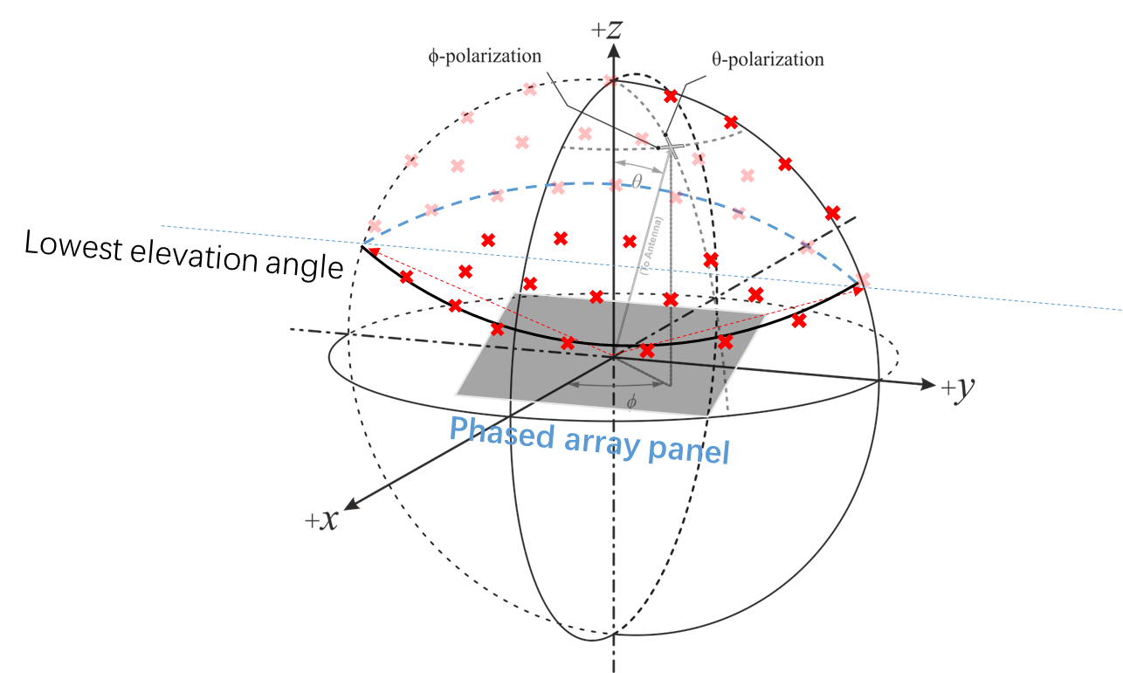

- Proposal 3: All types of VSAT should declare its lowest supported elevation angle. [Samsung]
- For Type 1/4, it can be derived from its capability from the associated rotating motors/platforms.
- For Type 2/3/5, this can be derived from its beam steering capacity.
- For hybrid, it should first declare its VSAT type as agreed, and the lowest elevation angle can be derived from its mechanical and/or beam steering capabilities.
- Proposal 4: RAN4 to define this declared lowest elevation angle shall be at most [60-deg].
Recommended for further discussion:
  - NTN VSAT need to declare its supported lowest elevation angle from receiver perspective regardless of mechanical steering antenna or electronic steering antenna or hybrid.
  - Within the declared supported elevation range or beam steering range, the minimum EIS requirement should be fulfilled at Rx beam peak direction of any steered beam.
  - Further discuss whether lowest elevation angle shall be at most [60-deg]

Issue 2-5: Receiver antenna off-axis performance
- Proposal 1: to consider receiver antenna off-axis performance as in R4-2408702
- Recommended WF:
  - Proposal 1 is agreeable.

