3GPP TSG-RAN WG4 Meeting # 110bis R4-2408928
Fukuoka, Japan, 20th – 24th May, 2024

Agenda item: 7.1.1
Source: Moderator (vivo)
Title: Topic summary for [111][117] FR1_enh2_R18
Document for: Information

Introduction
Briefly introduce background, the scope of this email discussion (e.g. list of treated agenda items) and provide some guidelines for email discussion if necessary.

Topic #1: 4Tx Requirements
Main technical topic overview. The structure can be done based on sub-agenda basis.

Companies’ contributions summary
T-doc number | Company | Proposals / Observations
R4-2407583 | Qualcomm Technologies Int | 4 Tx DeltaP_PowerClass for SRS antenna switching  Observation1: SRS sounding scheme proposed in [1] is complicated and permits larger than required power back-offs for certain architectures.  Observation2: For 4 Tx architectures that have a 26 dBm PA which can be used for SRS transmission all sounding schemes of t1ry, t2ry and t4ry are possible. For the 4X23 dBm architecture SRS sounding is possible with t4ry.  Observation3: The scheme of using a 26 dBm PA for SRS antenna switching leaves the current standard unchanged.  Proposal 1: For 4 Tx architectures defined in Rel-18 use a 26 dBm PA to perform SRS transmission. If for a given architecture only a 23 dBm PA is available for SRS transmission, then limit SRS antenna switching to t4ry.
R4-2407682 | Huawei, HiSilicon | Delta Ppowerclass and Delta TRxSRS for 4Tx for SRS antenna switching  Observation 1: Current specification for 2Tx allows a specific implementation such that UE with 26 + 23 dBm PA, but the UE does not use 26 dBm PA to transmit SRS from other than main antenna to keep maximum power the same as that of the advertised power class. For this purpose, ΔP_{PowerClass} is kept 0 dB, while, ΔT_{RxSRS} is relaxed by 3 dB instead.  Observation 2: Applying the same principle for 2Tx written in Observation 1 to 4Tx makes requirements even more complicated, since achievable power by UE with 4Tx per SRS transmission occasion has variation such that 23 or 26dBm@one port for t1ry, 26, 29 or 27.8 dBm@two ports for t2ry and 29 dBm@four ports.  Observation 3: Mixing ΔP_{PowerClass} and ΔT_{RxSRS} will lead to confusion when solution for power imbalance across ports is discussed, since the current requirements mean that in some cases ΔT_{RxSRS} include both PA power ability and IL, and in some other cases, it doesn’t include only IL.  Observation 4: Extending a way for PC2 2Tx to avoid antenna virtualization to PC1.5 UE with 4Tx makes the requirement become too pessimistic and it doesn’t allow UE to transmit 26 dBm even if the UE implements 26 dBm x 4 PA configurations if ΔP_{PowerClass} of 6 dB is applied.  Observation 5: Extending a way for PC2 2Tx to avoid antenna virtualization to PC1.5 UE with 4Tx will not function unless ΔP_{PowerClass} is set to “6 dB + ΔT_{RxSRS}”, since if ΔT_{RxSRS} is larger than or equal to 3 dB, even UE uses two 23 dBm PAs at a time, the total power is less or almost the same as that from 23 dBm from main port with ΔT_{RxSRS} with 0 dB.  Observation 6: From Observation 1 to 5, extension of the current ways for 2Tx dedicated to a certain implementation or to avoid certain implementation doesn’t function unless more complicated requirements are introduced or even larger relaxation is introduced.  Proposal 1: Do not make ΔT_{RxSRS} include PA ability, i.e., decouple ΔP_{PowerClass} and ΔT_{RxSRS}  Proposal 2: Do not lower P_{CMAX_H,f,c} depending on the number of SRS ports in each SRS transmission occasion due to variation of PA configurations  Proposal 3: Apply ΔP_{PowerClass} to only P_{CMAX_L,f,c} as exception in case of SRS antenna switching as follows.  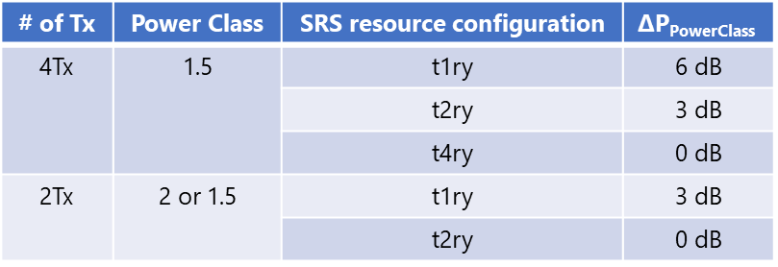  Proposal 4: Remove following texts and similar from the specification if Proposal 3 is agreed.  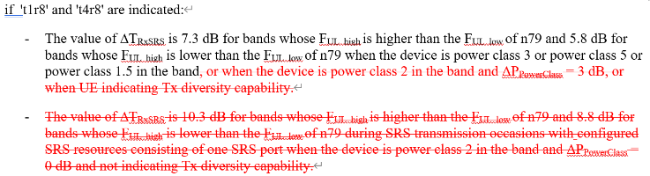
R4-2407683 | Huawei, HiSilicon | Correction of Delta Ppowerclass and Delta TRxSRS for 4Tx for SRS antenna switching
R4-2408113 | vivo | Further discussion on 4Tx power degradation for SRS antenna switching  Observation 1: Option 1 is too complicated and also have extra relaxation for certain implementations, thus is not preferred.  Observation 2: Option 2 unnecessarily restricted the uplink power for certain even majority implementations, thus are harmful for this feature.  Observation 3: Do not define such requirements for 4Tx (option 3) is also a reasonable WF, and the performance may not be worse than option 1 and 2.  Proposal: Do not define new ΔP_{PowerClass} requirements for 4Tx to restrict the architectures or power in SRS antenna switching, and to refine the wording of current requirements to insure only appliable for 2Tx.
R4-2408114 | vivo | CR for 4Tx power degradation for SRS antenna switching  - 3dB is applied during SRS transmission occasions with usage in SRS-ResourceSet set as ‘antennaSwitching’ with configured SRS resources in each SRS resource set(s) consisting of one SRS port when PC2 UE with txDiversity-r16 or txDiversity2Tx-r18 capability or 2Tx PC1.5 UE further indicates SRS-TxSwitch capability ‘t1r2’ or ‘t1r4’ or ‘t1r1-t1r2’ or ‘t1r1-t1r2-t1r4’ or further indicates srs-AntennaSwitchingBeyond4RX-r17 as ‘t1r8’;
R4-2409772 | Ericsson India Private Limited | On DeltaP_PowerClass for SRS antenna switching for 4Tx  Observation 1: ΔP_{PowerClass} requirement definition has been extended in Rel-17 to apply for SRS transmission occasions with usage in SRS-ResourceSet set as ‘antennaSwitching’, where the main motivation was to prevent UEs which indicate PC1.5 or PC2 together with txDiversity-r16 to virtualize the SRS ports by using 2 Tx chains.  Observation 2: The introduction of additional 3dB relaxation of ΔT_{RxSRS} was motivated by the case of a UE sounding some SRS ports with 26dBm while other with 23dBm. Due to the nature of ΔT_{RxSRS}, which is a maximum allowed relaxation, UEs equipped with only PAs of 26dBm or with both 23dBm and 26dBm PAs and where PA of 26dBm is used for SRS sounding could also apply the relaxed values of ΔT_{RxSRS} which should not be allowed.  Observation 3: The drawbacks of the solution proposed in R4-2400341 are that for the case of no 4TxD capability being indicated, SRS ports are not sounded with the same power and also in that case there is no guarantee that the UE is equipped with at least two PAs of 26dBm.  Observation 4: The main drawback of the solution proposed in R4-2404658 is that the additionally relaxed ΔT_{RxSRS} allows unnecessary relaxation in the number of cases, e.g. the UE equipped with at least one PA of 26 dBm indicating ‘t1ry’ AS capability. The uncertainty of SRS transmission power at the gNB would be even larger which would very negatively affect the channel estimation accuracy.  Observation 5: The absence of knowledge of the increased SRS power being used for AS may introduce performance degradation rather than a gain.  Observation 6: Ultimately, there is no perfect solution among the ones proposed so far, but we still believe that our proposed one (Proposal 2) would minimize the uncertainty at the gNB and thus maximize the performance of the channel state estimation in the field, which is the main goal of the antenna switching usage of SRS.  Proposal 1: To address the power limitation issue for SRS transmissions for AS for UEs equipped with 4 Tx chains, avoid combining ΔP_{PowerClass} and ΔT_{RxSRS} requirements since those two have a different nature and introduce uncertainty at the gNB and thus degrade the channel estimation accuracy.  Proposal 2: We propose that different values should be applicable for ΔP_{PowerClass} as a function of the indicated AS capability:  - For ‘t4ry’ AS capability, ΔP_{PowerClass} = 0 dB.  - For ‘t2ry’ and similar AS capabilities, ΔP_{PowerClass} = 3 dB.  - For ‘t1ry’ and similar AS capabilities, ΔP_{PowerClass} = 6 dB.  Proposal 3: The optimal solution from the channel estimation performance perspective, which we would prefer if it were acceptable for all companies, is to let the UE report the appropriate ΔP_{PowerClass} depending on its PA configuration. That would allow reporting a different ΔP_{PowerClass} for different SRS ports. With such solution both the transmitted power of each SRS port would be maximized and there would be no uncertainty at the gNB regarding the SRS transmission power.
R4-2409774 | Ericsson India Private Limited | CR to 38.101: DeltaP_PowerClass correction for SRS AS for 4Tx
R4-2407902 | CHTTL, Rohde & Schwarz, NTT DOCOMO INC, Samsung, SGS Wireless, ZTE Corporation, Vivo, Google Inc. | CR for TS 38.101-1: some update on EVM requirement for 4Tx UL MIMO  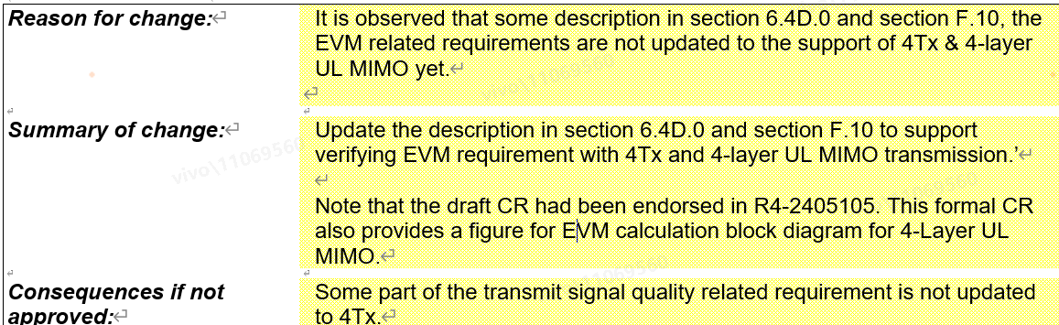
R4-2407648 | Huawei, HiSilicon | R18 Cat-F CR 38.101-1 correction CR for 4Tx requirements  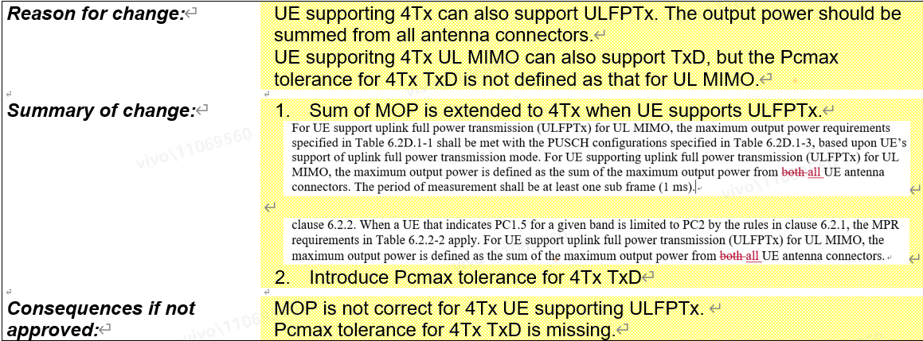

Open issues summary
Before Meeting, moderators shall summarize list of open issues, candidate options and possible WF (if applicable) based on companies’ contributions.

Sub-topic 1-1 4Tx ΔP_{PowerClass} and Related
Sub-topic description
Open issues and candidate options before meeting:
Issue 1-1-1: How to solve the 4Tx ΔP_{PowerClass} issue?
- Proposals
  - Proposal 1: Do not define new ΔP_{PowerClass} requirements for 4Tx to restrict the architectures or power in SRS antenna switching, and to refine the wording of current requirements to insure only appliable for 2Tx. (vivo)
  - Proposal 2: For 4 Tx architectures defined in Rel-18 use a 26 dBm PA to perform SRS transmission. If for a given architecture only a 23 dBm PA is available for SRS transmission, then limit SRS antenna switching to t4ry. (Qualcomm)
  - Proposal 3: (Huawei)
    - Proposal 3-1: Do not make ΔT_{RxSRS} include PA ability, i.e., decouple ΔP_{PowerClass} and ΔT_{RxSRS}
    - Proposal 3-2: Do not lower P_{CMAX_H,f,c} depending on the number of SRS ports in each SRS transmission occasion due to variation of PA configurations
    - Proposal 3-3: Apply ΔP_{PowerClass} to only P_{CMAX_L,f,c} as exception in case of SRS antenna switching as follows.
    - Proposal 3-4: Remove following texts and similar from the specification if Proposal 3 is agreed.
  - Proposal 4: (Ericsson):
    - Proposal 1: To address the power limitation issue for SRS transmissions for AS for UEs equipped with 4 Tx chains, avoid combining ΔP_{PowerClass} and ΔT_{RxSRS} requirements since those two have a different nature and introduce uncertainty at the gNB and thus degrade the channel estimation accuracy.
    - Proposal 2: We propose that different values should be applicable for ΔP_{PowerClass} as a function of the indicated AS capability:
      - For ‘t4ry’ AS capability, ΔP_{PowerClass} = 0 dB.
      - For ‘t2ry’ and similar AS capabilities, ΔP_{PowerClass} = 3 dB.
      - For ‘t1ry’ and similar AS capabilities, ΔP_{PowerClass} = 6 dB.
    - Proposal 3: Let the UE report the appropriate ΔP_{PowerClass} depending on its PA configuration. That would allow reporting a different ΔP_{PowerClass} for different SRS ports.
  - Proposal 5: Others.

- Recommended WF
  - TBD

Sub-topic 1-1 Other 4Tx (CRs)

Issue 1-2-1: EVM for 4Tx UL-MIMO.
- Proposals
  - Proposal : Accept update on EVM requirement for 4Tx UL MIMO (As in CR R4-2407902).

- Recommended WF
  - TBA

Issue 1-2-2: General correction for 4Tx requirements.
- Proposals
  - Proposal : Accept corrections on 4Tx requirements (As in CR R4-2407648).

- Recommended WF
  - TBA

Topic #2: Lower MSD and 8Rx
Main technical topic overview. The structure can be done based on sub-agenda basis.

Companies’ contributions summary
T-doc number | Company | Proposals / Observations
R4-2408618 | Huawei, Hisilicon | CR on 38.101-1: adding missing 8Rx requirements  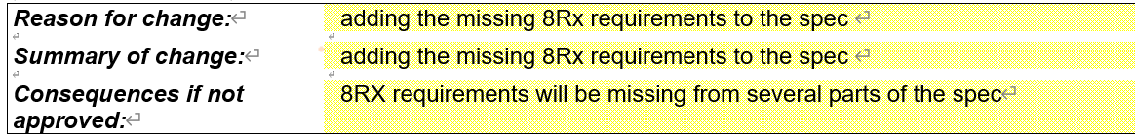
R4-2408370 | ZTE Corporation, CHTTL, Samsung, Sanechips | CR for TS 38.101-1: 4Rx/8Rx applicability for Lower-MSD requirements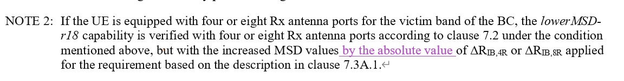  (Resubmission of endorsed draft CR)
R4-2408371 | ZTE Corporation, CHTTL, Samsung, Sanechips | CR for TS 38.101-3: 4Rx/8Rx applicability for Lower-MSD requirements  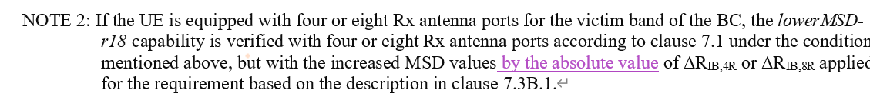  (Resubmission of endorsed draft CR)
R4-2409640 | Huawei, HiSilicon | (NR_ENDC_RF_FR1_enh2-Core) Correction on lowerMSD verification  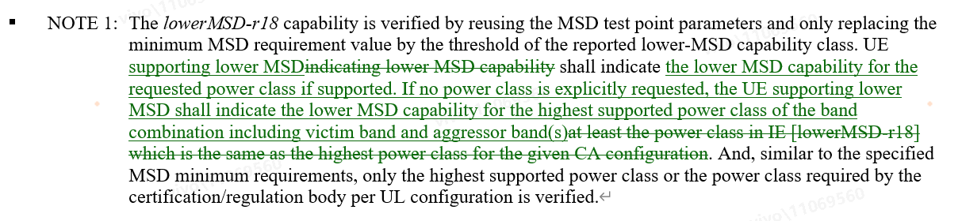  (Resubmission of endorsed draft CR)
R4-2409641 | Huawei, HiSilicon | (NR_ENDC_RF_FR1_enh2-Core) Correction on Lower-MSD verification for EN-DC  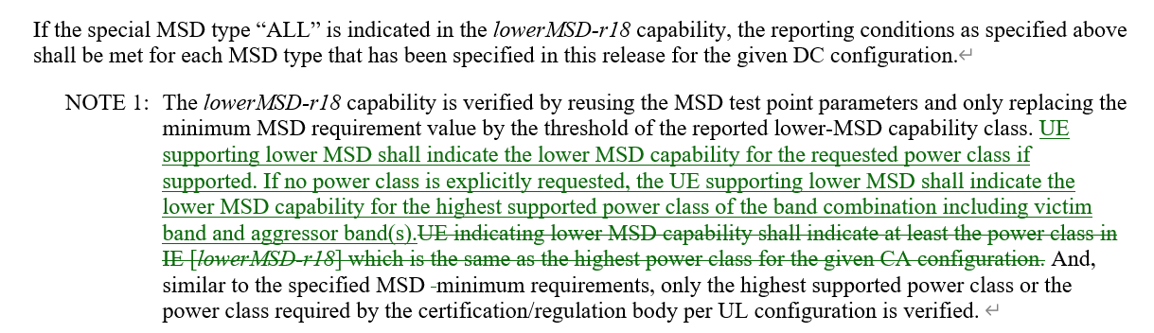  (Resubmission of endorsed draft CR)

Open issues summary
Before Meeting, moderators shall summarize list of open issues, candidate options and possible WF (if applicable) based on companies’ contributions.

Sub-topic 2-1 CRs
Sub-topic description
Open issues and candidate options before meeting:
Issue 2-1-1: 8 Rx requirements CR
- Proposals
  - Proposal : Accept corrections on 8Rx requirements (As in CR R4-2408618).

- Recommended WF
  - TBA

Issue 2-1-2: Other endorsed CRs
- Proposals
  - Proposal : Accept Other endorsed CRs

- Recommended WF
  - TBA

