3GPP TSG-RAN WG2 Meeting #126 R2-240xxx
Fukuoka, Japan, May 20th – 26th, 2024

Agenda item: 7.2.5
Source: Huawei, HiSilicon
Title: Summary for [AT126][407][POS] Rel-18 SRSp enhancement fields in INMs (Huawei)
Document for: Discussion and Decision

Introduction
During RAN2#126, the following proposals from the tdoc have been discussed on whether internode message needs to include the fields related to SRS enhancements in Release 18
R2-2404764 Discussion on the remaining issues for R18 RRC [H905][H920-921] Huawei, HiSilicon discussion Rel-18 NR_pos_enh2

Proposal5: Add the RRC fields for R18 enhancements for positioning SRS transmission in RRC_INACITVE in R18 in the internode message HandoverPreparationInformation

In this email discussion, we discuss on the issues have been presented

Discussion

RAN2/3 to discuss the issue?
During the discussion in RAN2#126, the issue in the above section has been discussed in RAN2 and companies think there is a parallel discussion in RAN3 and parallel discussion should be avoided, and we should wait for RAN3 conclusions.
However, during offline discussion in RAN3 [CB # 13_Positioning], the following agreement has been reached regarding which group to discuss:
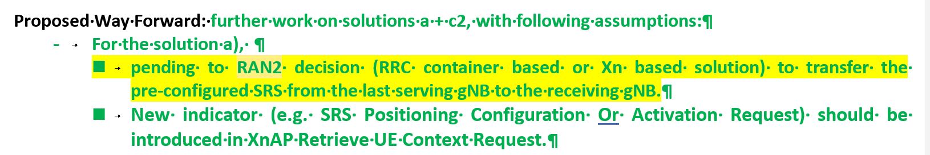
Based on the above progress, it seems that RAN3’s understanding is that RAN2 should discuss on this issue first. Hence, we would like to ask the following question:
Question1: Do companies agree that RAN2 should discuss the issue of whether to include R18 SRS enhancements for RRC_INACTIVE in RAN2?
Companies | Yes/No | Comments
Samsung | Yes | Now it seems like that RAN2 and RAN3 ping pong this issue. In our view, RAN2 should discuss it and make a decision to support the pre-configuration feature correctly before ASN.1 freeze.
ZTE | No | It is a totally RAN3 functionality issue, not RAN2.  This is all about how neighbor gNB knows the UE’s pre-configured SRS configuration from the last serving gNB. It is the interaction between neighboring gNB and last serving gNB (e.g., relocation/non-relocation way).
Intel | Yes | Based on RAN2 agreements, they left the issue to RAN2.
CATT | Yes | RAN3 has already discussed the issue as pending to RAN2 progress.

Discussions on the INM
The background of the field in the legacy releases are as follows. In the legacy CG-SDT, the following has been captured in the current RRC spec in the internode message.
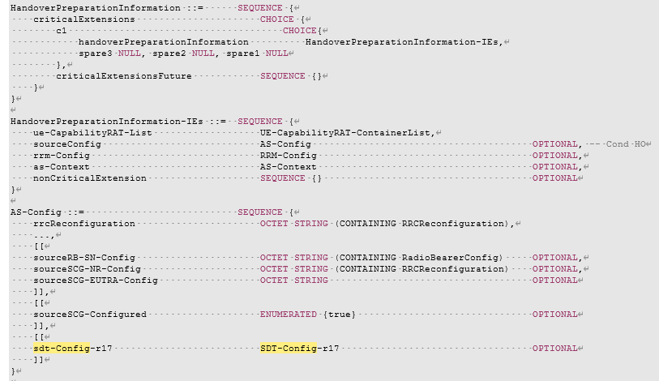
With the same reason as CG-SDT, we think the SRS configurations should also be included in the internode message to support the case when the UE sends RRC resume request in a cell different from the last serving gNB. This is already clear in the following procedure agreed in RAN3 for 38.305
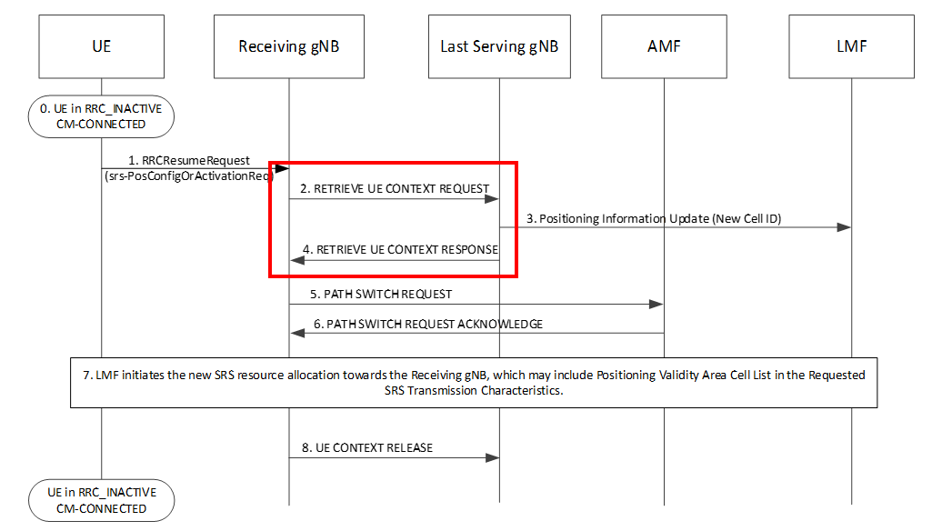
Within the XN-AP message RETRIEVE UE CONTEXT RESPONSE, the internode message HandoverPreparationInformation is used
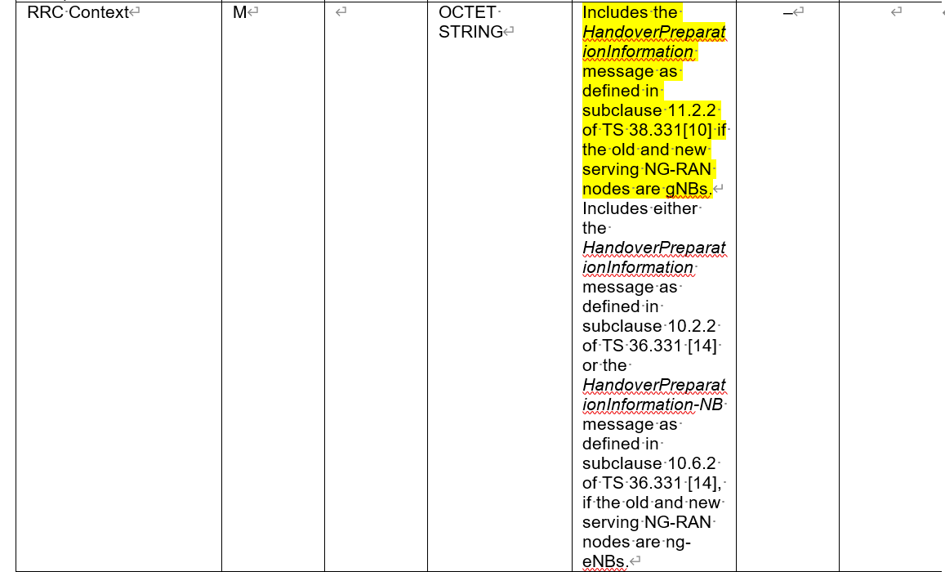
Hence, we ask the following question:
Question2: Do companies agree that SRS configurations for LPHAP introduced in RRCRelease message in R18 should be added to the internode message HandoverPreparationInformation?
Companies | Yes/No | Comments
Samsung | Yes | The positioning SRS pre-configuration forwarding from last serving gNB to new serving gNB is essential to support the R18 pre-configuration feature.  The only issue is now whether it is done by either RRC container-based solution or Xn-based solution. In our view, we can simply go with the RRC container-based solution as in the case of R17 SDT since both solution can work and there is no reason to have different solution for R18 SRS.
ZTE | No | Since it is totally RAN3 issue, XnAP is more suitable to be specified. we prefer to specify the interaction/signaling directly in XnAP message.  RAN3 should be responsible of making the spec change.
Intel | Yes | Considering RAN3 left issue to RAN2, we can decide.
CATT | Yes | HandoverPreparationInformation is used to convey the UE Context between the gNBs for Inactive, for SDT. The Pre-configured SRS Configuration is part of the configuration for the Inactive UE, it’s ok to include it in the RRCContainer, no need to add additional IEs in XnAP Retrieve UE Context Response.

Conclusion
TBD

