3GPP TSG RAN WG1 Meeting #118 R1-2405815

**Maastricht, NL, August 19th – 23rd, 2024**

**Agenda item: 9.3.1**

**Source: MediaTek Inc.**

**Title: Discussion on SBFD TX/RX/measurement procedures**

**Document for:** **Discussion and Decision**

# Introduction

The following is agreed as part of the scope of the Rel-19 WI on Evolution of NR Duplex Operation [1]

|  |
| --- |
| * Specify semi-static indication of time location of SBFD subbands to UEs in RRC_CONNECTED mode [RAN1, RAN2]   + Indication of time location of SBFD subbands in SIB is not precluded * Specify semi-static indication of frequency domain location of SBFD subbands to UEs in RRC_CONNECTED mode [RAN1, RAN2]   + Indication of frequency domain location of SBFD subbands in SIB is not precluded * Specify UE transmission, reception and measurement behavior and procedures in SBFD symbols and/or non-SBFD symbols for SBFD aware UE [RAN1, RAN2]   + Transmission and reception behaviours on SBFD subbands configured in DL and/or flexible symbol indicated by *TDD-UL-DL-ConfigCommon*   + Enhancement on resource allocation in frequency domain in SBFD symbols   + Enhancements on physical channels/signals and procedure across SBFD symbols and non-SBFD symbols in different slots, where each transmission/reception within a slot has either all SBFD or all non-SBFD symbols   + Configurations for SRS, PUCCH and PUSCH on SBFD symbols and non-SBFD symbols, e.g., resources, frequency hopping parameters, UL power control parameters and/or beam/spatial relation   + Collision handling between DL reception in DL subband(s) and UL transmission in UL subband in a SBFD symbol |

In this contribution, we discuss semi-static indication of time/freqeuncy location of SBFD subbands. In addition, we discuss transmission/reception behaviour of SBFD-aware UE in SBFD symbols, including enhancements to frequency domain resource allocation for various PHY channels/signals.

# Discussion

## Cell-specific Indication of SBFD Subbands

In this section, we provide our views on cell-specific indication of time and frequency location of SBFD subbands in RRC_CONNECTED mode.

### Cell-specific Indication of Time Location of SBFD Subbands

In legacy TDD operation, the network provides cell-specific TDD configuration to UEs using the higher layer parameter *tdd-UL-DL-ConfigurationCommon,* which indicates the time location of downlink (DL), flexible (F) and uplink (UL) slots/symbols. This parameter is configured in *ServingCellConfigCommonSIB* for the UE’s primary serving cell and in *ServingCellConfigCommon* for the UE’s other serving cells. The same parameter can be used to indicate the time location of DL, F and UL slots/symbols to a SBFD aware UE.

However, an additional cell-specific parameter (e.g., *SBFD-ConfigurationCommon*) is required to indicate the time location of SBFD subbands (i.e., the location of SBFD slots/symbols) to a SBFD-aware UE. The new cell-specific parameter can provide additional information on which slots – configured by *tdd-UL-DL-ConfigurationCommon* – are SBFD slots and non-SBFD slots. Like the TDD case, the new parameter can be provided within *ServingCellConfigCommonSIB* and/or *ServingCellConfigCommon*.

In RAN1#116 it was agreed that for semi-static indication of subband time location, SBFD symbols are configured in a consecutive manner within a TDD pattern period. Following this agreement, the cell-specific parameter to indicate time location of subband can be configured using two pairs of integer values. A first pair of integer values is used to indicate the time location of the first and last slots within a TDD pattern which contain SBFD symbols. Figure 1 shows an example in which ***slot#1*** is indicated as the first slot with SBFD symbols (i.e., ***startSlot***) and ***slot#3*** is indicated as the last slot with SBFD symbols (i.e., ***endSlot***). A second pair of integer values is used to indicate location of the first SBFD symbol (i.e., ***startSymbol***) of the slot indicated as ***startSlot***and the last SBFD symbol (i.e., ***endSymbol***) of the slot indicated as ***endSlot***.

Since it is agreed that SBFD symbols are consecutive within a TDD pattern, any symbols sandwiched between the ***startSymbol***of the ***startSlot*** (Symbol#6 in Figure 1) and the ***endSymbol***of the ***endSlot*** (Symbol#11 in Figure 1) will be SBFD symbols. Therefore, explicit indication of these SBFD symbols is not required since the UE can determine this information implicitly from the combination of {***startSlot, endSlot***} and {***startSymbol*, *endSymbol***}. This reduces signalling overhead compared to explicitly indicating the time location of each SBFD symbol.

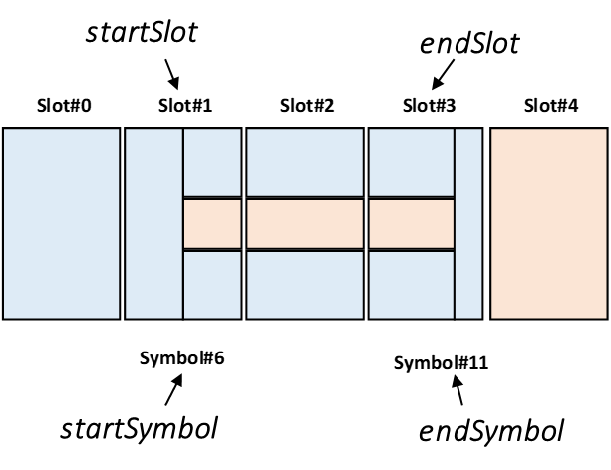

Figure 1: Two pairs of integers to indicate the time location of SBFD subbands.

1. ***SBFD aware UE can implicitly determine the time location of SBFD symbols sandwiched between the first and last SBFD symbols within a TDD pattern from the combination of {startSlot, endSlot} and {startSymbol, endSymbol}.***
2. ***Provide a new cell-specific parameter to indicate time location of SBFD subbands to SBFD-aware UE.***

* ***The new parameter can be configured as two pairs of integer values.*** 
  + ***One pair of integer values indicate the first and last slots within a TDD pattern containing SBFD symbols.***
  + ***Another pair of integer values indicate the first and last SBFD symbols within a TDD pattern.***

### Cell-specific Indication of Frequency Location of SBFD Subbands

For legacy TDD operation, the network provides the location and width of a TDD carrier to the UE using either the higher layer parameter *FrequencyInfoDL-SIB* or *FrequencyInfoDL.* Both *FrequencyInfoDL-SIB* and *FrequencyInfoDL* contain the parameter *scs-SpecificCarrierList* which provides a set of TDDcarriers for different subcarrier spacings. For SBFD operation each configured carrieris partitioned into subband(s) – during SBFD symbols. The knowledge of the frequency location of subbands must be provided to a SBFD-aware UE. One way to achieve this is to provide a new cell-specific parameters within *FrequencyInfoDL-SIB* or *FrequencyInfoDL* which can indicate the frequency location of SBFD subbands to the UE.

In RAN1#117, RAN1 agreed that for cell-specific indication of SBFD subband frequency location, the frequency locations of UL subband and DL subband(s) are explicitly configured (Guardband(s) if any are implicitly derived as the RBs which are not within UL subband or DL subband(s)). Therefore, the new cell-specific parameters provided within *FrequencyInfoDL-SIB* or *FrequencyInfoDL* can explicitly indicate the frequency location of DL subband and UL subband to SBFD aware UEs.

For example, new cell-specific parameters *scs-SpecificDownlinkSubbandList* and *scs-SpecificUplinkSubbandList* can be configured within *FrequencyInfoDL-SIB* or *FrequencyInfoDL* which can be used to provide a set of DL and UL subband configurations, respectively, for different subcarrier spacings. Each entry of the new cell-specific parameters can be configured as a single integer value representing the location and bandwidth of the respective subband, similar to the SLIV approach used in existing configuration for bandwidth part (BWP) indication.

1. ***Provide new cell-specific parameters within FrequencyInfoDL-SIB or FrequencyInfoDL to indicate the frequency location of UL-SB and DL-SB(s) for each configured cell-specific carrier.***

## Interaction between SBFD operation and UE-specific TDD slot Indication

In this section, we provide our views on interaction between SBFD-aware UE behaviour and legacy TDD slot configuration via *TDD-UL-DL-ConfigDedicated*. In particular, we discuss the use of existing UE-specific TDD slot indication for transmission direction indication in SBFD operation.

|  |
| --- |
| **Agreement RAN1#116**  For SBFD-aware UE transmission and reception in an SBFD symbol, consider the following options to determine link direction, i.e., whether to transmit or to receive in the SBFD symbol.   * Option 1: UE determines link direction based on configured/scheduled transmissions/receptions and collision handling (if any). * Option 2: link direction is indicated by gNB explicitly |

### Transmission Direction Indication using TDD-UL-DL-ConfigDedicated

In SBFD operation UE remains a half-duplex node, which implies that in SBFD symbols, the UE can perform either DL reception (on DL subbands) or UL transmission (on UL subband), but not both. To avoid collisions between DL receptions and UL transmissions, the network must provide a way for UE to determine the link direction on SBFD symbols, i.e., whether UE transmit or receive in a SBFD symbol.

In RAN1#116, RAN1 agreed two main options to determine link direction of SBFD symbols. Option 2 (explicit link direction indication by gNB) can avoid many potential collision cases by instructing UE to perform either DL reception or UL transmission on a given SBFD symbol. This simplifies the UE implementation for operation by

* Simplifying collision handling procedures.
* Allowing UE to optimize hardware configuration on a specific slot/symbol for only UL transmission (if the configured direction is UL), or for only DL reception (if the configured direction is DL).

A more advanced UE can support Option 1, where both directions (UL and DL) are considered valid on a SBFD symbol, and certain collision and prioritization rules will determine whether an UL transmission or DL reception will occur at a given instant.

1. ***Option 2, which provides an explicit link direction indication, enables low-complexity UE implementation for operations on SBFD symbols.***

Moreover, Option 2 can be achieved by reusing existing UE-specific signalling for *tdd-UL-DL-ConfigurationDedicated.* Currently *tdd-UL-DL-ConfigurationDedicated* only interacts with symbols defined as F by *tdd-UL-DL-ConfigurationCommon*. However, from a signalling point of view *tdd-UL-DL-ConfigurationDedicated* can point to any slot index (including DL slots) within a TDD pattern using the parameter “*slotIndex”*. Therefore, if in addition to F symbols, *tdd-UL-DL-ConfigurationDedicated* is allowed to interact with symbols defined as DL by *tdd-UL-DL-ConfigurationCommon,* the existing signalling can be directly reused for link direction indication in SBFD.

1. ***Explicit link direction indication (Option 2) can be achieved by reusing existing UE-specific signalling for tdd-UL-DL-ConfigurationDedicated.***

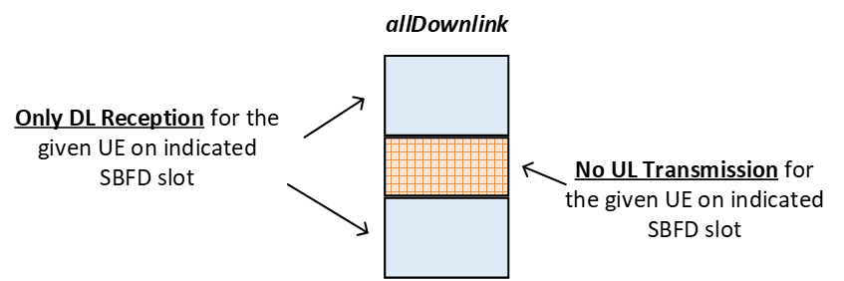

(a)

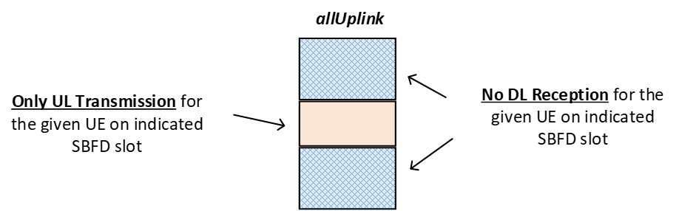

(b)

Figure 2: Transmission direction indication using *tdd-UL-DL-ConfigurationDedicated.*

The two parameters, “*slotIndex”* and “*symbols”,* within *tdd-UL-DL-ConfigurationDedicated* can be used to instruct a UE to perform either DL reception or UL transmission on SBFD symbols. The parameter “*symbols”* can be configured as “*allDownlink*”, “*allUplink*” or “*explicit*”. These parameters can be used to determine link direction on SBFD symbols as follows (see Figure 2):

* If the parameter “*slotIndex”* coincides with a slot containing SBFD symbols and the parameter “*symbols”* is configured as “*allDownlink*”
  + UE performs only DL reception on all SBFD symbols of the indicated slot (Figure 2 (a)).
* If the parameter “*slotIndex”* coincides with a slot containing SBFD symbols and the parameter “*symbols”* is configured as “*allUplink*”
  + UE performs only UL transmission on all SBFD symbols of the indicated slot (Figure 2 (b)).

1. ***Support the use of existing UE-specific TDD signalling (tdd-UL-DL-ConfigurationDedicated) for explicit transmission direction indication on SBFD symbols.***
2. ***Option 1 of transmission direction indication can be supported based on UE capability.***

## TX/RX/Measurement Behaviour for SBFD-aware UE

### FDRA Enhancements in SBFD Symbols

#### PDSCH Resource Allocation

In the current specification, the network can configure the UE to apply precoding over a resource block group (PRG) of size 2 RBs (default value), 4 RBs or “wideband”. The case of 2 RBs and 4 RBs can be directly applied on SBFD symbols – the only potential issue being the possible misaligned boundaries between PRG and UL-SB. Like the RBG case, the part of the PRG inside the DL usable PRBs can be considered as valid, which implies that the UE may perform channel estimation on fewer RB at the edge of DL-SB(s).

If PRG size is determined as “wideband” it only applies to contiguous RB allocations. To enable flexible resource allocation in SBFD operation, indication of “wideband” PRG can be allowed to cover non-contiguous RB allocation across DL-SB(s) – with contiguous resources within each DL-SB. In this case, the UE can assume that the allocated RBs within each DL-SB experience similar channel conditions. Therefore, the gNB applies the same precoding to the RBs in each DL-SB.

However, it is still unclear at this stage the impact of allowing wideband PRG to be used for channel estimation across non-contiguous DL-SBs. Any potential impact to channel estimation accuracy and UE implementation must be clearly understood before any agreement is reach by RAN1.

1. ***For partial PRG overlapping with RBs outside DL usable PRBs, the PRGs inside DL usable PRBs is considered valid. UE performs channel estimation on the non-overlapping RBs.***
2. ***Further study the performance gain and UE impact of allowing “wideband” support non-contiguous frequency resources across DL subbands.***

#### CSI-RS Resource

|  |
| --- |
| **Working Assumption**  For frequency resource allocation for CSI-RS across downlink subbands for SBFD-aware UEs, support one contiguous CSI-RS resource allocation with non-contiguous CSI-RS resource derived by excluding frequency resources outside DL usable PRBs.   * + No impact on CSI-RS sequence generation   + CSI-RS sequence mapping is applied to CSI-RS resources within DL usable PRBs only (effectively, this is same as the case when the CSI-RS sequence mapped to the RBs outside the DL usable PRBs are punctured)   + RAN1 to further study the impact on CSI processing timeline in SBFD symbols to process the CSI-RS across the two DL subbands |

In RAN1#117, RAN1 agreed a working assumption to support one contiguous CSI-RS resource allocation with non-contiguous CSI-RS resource derived by excluding frequency resources outside DL usable PRBs. RAN1 needs to further investigate the impact on CSI processing timeline in SBFD symbols to process the CSI-RS across the two DLSBs.

In our view, when UE computes a CSI report using non-contiguous CSI-RS resource(s) across the two DL-SBs, one of the following options can be considered.

* **Option#1**: The CSI processing timeline is extended by X symbols in addition to the CSI processing timeline required for computing the same CSI report(s) using contiguous CSI-RS resource(s).
  + The exact value of X can be futher studied by RAN1.
* **Option#2**: The CPUs count for computing CSI report(s) based on non-contiguous CSI-RS resource(s) across the two DL-SBs, can be considered as **twice** the CPUs count required for computing the same CSI report(s) using contiguous CSI-RS resource(s).

1. ***When UE computes a CSI report using CSI-RS resource(s) across two DL-SBs, RAN1 should adopt one of the following options.***

* ***Option#1: The CSI processing timeline is extended by X symbols. FFS the value(s) of X.***
* ***Option#2: The CPUs count for computing the CSI report(s) is twice the CPUs count required for computing the same CSI report(s) using contiguous CSI-RS resource(s).***

### PHY Channels/Signals/Procedures across SBFD and non-SBFD Symbols in Different Slots

#### CSI Reporting Configuration

|  |
| --- |
| **Agreement**  For CSI report associated with periodic/semi-persistent CSI-RS, discuss and decide whether to support the following options.   * Option A: For separate CSI reports on SBFD and non-SBFD, one *CSI-ReportConfig* is associated with CSI-RS(s) restricted to SBFD symbols only and the second *CSI-ReportConfig* is associated with CSI-RS(s) restricted to non-SBFD symbols only.   + gNB configuration may not ensure that the CSI-RS associated with each *CSI-ReportConfig* is confined to either SBFD symbols or non-SBFD symbols only.     - For the *CSI-ReportConfig* associated with CSI-RS(s) restricted to SBFD symbols only, only CSI-RS transmission occasions within SBFD symbols are used for CSI derivation. For the *CSI-ReportConfig* associated with CSI-RS(s) restricted to non-SBFD symbols only, only CSI-RS transmission occasions within non-SBFD symbols are used for CSI derivation. * Option B: Enhance Rel-18 NES CSI reporting framework to support one *CSI-ReportConfig* with one sub-configuration associated with SBFD symbols and the other sub-configuration associated with non-SBFD symbols |

In RAN1#117, RAN1 agreed to further discuss two main options for CSI report associated with periodic/semi-persistent CSI-RS. Option A can be achieved with minimal specification impact since the existing specification can configure UE with multiple CSI reporting Configurations (*CSI-ReportConfig*). For SBFD operation, separate CSI reporting configurations can be assigned to each SBFD slot type. A new higher layer parameter (e.g., *slotType*) can be provided within *CSI-ReportConfig* to indicate the slot type for which the CSI-RS reporting configuration is applied. Thus, *CSI-ReportConfig* and the associated *CSI-ResourceConfig* is used to provide CSI reports based on measurement performed on the sets of slots indicated by the parameter *slotType.* For Option B, on the other hand, a higher specification effort is required to enhance the Rel-18 NES CSI reporting framework to support separate CSI reporting sub-configurations for SBFD and non-SBFD symbols. Therefore, we prefer Option A.

1. ***Support Option A for CSI report associated with periodic/semi-persistent CSI-RS.***

#### Resource Allocation for Multi-slot Transmissions

In RAN1#116bis, various options were agreed to address issues relating to reception/transmission occasions across SBFD symbols and non-SBFD symbols in different slots. Our views on the agreed options are presented below.

SPS PDSCH/CG PUSCH without repetitions across SBFD symbols and non-SBFD symbols

In our view, Option 4 of SPS PDSCH without repetitions and CG PUSCH without repetitions (i.e., Only SPS PDSCH/CG PUSCH reception/transmission occasion in one symbol type is valid and SPS PDSCH/CG PUSCH reception/transmission occasion in the other symbol type is invalid) can be supported as baseline. This is because existing PDSCH/PUSCH configuration can be reused for Option 4 with minimal specification impact. In this case, the network can configure the UE with a new parameter (e.g., *slotType*) in addition to the FDRA indication, which indicated to the UE the slot/symbol type on which the SPS PDSCH/CG PUSCH configuration is applied. The new parameter can be configured with one of three possibilities – which indicates whether the SPS PDSCH/CG PUSCH configuration is valid in SBFD symbols, non-SBFD symbols or both. For example,

* *slotType* configured as *partitionedSymbols*, the SPS-PDSCH/CG-PUSCH configuration is valid only in SBFD symbols
* *slotType* configured as *non-partitionedSymbols*, the SPS-PDSCH/CG-PUSCH configuration is valid only in non-SBFD symbols
* *slotType* configured as *both*, (or *slotType is not* configured), the SPS-PDSCH/CG-PUSCH configuration is valid on both SBFD and non-SBFD symbol
  + UE does not expect the network to configure the FDRA such that it overlaps (partially or fully) with resources outside the DL-SB(s) on SBFD symbols

1. ***Support Option 4 as baseline for both SPS PDSCH without repetitions and CG PUSCH without repetitions if the reception/transmission occasions are across SBFD symbols and non-SBFD symbols.***

* ***Option 4: Only SPS PDSCH/CG PUSCH reception/transmission occasion in one symbol type is valid and SPS PDSCH/CG PUSCH reception/transmission occasion in the other symbol type is invalid.***

PDSCH repetitions across SBFD symbols and non-SBFD symbols

In the case of PDSCH repetitions, Option 3 (i.e., A PDSCH in a slot overlapping with RBs outside DL usable PRBs in SBFD symbols is invalid, e.g., the PDSCH in the slot is dropped) can be supported as baseline – since the existing PDSCH configuration can be reused for Option 3 with minimal specification impact. The UE can be instructed to drop or postpone any repetition which overlaps (fully or partially) with resources outside DL-SB(s).

1. ***Support Option 3 as baseline for PDSCH repetitions*** ***if the reception occasions are across SBFD symbols and non-SBFD symbols.***

* ***Option 3: A PDSCH in a slot overlapping with RBs outside DL usable PRBs in SBFD symbols is invalid, e.g., the PDSCH in the slot is dropped.***

PUSCH repetition type-A across SBFD symbols and non-SBFD symbols

In our view, Option 2 for PUSCH repetition type-A (i.e., Single FDRA configuration/indication for one symbol type (SBFD or non-SBFD symbol) and RB offset(s) configuration/indication/determination to determine resource for the other symbol type) can be supported as baseline – since it supports fully flexible resource utilization with minimum signalling overhead.

1. ***Support Option 2 as baseline for CG PUSCH with repetition type-A if repetitions are across SBFD symbols and non-SBFD symbols in different slots.***

* ***Option 2: Single FDRA configuration/indication for one symbol type (SBFD or non-SBFD symbol) and RB offset(s) configuration/indication/determination to determine resource for the other symbol type.***

#### Frequency Hopping

|  |
| --- |
| **Agreement**  Support separate FH offsets for PUSCH transmissions in SBFD symbols and non-SBFD symbols respectively.   * FFS: How to indicate/determine the FH offsets for PUSCH transmissions in SBFD and non-SBFD symbols, respectively. * FFS: Whether/how to update FH calculation to only consider the UL usable PRBs |

In RAN1#117, RAN1 agreed to support separate FH offsets for PUSCH transmissions in SBFD symbols and non-SBFD symbols. Effectively, this is to allow each frequency hop to occur on valid UL resources in each slot type. To achieve this the FH calculation can be updated to ensure that a frequency hop on SBFD slots occur within UL usable PRBs.

In the case of intra-slot FH on SBFD symbols, the FH calculation can be update by changing the number of RBs used in the modulo expression for determining the frequency position of the second hop. The number of RBs can be set to the total number of UL usable PRBs (instead of total number of RBs in UL BWP) to ensure that second hop occurs within UL usable PRBs. The resulting FH expression for intra-slot FH is given as

$${RB}_{start}=\left\{\begin{aligned}{RB}_{start} i=0 \\ {(RB}_{start}+{RB}_{offset})mod N_{RB}^{size}\left(j\right) i=1\end{aligned}\right.$$

Where

* ${RB}_{start}$ is the starting RB based on FDRA (Network ensures that ${RB}_{start}$ occurs in UL usable PRBs)
* ${RB}_{offset}$ is the frequency hopping offset,
* $i=0$ and $i=1$ are the first hop and second hop, respectively,
* $N_{RB}^{size}\left(j\right)$ is the maximum number of RBs for the set of slots with index *j*, $j∈\left\{0,1\right\}$.
  + $j=0$ for non-SBFD slots/symbols - $N_{RB}^{size}\left(0\right)=$ total RBs of UL BWP
  + $j=1$ for SBFD slots/symbols - $N_{RB}^{size}\left(1\right)=$ total RBs of UL usable PRBs

In the case of inter-slot FH, the FH calculation can be update by

* Setting the number of RBs used in the modulo expression for determining the frequency position of the second hop to the total number of UL usable PRBs
* Including an offset which points to the lowest RB index of the corresponding slot type

The resulting FH expression for inter-slot FH is given as

$${RB}_{start}\left(n\right)=\left\{\begin{aligned}{RB}_{start} n mod 2=0 \\ {(RB}_{start}+{RB}_{offset})mod N_{RB}^{size}\left(j\right)+{RB}_{first}\left(j\right) n mod 2=1\end{aligned}\right.$$

Where

* ${RB}_{first}\left(j\right)$ is the lowest RB index for the set of slots with index *j, $j∈\left\{0,1\right\}$* .
  + $j=0$ for non-SBFD slots/symbols - ${RB}_{first}\left(0\right)=$ lowest RB index of UL BWP
  + $j=1$ for SBFD slots/symbols - ${RB}_{first}\left(1\right)=$ lowest RB index of UL usable PRBs
* *n* is the current slot number within a system radio frame

1. ***For intra-slot FH on SBFD slot update FH hopping calculation as follows.***

* ***Set number of RBs used in modulo expression to total number of symbols in UL usable PRBs, when determining position of second frequency hop.***

1. ***For inter-slot frequency hopping update FH hopping calculation as follows.***

* ***On SBFD slots set the number of RBs used in modulo expression to the total number of RBs of UL usable PRB, when determining position of the second frequency hop***
* ***Include an offset which points to the lowest RB index of the corresponding slot type.***

### SBFD Operation in SSB Symbols

|  |
| --- |
| **Agreement**  Re-use the existing collision handling principles for NR TDD that SSB is prioritized over configured UL transmission and dynamically scheduled UL transmission.   * FFS whether a slot consisting of SSB symbols is considered as a full DL slot or SSB symbols configured with SBFD subbands are SBFD symbols and only DL receptions within DL usable PRBs are allowed for SBFD aware UEs. |

In RAN1#117, RAN1 agreed to prioritize SSB measurement over configured UL transmission and dynamically scheduled UL transmission in SBFD symbols. It needs to be determined whether a slot consisting of SSB symbols is considered as a full DL slot or not. Based on the above agreement, UL resources of SBFD slots containing SSBs will be wasted if not converted to full DL slots. On each such slot, as high as 20 MHz of frequency resources could be wasted. For configuration with high number of SSBs within an SSB burst, the resource wastage may be significant.

Therefore, to avoid any waste of frequency resources, SBFD slots consisting of SSBs can be considered as full DL slots. The UE can use the combination of TDD configuration, SBFD configuration and SSB configuration to determine which slots within a TDD pattern are actual SBFD slots. Following the existing configuration, SSBs may occur on non-contiguous slots (based on the higher layer parameter *ssb-PositionsInBurst*). However, RAN1 agreed in previous meetings that (i) SBFD symbols are consecutive within a TDD pattern (ii) there is a maximum of 2 transition points between SBFD symbols and non-SBFD symbols within a TDD pattern.

It must be ensured that the above rules are not violated when SBFD slots consisting of SSBs are converted to full DL slots. As such, within a half radio frame containing SSBs, the UE can determine a “reference slot” as the slot on which the last SSB within an SSB burst occurs, as shown in Figure 3. All SBFD slots before and including the given reference slot can be considered as full DL slots. Since the reference slot contains the last SSB occurrence in a half frame, all SBFD slots after the reference slot are guaranteed not to contain any SSBs. These SBFD slots are not converted to full DL slot. Note that conversion of SBFD slots to full DL slots occurs only within half radio frames containing SSBs. This approach ensures that starting from the reference slot, SBFD symbols will be consecutive.

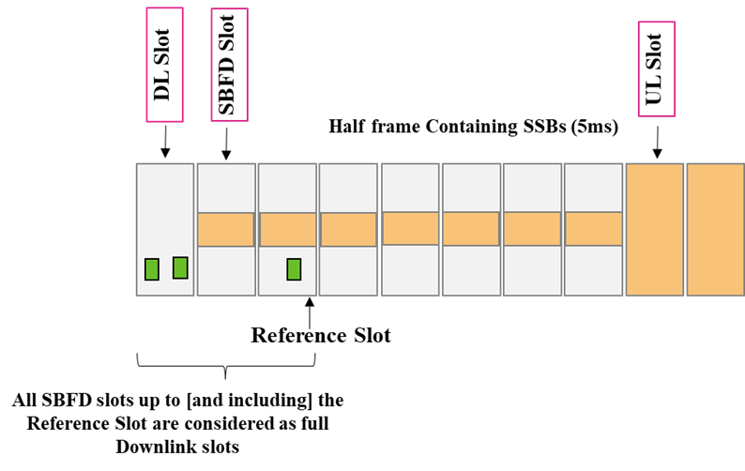

Figure 3: Convert SBFD slots before reference slot to full DL slots.

1. ***UL resources of SBFD slots containing SSBs will be wasted if not converted to full DL slots. For configuration with high number of SSBs within an SSB burst, the resource wastage may be significant.***
2. ***SBFD slot consisting of SSBs symbols are considered as full DL symbol.***
3. ***Within a half radio frame containing SSBs, all SBFD slots up to a “reference slot” are considered as full downlink slots. The reference slot overlaps with the slot containing the last SSB within the half frame.***

# Conclusion

In this contribution, we discussed indication of time/frequency location of SBFD subbands. We also provided our views on SBFD-aware UE behaviour in SBFD symbols.

1. ***SBFD aware UE can implicitly determine the time location of SBFD symbols sandwiched between the first and last SBFD symbols within a TDD pattern from the combination of {startSlot, endSlot} and {startSymbol, endSymbol}.***
2. ***Option 2, which provides an explicit link direction indication, enables low-complexity UE implementation for operations on SBFD symbols.***
3. ***Explicit link direction indication (Option 2) can be achieved reusing the existing UE-specific signalling for tdd-UL-DL-ConfigurationDedicated.***
4. ***UL resources of SBFD slots containing SSBs will be wasted if not converted to full DL slots. For configuration with high number of SSBs within an SSB burst, the resource wastage may be significant.***
5. ***Provide a new cell-specific parameter to indicate time location of SBFD subbands to SBFD-aware UE.***

* ***The new parameter can be configured as two pairs of integer values.*** 
  + ***One pair of integer values indicate the first and last slots within a TDD pattern containing SBFD symbols.***
  + ***Another pair of integer values indicate the first and last SBFD symbols within a TDD pattern.***

1. ***Provide new cell-specific parameters within FrequencyInfoDL-SIB or FrequencyInfoDL to indicate the frequency location of SBFD subbands for each configured cell-specific carrier.***
2. ***Support the use of existing UE-specific TDD signalling (tdd-UL-DL-ConfigurationDedicated) for transmission direction indication on SBFD symbols.***
3. ***Option 1 of transmission direction indication can be supported based on UE capability.***
4. ***For partial PRG overlapping with RBs outside DL usable PRBs, the PRGs inside DL usable PRBs is considered valid. UE performs channel estimation on the non-overlapping RBs***
5. ***Further study the performance gain and UE impact of allowing “wideband” support non-contiguous frequency resources across downlink subbands.***
6. ***When UE computes a CSI report using CSI-RS resource(s) across two DL subbands, RAN1 should adopt one of the following options.***

* ***Option#1: The CSI processing timeline is extended by X symbols. FFS the value(s) of X.***
* ***Option#2: The CPU count for computing the CSI report(s) is twice the CPUs required for computing the same CSI report(s) using contiguous CSI-RS resource(s).***

1. ***Support Option A for CSI report associated with periodic/semi-persistent CSI-RS.***
2. ***Support Option 4 as baseline for both SPS PDSCH without repetitions and CG PUSCH without repetitions if the reception/transmission occasions are across SBFD symbols and non-SBFD symbols.***

* ***Option 4: Only SPS PDSCH/CG PUSCH reception/transmission occasion in one symbol type is valid and SPS PDSCH/CG PUSCH reception/transmission occasion in the other symbol type is invalid.***

1. ***Support Option 3 as baseline for PDSCH repetitions*** ***if the reception occasions are across SBFD symbols and non-SBFD symbols.***

* ***Option 3: A PDSCH in a slot overlapping with RBs outside DL usable PRBs in SBFD symbols is invalid, e.g., the PDSCH in the slot is dropped.***

1. ***Support Option 2 as baseline for CG PUSCH with repetition type-A if repetitions are across SBFD symbols and non-SBFD symbols in different slots.***

* ***Option 2: Single FDRA configuration/indication for one symbol type (SBFD or non-SBFD symbol) and RB offset(s) configuration/indication/determination to determine resource for the other symbol type.***

1. ***For intra-slot FH on SBFD slot update FH hopping calculation as follows.***

* ***Set number of RBs used in modulo expression to total number of symbols in UL usable PRBs, when determining position of second frequency hop.***

1. ***For inter-slot frequency hopping update FH hopping calculation as follows.***

* ***On SBFD slots set the number of RBs used in modulo expression to the total number of RBs of UL usable PRB, when determining position of the second frequency hop***
* ***Include an RB offset which points to the lowest RB index of the corresponding slot type.***

1. ***SBFD slot consisting of SSBs symbols are considered as full DL symbol.***
2. ***Within a half radio frame containing SSBs, all SBFD slots up to a “reference slot” are considered as full downlink slots. The reference slot overlaps with the slot containing the last SSB within the half frame.***

# References

1. RP-241614, “Revised WID: Evolution of NR duplex operation: Sub-band full duplex (SBFD)”, 3GPP TSG RAN Meeting #103, June 2024.