3GPP TSG RAN WG1 #118 R1-2407281
Maastricht, The Netherlands, August 19th – 23rd, 2024

Agenda item: 9.2.2
Source: Moderator (Samsung)
Title: Moderator Summary#4 on Rel-19 CSI enhancements: Round 4
Document for: Discussion and Decision

Introduction
The scope given in the Rel-19 NR MIMO Phase 5 WID pertaining to CSI enhancement is as follows:
- Specify CSI support for up to 128 CSI-RS ports, targeting FR1
  - Type-I codebook refinement supporting up to a total of 128 CSI-RS ports across all resources, assuming legacy CSI-RS resources (with up to 32 CSI-RS ports per resource), based on extension of legacy codebooks
  - Type-II codebook refinement supporting up to a total of 128 CSI-RS ports across all resources, assuming legacy CSI-RS resources (with up to 32 CSI-RS ports per resource), based on extension of legacy codebooks, without modifying any codebook parameter other than introducing additional values for the number of ports codebook parameter(s)
  - Extension of CRI(s)-based CSI reporting (CQI/PMI/RI calculated per CRI for ≥1 CRIs) for hybrid beamforming supporting up to a total of 128 CSI-RS ports across all resources, with up to 32 CSI-RS ports per resource, without new codebook design
- Specify UE reporting enhancement for CJT deployments under non-ideal synchronization and backhaul, targeting FR1, both FDD and TDD
- Inter-TRP time misalignment and frequency/phase offset measurement and reporting, assuming legacy CSI-RS design, with stand-alone aperiodic reporting on PUSCH

Summary of companies’ proposals and views

Ground rules in sharing your inputs:
- Please do NOT input anything in Tables 1A, 2A, and 3A
  - Including company names - appreciate your trying to save me some work, but …
  - For some reason, most likely due to poor MS Word inter-platform/version compatibility support (if any), the formatting of the FL proposals will change (for the worse) if you do so. This has happened several times in Athens and Changsha ☹
- Please input your comments ONLY in Tables 1C, 2C, and 3C, thanks! 😊

Issue 1 (WID objective 2a and 2b): Type-I and Type-II codebook refinement for up to 128 CSI-RS ports
Table 1A Summary: issue 1
# | Issue/proposal | Companies’ views
1.2.1 | Proposal 1.B.1: For the Rel-19 Type-I SP and Type-II codebook refinements (except based on Rel-18 Type-II Doppler) for 48, 64, and 128 CSI-RS ports, active resource counting is:  - FFS: For Capability 1 timeline: 1 vs K  - For Capability 2 timeline: 1  FL assessment: This was discussed OFFLINE [2].  Since Capability 2 is quite (too) relaxed, there is no reason to further relax both OCPU and ARC for Capability 2.  For ARC, since the increase in the total # antenna ports (to up to 128) will be addressed in the ‘triplet’, there doesn’t seem any need to double-book this (mostly relevant to measurement buffering) in ARC (hence 1 should be more fitting, and K is excessive). Hence legacy in FG 2-33 can be interpreted as “Ks=1” (post aggregation) rather than “Ks=K”(pre-aggregation) | 1:  Support/fine: Ericsson, Nokia/NSB, ZTE, Fraunhofer IIS/HHI, Intel, TCL, Samsung, vivo, Google, CATT, Qualcomm, NTT DOCOMO, Xiaomi, HONOR, Lenovo/MotM (Cap2), Spreadtrum, CMCC, Sharp, OPPO, MediaTek, NEC, New H3C, KDDI, Kyocera,  Concern: Huawei/HiSi, Fujitsu (Cap1), Apple (Cap1)  K:  Support/fine: Huawei/HiSi, Fujitsu (Cap1), Apple (Cap1), Samsung (2nd), vivo, OPPO, Google (Cap 1), Lenovo/MotM (Cap1), TCL (Cap1)  Concern: Qualcomm  1 and K (UE indicates):  Support/fine: Apple, Fujitsu, Qualcomm,  Concern: Huawei/HiSi, Samsung, Ericsson, CMCC, vivo,
1.3.1 | [117] Agreement  For the Rel-19 Type-I codebook refinement for 48, 64, and 128 CSI-RS ports, for RI=v=1, support the following:  - for each group of $X_{1}X_{2}$ SD basis vectors, a 3-bit scaling factor can be NW-configured via higher-layer (RRC) signalling, where the scaling factors are defined as scalings on the power control offset configured for the associated CSI-RS resources  - The values of $X_{1}$ and $X_{2}$ for this feature are separately configured from those for CBSR  - Separate configuration (RRC signalling) from CBSR  - The candidate values of $X_{1}$ and $X_{2}$ are the same as those agreed for CBSR  - The codepoints of each of the group-specific 3-bit scaling factors are mapped to values of $\left\{\sqrt{1}, \sqrt{1/2}, \sqrt{1/3} ,\sqrt{1/4},\sqrt{1/6},\sqrt{1/8},\sqrt{1/12},\sqrt{1/16}\right\}$  - Note: This feature is a separate UE capability  FFS: Whether this can be extended to RI=v>1 …  Proposal 1.C.1: For the Rel-19 Type-I codebook refinement for 48, 64, and 128 CSI-RS ports, for RI= $ϑ$ >1, apply the 3-bit scaling factor(s) as agreed in RAN1#117, where the scaling factor applied to the $i^{th}$ selected SD basis vector is given by $min\left\{1,\frac{ϑs_{i}^{2}}{r_{i}}\right\}$, where unit scaling factor “1” is associated with the PDSCH-to-CSIRS EPRE offset “portion” contributed by the $i^{th}$ selected SD basis vector without the 3-bit scaling factor $s_{i}$ configured, $s_{i}∈\left\{\sqrt{1}, \sqrt{\frac{1}{2}}, \sqrt{\frac{1}{3}} ,\sqrt{\frac{1}{4}},\sqrt{\frac{1}{6}},\sqrt{\frac{1}{8}},\sqrt{\frac{1}{12}},\sqrt{\frac{1}{16}}\right\}$ is the scaling factor associated with the $i^{th}$ beam, and $r_{i}∈\left\{1,2\right\}$ is the number of layers transmitted using the $i^{th}$ SD basis vector.  - Note: This feature is a separate UE capability  FL assessment: For the Rel-19 Type-I SP codebook refinement for 48, 64, and 128 CSI-RS ports, regarding the 3-bit scaling factor, please share your view whether this can be extended to RI=v>1 (and provide justification)  Yes: Ericsson, Nokia/NSB,  No: IDC, TCL, OPPO, Xiaomi, Huawei/HiSi, ZTE, Fujitsu,  Need more discussion/study: Qualcomm, CMCC, Samsung, Apple, NTT DOCOMO, Xiaomi (ok), HONOR, Google, Lenovo/MotM, Fraunhofer IIS/HHI, | Support/fine: Ericsson, Nokia/NSB, MediaTek, Lenovo/MotM, NTT DOCOMO, [Qualcomm], Spreadtrum, KDDI,  Not support: ZTE, Apple (more discussion)
1.9 | Proposal 1.I: For the Rel-19 Type-I SP and MP codebook refinement for 48, 64, and 128 CSI-RS ports, for RI=v>1, for each PMI sub-band, UE shall select a recommended P-by-v precoder matrix (associated with the reported PMI) with v orthogonal columns.  FL assessment: This is to ensure orthogonality constraint for Type-I is maintained. It is argued that this is especially crucial for SU-MIMO where the gNB typically follows the recommended PMI. | Support/fine: Qualcomm, ZTE (open), MediaTek (SP), Nokia/NSB, Apple, Lenovo/MotM, Tejas,  Not support: vivo, Samsung, Fujitsu, NTT DOCOMO, Huawei/HiSi, CMCC, OPPO, Xiaomi, TCL, Ericsson,

Table 1B SLS results: issue 1
Company | SLS results
 | Issue # | Metric | Observation
Huawei/HiSi | Other (SRS port grouping) | Normalized throughput (LLS) | It is observed in Figure 4 that 43% performance gain can be achieved by PDSCH reception with SRS port grouping compared to max Rank-4. The performance of 8R rank-8 is also shown in the figure as an upper bound, which is difficult to be implemented due to the high complexity currently. Moreover, it can be observed from figure 9 that the performance of low complexity receiver (two antenna groups) without SRS port grouping enhancement is very poor even at high SNR.  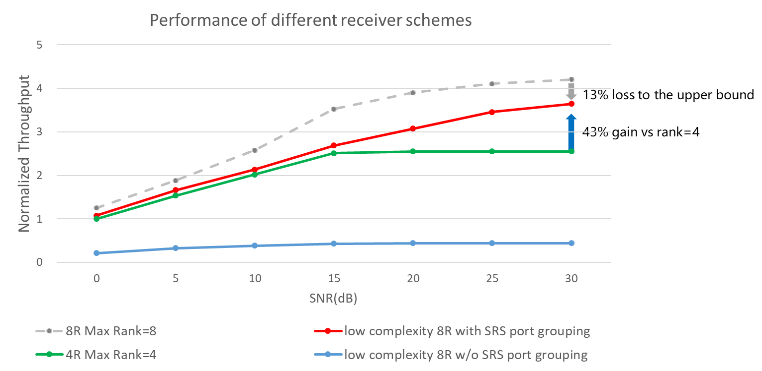  Figure 4 Performance of 8Rx UE with different receiver schemes under practical interference
Samsung | Other (SRS port grouping) | Avg UPT gain | The case of low complexity 8 RX receiver w/o SRS port grouping incurs 65% UPT loss com-pared to 4RX scenario. This basically implies that it is not possible to work for RI>4 without SRS port grouping assumption for low-complexity 8RX receiver
Ericsson | 1.3.3 | Mean user throughput gain, 5%-tile throughput gain | In the table below, it is shown that the impact of using a group size larger than 1 along the $N_{2}$dimension, i.e., $X_{2}>1$. As seen in the results, the mean and 5th-percentile throughput decrease with increasing group sizes along the $N_{2}$dimension.

Table 1C Additional inputs: issue 1
Company | Input
Mod V0 | Please share your inputs on each of the issues and, if applicable, proposals in TABLE 1A

Issue 2 (WID objective 2c): CRI-based CSI for hybrid beamforming (HBF)

Table 2A Summary: issue 2
# | Issue | Companies’ views
2.2 | Proposal 2.B.3: For the Rel-19 CRI-based CSI refinement for up to 128 CSI-RS ports, regarding resource-specific CBSR, support following two-level structure:  - First level: resource-common group-based restriction via $\frac{N_{1}⋅O_{1}⋅N_{2}⋅O_{2}}{X_{1}⋅X_{2}}$-bit bitmap (reuse 128-port design)  - Second level: resource-specific restriction via X₁·X₂-bit bitmap for each unrestricted group  FL assessment: This proposal is to finalize CBSR design for HBF | Support/fine: Huawei/HiSi,  Not support:

Table 2B SLS results: issue 2
--
Table 2C Additional inputs: issue 2
Company | Input
Mod V0 | Please share your inputs on each of the issues and, if applicable, proposals in TABLE 2A

Issue 3 (WID objective 3): CJT calibration reporting for non-ideal synchronization and backhaul

Table 3A Summary: issue 3
# | Issue | Companies’ views
3.4.2 | Proposal 3.D.2: For the Rel-19 aperiodic standalone CJT calibration reporting, support joint Dd + phase offset (PO) reporting as follows:  - Only wideband (Σ=1) PO is supported  - No further optimization of CSI reporting format, e.g. configurability of not reporting {d_{n}}  - The UCI parameters are captured in the table below  When ReportQuantity is ‘cjtc-Dd-P’ (joint Doffset+d and PO)  Parameter Details/description  nref1 Reference TRS resource set index for Doffset+d, based on the ordering from RRC configuration: $\left\lceil log\left(N_{TRP}\right)\right\rceil$ bits  nref2 Reference TRS resource set index for PO, based on the ordering from RRC configuration: $\left\lceil log\left(N_{TRP}\right)\right\rceil$ bits  {D_{n,offset}, n=0, 1, …, N_{TRP} – 1 n≠nref1} Delay offset for CSI-RS resource set n: $\left(N_{TRP}-1\right)\left\lceil log\left(M_{D}\right)\right\rceil$ bits  {d_{n}, n=0, 1, …, N_{TRP} – 1, n≠nref1 } 1-bit inside/outside indicator for CSI-RS resource set n: $\left(N_{TRP}-1\right)$ bits  {PO_{n} , n=0, 1, …, N_{TRP} –1, n≠nref2} Wideband phase offset for CSI-RS resource n: $\left(N_{TRP}-1\right)\left\lceil log\left(M_{Φ}\right)\right\rceil$ bits  - The UCI mapping order is as follows:  - nref1,  - nref2,  - {D_{n,offset}, n=0, 1, …, N_{TRP} – 1, n≠nref} ordered from the lowest to highest CSI-RS resource set ID,  - {d_{n}, n=0, 1, …, N _{TRP} – 1, n≠nref} ordered from the lowest to highest CSI-RS resource set ID  - {PO_{n}, n=0, 1, …, N_{TRP} – 1, n≠nref} ordered from the lowest to highest CSI-RS resource ID, | Support/fine: Qualcomm, vivo, Sony, Samsung (ok), Google, ZTE, Fujitsu, Sony,  Not support: Huawei/HiSi, MediaTek, NTT DOCOMO, Ericsson, NEC, Intel, Apple, TCL, Huawei/HiSi, Xiaomi, IDC, Sharp, KDDI, CMCC, ETRI, OPPO, Lenovo/MotM (open, only if TRS can be used for PO), Apple (same as Lenovo)
3.4.3 | Proposal 3.D.3: For the Rel-19 aperiodic standalone CJT calibration reporting, support reporting, in one CSI reporting instance, L1-RSRPs associated with the configured N_{TRP} CSI-RS resources and the following CJT calibration report type:  - ReportQuantity is ‘cjtc-Dd’ (delay offset), or  - ReportQuantity is ‘cjtc-F’ (frequency offset), or  - ReportQuantity is ‘cjtc-Dd-F’ (delay+frequency offset), or  - ReportQuantity is ‘cjtc-P’ (DL/UL phase offset)  Regarding the L1-RSRP:  - The legacy L1-RSRP is fully reused, where the L1-RSRP associated with nref is the reference for the other (N_{TRP}-1) differential L1-RSRP(s)  - The N_{TRP} CRI(s) are not reported  - FFS: Whether this is supported via a new ReportQuantity or a joint CSI request/triggering  FL assessment: This proposal is an optimization primarily for TRP selection (which utilizes both RSRP and CJTC report) | Support/fine: NEC, NTT DOCOMO,  Not support: ZTE, Xiaomi, Fujitsu, Ericsson, Apple, Huawei/HiSi, OPPO, Lenovo/MotM, TCL, Sony,

Table 3B LLS/SLS results: issue 3
--
Table 3C Additional inputs: issue 3
Company | Input
Mod V0 | Please share your inputs on each of the issues and, if applicable, proposals in TABLE 3A

References

1 | RP-240087 | Revised WID: NR MIMO Phase 5 | Samsung (Moderator)
2 | R1-2406643 | Moderator Summary for OFFLINE discussion on Rel-19 CSI enhancements | Moderator (Samsung)
3
4

