3GPP TSG-CT WG3 Meeting #135 C3-243088_R1

Hyderabad, IN, 27th – 31 th May, 2024
CR-Form-v12.3
CHANGE REQUEST
 | 29.549 | CR | 0258 | rev | 1 | Current version: | 18.5.0
For HELP on using this form: comprehensive instructions can be found at
http://www.3gpp.org/Change-Requests.

Proposed change affects: | UICC apps |  | ME |  | Radio Access Network |  | Core Network | X

Title: | EN resolution for VAL UE(s) and User(s) identifiers in the SS_VALServiceData API
Source to WG: | Ericsson
Source to TSG: | CT3
Work item code: | SEAL_Ph3 |  |  |  |  |  | Date: |  |  | 2024-05-09
Category: | F |  |  |  |  |  | Release: |  |  | Rel-18
 | Use one of the following categories:  F (correction)  A (mirror corresponding to a change in an earlier release)  B (addition of feature),  C (functional modification of feature)  D (editorial modification)  Detailed explanations of the above categories can  be found in 3GPP TR 21.900. |  |  |  |  |  |  |  | Use one of the following releases:  Rel-8 (Release 8)  Rel-9 (Release 9)  Rel-10 (Release 10)  Rel-11 (Release 11)  …  Rel-17 (Release 17)  Rel-18 (Release 18)  Rel-19 (Release 19)  Rel-20 (Release 20)
Reason for change: |  | The SA#6 decided to note the related incomming LS. It was decided that the combination of VAL UE(s) and User(s) identifiers in the SS_VALServiceData API is within the CT3 scope.  Thus, CT3 can resolve the EN and keep alignenment with with other SEAL interfaces. See the additional consideration in Additional discussion section.
Summary of change: |  | This CR resolves the EN in the SS_VALServiceData API.
Consequences if not approved: |  | The stage 3 cannot be frozen without EN resolution.
Clauses affected: |  | 7.3.2.2.2.3.1
 |  | Y | N
Other specs |  |  | X | Other core specifications |  |  |  | TS/TR ... CR ...
affected: |  |  | X | Test specifications |  |  |  | TS/TR ... CR ...
(show related CRs) |  |  | X | O&M Specifications |  |  |  | TS/TR ... CR ...
Other comments: |  | - This CR does not impact any OpenAPI file
()
This CR's revision history:

Additional discussion(if needed):
In CT3 specification 29.549, the list of VAL UEs or VAL Users may include the combination from Release-16 in each API. In stage 3, the OpenAPI implementation takes precedence over descriptions in the main body. Furthermore, there is no indication that it is not allowed to provide the combination in stage 2.

Let’s focus our discussion on SS_VALServiceData API, this is SEAL-X API that requires the combination of VAL UEs/Users to be provided in list.
Justification (see illustration below):
- Clause 10.3.7 for location group creation:
  - In steps 2 and 4, the SS_LocationAreaInfoRetrieval API returns all VAL Users/VAL UEs in the given location for ALL VAL services; this API does not support indication of the particular VAL service; Thus, the combination of VAL UEs/Users will be for sure received in step 4 when SS_LocationAreaInfoRetrieval API is used.
  - In step 5, the GM server shall map the received combination to the VAL services via SS_VALServiceData API. Thus, the combination received in step 4 shall be provided in the identity list in the SS_VALServiceData API.
    - The limitation for providing the combination in the identity list is artificial and very questionable, i.e., if the limitation is enforced, the implementation of the GM server shall:
      - Filter the received combination in step 4 into TWO sub-lists;
      - Provide TWO requests via SS_VALServiceData API;
      - Implement the logic of the joint processing of the TWO responses.

The main points are:
- The implementation in Stage 3 allows providing combination of VAL Users/VAL Users from Release-16. Thus, enforcement of the limitation is Non Backward Compatible.
- The limitation in SS_VALServiceData API does not make any sense and leads to non-efficient implementation, high energy consumption, redundant signaling, etc.

Illustration:
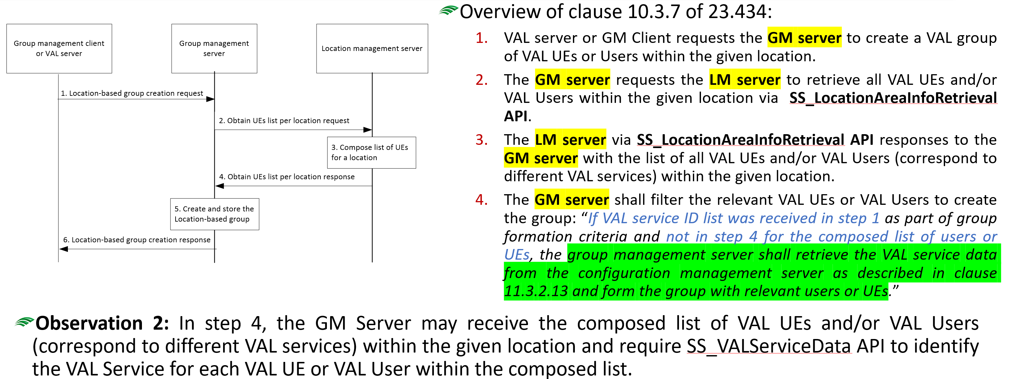

Proposed changes:
* * * First Change * * * *

7.3.2.2.2.3.1 GET
This operation retrieves the VAL service data satisfying the filter criteria. This method shall support the URI query parameters specified in table 7.3.2.2.2.3.1-1.
Table 7.3.2.2.2.3.1-1: URI query parameters supported by the GET method on this resource
Name | Data type | P | Cardinality | Description
val-tgt-ues | array(ValTargetUe) | O | 1..N | Identifying the list of the target VAL UE(s) or VAL user(s). (NOTE)
val-service-ids | array(string) | O | 1..N | Identifying the list of the target VAL service(s). (NOTE)
supp-feats | SupportedFeatures | O | 0..1 | To filter irrelevant responses related to unsupported features.
NOTE: At least one of these query parameters shall be present, unless the request targets to retrieve all the VAL Service Data Sets managed by the CM Server.

This method shall support the request data structures specified in table 7.3.2.2.2.3.1-2 and the response data structures and response codes specified in table 7.3.2.2.2.3.1-3.
Table 7.3.2.2.2.3.1-2: Data structures supported by the GET Request Body on this resource
Data type | P | Cardinality | Description
n/a

Table 7.3.2.2.2.3.1-3: Data structures supported by the GET Response Body on this resource
Data type | P | Cardinality | Response  codes | Description
ValServDataResp | M | 1 | 200 OK | Represents the requested VAL service data.
n/a |  |  | 307 Temporary Redirect | Temporary redirection, during resource retrieval. The response shall include a Location header field containing an alternative URI of the resource located in an alternative CM Server.  Redirection handling is described in clause 5.2.10 of 3GPP TS 29.122 [3].
n/a |  |  | 308 Permanent Redirect | Permanent redirection, during resource retrieval. The response shall include a Location header field containing an alternative URI of the resource located in an alternative CM Server.  Redirection handling is described in clause 5.2.10 of 3GPP TS 29.122 [3].
NOTE: The mandatory HTTP error status codes for the GET method listed in table 5.2.6-1 of 3GPP TS 29.122 [3] also apply.

Editor's Note: The application errors in the SS_VALServiceData API are FFS.
Table 7.3.2.2.2.3.1-4: Headers supported by the 307 Response Code on this resource
Name | Data type | P | Cardinality | Description
Location | string | M | 1 | An alternative URI of the resource located in an alternative CM Server.

Table 7.3.2.2.2.3.1-5: Headers supported by the 308 Response Code on this resource
Name | Data type | P | Cardinality | Description
Location | string | M | 1 | An alternative URI of the resource located in an alternative CM server.

* * * End of changes * * * *

