**3GPP TSG-SA5 Meeting #157 *S5-246156***

Hyderabad, India, 14 - 18 October 2024

|  |  |  |  |  |  |  |  |  |
| --- | --- | --- | --- | --- | --- | --- | --- | --- |
| *CR-Form-v12.3* | | | | | | | | |
| **CHANGE REQUEST** | | | | | | | | |
|  | | | | | | | | |
|  | **28.405** | **CR** | **0038** | **rev** | **1** | **Current version:** | **19.1.0** |  |
|  | | | | | | | | |
| *For* [***HE******LP***](http://www.3gpp.org/3G_Specs/CRs.htm#_blank)*on using this form: comprehensive instructions can be found at* [*http://www.3gpp.org/Change-Requests*](http://www.3gpp.org/Change-Requests)*.* | | | | | | | | |
|  | | | | | | | | |

|  |  |  |  |  |  |  |  |  |
| --- | --- | --- | --- | --- | --- | --- | --- | --- |
| ***Proposed change affects:*** | UICC apps |  | ME |  | Radio Access Network | **X** | Core Network | **X** |

|  |  |  |  |  |  |  |  |  |  |  |
| --- | --- | --- | --- | --- | --- | --- | --- | --- | --- | --- |
|  | | | | | | | | | | |
| ***Title:*** | Rel-19 CR TS 28.405 Correct the procedure description of management based activation in NR | | | | | | | | | |
|  |  | | | | | | | | | |
| ***Source to WG:*** | ZTE Corporation | | | | | | | | | |
| ***Source to TSG:*** | SA5 | | | | | | | | | |
|  |  | | | | | | | | | |
| ***Work item code:*** | eQoE | | | | |  | ***Date:*** | | | 2024-09-25 |
|  |  | | | |  | |  | | |  |
| ***Category:*** | **A** |  | | | | | ***Release:*** | | | Rel-19 |
|  | *Use one of the following categories:* ***F*** *(correction)* ***A*** *(mirror corresponding to a change in an earlier release)* ***B*** *(addition of feature),* ***C*** *(functional modification of feature)* ***D*** *(editorial modification)*  Detailed explanations of the above categories can be found in 3GPP [TR 21.900](http://www.3gpp.org/ftp/Specs/html-info/21900.htm). | | | | | | | | *Use one of the following releases: Rel-8 (Release 8) Rel-9 (Release 9) Rel-10 (Release 10) Rel-11 (Release 11) … Rel-17 (Release 17) Rel-18 (Release 18) Rel-19 (Release 19)  Rel-20 (Release 20)* | |
|  |  | | | | | | | | | |
| ***Reason for change:*** | | 1. There is a typo in step 13 of activation of measurement collection job and reporting of collected information in NR, which needs to be corrected. “MCE associated to the qoECollectionEntityAddress” should be changed to “MCE associated to the qoEReference”. | | | | | | | | |
|  | |  | | | | | | | | |
| ***Summary of change:*** | | 1. Correcet a typo. Correct “MCE associated to the qoECollectionEntityAddress” to “MCE associated to the qoEReference”. | | | | | | | | |
|  | |  | | | | | | | | |
| ***Consequences if not approved:*** | | Typo may lead to misunderstanding. | | | | | | | | |
|  | |  | | | | | | | | |
| ***Clauses affected:*** | | 4.5.1 | | | | | | | | |
|  | |  | | | | | | | | |
|  | | **Y** | **N** |  | | | |  | | |
| ***Other specs*** | |  | **X** | Other core specifications | | | | TS/TR ... CR ... | | |
| ***affected:*** | |  | **X** | Test specifications | | | | TS/TR ... CR ... | | |
| ***(show related CRs)*** | |  | **X** | O&M Specifications | | | | TS/TR ... CR ... | | |
|  | |  | | | | | | | | |
| ***Other comments:*** | | No impact on stage 3. | | | | | | | | |
|  | |  | | | | | | | | |
| ***This CR's revision history:*** | | Revision of S5-245224 | | | | | | | | |

***Start of First change***

### 4.5.1 Activation of measurement collection job and reporting of collected information in NR

Management Based Activation enables collection of application layer measurements from the UEs in the specified area for specified end user service type.

The parameters for the network request session are sent from the MnS Consumer via the management system to the gNBs that host the cells that are included in the QoE Measurement Collection job request in the Create MOI QMC operation [15]. A QMC Job is activated by creating a QMCJob object instance in the MnS producer.

Figure 4.5.1-1 and the text below describe the activation of QoE measurement collection.

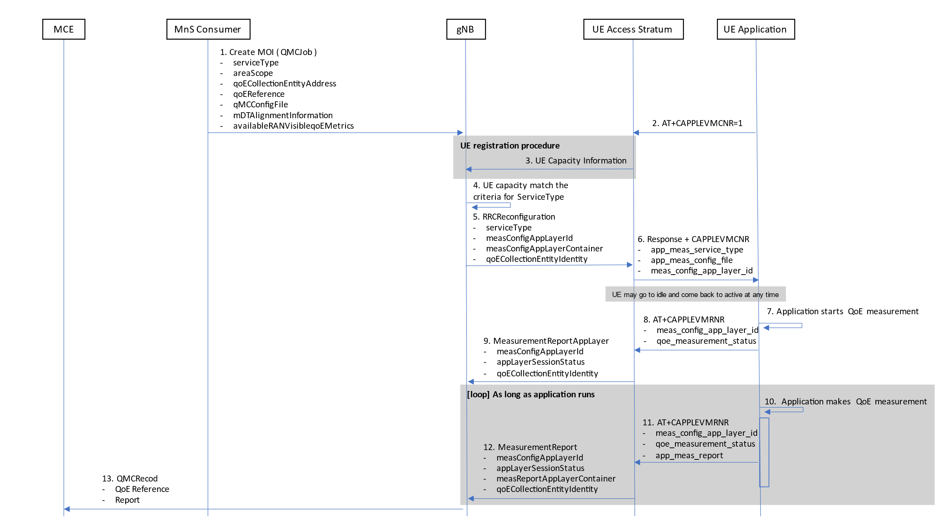

Figure 4.5.1-1: QMC activation example for Management Based Activation and Reporting in NR

1) A QoE Measurement Collection Job begins when the MnS Consumer sends createMOI request for QMCJob to the MnS Producer serving the impacted gNB(s), and includes the parameters: serviceType, areaScope, qoECollectionEntityAddress, qoEReference, mDTAlignmentInformation, availableRANqoEMetrics and qMCConfigFile. Step 2 and step 3 are asynchronous in time with respect to Step 1; they may occur before or after step 1.

NOTE: The RAN visible QoE measurements are supported for the DASH streaming and VR services.

2) Application level measurement configuration. The Application in the UE shall send AT command +CAPPLEVMCNR [5] containing the parameter <n> set to 1 to the Access Stratum. This enables the the Access Stratum to present an unsolicited result code to the Application at a later time. Step 2 and step 3 are asynchronous in time with respect to Step 1; they may occur before or after step 1.

3) UE registration procedure. The UE shall register QMC capability with the gNB by setting qoe-Streaming-MeasReport to “supported” in UE-NR-Capability [11]. Step 2 and step 3 are asynchronous in time with respect to Step 1; they may occur before or after step 1.

4) The gNB starts a network request session, with the QoE Reference [3] given in createMOI for QMCJob [3]. For the duration of the network request session, the gNB(s) checks for connections where the UE has qoe-Streaming-MeasReport set to “supported” [11] in step 2.

5) If a UE has the wanted capability, the gNB stores the associated qoECollectionEntityAddress and starts a UE request session by sending RRCReconfiguration to the UE including serviceType, measConfigAppLayerId (corresponding to the value of qoEReference from step 4) and measConfigAppLayerContainer.

If QoE measurement configuration pertains to MBS communication service, the gNB translates the qoECollectionEntityAddress into qoECollectionEntityIdentity and includes qoECollectionEntityIdentity in the RRCReconfiguration.  
  
NOTE: The IE measConfigAppLayerId indicates the identity of the application layer measurement configuration, see [11].

6) The access stratum in the UE sends an unsolicited response to the Application including app‑meas_service_type, meas_config_app_layer_id and app-meas_config_file. These IEs map directly to the IEs in step 5. The unsolicited response is for the AT command +CAPPLEVMCNR [5] which is sent from Application in step 2.

7) The QMC Job remains inactive until the Application for the specified serviceType initiates service.

8) When the Application begins service, it sends the AT command +CAPPLEVMRNR [5], including meas_config_app_layer_id and qoe_measurement_status to indicate a recording session has started, to the access stratum.

9) The UE sends the message MeasurementReportAppLayer including measConfigAppLayerId, appLayerSessionStatus, and qoECollectionEntityIdentity to the gNB to indicate a recording session has started.

10) While active, the Application collects measurement reports. When the QMC is completed or at the end of period for periodic report, the recorded information is formatted in a QMC report, see [6] for DASH, [7] for MTSI or [13] for VR.

11) When a formatted measurement report is available, the Application sends the AT command +CAPPLEVMRNR [5] including meas_config_app_layer_id, qoe_measurement_status and app-meas_report to the Access Stratum. If the QMC Job has ended, qoe_measurement_status is set to indicate the Job has ended.

12) When the AT command +CAPPLEVMRNR is received from the Application, the Access Stratum sends the message MeasurementReportAppLayer including measConfigAppLayerId, appLayerSessionStatus, measReportAppLayerContainer, and qoECollectionEntityIdentity to the gNB.

13) The gNB translates the qoECollectionEntityIdentity into qoECollectionEntityAddress if it is needed, and sends the QMCRecord to the MCE associated to the qoEReference. The report contains the QoEReference from step 4 and measReportAppLayerContainer from step 12.

***End of First change***