**3GPP TSG-SA5 Meeting #157 *S5-246122***

Hyderabad, India, 14 - 18 October 2024

**Source: Rakuten Mobile**

**Title: Add declarative section and evaluation of solutions for termination of a NF deployment instance**

**Document for: Approval**

**Agenda Item: 6.19.6**

# 1 Decision/action requested

***For approval***

# 2 References

[1] 3GPP TR 28.869: “Study on cloud aspects of management and orchestration”.

# 3 Rationale

Added section for declarative descriptor and evaluation of solutions for termination of a NF deployment instance.

# 4 Detailed proposal

It is proposed to make the following changes to TR 28.869 [1].

|  |
| --- |
| **1st change** |

##### 5.2.5.3.2 Use of deployment management reference point based on declarative descriptor

In this solution, as illustrated in figure 5.2.5.3.2-1, 3GPP management system interacts with an orchestration and management system using the deployment management reference point as described in clause 5.2.1.3, for termination of a NF deployment instance.

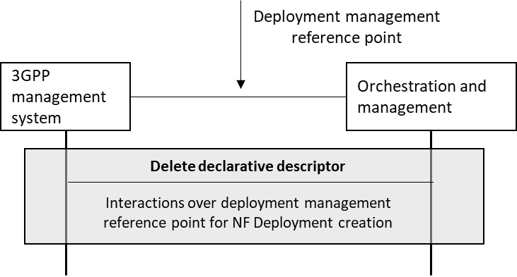

Figure 5.2.5.3.2-1. Interaction between 3GPP management system and orchestration and management system using deployment management reference point based on declarative descriptor

The previous descriptor or its reference created in the orchestration and management entity is deleted by the 3GPP management system via the deployment management reference point. The orchestration and management entity removes the existing resources allocated to the NF and terminates the NF.

|  |
| --- |
| **2nd change** |

#### 5.2.5.4 Evaluation of solutions

The proposed solution 5.2.5.3.1 defines the lifecycle operation for the termination of a NF deployment instance by a 3GPP management system using the deployment management reference point. In the proposed solution 5.2.5.3.2, the 3GPP management system deletes the descriptor or its reference. The orchestration and management entity removes the resources allocated to the NF deployment and terminates the NF. The deployment management declarative approach (5.2.5.3.2) using the reference point (5.2.5.3.1) enables interoperability and decoupling between the 3GPP management system and the orchestration entity and fulfils the use case requirements expressed in clause 5.2.5.2.

|  |
| --- |
| **End of changes** |