**3GPP TSG-SA5 Meeting #157 *S5-246118d2***

Hyderabad, India, 14 - 18 October 2024

**Source:** **NTT DOCOMO, China Mobile**

**Title: pCR 28.869 VNF traffic mgmt solution and evaluation**

**Document for: Approval**

**Agenda Item: 6.19.6**

# 1 Decision/action requested

***In this box give a very clear / short /concise statement of what is wanted.***

# 2 References

1. 3GPP TR 28.869 v1.0.1 Study on cloud aspects of management and orchestration.

# 3 Rationale

The contribution proposes to add evaluation of solutions for Cloud-native VNF traffic management.

# 4 Detailed proposal

It proposes to make the following changes to TR 28.869 [1].

|  |
| --- |
| **1st Change** |

# 5 Use cases, potential requirements, and potential solutions

## 5.1 Use of VNF generic OAM functions

Editor's Note: This clause describes the use cases, issues, requirements, and solutions related to WT-1.

### 5.1.3 Use case #3: Cloud-native VNF Traffic management

#### 5.1.3.1 Description

Effective traffic management for cloud-native functions is essential to ensure high quality of service levels. Nevertheless, especially in containerized deployments additional challenges need to be considered since many OS containers realizing the cloud-native VNF instances are usually deployed per host, while OS containers are often created and destroyed rapidly, requiring the network to adapt quickly to topological changes. In the context of a cloud-native VNF, traffic management includes controlling the inbound/outbound traffic to, from and within the cloud-native VNF instance.

Traffic management actions to be considered in a 3GPP management system context are, for example, controlling the rate of incoming requests to prevent overloading services and directing traffic to different VNFCs realizing a cloud-native VNF. These actions can surge in the context of diverse OAM procedures of maintenance, re-configuration, and upgrade of NFs, etc. managed through the 3GPP management system.

The 3GPP management system needs to be able to support an operator to manage and orchestrate the traffic management actions for cloud-native VNF instances.

#### 5.1.3.2 Potential requirements

**REQ-CVNF_TM-1** The 3GPP management system should have the capability to support traffic management of cloud-native VNF instances.

**REQ-CVNF_TM-2** The reference point between 3GPP management system and external OAM entity should have the capability enabling the 3GPP management system to interact with external (non-3GPP) traffic management entities for the purpose of performing traffic management for cloud-native VNF instances.

#### 5.1.3.3 Potential solutions

##### 5.1.3.3.1 Traffic Enforcer function

As shown in figure 5.1.3.3.1-1, this solution introduces a platform entity that interacts with 3GPP management system for traffic management of cloud-native VNFs via a new PaaS reference point.

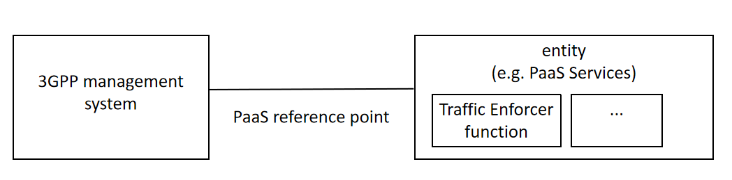

Figure 5.1.3.3.1-1: Traffic management of cloud native VNF

The solution proposes using Traffic Enforcer function defined in ETSI GS ISG NFV-IFA 049 [2], which is one of the VNF generic OAM functions. Some key functionalities supported by the Traffic Enforcer function are the capability to perform the required traffic blocking and rerouting operations on the VNFC instances.

According to ETSI GS ISG NFV-IFA 049 [2] Traffic Enforcer functionality can be called by functions residing inside the 3GPP management system or other VNF generic OAM functions (e.g. the Upgrade VNF function) or other PaaS Services (e.g. the Policy Agent).

The present solution addresses the potential requirement REQ-CVNF_TM-2.

##### 5.1.3.3.2 3GPP Management System to support traffic management of cloud-native VNF instances

In TS 28.622, it is specified that the 3GPP management system can set a managed object’s administrative state as UNLOCKED which means the managed object administratively allowed to be used, and LOCKED which means the managed object is not administratively allowed to be used. As NF services (according to TS 28.622) and network slice and network slice subnets (according to TS 28.541) , can be managed objects of 3GPP management systems, their administrative state can be configured by the 3GPP system as part of management workflow. If the administrative state of a managed object (which in turn can be realized as one or more of cloud-native VNF) is LOCKED, for example during fault management, then 3GPP management system can determine the need to block any traffic to/from the affected NF. Similarly, if the administrative state of the same managed object is UNLOCKED, then 3GPP management system can decide to enable traffic to/from the affected NF.

Furthermore, in TS 28.622, the EP_RP IOC is specified in order to represent an end point of a communication link or a reference between two network entities, while in TS 28.541, the end points between specific entities are specified with dedicated EP_<rp> IOCs where <rp> is a string that represents the name of the reference point. (i.e. EP_F1C represents control plane interface between gNB-DU and gNB-CU or gNB-CU-CP ). If an MOI of an EP_<rp> associated to the link between two network functions is removed, this can also imply that there is no more connectivity/link between these network functions so that 3GPP management system can decide to block the traffic over this link.

The above two cases described do not imply that 3GPP management system is performing traffic management, but rather highlight that OAM procedures performed by or through the 3GPP management system can have implications on the connectivity and traffic handling by objects managed by the 3GPP management system. These, when taken in the context of control loops, automation, and interactions with external entities responsible for management and orchestration in cloud-native environments, can represent outcome actions to request traffic management from the external entities.

Therefore, current referenced 3GPP specifications already satisfy REQ-CVNF_TM-1.

|  |
| --- |
| **2nd Change** |

|  |
| --- |
| **End of Changes** |