**3GPP TSG-SA5 Meeting #157 *S5-246043***

Hyderabad, India, 14 - 18 October 2024

**Source: ZTE Corporation**

**Title: Rel-19 pCR TR 28.858 Update Solution for Nested NDT**

**Document for: Approval**

**Agenda Item: 6.19.5**

# 1 Decision/action requested

***In this box give a very clear / short /concise statement of what is wanted.***

# 2 References

[1] 3GPP TR 28.915: "Study on management aspect of Network Digital Twin"

# 3 Rationale

In the existing solution, the relation for NRM between NestedNDT and NDT is unclear. This contribution proposes to update the solution of nested NDTs.

# 4 Detailed proposal

***Start of First change***

## 5.7 Use case 7: Nested NDTs

### 5.7.1 Description

An NDT may use or rely on other NDTs as layered/nested components.

EXAMPLE: An NDT that simulates load prediction, e.g. for the RAN energy saving purposes may rely on 2 NDTs - "DT-1" that models network traffic but relies on another DT that models user movement "DT-1" and "DT-2" that models the active equipment of the cell. And "DT‑2" may also be composed of other DTs as illustrated by figure 5.7.1-1. The MnS consumer relying on the simulation services of NDT "A" should be enabled get information on the structure of the DT relations and configure the characteristics of DTs.



Figure 5.7.1-1- An example of nested NDTs for load prediction

### 5.7.2 Use cases

### 5.7.2.1 Traceability of NDT composition

The DTs that are components of the NDT are composed in a particular way to provide a specific modelling service. Due to the dependency and nested characteristics of NDTs, any errors, malfunctions, or degradation of service may propagate and effect the services of overall NDT. Therefore, it is necessary to have the NDT's capabilities information.

An MnS consumer consuming the services of an NDT may need to configure or modify the composition of the NDT or the mapping and relationship of the DTs with respect to each other. Any modifications in these characteristics would change the context of the NDT resulting in a need for performing validation and feasibility checks. Any modification to the connected nested NDTs should be assessed and a report shall be provided on the validity and conformity with guaranteed services and feasibility of the new composition.

As an example, the MnS consumer may want to know whether the NDT models traffic for a city or for a village, i.e. whether the NDT has capabilities for a city or for a village. An NDT with city capabilities a then be requested to simulate a specific city.

### 5.7.3 Potential requirements

**REQ-NDT-1:** The management system should have a capability enabling an authorized NDT MnS consumer to request information about the NDT capabilities.

**REQ-NDT-3:** The management system should have a capability enabling an authorized NDT MnS consumer to subscribe to receive information about any modifications in the characteristics of a NDT capability supported by the MnS producer.

**REQ-NDT-4:** The management system should have a capability enabling an authorized NDT MnS producer to inform the consumers of the validity and feasibility of the modifications in NDT capabilities.

### 5.7.4 Potential Solutions

The following are two examples of NRM for NDT management.

Option 1:

The NDT IOC is name-contained by SubNetwork or ManagedElement.

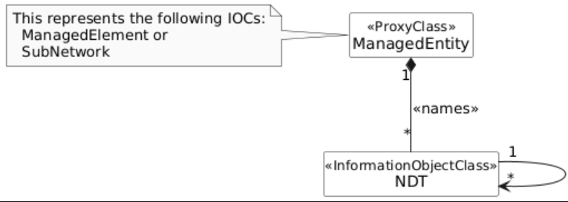

Figure 5.7.4-1- Example 1 NRM for NDT management

Option 2:

Introduce a NDTRepository IOC to support centralized storage for (N)DTs. The IOC NDTRepository represents the repository that contains the (N)DT components. It is name-contained by SubNetwork or ManagedElement.

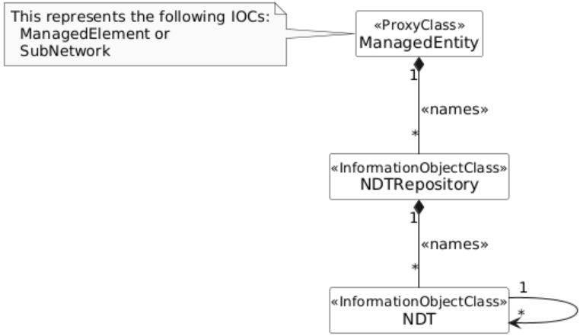

Figure 5.7.4-2- Example 2 NRM for NDT management

Introduce on the NDT <IOC>:

1. An attribute that lists the ids of the NDT capabilitiescomposing the (N)DT. It may be named dTComponentIds. The ids of DTs in this attribute indicate the reliance of the NDT on the included DTs to provide its services.
2. An attribute that describes the compositional information required to compose the components in dTComponentIds to provide a meaningful operational NDT service. It may be named nDTContext. An NDT may be associated to more than one NDTContexts indicating multiple potential compositional relations. The may NDTContext may contain:

- An identifier of the nDTcontext to be used to differentiate the multiple NDTContexts associated to one NDT.

- A map or graph describing the relations among the components, i.e. which component can provide input to which other component.

### 5.7.5 Evaluation of solutions

The potential solution described in clause 5.7.4 is a fully NRM-based approach that extends the existing NRM to realize Traceability of NDT composition in nested NDTs. The proposed solution introduces the NDTRepository IOC to store (N)DTs. NDT modelling will be further studied in normative work. The solution allows NDT MnS consumer to request information about the NDT capabilities, subscribe to and receive information about any modifications in the characteristics of a NDT capability as well as enabling NDT MnS producer to inform the consumers of the validity and feasibility of the modifications. The solution involves simple extensions to the NRM which are implementable. Therefore, the solution described in clause 5.7.4 is a feasible solution for enabling traceability of NDT composition in nested NDTs.

***End of First change***