**3GPP TSG-SA5 Meeting #157 *S5-245553***

Hyderabad, India, 14 - 18 October 2024

**Source: Rakuten Mobile**

**Title: Add evaluation of solutions for creation of a NF deployment instance**

**Document for: Approval**

**Agenda Item: 6.19.6**

# 1 Decision/action requested

***For approval***

# 2 References

[1] 3GPP TR 28.869: “Study on cloud aspects of management and orchestration”.

# 3 Rationale

Fixed the XYZ reference point name and added more details for evaluation of solutions for creation of a NF deployment instance.

# 4 Detailed proposal

It is proposed to make the following changes to TR 28.869 [1].

|  |
| --- |
| **1st change** |

5.2.3.3.2 Use of deployment management reference point based on declarative descriptor

In this solution the 3GPP management system interacts with an orchestration and management entity using the deployment management reference point as described in clause 5.2.1.3 for creation of a NF deployment instance. The deployment requirements for creating a workload of a NF are conveyed from the 3GPP management system to the orchestration and management system via a declarative descriptor.

Figure 5.2.3.3.2-1 depicts a high-level view of proposed procedure for creation of a NF deployment instance based on declarative descriptor.

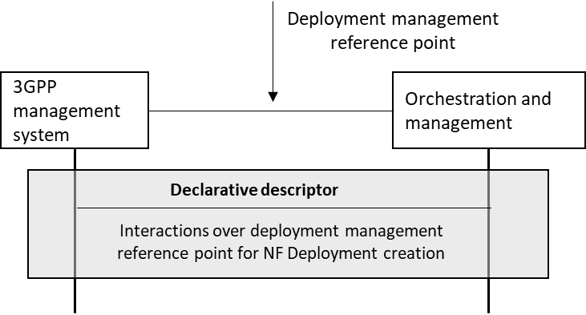

Figure 5.2.3.3.2-1: Interaction between 3GPP management system and orchestration and management system using deployment management reference point based on declarative descriptor

The declarative descriptor provides a declaration in high-level on what to be achieved by the orchestration and management system rather than how to achieve it.

If the orchestration and management entity is ETSI NFV MANO, the interactions over deployment management reference point are as specified in clause 7.10 of 28.531 [7].

NOTE: In case the orchestration and management system is ETSI NFV MANO,  VNFD is defined to convey the deployment requirement information. For other industry solutions, currently there is no standardized descriptor.

|  |
| --- |
| **2nd change** |

5.2.3.3.3 Evaluation of solutions

The proposed solution 5.2.3.3.1 defines the lifecycle operation for the creation of a NF deployment instance by a 3GPP management system using the deployment management reference point. In the proposed solution 5.2.3.3.2, the descriptor containing the deployment requirements for the NF deployment is transferred or referenced over the deployment management reference point to the orchestration and management entity. The orchestration and management entity processes the requirements in the descriptor, creates the NF deployment instance and allocates the appropriate resources to meet the requirements in the descriptor. The deployment management declarative approach (5.2.3.3.2) using the reference point (5.2.3.3.1) enables interoperability and decoupling betweenthe 3GPP management system and the orchestration and management entity and fulfils the use case requirements expressed in clause 5.2.3.2.

|  |
| --- |
| **End of changes** |