**3GPP TSG-SA5 Meeting #157 *S5-245296***

Hyderabad, India, 14 - 18 October 2024

|  |  |  |  |  |  |  |  |  |
| --- | --- | --- | --- | --- | --- | --- | --- | --- |
| *CR-Form-v12.3* | | | | | | | | |
| **CHANGE REQUEST** | | | | | | | | |
|  | | | | | | | | |
|  | **32.422** | **CR** | **0486** | **rev** | **1-** | **Current version:** | **19.0.0** |  |
|  | | | | | | | | |
| *For* [***HE******LP***](http://www.3gpp.org/3G_Specs/CRs.htm#_blank)*on using this form: comprehensive instructions can be found at* [*http://www.3gpp.org/Change-Requests*](http://www.3gpp.org/Change-Requests)*.* | | | | | | | | |
|  | | | | | | | | |

|  |  |  |  |  |  |  |  |  |
| --- | --- | --- | --- | --- | --- | --- | --- | --- |
| ***Proposed change affects:*** | UICC apps |  | ME |  | Radio Access Network | **X** | Core Network | **X** |

|  |  |  |  |  |  |  |  |  |  |  |
| --- | --- | --- | --- | --- | --- | --- | --- | --- | --- | --- |
|  | | | | | | | | | | |
| ***Title:*** | Rel-19 CR TS 32.422 updated procedure for Trace session activation for RRC reporting in NG-RAN | | | | | | | | | |
|  |  | | | | | | | | | |
| ***Source to WG:*** | Huawei, Ericsson | | | | | | | | | |
| ***Source to TSG:*** | S5 | | | | | | | | | |
|  |  | | | | | | | | | |
| ***Work item code:*** | TraceQoE_OAM | | | | |  | ***Date:*** | | | 2024-09-24 |
|  |  | | | |  | |  | | |  |
| ***Category:*** | **F** |  | | | | | ***Release:*** | | | Rel-19 |
|  | *Use one of the following categories:* ***F*** *(correction)* ***A*** *(mirror corresponding to a change in an earlier release)* ***B*** *(addition of feature),* ***C*** *(functional modification of feature)* ***D*** *(editorial modification)*  Detailed explanations of the above categories can be found in 3GPP [TR 21.900](http://www.3gpp.org/ftp/Specs/html-info/21900.htm). | | | | | | | | *Use one of the following releases: Rel-8 (Release 8) Rel-9 (Release 9) Rel-10 (Release 10) Rel-11 (Release 11) … Rel-15 (Release 15) Rel-16 (Release 16) Rel-17 (Release 17) Rel-18 (Release 18)* | |
|  |  | | | | | | | | | |
| ***Reason for change:*** | | * The S5-244786 is already approved in last SA5 156# meeting but the description is very vague | | | | | | | | |
|  | |  | | | | | | | | |
| ***Summary of change:*** | | * Clarify the description in clause 4.11.1. | | | | | | | | |
|  | |  | | | | | | | | |
| ***Consequences if not approved:*** | | A vague descriptionmay lead to different implementations that causes interoperability. | | | | | | | | |
|  | |  | | | | | | | | |
| ***Clauses affected:*** | | 4.11.1 | | | | | | | | |
|  | |  | | | | | | | | |
|  | | **Y** | **N** |  | | | |  | | |
| ***Other specs*** | |  | **X** | Other core specifications | | | | TS/TR ... CR ... | | |
| ***affected:*** | |  | **X** | Test specifications | | | | TS/TR ... CR ... | | |
| ***(show related CRs)*** | |  | **X** | O&M Specifications | | | | TS/TR ... CR ... | | |
|  | |  | | | | | | | | |
| ***Other comments:*** | |  | | | | | | | | |
|  | |  | | | | | | | | |
| ***This CR's revision history:*** | |  | | | | | | | | |

|  |
| --- |
| **1st change** |

## 4.11 RRC reporting

### 4.11.1 Trace session activation for RRC reporting in NG-RAN

RRC reporting is activated to the gNB as a special Trace Session where the Job Type parameter indicates RRC report, and the RRC Report Type parameter indicates which RRC reports should be traced. The detailed procedure is shown in figure 4.11.1.1 where one UE experiences an event which results in a RRC report being generated and traced.

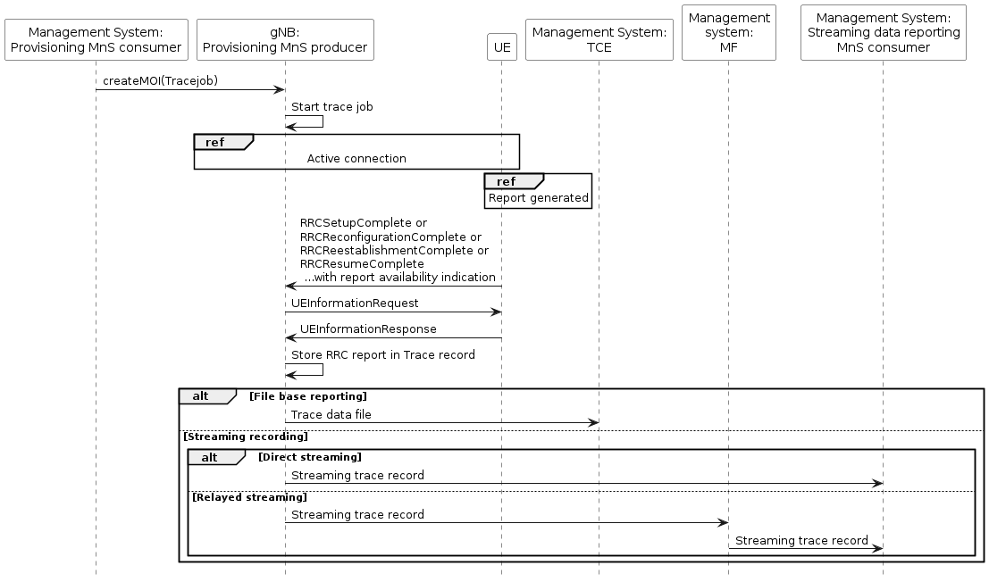

Figure 4.11.1.1 Example scenario for RRC reporting when UE generates a RRC report.

Upon Trace Session activation indicating RRC reporting, the gNB shall start a Trace Session. This Trace Session shall collect one or more RRC reports received from the UE. The gNB shall report the trace record to the TCE directly or via the management system (e.g. MF) in case of file base reporting. In case of streaming data reporting to the TCE, the gNB shall report the recorded data directly to the TCE or via the management system (e.g. MF) (see clause 7). The Trace Session activation shall contain the following information:

- Trace Reference

- Job Type: RRC report.

- RRC Report Type.

- TCE IP Address for file based reporting and Trace Reporting Consumer URI for streaming reporting if streaming based report is supported.

|  |
| --- |
| **End of change** |