3GPP TSG-SA5 Meeting #155 S5-243109
Jeju, South Korea, 27-31 May 2024

Source: Huawei

Title: Rel-19 pCR TR 28.9xx add ML knowlege transfer use case and requirements

Document for: Approval
Agenda Item: 6.19.1

1 Decision/action requested
The group is asked to discuss and approval.

2 References
[1] S5-242150 Rel-19 pCR TR28.9xx R19 Study usecases for continuation from 28.908
[2] TR 28.9xx Study on Artificial Intelligence / Machine Learning (AI/ML) Lifecycle Management (LCM) Phase 2

3 Rationale
The term of ML transfer learning is used in the current use case description in TR 28.9xx [1]. It is recommended to add this term in clause 3.1 and add MLTL as abbreviation in clause 3.3.
In order to better understand ML tranfer learning, the contribution propose to add a general description.
MnS Producers should also have the ability to trigger ML transfer learning. The contribution proposes to add new use case “ML transfer learning initiated by producer”.

4 Detailed proposal
This contribution prope to add the following change in TR 28.9xx[2].
1st Change

5.1.12 ML Knowledge Transfer Learning

5.1.12.1 Description

Transfer learning (TL) is a technique in machine learning (ML) in which knowledge learned from trained ML model is used in order to boost performance for training a new ML model. TL relies on training task similarity where learned knowledge from training a model can be used to train another model. ML knowledge transfer are not subeject of a multi-vendors scenarios. Instead, the knowledge contained in the model should be transferred instead of transferring the ML model itself.
The transfer of knowledge between models shall remain within the same vendor domain management system.

5.1.12.2 Use cases

5.1.12.2.X ML knowledge transfer learning initiated by producer
The ML MnS producer may discover similarity between a new training request and a previous request which led to a trained model. The producer may utilize the knowledge learned from that previously trained model (ML model 1) to train a new model (ML model 2). It could also be the case that the ML MnS consumer includes policy in the training request indicating similarity with a previously trained model (ML model 1). It is up to the ML MnS producer to decide if knowledge learnd from that previously trained model (ML model 1) should be used to train the new model (ML model 2). The policy could be, for example, data thresholds, data characteristic including data volume thresholds and data similarity thresholds.
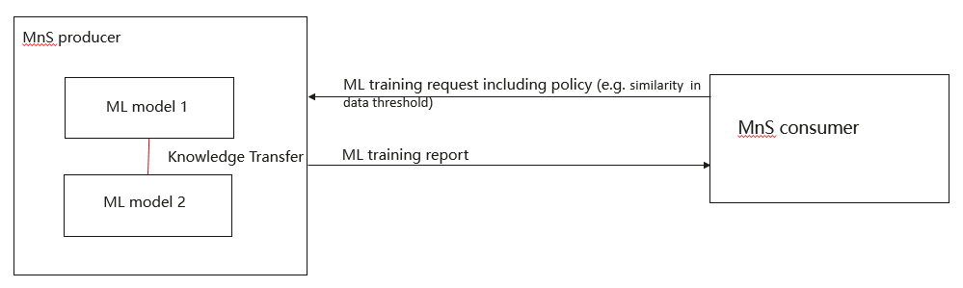

Figure 5.1.12.1-x: ML knowledge transfer learning based on consumer set policy.

5.1.12.3 Potential requirements
REQ-MLTL-X1: The ML MnS producer should have a capability to utilize ML knowledge transfer learning to train a new model based on the policy set by the MnS consumer.

End of changes

