3GPP TSG-SA5 Meeting #155 S5-243084d1
Jeju, South Korea, 27-31 May 2024

Source: Huawei, AsiaInfo?

Title: pCR TR 28.866 Add key issue for UE Throughput analysis

Document for: Approval
Agenda Item: 6.19.2

1 Decision/action requested
The group is asked to discuss and approval.

2 References
[1] SP-231726 "Study on Management Data Analytics (MDA) – Phase 3"

3 Rationale
This contribution proposes to add key issue for UE Throughput analysis to support user experience assurance.
This contribution related to WT-6 in SP-231726 [1]

4 Detailed proposal
1st Change

5.6 UE Throughput analysis

5.6.1 Description
With the development of diverse communication services and the increasing number of connections, user data volume demanded by end users grows rapidly. As the user traffic increases, user experience deteriorates significantly. Therefore, UE throughput needs to be analysed to identify the traffic congestion in a timely manner and corresponding optimization can be implemented to improve user experience.
In the real network, two types of traffc congestion as follows.
- Non-burst traffic congestion: Congestion that have heavy traffic which occurs at a fixed time or place every day, for example, during peak hours of daily morning, heavy traffic will resulting in a degraded user experience
- Burst traffic congestion: user traffic increase sharply in a specific area, for example, in commercial activities and sports events, a large number of users gather for a period of time, resulting in rate experience deterioration.
The occurrence of such traffic congestion problem may seriously affect user experience and can be detected based on the UE throughput related measurements analysis.

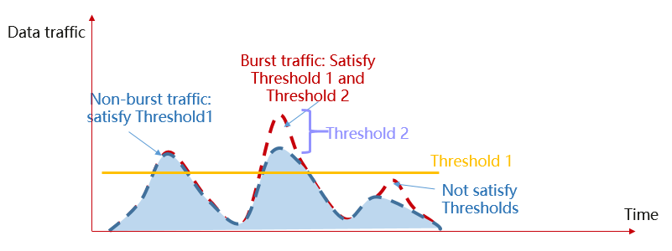
Figure5.6.1-1 UE throughput anlysis
Due to the complexity of 5G network and wireless environment, multiple types of performance deteriorate are related with high user traffic volumn, e.g., the related performance measurements such as UE throughput, PRB utilisation, UE numbers can be used to analyze, Once the preset threshold is reached, it may be considered that there is a traffic congestion problem as shown in the Figure5.6.1-1. The user experience related performance should be analysed and identified to help to resolve improve the user experience. In this case, the consumer may need to be able to set the policy to help producer to analyze the congestion problems. The policy could be, for example, the threshold of the UE throughput related performance measurements (threshold 1 and threshold 2 in the figure).
The MDAS producer for radio network may also provide the recommendations to solve the UE throughput issues identified by the analytics congestion scenarios. The recommended actions may be for example to change the mobility parameters (e.g. MRO or MLB) or antenna RF paramters (e.g. CCO) such as downtilt and azimuth to where they are needed.

5.6.2 Potential requirements
REQ1: The MDAS producer for radio network should be able to analyze and identify the traffic congestion based on the threshold of UE throughput related performance measurements and provide the analysis report to the MnS consumer.
The traffic congestion problems should contain the following information:
- The traffic congestion type and its severity level;
- The start time and end time of the traffic congestion;
- The geographical area and location where the traffic congestion affects;
- Root cause of the traffic congestion;
- The recommended actions to solve the traffic congestion problem.

5.6.3 Potential solutions
TBD

5.6.4 Evaluation of solutions
TBD

End of changes

