3GPP TSG-SA5 Meeting #155 S5-243082
Jeju, South Korea, 27 - 31 May 2024

Source: Nokia

Title: Rel-19 pCR Usecase, requirement and solution for Handover and service data correlation analytics

Document for: Approval
Agenda Item: 6.19.2

1 Decision/action requested
In this box give a very clear / short /concise statement of what is wanted.

2 References

3 Rationale
This pCR to propose Usecase, requirement and solution for Handover and service data correlation analytics.

4 Detailed proposal
Start of first change

2 References
The following documents contain provisions which, through reference in this text, constitute provisions of the present document.
- References are either specific (identified by date of publication, edition number, version number, etc.) or non-specific.
- For a specific reference, subsequent revisions do not apply.
- For a non-specific reference, the latest version applies. In the case of a reference to a 3GPP document (including a GSM document), a non-specific reference implicitly refers to the latest version of that document in the same Release as the present document.
[1] 3GPP TR 21.905: "Vocabulary for 3GPP Specifications".
[2] 3GPP TS 28.104: "Management and orchestration; Management Data Analytics (MDA)".
[x] 3GPP TS 37.817: "Study on enhancement for data collection for NR and ENDC"
[y] 3GPP TS 38.423: "NG-RAN; Xn Application Protocol (XnAP) "

Start of next change

5.3.K Use case K: Handover and service data correlation analytics

5.3.K.1 Description
Handover performance may be affected by multiple aspects including:
- Signal measurements, either as measured in the network or as predicted.
- User speeds which may be measured or predicted.
- User paths or trajectories, by predicting the likely destination based on the user current path and learning from previous user trajectories.

These may be combined in different forma to either derive the optimal handover settings or to also determine the related service configurations. It is desired that the MDA supports analytics that enables the consumer to request analytics on real or predicted signal measurements, on real or predicted user speeds, on learned and predicted user trajectories or paths, or any combination of these aspects. The predicted user speed and predicted trajectory mentioned here are referring to the RAN3 agreed predicted outputs on the same as described in [x] and [y].
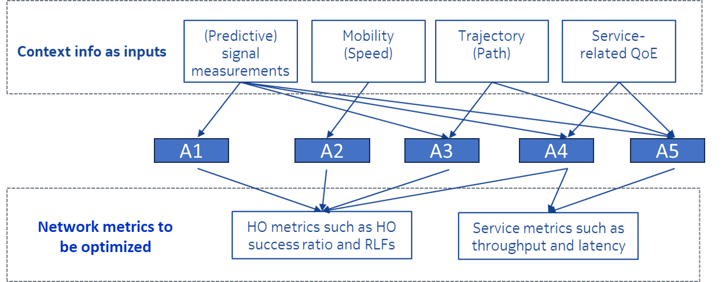
Figure 5.3.K.1-1: Examples of various context information and HO performance metrics can be used for handover optimization through different combinations A1 to A5.

5.3.K.2 Potential requirements
REQ-MDA-CORR-1: The MDA producer for handover and service data correlation analytics should have a capability of allowing the use the predicted signal measurements, predicted user speeds and predicted user trajectories for providing recommendations for Handover analytics.
REQ-MDA-CORR-2: The MDA producer for handover and service data correlation analytics should have a capability of allowing the consumer to use the service characteristics such as QoE for providing recommendations for handover analytics.

5.3.K.3 Potential solutions

5.3.K.3.1 Possible solution for handover and service data correlation analytics
- Extend the existing usecase on Handover optimization analytics by enhancing the enabling data to include predicted signalling measurements, predicted user trajectories and predicted signal measurements.
- Extend the existing usecase on Handover optimization analytics by enhancing the enabling data to include service characteristics such as QoE.

5.3.K.4 Evaluation of solutions

End of changes

