**3GPP TSG-RAN WG1 #117R1-24xxxx**

Fukuoka City, Fukuoka, Japan, May 20th – 24th, 2024

**Title : Summary on the channel model adaptation and extension**

**Source : Moderator (ZTE)**

**Agenda item : 9.8.2**

**Document for : Discussion and Decision**

# Introduction

In RAN#102 meeting, a study item on 7-24 GHz channel model is initialized as following.

|  |
| --- |
| *The objectives of this study are:*   * *Validate using measurements the channel model of TR38.901 at least for 7-24 GHz*   + *Note: Only stochastic channel model is considered for the validation.*   + *Note: The validation may consider all existing scenarios: UMi-street canyon, UMa, Indoor-Office, RMa and Indoor-Factory.* * *Adapt/extend as necessary the channel model of TR38.901 at least for 7-24 GHz, including at least the following aspects for applicable scenarios:*    + *Near-field propagation (with consideration being given to consistency between near-field and far-field)*   + *Spatial non-stationarity*   *Note 1: Continuity of the channel model in the frequency domain below 7 GHz and above 24 GHz shall be ensured.*  *Note 2: Mathematical and/or theoretical aspects (if any) may be studied before results of measurement campaigns are available. While measurement results may be available and submitted at any time, the study of measurement results may start later (e.g., Q3 2024).* |

This contribution summarizes the proposals in companies’ input under the AI 9.8.2 with following aspects:

* Channel model for Near field propagation
* Channel model for Spatial non-stationarity
* Other aspects

The details of each part are provided in corresponding section below.

# **Views on the near-field propagation**

## **Necessity and clarification on near-field phenomenon**

### **1.1.1 Company view (Round-1)**

In last RAN1#116bis meeting, the following agreement has been agreed to clarify the main intention of this agenda item, i.e., impact of the assumption of wavefront.

|  |
| --- |
| Agreement  For the near-field channel model:   * The impact of the assumption of wavefront is only considered from the perspective of antenna array. * The near field for each element within the antenna array is not considered in this SI. |

It’s aligned with the views from almost all companies. For example, [InterDigital, LGE, Intel, Ericsson, Samsung, vivo, ZTE, Apple, Lenovo, CATT, NVIDIA, MTK, Qualcomm, CEWiT] highlight the spherical wavefront terminology when discussing the near-field modeling. [Qualcomm] proposes to study the impact of spherical wavefront modeling comparing to planar wavefront modeling, Thus, it is commonly acknowledged that the near-field channel model is to model the impact on channel parameters due to the spherical wavefront propagation.

Moreover, the relevant phenomenon has also been observed in the real field. For example, [ZTE, BUPT, CMCC, vivo] provide the measurement results for the indoor scenarios, which can clearly observe the non-linear parameters variation that is different from the characteristics of far-field propagation. [vivo] highlights that the channel model behaving the un-parallel element-paired channel link should be prepared prior to starting the 6G specification in RAN1, and [NVIDIA] highlights that the appropriate model and technique tailored to the characteristics of the near-field region is essential.

Additionally, [Ericsson] mentions the antenna array gain loss under the planar wavefront and spherical wavefront approximation, and proposes that the impact on communication performance of spherical wavefront modelling shall be studied. [Qualcomm] also provides the preliminary simulation evaluations to observe the impact on multi-user multiplexing.

According to the above inputs, from FL’s perspective,

* For the essential part of the near-field channel modelling, the majority’s view is to capture the impact on the channel parameters of spherical wavefront propagation. Regarding the technical solution related action, e.g., performance evaluation, which it is out of the scope of channel model study.
* According to the measurement results and analysis provided from companies, for channel modelling, the existence and impact of near-field phenomenon have been clarify identified, which motivate the support of the near-field channel modelling.

Then, the following is proposed:

***Proposal 1-1-1:*** *The near-field propagation characteristics (i.e., characteristics of non-planar wavefront) should be supported for the channel modelling.*

Companies are encouraged to share your views.

|  |  |
| --- | --- |
| Companies | Comments and Views |
| QC | It’s a little too early to come to this conclusion. There is not enough evidence to suggest this modelling is needed. Suggest that we agree to make a decision in the August meeting once all companies have had a chance to complete their measurement campaigns. |
| CATT | In principle support. |
| Huawei, HiSilicon | Prefer to delay until the necessity is clearly proved. |
| Samsung | Support to FL’s proposal. Based on the study of non-planar wavefront characteristics and comparison with planar wavefront, channel parameters which need to be specified could be clarified. |
| vivo | Support |
| Nokia | We share QC’s view that it is too early to reach a conclusion like this without further study. Some of the presented simulation results have shown an observable spherical wave propagation phenomenon in some limited scenarios, but the loss in validity, assuming plane wave propagation has not been fully quantified. Given the potential modeling complexity in incorporating near-field propagation, further study is necessary before concluding this must be modeled. |
| CEWiT | We support |
| Lenovo | Support |
| InterDigital | Support |

## **1.2 Assumption for the near-field channel modeling**

### **1.2.1 Company view (Round-1)**

In last RAN1#116-bis meeting, as for the aperture size of antenna array for channel model study, the following agreement has been achieved and the detailed value is still pending issue.

|  |
| --- |
| **Agreement**  For the assumption on the aperture size of antenna array, the following is considered as reference for channel model study.   * up to [TBD] m, or [TBD] lambda for UMi * up to [TBD] m, or [TBD] lambda for UMa * up to [TBD] m, or [ TBD] lambda for Indoor office * up to [TBD] m, or [TBD] lambda for Indoor factory |

In this meeting, regarding the format of aperture size, [vivo, ZTE, Ericsson, Apple, Qualcomm] propose that the physical aperture size (i.e., meter) of antenna array is used as reference, and [Ericsson] further proposes that the number of antenna elements per antenna array shall also need to be kept within reasonable limits, which can be an upper bound on the electrical size of antenna array. While [Samsung, Nokia] propose that both the physical aperture size and the frequency shall be considered for the upper bound determination.

More specifically, for the detailed maximum value of aperture size for different scenarios, [Ericsson, ZTE] propose that for the future consideration, the size of antenna arrays considered in this study should be significantly larger than what is used in existing 5G systems, and the feasibility of practical deployment shall also be considered [Ericsson, Samsung]. And [vivo, ZTE] propose that for indoor scenarios, the different shapes of antenna arrays (e.g., the linear array) shall be considered.

Following detailed values are summarized according to companies’ input:

|  |  |  |  |  |  |  |  |  |
| --- | --- | --- | --- | --- | --- | --- | --- | --- |
| Scenarios | Ericsson | vivo | ZTE | Samsung | Nokia | Apple | CATT | Qualcomm |
| UMi | 0.71m, but no more than 2500 antenna elements | 1.414m for antenna panel | 1.3m | 1 m, or less than 30 $λ$ | $$\min\left(0.5 m, 18⋅λ\right)$$ | 1m | 0.5m/10 λ | $\frac{1}{\sqrt{2}}$ m |
| UMa | 1.41m, but no more than 10000 antenna elements | 1.414m for antenna panel | 1.3m | 1 m, or less than 40 $λ$ | $$\min\left(1 m, 36⋅λ\right)$$ | 1m | 1m/20λ | $\sqrt{2}$ m |
| Indoor office | 0.35m, but no more than 625 antenna elements | 1m for linear array | 1.5m | 0.5 m, or less than 15 $λ$ | $$\min\left(0.5 m, 18⋅λ\right)$$ | 0.5m | 0.5m/10λ | $\frac{1}{2\sqrt{2}}$ m |
| Indoor factory | 0.71m, but no more than 2500 antenna elements | 1m for linear array | 1.5m | / | $$\min\left(0.5 m, 18⋅λ\right)$$ | 0.5m | 0.5m/10λ | $\frac{1}{2\sqrt{2}}$ m |

Then, from FL’s perspective, both the physical size of antenna array and the frequency can be considered for the upper bound of aperture size. And considering inputs from companies, e.g., by assuming the antenna space as 0.5 *λ*, the following is proposed to provide the aperture size (i.e., diagonal) of reference antenna array:

***Proposal 1-2-1:*** *For the assumption on the aperture size of antenna array, the following is considered as reference for channel model study, e.g., simulation/measurement and calibration:*

* *min(1.414m, $50\sqrt{2}$ λ) for UMi*
* *min(1.414m, $50\sqrt{2}$ λ) for UMa*
* *min(1m, $25\sqrt{2}$ λ) for Indoor office*
* *min(1m, $25\sqrt{2}$ λ) for Indoor factory*

Companies are encouraged to share your views.

|  |  |
| --- | --- |
| Companies | Comments and Views |
| QC | UMi deployments are at a lower height, mounted on streep lamps. We don’t see the need to study panel up to 1m x 1m for such deployments.  Similarly, indoor panel sizes are also too large compared to practical deployments. Suggest reduing UMi and Indoor values by a factor of 2 at least. |
| CATT | Agree with QC that the Umi and indoor values need to be reduced. |
| Huawei, HiSilicon | Prefer to include 1.5m (1.45m \* 0.4m) as the aperture size for Umi/Uma as below:  ***Proposal 1-2-1:*** *For the assumption on the aperture size of antenna array, the following is considered as reference for channel model study, e.g., simulation/measurement and calibration:*   * *min(1.5m, $50\sqrt{2}$ λ) for UMi* * *min(1.5m, $50\sqrt{2}$ λ) for UMa* * *min(1m, $25\sqrt{2}$ λ) for Indoor office*   *min(1m, $25\sqrt{2}$ λ) for Indoor factory* |
| Samsung | We would like to ask how to derive values in $X√Yλ$ for each scenarios. The specific values for frequency dependent antenna aperture size need to be discussed more. In addition, we don’t see the large antenna aperture size is practical when it comes to all spectrum (7 – 24 GHz) |
| vivo | Support |
| Nokia | Similar view as QC and CATT regarding antenna aperture size for UMi and indoor scenarios. Indoor scenarios do not show a strong frequency dependence in excess loss that would motivate larger antenna apertures. |
| CEWiT | We also prefer to have Indoor scenarios with half the aperture size of UMa. |
| Lenovo | We share the same opinion as Samsung. More discussion is needed for each scenarios. |
| InterDigital | OK |

Additionally, regarding the RMa scenario, [vivo] proposes that impact of near-field on channel modelling is relatively insignificant due to the cell range and the lower possibility to deploy the large-scale antenna arrays, which can be de-prioritized in the near-field study[vivo]. [ZTE] mentions that it’s up to companies’ input.

Companies are encouraged to share your views.

|  |  |
| --- | --- |
| Companies | Comments and Views |
| QC | We can reuse UMa guidance on panel sizes for RMa as well. |
| Huawei, HiSilicon | Fine to deprioritize RMa scenario. |
| vivo | For RMA, in consideration of the cell range (i.e., ISD), the minimum distance between gNB and UE, and the practical antenna aperture size, the impact of near-field and spatial non-stationarity on channel modeling is relatively insignificant. Hence, it can be de-prioritized. |
| CEWiT | We consider RMa to be a low priority item as we expect very less effect of near field. |

## **1.3 Details of near-field channel modeling**

### **1.3.1 Large scale parameters determination**

**1.3.1.1 Company view (Round-1)**

Based on the existing procedure in TR38.901, when considering the near-field channel modeling, some companies mention that there may be changes on the existing large-scale parameters generation procedure. Specifically, [InterDigital, Intel] propose that the pathloss model may require some modifications and need re-evaluation considering the different distance and phase shifts experienced by the different antenna element pairs, and [CEWiT] proposes that the possibility of reusing the existing path loss models can be further studied for near-field region.

Additionally, for the generation of correlated large-scale parameters (e.g., DS, ASD, SF, K), [InterDigital, CEWiT] mention that no major revision is expected for this step and only the value range of some parameters may need re-evaluation to adapt to the near-field channel modeling.

However, the majority companies share the views that no changes are expected on the existing large-scale parameters for the near-field channel modeling. More specifically,

* [Apple] proposes that the impact on large scale parameters is negligible and it does not have impact on scenario/network layout/antenna parameters, as well as coefficient generation.
* [Samsung] proposes that large scale channel parameters such as pathloss, shadow fading, and O2I penetration loss are functions of distance and frequency. Therefore, their definitions do not vary across field domains, and RAN1 reuse section 7.4 defined in TR 38.901 for the pathloss, shadow fading, O2I penetration loss.
* [MTK] proposes that large-scale fading is influenced by factors such as path loss, shadowing from large obstacles, and the overall propagation scenarios, rather than the intricate phase and amplitude variations seen in the near-field. Therefore, they are not the primary factor in large-scale fading.
* [Qualcomm] proposes that a single pathloss/attenuation value is computed based only on UE and gNB locations.
* [Huawei, ZTE, vivo] highlight that no changes are expected on the existing large-scale parameters.

From FL’s perspective, the pathloss/SF model is to capture the power variation by considering the average power over the relative larger region and longer time duration, e.g., averaged over all antenna elements at Tx/Rx side. So, it’s should not be modelled in element-wise, which is not aligned with the existing structure. Additionally, for other large-scale parameters (e.g., DS, ASA), it is only to reflect the propagation environment and used to generate the basic set of small-scale parameters for the BS-UE link. The MIMO channel is further generated by taking impact of multiple-antennas in addition to the basic set, e.g., antenna element-wise variation for delay, angle, etc.

Then, from FL’s perspective, it’s recommended that for the near-field channel modeling, no changes are expected on both modeling and parameters of the existing large-scale parameters of TR 38.901.

Then, following is proposed:

***Proposal 1-3-1-1:*** *For the near-field channel modeling,**no changes are expected on both value and parameter generation procedure of the existing large-scale parameters (i.e., pathloss model, DS, ASA, ASD, ZSA, ZSD, SF, K factor, LOS probability) in TR 38.901****.***

Companies are encouraged to share your views.

|  |  |
| --- | --- |
| Companies | Comments and Views |
| Huawei, HiSilicon | Fine. |
| Samsung | All of channel parameters will need to be validated. However, we consider that pathloss model, SF and LOS probability is will not be changed, at least. Because those are parameters which is related to geometrical point of view. But, for the remaining large-scale parameters, we are not sure it is really independent parameters for the antenna configuration and propagation field. So, we would like to suggest the discussion whether all of parameters are independent for field definition, first. And then, RAN1 can reach to consensus for the proposal. |
| vivo | Support |
| CEWiT | Support |
| Lenovo | Fine with the proposal. |
| Intel | For pathloss, it is premature to come to conclusion on having no change on pathloss model for near-field channel modeling. So, we suggest to put pathloss model as FFS. |
| QC | This reflects our expectation at least for outdoor deployments (UMi, Uma, and RMa). For indoor, we may need some additional discussions. |
| InterDigital | Support in principle that the existing procedure should be re-used, however we would like to soften the wording a bit as follows,  ***Proposal 1-3-1-1:*** *For the near-field channel modeling,**no changes are expected on ~~both value and~~ parameter generation procedure of the existing large-scale parameters (i.e., pathloss model, DS, ASA, ASD, ZSA, ZSD, SF, K factor, LOS probability) in TR 38.901****.*** |

### **1.3.2 Small scale parameters determination**

#### **1.3.2.1 Company view (Round-1)**

For this topic, there are following two issues highlighted by companies:

* **Issue#1: small scale parameters determination of direct path between BS and UE**

In last RAN1#116bis meeting, following agreement has been achieved:

|  |
| --- |
| **Agreement**  For near-field channel, if necessary, to model the following antenna element-wise channel parameters of direct path between TRP and UE,   * Angular domain parameters (i.e., AoA, AoD, ZoA, ZoD), Delay, initial phase, Doppler shift, Amplitude * FFS: Impacts on the polarization   The following options are considered:   * Option-1: Determined by the locations of both TRP and UE. * Option-2: Determined by the antenna element locations of both TRP and UE |

In this meeting, regarding which channel parameters are necessary to be modeled as the antenna element-wise channel parameters, following are summarized according to companies’ input. And the following figure is given to show the impact of different channel parameters on the channel coefficient generation for direct path. For example, the amplitude of the LoS is assumed as 1, which will be further updated by K\_factor.

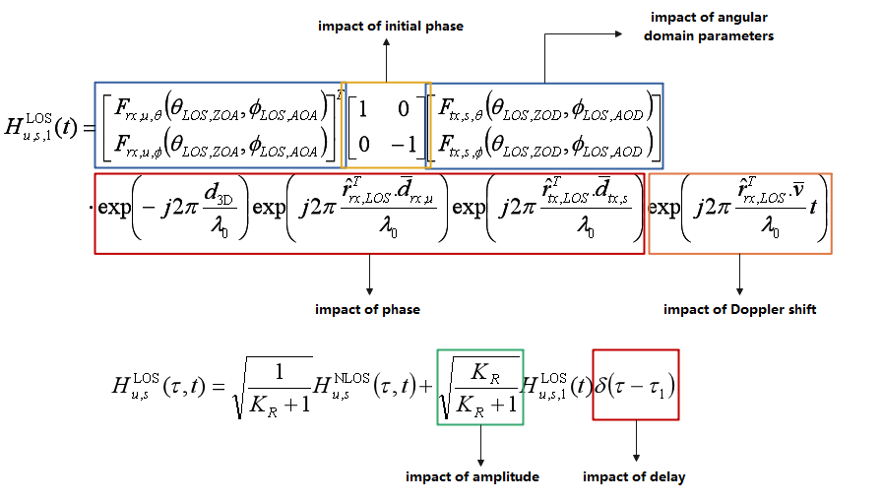

* Angular domain parameters:
* [InterDigital, LGE, Huawei, Intel, Samsung, vivo, ZTE, Apple, BUPT, CMCC, Lenovo, CATT, NVIDIA, CEWiT] propose to model the antenna element-wise angular parameters.
* Delay:
* [ZTE, Lenovo, NVIDIA, CATT] propose to model the antenna element-wise delay parameters.
* [vivo, Huawei, CEWiT] propose that there is no need to model the antenna element-wise delay parameters. And [vivo] highlights that the delay difference between the paths are smaller than the A/D sampling interval, then the effect of the arrival delay of the direct path caused by small changes in the position of the antenna array can be ignored.
* Phase:

Regarding the phase, there are two aspects related to the phase,

* The initial phase part:
* The initial phase in existing TR 38.901 is assumed to be zero for the direct path [ZTE], then [InterDigital, Huawei, Intel, ZTE, vivo, Qualcomm, CEWiT] propose that there is no need to model the antenna element-wise initial phase.
* [NVIDIA] proposes to model the antenna element-wise initial phase.
* The phase due to the propagation distance:
* [InterDigital, LG, Huawei, Intel, Samsung, vivo, ZTE, Apple, Lenovo, CEWiT, Qualcomm] propose that it can be calculated according to the distance between the location of Tx antenna element and Rx antenna element;
* Doppler shift:
* [LGE, Intel, vivo, ZTE, Lenovo, NVIDIA, Qualcomm] propose to model the antenna element-wise Doppler shift parameters, since it is related to the antenna element-wise angular parameters.
* [Huawei, CEWiT] proposes that no change is needed on Doppler shift parameters.
* Amplitude:
* [InterDigital, Huawei, Intel, vivo, ZTE, CEWiT, Qualcomm] propose that no change is needed on the amplitude of LOS ray/cluster.
* [CATT] proposes to model the antenna element-wise amplitude of LOS ray/cluster.

Besides, [Qualcomm] proposes that the complexity of spherical-wavefront modeling can be executed to different degrees of accuracy, then different options can be considered based on overall impact on simulation outcomes. And considering the practical deployment scenarios and commercially relevant gNB antenna arrays, it is suggested that the phase/delay of a ray can be prioritized studied.

Moreover, as for how to determine the antenna element-wise parameters, almost all companies [InterDigital, LGE, Huawei, Intel, Samsung, vivo, ZTE, Apple, BUPT, CMCC, Lenovo, NIVIDIA, CEWiT] propose that the Option-2 (i.e., determined by the antenna element locations of both TRP and UE) shall be used. And [ZTE] further provides the measurement delay results, which are aligned with the geometric calculation results of antenna element-wise delay for the direct path between BS and UE.

According to companies’ views, following is proposed from FL’s perspective:

***Proposal 1-3-2-1-1:*** *For near-field channel, the following channel parameters of direct path between TRP and UE should be modeled as antenna element-wise parameter and determined by the antenna element locations of both TRP and UE.*

* *Angular domain parameters, phase, delay, Doppler shift.*

Companies are encouraged to share your views.

|  |  |
| --- | --- |
| Companies | Comments and Views |
| Huawei, HiSilicon | Generally fine. The phase and delay in the sub-bullet are duplicated to a certain extent. |
| Samsung | As discussed in proposal 1-1-1, a study on non-planar wavefronts can be conducted, accompanied by an analysis of their impact. Based on these results, the parameters considered in proposals 1-3-2-1-1 and 1-3-2-1-2 may need to be revised. Therefore, we suggest re-evaluate the parameters in light of the study on the channel impact of non-planar wavefronts or make a room for revisit |
| vivo | We are supportive of the parameters of angle, phase, Doppler, but delay. As we indicated in our contribution, the changes of delay between the elements are much smaller than the sampling interval in general, that does not impact the channel modeling. For instance, on one hand, assuming the signal is transmitted over 100MHz band, and the sampling rate is 200MHz, this results in the sampling interval to be 5ns. On the other hand, if assuming 15GHz band with the antenna spacing of λ/2, this results in the maximum delay between two neighbor elements to be 0.01m/3e8=0.033ns, which is much smaller than sampling interval. Hence, the impact of this delay on the channel modeling can be negligible. We suggest FFS to the parameter of delay. |
| Lenovo | Support in general. But we think delay is not needed here. When we model the channel antenna-element wise, delay and phase are directly related to each other and only one is needed. |
| Intel | Support |
| QC | For now, we suggest focusing on phase. All other aspects can be left under an FFS and included if clear evidence is provided via simulation outcomes that it is important to model the other aspects. |
| InterDigital | From our perspective, phase and delay is the same thing and don’t need to be repeated. So, the initial focus should be on phase and angular domain parameters, and then FFS Doppler shift. |

***Proposal 1-3-2-1-2:*** *For near-field channel, following channel parameters of direct path are not necessary to be modeled as antenna element-wise parameter.*

* *Amplitude, initial phase.*

Companies are encouraged to share your views.

|  |  |
| --- | --- |
| Companies | Comments and Views |
| Huawei, HiSilicon | Support. |
| vivo | Support |
| CEWiT | Support |
| Lenovo | Support |
| Intel | Amplitude is confusing here. In fact, the “Angular domain parameters” are part of channel amplitude. If the intention is to refer to , we think this component is not part of direct path itself. It is related to the power ratio of direct path and indirect path. So, it needs to be discussed separately together with the parameter . So, we suggest to remove “Amplitude” from the proposal. Also, the term “not necessary to be modelled” is unclear. Is it still allowed to model per element or it is never modelled per element? |
| QC | May be okay for outdoor deployments. Indoor deployments require further discussions. |
| InterDigital | Support |

* **Issue#2: small scale parameters determination of non-direct paths between BS and UE**

Regarding which channel parameters are considered to be modeled as the antenna element-wise channel parameters for the non-direct paths between BS and UE, following are summarized according to companies’ input. And the following figure is given to show the impact of different channel parameters on the channel coefficient for non-direct paths.

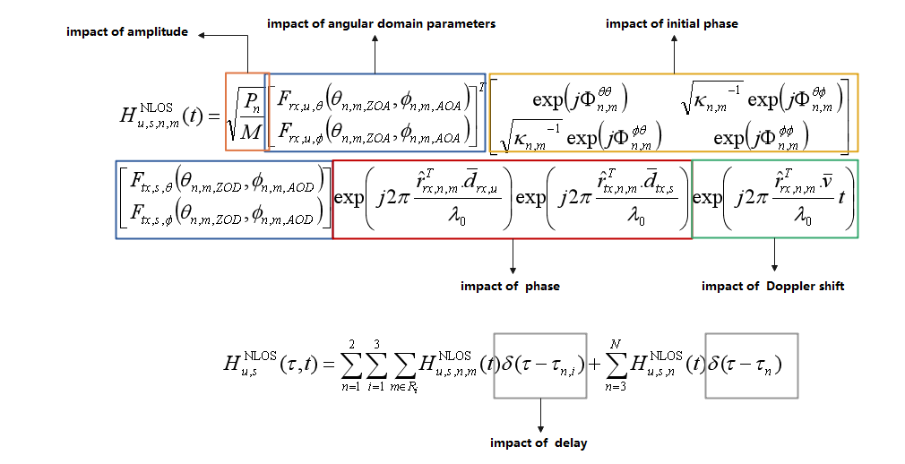

* Angular domain parameters:
* [InterDigital, Huawei, Intel, vivo, BUPT, CMCC, CEWiT, ZTE, Apple, CATT] propose to model the antenna element-wise angular domain parameters.
* Delay:
* [vivo, Huawei, CEWiT] propose that there no change is needed on delay parameters.
* [ZTE, Lenovo, CATT, NVIDIA] propose to model the antenna element-wise delay parameters.
* Phase:
* For the initial phase:
* [InterDigital, Huawei, Intel, vivo, ZTE, CEWiT] propose that no change is needed on initial phase part;
* For the phase due to the propagation distance:
* [InterDigital, Huawei, Intel, vivo, ZTE, BUPT, CMCC, CEWiT] propose that it can be calculated from the distance between the location of antenna element and the cluster.
* Amplitude:
* [InterDigital, Huawei, Intel, vivo, CEWiT, Qualcomm] propose there is no need to model the antenna element-wise amplitude. While [CATT] proposes that the antenna element-wise amplitude can be considered.
* Doppler shift:
* [Intel, vivo, ZTE, BUPT, CMCC, Lenovo] propose to model the antenna element-wise Doppler shift parameters. While [Huawei] proposes that no change is needed on the Doppler shift parameters.

And similar as the direct path, [Qualcomm] proposes that different options can be considered based on overall impact on simulation outcomes. And considering the practical deployment scenarios and commercially relevant gNB antenna arrays, it is suggested that the phase/delay of a ray can be prioritized studied.

Moreover, regarding how to calculate the antenna element-wise channel parameters for the non-direct path, according to companies’ views, following methods are summarized according to companies’ inputs:

* Option-1: The cluster location-based approach is used to determine the antenna element-wise channel parameters [InterDigital, LGE, Huawei, Intel, Samsung, vivo, Apple, BUPT, CMCC, Lenovo, CATT, Qualcomm, CEWiT]. More specifically, as for how to determine the cluster location, following alternatives are summarized:
* Alt-1: [InterDigital, Huawei, Samsung, vivo, Apple, BUPT, CMCC] proposes that the cluster location is implicitly derived based on the distance between the BS and cluster, and the distance is related to the cluster delay generated in existing TR 38.901, e.g., upper bounded by the cluster delay [Apple], or a parameter for the propagation distance from the TRP to the first-bounce scatter is introduced [BUPT, CMCC].

[Huawei] proposes that the delay and angle of a ray generated according to current 38.901 can be treated as the observed delay and angle at the reference antenna element, which is used to locate the first-/last-bounce scatter.

* Alt-2: [Intel, Lenovo, CATT, CEWiT] proposes that the cluster location can be directly dropped and generated. In detail:

[Intel] proposes that the deterministic or stochastic approaches or a combination thereof can be considered to determine the cluster location.

[Lenovo] proposes that the statistical distribution of the scatters including the number of scatters, positions, reflection coefficients, sizes and orientations for different scenarios can be studied.

[CEWiT, CATT] mention that the generation of cluster location shall consider the effect of cluster delay generated in TR 38.901, e.g., a cluster dropping boundary can be identified according to the shorted delay of all paths [CEWiT].

* Option-2: The parameter-based approach is used to determine the antenna element-wise channel parameters [ZTE, LGE, MTK]. More specifically, [ZTE, MTK] propose to model the element-wise parameters with considering on the existing spatial consistency procedure of TR 38.901, or model the variation over the element in statistic way [ZTE]. [LGE] proposes to directly reuse the existing far-field channel model for the NLOS path.

According to the companies’ views above, following are proposed from FL’s perspective:

***Proposal 1-3-2-1-3:*** *For near-field channel, the following parameters of the non-direct path between TRP and UE should be modeled as antenna element-wise parameter.*

* *Angular domain parameters, delay, phase, Doppler shift*

Companies are encouraged to share your views.

|  |  |
| --- | --- |
| Companies | Comments and Views |
| Huawei, HiSilicon | Generally fine. The phase and delay in the sub-bullet are duplicated to a certain extent. |
| Samsung | Same comments in proposal 1-3-2-1-1 for proposal 1-3-2-1-3 and 4. |
| vivo | We are supportive of the parameters of angle, phase, Doppler, but delay. It is the same reason to have the concern on delay as Proposal 1-3-2-1-1. |
| Lenovo | Support in general. But we think delay is not needed here. When we model the channel antenna-element wise, delay and phase are directly related to each other and only one is needed. |
| Intel | Support |
| QC | Whether non-direct paths need near-field modelling or not has not been shown to be necessary. As things stand right now, there is insufficient evidence to suggest that this modelling is required.  We should prioritize modelling just the phase term and assess whether there is any benefit to modelling this carefully in the context of spherical wavefront modelling. We need much stronger proof that its important to model any of these other effects.  Consider the following: For a 1m x1m panel in an outdoor deployment, if the UE is 25m away along boresight, the maximum angular variation is only about 2 degrees or so for the line of sight path. This will have little to no impact on the angle-dependent antenna gains. Its not clear why this level of accuracy is even necessary. Similar arguments can be extended to doppler shift as well. |
| InterDigital | Doppler shift should be FFS |

***Proposal 1-3-2-1-4:*** *For near-field channel, following parameters of the non-direct path between TRP and UE are not necessary to be modeled as antenna element-wise parameter:*

* *Amplitude, initial phase.*

Companies are encouraged to share your views.

|  |  |
| --- | --- |
| Companies | Comments and Views |
| Huawei, HiSilicon | Support. |
| vivo | Support |
| CEWiT | Support |
| Lenovo | Support |
| Intel | Similar comment to our comment on Proposal 1-3-2-1-2: Amplitude is confusing here. In fact, the “Angular domain parameters” are part of channel amplitude. If the intention is to refer to , we think this component is not part of direct path itself. It is related to the power ratio of direct path and indirect path. So, it needs to be discussed separately together with the parameter . So, we suggest to remove “Amplitude” from the proposal. Also, the term “not necessary to be modelled” is unclear. Is it still allowed to model per element or it is never modelled per element? |
| QC | May be okay for outdoor deployments. Indoor deployments need further discussion. |
| InterDigital | Support |

***Proposal 1-3-2-1-5:*** *For near-field channel, the antenna element-wise channel parameters of non-direct path between TRP and UE can be determined by following options:*

* *Option-1: The cluster location-based approach, wherein the cluster location is obtained with following alternatives:*
* *Alt-1: cluster location is derived based on at least the distance between the BS/UE and clusters.*
  + *FFS: How to obtain the distance.*
  + *FFS: Other parameters.*
* *Alt-2: cluster location is directly dropped and generated.*
* *Option-2: The parameter-based approach with following detailed alternatives:*
* *Alt-1: Introduce the model of variation rate of parameter over antenna elements.*
* *Alt-2: Modelling the variation by taking the existing spatial consistency procedure of TR 38.901 as baseline.*

Companies are encouraged to share your views.

|  |  |
| --- | --- |
| Companies | Comments and Views |
| Huawei, HiSilicon | Fine. |
| Samsung | Thanks FL for the proposal. However, before discussing methodologies, we prefer to first address whether the clusters within the near-field region can reuse the existing modeling. This is because we do not yet understand how or in which areas the current channel modeling’s cluster generation methods affect the field. Therefore, we suggest that RAN1 first discuss the characteristics of the current modeling methods (whether the existing cluster generation method is valid in near-field region or not) and the necessity for new methodologies specifically for the near-field region, and then proceed to discuss the proposal. |
| vivo | According to the input from the proponents, the majority is supportive of Option-1. Therefore, only Option-1 is enough. |
| CEWiT | We also favour Option-1 and open to discuss both Alt-1 and Alt-2 |
| Lenovo | We prefer Option-1. |
| Intel | Support |
| QC | We prefer to have some agreement on this to facilitate simulations that can compare results with NF and FF modelling.  With a cluster’s delay ($τ_{n}$), AoD and ZoD, it may already be possible to give global location coordinates to a cluster. This could serve as a starting point. We can then assess whether we need anything further from Option 1 or Option 2. |
| InterDigital | Support, and prefer Option-1. |

Additional aspects related to the small-scale channel parameters are also proposed by companies. For example:

* [CATT] proposes that the power loss of different antenna pairs due to different polarization directions shall also be considered.
* [CEWiT] proposes that the number of strongest clusters, cluster delay offset, ray mapping, power association to rays within a cluster for the near-field from measurements shall be validated.
* [InterDigital, CEWiT] propose that the exponential decay behaviors of cluster power with respect to their delays are not observed in near-field measurements, which may need to be revisited for near-field effect.

Companies are encouraged to share your views.

|  |  |
| --- | --- |
| Companies | Comments and Views |
|  |  |

## **1.4 Methodology for the near-field channel modelling**

### **1.4.1 Criteria to define the near-field region**

#### **1.4.1.1 Company view (Round-1)**

In last RAN1#116bis meeting, following agreement has been achieved:

|  |
| --- |
| **Agreement**  For the study of near-field channel modelling, at least following aspects should be considered:   * Whether/How to define the near-field region. * The parameters variation for each ray/cluster across different antenna element pairs. |

In this meeting, [Intel, Samsung, Lenovo, ZTE, CATT, vivo, Apple, CEWiT, Qualcomm] propose that the near-field region shall be defined using a criterion. [Samsung] highlights that whether the near-field region of the BS remains unchanged regardless of the configuration of the actual antenna array being used shall also be discussed, and the complexity of boundary determination shall not be too high and different near-field and far-field boundaries can be defined according to different evaluation requirements [CATT]. While [Ericsson] further proposes that before defining near-field region, the impact on communication performance of spherical-wave modelling for both direct and non-direct paths should be studied.

Regarding how to define the near-field region, [Intel, Lenovo, CATT, ZTE, Apple, Qualcomm] propose that the channel model error-based way (e.g., phase, amplitude, angle error-based) can be used to determine the boundary. More specifically,

* [Intel] proposes that for LOS channel, the boundary of the near-field region can be defined based on the non-negligible channel phase.
* [Lenovo] proposes that the maximal phase error and maximal amplitude error can be used to define the boundary. And the angular-based Rayleigh distance can be considered, the near-field region can be approximated as a circle with the Rayleigh distance as its diameter pointing away from the center of the antenna array.
* [CATT] proposes that the phase error criterion, power ratio criterion can be considered. And the near-field and far-field boundary under NLOS scenarios can be defined according to the change of angle parameters.
* [Apple] proposes that the Rayleigh distance can be used to determine the boundary.
* [Qualcomm] proposes that a scaled Fraunhofer distance, i.e., $α*F_{d}$, can be considered to determine whether a UE-gNB link is modeled using spherical wavefront. And the value of $α$ is less than 1.

Further, [Lenovo, ZTE] highlight that the boundary determination of near-field region shall not be based on the performance metric of particular technologies, since the different performance metric used for different technologies may result in different impact on the near-field region determination, and such technologies may not be supported/used in the future.

Additionally, [MTK] proposes that the need for strict criteria to define the near-field region can be tackled by treating groups of antenna elements as single/multiple entities.

From FL’s perspective, for the performance metric-based way, the impact on near-field region determination is diverse due to the different performance metrics of different technical solutions. And as highlighted in Section 1.1, the near-field channel modelling is to capture the impact on channel parameters of spherical wavefront, which should be decoupled with technical solutions. And according to the above summary, the majority companies propose to define such criteria based on channel model error, which can be considered as a potential and feasible way. Thus, following is given:

***Observation 1-4-1-1:*** *The criteria to determine the near-field region based on performance metric is diverse when different technical solutions and performance metrics are considered.*

Companies are encouraged to share your views.

|  |  |
| --- | --- |
| Companies | Comments and Views |
| CATT | Support the proposal |
| Samsung | Support to FL’s proposal. The near-field regions can diverse depending on actual antenna port utilization on total antenna panel. Legacy studies considered different antenna configuration during evaluation e.g., Rel-18 duplex and NES. So, we would like to suggest to consider this diversity in the definition of the near-field region. |
| CEWiT | We agree with FL’s assessment. And though we agree with Samsung on their views partially, we believe consideration of port-adaptation and other features can be taken into consideration when we do evaluation. So at this stage, we would like to consider all elements to be active to define the near-field region. |
| Lenovo | Agree with this observation. That is why we think the modelling error is a better evaluation criterium for the channel model than the impact to particular technologies. |

***Proposal 1-4-1-1:*** *The impacts on the variation of antenna-element wise channel parameters (e.g., phase, angle, delay) based method can be considered to define the near-field region.*

Companies are encouraged to share your views.

|  |  |
| --- | --- |
| Companies | Comments and Views |
| CATT | Support. |
| Huawei, HiSilicon | If the definition of near-field region is indeed necessary, we prefer a simpler method. |
| Samsung | Support. If channel parameters are changed depending on propagation field, antenna-element wise channel parameter need to be considered the variation, as well. |
| vivo | We are not sure whether we need a region to differentiate the near-field and far-field in a unified channel modeling. It can be discussed later. |
| CEWiT | Though we support defining a near-field region, we are not clear how the proposed method would work in terms of the steps in 38.901. For us , having a simpler method to classify the regions is preferred similar to the classification of LoS/NLoS. |
| Lenovo | Support. The modelling error is a better evaluation criterium for the channel model. |
| Intel | In our understanding, defining an explicit “near-field region” may not be necessary for characterization of near-field channel, and it suffices to determine the near-/far-field condition(s) in the form of distances between different entities of the channel model. |
| QC | While this is definitely an important step for the study, eventually we need to translate this to a simple check that can be implemented in a system simulator. We think there aren’t too many good options besides using geometric distance as a guideline.  We are okay with taking a parameterized approach, where the NF modelling is suggested for distances less than a threshold where the threshold can be set based on the exact use case of interest. This was the intent behind proposing $α*F_{d}$ as a potential boundary, with the option to optimize $α$ based on exact use case. |
| InterDigital | Similar view as vivo and Intel that from channel modeling perspective, we don’t need to define a near-field region. |

### **1.4.2 Near-field/far-field condition of non-direct paths**

#### **1.4.2.1 Company view (Round-1)**

In last RAN1#116bis meeting, following agreement has been achieved:

|  |
| --- |
| **Agreement**  The near- or far-field condition should be studied for the direct path and non-direct paths between BS and UE.   * The near-/far-field condition for the direct path may be assessed by using the 3D BS-UE distance.   + FFS: The determination of near-/far-field condition for the non-direct paths * Note: The direct path is referring to the LoS ray in the TR 38.901 in principle. * Note: The non-direct paths are referring to the cluster/ray(s) without including LoS ray in the TR 38.901. |

In this meeting, the granularity to determine the near-/far-field condition of non-direct paths are mentioned by some companies. And following are summarized according to companies’ inputs:

* [Intel] proposes that for determination of near-/far-field condition for the non-direct paths, different granularities, i.e., per TX-cluster and cluster-RX links, one far-field/near-field determination for TX-cluster links and one far-field/near-field determination for cluster-RX links, per TX-cluster-RX links, entire NLOS channel, or the entire channel, can be considered.
* [ZTE, Lenovo, CATT] propose that the near-/far-field condition shall be determined per cluster.
* [Samsung] proposes that only near-field clusters when UEs are in near-field regions, or only far-field clusters when UEs are in far-field regions, or both near-field and far-field clusters when UEs are in near-field regions, shall be discussed.
* [Qualcomm] proposes that different options, e.g., per subset of NLOS paths, per entire NLOS paths, shall be considered.

Besides, as for how to determine the near-/far-field condition for the non-direct paths, following options are summarized according to the inputs:

* Option-1: Follow the direct path [CEWiT, MTK]
* Option-2: Assessed by using the distance between antenna array and cluster location [Intel, CATT, Lenovo].
* Option-3: Introduce the near-field probability to measure the probability that the non-direct paths between BS and UE are in near-field condition [ZTE].

Additionally, [Intel] proposes that different near-/far-field conditions for large-scale and small-scale parameters of the channel, and different near-/far-field conditions for channel amplitude and channel phase can also be considered. And [Lenovo] proposes that each non-direct path can be treated as a product of cascading channel segments, where each segment is a LOS channel in the far-field or the near-field depending on the location of the scatter relative to the antenna arrays.

Then, following is proposed from FL’s perspective:

***Proposal 1-4-2-1-1:*** *The granularity of near- or far-field condition for the non-direct paths between BS and UE should be determined per cluster.*

Companies are encouraged to share your views.

|  |  |
| --- | --- |
| Companies | Comments and Views |
| CATT | OK |
| Huawei, HiSilicon | If the near-/far-field condition determination is indeed necessary, we prefer its granularity to be per ray. |
| Samsung | We prefer to discuss the necessity of different cluster generation methodology, first. If the different aspect according to propagation field are specified, RAN1 can discuss this proposal, naturally. |
| vivo | We are not sure whether we need a region to differentiate the near-field and far-field in a unified channel modeling. It can be discussed later. |
| CEWiT | Our understanding is, if we decide to go with Option-1 in **Proposal 1-3-2-1-5,** then the placement of the clusters for the non-direct path can be restricted based on the distance between the BS and the UE. So considering the direct path is sufficient to decide between near-field/far-field condition.  If the intension is also to model near-field for far-field users having near-field clusters, it means we are re-defining the channel model for the far-field users than using the existing 38.901 model. |
| Lenovo | Support |
| Intel | We think it is too early to agree on a particular option on the near-field conditions at this stage, before making more progress on the actual channel modeling details of the non-direct paths. At this stage, all available options can be listed for study, or alternatively, the discussion can be deferred to a later stage. |
| QC | Support |
| InterDigital | Similar view as previous proposal that definition of a near-field region is not necessary. |

***Proposal 1-4-2-1-2:*** *The near- or far-field condition for the non-direct paths between BS and UE can be determined by following options:*

* *Alt-1: Follow the near- or far-field condition for the direct path*
* *Alt-2: Assessed by using the distance between antenna array and cluster locations*
* *Alt-3: Determined by the near-field probability*

Companies are encouraged to share your views.

|  |  |
| --- | --- |
| Companies | Comments and Views |
| CATT | OK |
| Huawei, HiSilicon | If the near-/far-field condition determination is indeed necessary, we prefer the following updated alternative:  *Alt-2: Assessed by using the distance between antenna array and cluster/ray locations* |
| vivo | We are not sure whether we need a region to differentiate the near-field and far-field in a unified channel modeling. It can be discussed later. |
| CEWiT | We support Alt-1 |
| QC | Support |
| InterDigital | Need further study to clarify the benefit |

### **1.4.3 Methodology of channel realization**

#### **1.4.3.1 Company view (Round-1)**

In last RAN1#116bis meeting, following agreements has been achieved:

|  |
| --- |
| Agreement  For near-field channel model, RAN1 strives to design a unified model to explicitly reflect the new properties of near- and existing properties of far-field under the structure of existing stochastic model TR 38.901.   * FFS: whether the same or different implementations, e.g., procedures/equations, are used for near- and far-field channel realization |

In this meeting, regarding whether the same or different implementations are used for near-field and far-field channel realization, [InterDigital, vivo, MTK] propose that the same implementation are used to ensure the consistency, while [Huawei, Intel, ZTE, CATT, CEWiT] propose that different implementations are used since the complexity of model will significantly increase if using the same procedures.

Additionally, [Lenovo] proposes that the modeling methodologies, including all the model parameters, for the near-field and the far-field shall be compared before deciding whether they can be incorporated into a unified channel model. And the continuity between the near-field and the far-field shall be ensured. And [InterDigital] proposes that the independent modelling of Tx-scatter and scatter-Rx channels based on near-field and far-field approximation can be considered.

Besides, [Ericsson] proposes that whether spherical wavefront incidence and/or spatial non-stationarity should be modeled on the UE side shall also be studied. While [Qualcomm] proposes that only the gNB-cluster link of a NLOS path is modeled using spherical wavefront.

Then, considering the model complexity, following is proposed from FL’s perspective:

***Proposal 1-4-3-1:*** *Different implementations, e.g., procedures/equations, are used for near- and far-field channel realization.*

Companies are encouraged to share your views.

|  |  |  |
| --- | --- | --- |
| Companies |  | Comments and Views |
| CATT | Support |  |
| Samsung | It will depends on the conclusion of impact of non-planar wavefront study. The implementation could be reuse or need to different with existing methodology. So, we consider that it may be difficult whether the proposal is supportive or not at this time |  |
| vivo |  | We are not exactly sure the difference between newly design channel model and the legacy channel model. How to implement it is up to the outcome of new channel modeling.  According to our investigation, the maximum additional computational complexity if using a unified channel model (under the assumption of near-field even in far-field) is less than 20% percent, which does not incur too much burden in SLS simulation. |
| CEWiT | We support the proposal considering for far-field we re-use existing 38.901 model. |  |
| Lenovo | We think this is necessary because many procedures for the near field need to be performed antenna-element wise. We can postpone this until more details of the near-field model are discussed. |  |
| QC | Support | This approach has already been taken for other modelling aspects, for e.g. ground reflection modelling. |
| InterDigital | This needs to be studies and verified. |  |

Regarding the detailed channel coefficient generation procedure, the companies’ inputs are summarized and shown in Appendix-A.

From FL’s perspective, it seems more reasonable to update the relevant component as the element-wise parameter in existing equation. Regarding the proposed updates on the diagram, it can be considered for reference and detailed changes can be discussed later once the details of model are stable.

Companies are encouraged to share your views regarding the above content if any.

|  |  |
| --- | --- |
| Companies | Comments and Views |
|  |  |

## **1.5 Others**

In addition, some proposal from individual company is also provided:

* [Samsung] proposes that the existing channel models lack terms representing distinct phases of field patterns for each antenna element, and the update of channel parameters with weighting vectors of each antenna element should be considered.

Companies are encouraged to share your views on the above issues:

|  |  |
| --- | --- |
| Companies | Comments and Views |
| Samsung | Our understanding is that spherical waves in the near field region require consideration of both angle and distance unlike the far-field region’s plane wave approximation. This is because not all antenna elements maintain the same angle with respect to the wave front in the near-field area. Therefore, it is necessary to validate the array factor for array operation along with the propagation characteristics of an antenna element. So, we would like to ask companies’ view for this proposal. |
| QC | @samsung, what kind of a deployment scenario do you have in mind? Do you think this is needed for a typical outdoor deployment? |

# **Views on Spatial non-stationarity**

## **2.1 Necessity and clarification on spatial non-stationarity phenomenon**

### **2.1.1 Company View (Round-1)**

According to contributions, [BUPT, CMCC, vivo, Huawei, Nokia, ZTE, China Telecom, BJTU] provide following measurement/simulation results regarding the phenomenon of spatial non-stationarity:

* [BUPT, CMCC, vivo]: In the UMa scenario, spatial non-stationarity caused by obstacles can be observed with over 15 dB between maximum power and minimum power of LOS path.
* [Huawei]: In the typical UMa scenario, ray-tracing simulation is conducted to draw visible probability curve with regard to max(Pm)-Pm.
* [ZTE]: In UMi scenario, the power variation can be observed in antenna element-wise with RT simulation due to a blocker between gNB and UE.
* [China Telecom, BJTU]: The measurement results show that the structure of road bridge will cause the blockage effects and extra propagation loss on received power.

In addition, [Nokia] also conducts measurement under the assumption of realistic smartphone antenna pattern, it can be seen that the human hand can cause element-wise blockage to the UE side. [Ericsson] also proposes to study whether spatial non-stationarity should be modeled on the UE side.

Based on the above observations, the following proposal is provided:

***Proposal 2-1-1:*** *The spatial non-stationarity characteristics (i.e., the antenna element-wise blockage effect at either BS or UE side) should be supported in the channel modelling.*

Companies are encouraged to share your views.

|  |  |
| --- | --- |
| Companies | Comments and Views |
| QC | It’s a little too early to come to this conclusion. There is not enough evidence to suggest this modelling is needed. Suggest that we agree to make a decision in the August meeting once all companies have had a chance to complete their measurement campaigns. |
| CATT | Support to model the spatial non-stationarity at BS side. The necessity of spatial non-stationarity at UE side needs further study. |
| Huawei, HiSilicon | Prefer to delay until the necessity is clearly proved. |
| Samsung | Before discussion of methodology, we prefer to discuss the condition when the spatial non-stationarity is occurred, first. E.g., is it consider the same situation with existing blockage model? (Human and vehicular blocking? Or static and/or temporal variability?) |
| vivo | Support |
| CEWiT | Support |
| Lenovo | Same as CATT. |
| Intel | The spatial non-stationarity characteristics is not equivalent to the antenna element-wise blockage effect. We suggest a clearer language: Antenna element-wise blockage phenomenon at BS and/or UE is supported as part of spatial non-stationarity effect modeling |
| InterDigital | Support and agree with Intel’s wording. |

## **2.2 Impact on the ray/cluster of elements**

### **2.2.1 Company View (Round-1)**

According to contributions, [Huawei, Intel, ZTE, Apple, CATT, Qualcomm, CEWiT] mention that the power variation of certain path over the antenna element/pair should be captured for modelling spatial non-stationarity. Additionally, regarding how the power varies when the ray/cluster is in blocked or invisible, the following two options are considered by companies:

* Option 1: Reduced power [Huawei, Apple, Qualcomm, CEWiT]
  + [Huawei]: The power attenuation factor is modelled as below:
 $$α_{s,n,m}=\frac{1}{1+e^{(\frac{d_{s,n,m}-d_{s,n,m}^{min}}{d_{s,n,m}^{max}-d_{s,n,m}^{min}}-V_{n})*C}}$$

 + [Apple]: To support spatial non-stationarity, in the step of “generate cluster power”, a cluster in near-field of base station has reduced cluster power.
  + [Qualcomm]: Portions of the array that fall outside the visibility region of a cluster see paths to/from that cluster with a high attenuation factor, for e.g. 30 dB.
  + [CEWiT]: Sub-array(s) physical location relative to the cluster(s) physical location is required to enable modeling of different PDPs as well as power variations for spatial non-stationarity.
* Option 2: Set to zero [CATT, Qualcomm, ZTE]
  + [ZTE]: If a ray/cluster is blocked, the power of the ray/cluster will decrease significantly. From the simulation results, it can be seen that the power of penetration ray/cluster is small enough to ignore in the spatial non-stationary model.
  + [CATT]: To reduce modeling complexity, if the link for antenna elements and clusters is invisible or blocked, the power attenuation factor can be 0.
  + [Qualcomm]: Portions of the array that fall outside the visibility region of a cluster do not see any paths to/from that cluster.

Additionally, [Intel] highlights that large-scale properties such as pathloss, shadowing, LOS/NLOS state and other may also vary between antenna elements of a relatively large gNB antenna on a gNB-UE link, 2D spatial random correlated process may be applied to LOS/NLOS state and shadowing per gNB-UE antenna element pair if these large-scale parameters are considered for non-stationarity modeling.

From FL’s perspective, majority companies agree to model the power reduction impact due to the non-stationarity, the only pending point is whether the power is reduced to zero or other values. In addition, since the impact is on ray/cluster, so it’s more of small-scale parameter change instead of large scale. Then, the following proposal is provided.

***Proposal 2-2-1:*** *For the modelling of spatial non-stationary, the reduction of power for the impacted ray/cluster within the element-pair link should be modelled.*

* *FFS: The value for power reduction*

Companies are encouraged to share your views.

|  |  |
| --- | --- |
| Companies | Comments and Views |
| QC | *Support with one small change: “For the modelling of spatial non-stationary caused by blockage, the reduction of power for the impacted ray/cluster within the element-pair link should be modelled.”* |
| CATT | Support. |
| Huawei, HiSilicon | Fine. |
| vivo | For simplicity, the power due to blockage should either 1 or 0. |
| CEWiT | Support |
| Lenovo | Support. A simple model of 0/1 is fine to us. |
| Intel | Proposal is unclear. what is “the impacted ray/cluster”. Is it referring to the blockage effect discussed in the previous proposal? |
| InterDigital | We understand the motivation of the proposal, however we first need to agree on how spatial non-stationary by blockage is modeled. |

Furthermore, [ZTE] thinks that the existence of the new object, i.e., blocker, may introduce some new paths including diffraction paths and scattering paths. But according to simulation results, the degradation of the received power is much larger than 80 dB, which is significant than the free space transmission for given distance between object and antenna element. So, the power of new path observed in receive antenna side due to blockage is negligible. The following options can be studied to model the parameters, e.g., power, of the new paths:

* Option 1: Do not consider new paths introduced by blocker.
* Option 2: Use the blockage attenuation determination process in blockage model B to emulate the impact (e.g., power) of the new paths.

Companies are encouraged to share your views on whether or not to consider new paths introduced by blocker.

|  |  |
| --- | --- |
| Companies | Comments and Views |
|  |  |
|  |  |

## **2.3 Methodology for the spatial non-stationarity modeling**

In RAN1#116-bis, the following agreement is achieved:

|  |
| --- |
| Agreement  For the modelling of spatial non-stationarity, at least the following options can be studied to identify the impacted ray/cluster and element-pair link:   * Option 1: Introducing per ray/cluster the visible probability, or visibility region for set of antenna element * Option 2: Introducing the physical blocker to emulate the blockage impact on the link for each element-pair   Note: The consistency across antenna elements and across clusters should be guaranteed. |

According to the contributions in this meeting, the following views are provided regarding how to determine the impacted elements for spatial non-stationarity:

* Option 1: Introducing per ray/cluster the visible probability, or visibility region for set of antenna element
* Supported by InterDigital, Huawei, vivo, Apple, BUPT, CMCC, Qualcomm, CEWiT
* Option 2: Introducing the physical blocker to emulate the blockage impact on the link for each element-pair
* Supported by Intel, ZTE, Ericsson, Lenovo, MediaTek, Qualcomm

Regarding the details of each option, companies’ views can be found in following section:

**2.3.1 Visible probability or visibility region**

**2.3.1.1 Company View (Round-1)**

**Definition**

Based on companies’ views, the following details are proposed by companies on how to define visible probability or visibility region:

* Granularity of visible probability or visibility region
* [Huawei]: Visible probability can be calculated per ray
* [Qualcomm, Apple, InterDigital, BUPT, CMCC, vivo]: Visibility region or visible probability is per cluster.
* Visibility region shape
* [vivo]: Circle or quadrilateral
* [Qualcomm]: Rectangular
* [BUPT, CMCC]: Necessary to be considered
* Visibility region size
* [BUPT, CMCC, vivo]: Depends on the distance between the TRP and cluster
* [Qualcomm]: Randomly determined with a minimum size limit;

Moreover, [BUPT, CMCC, vivo] also propose to study the VR centre point and the rules of VR arrangement. [Qualcomm, vivo] discuss the reason that causes the spatial non-stationarity, in addition to blockage effect, limited visibility may be also due to incomplete scatterer with limited size.

From FL’s perspective, the above-mentioned details can be considered in the discussion of visible probability or visibility region.

***Proposal 2-3-1-1:*** *For the modelling of spatial non-stationarity, if visible probability or visibility region is adopted, at least the following aspects should be considered for definition of VR/VP:*

* *Granularity of visible probability or visibility region (e.g., per cluster or per ray)*
* *Determination of visible probability (e.g., distribution) or visibility region (e.g., size, location)*

Companies are encouraged to share your views.

|  |  |
| --- | --- |
| Companies | Comments and Views |
| CATT | Support. |
| Huawei, HiSilicon | Support.  Specifically, the granularity of visible probability should be modelled per ray, and the determination of visible probability should be based on measurement/simulation results. |
| vivo | Support |
| CEWiT | Support |
| Lenovo | Support |
| Intel | Support |
| QC | Support |
| InterDigital | Support in principle, but this can be discussed later. |

**Methodology**

In addition, more detailed approaches are proposed for generating the visibility region or visible probability, the following views are provided according to contributions,

* Alt 1: Generate visible probability per ray/cluster
* [Huawei]: For each ray: (1) Locate the first-bounce scatterer. (2) Calculate the visible probability as well as the distances between the first-bounce scatterer and each BS antenna elements. (3) Calculate the power attenuation factor.

The visible probability model can be fitted in the following exponential-distribution form:

$V_{m}=Α*e^{-\frac{max\left(P_{m}\right)-P_{m}}{λ}}+Β+δ$

where A and λ are the parameters of exponential distribution, Pm is the ray power, B is the lower bound of visible probability, and $δ\sim N(0, ξ^{2})$.

To guarantee the consistency across elements and clusters, [Huawei] also proposes to define the attenuation factor as a function of distance between the elements and the first-bounce scatterer, the attenuation factor increases with the decreasing of distance.

* [BUPT, CMCC, vivo]: Initializes the visible probability of each cluster in the reference element/subarray, and uses Markov process to characterize the change in cluster visible probability along element/subarray. The state transition probability of Markov process can be obtained based on channel measurement.
* Alt 2: Generate visibility region per cluster
* [Qualcomm]: Option 1: Visibility regions of a cluster are randomly determined with a minimum size limit; Option 2: Visibility regions of a cluster are determined by first dividing the large antenna array into non-overlapping sub-arrays and mapping a visibility region to a set of contiguous sub-arrays.
* [BUPT, CMCC, vivo]: Determines the visible region of each cluster in the antenna array, the size of the visible region depends on the distance between the TRP and that cluster. In addition, it is necessary to consider the shape of the VR, the VR centre point and the rules of VR arrangement.
* [CATT]: The visible region for set of antenna element shall be correlated to the distance between the set of antenna element and the cluster. Judgment criteria for the visible region shall be correlated to the elevation and azimuth angles and angular spans between the set of antenna element and the cluster.
* [vivo]: RAN1 to study the distribution of VRs on the antenna array, and the relationship between the location of the VR on the antenna array and the location of the cluster in the channel space.

From FL’s perspective, the detailed solutions provided above can be used for further studying the details of visible probability or visibility region.

***Proposal 2-3-1-2:*** *For the modelling of spatial non-stationarity, if visible probability or visibility region is adopted, the following details can be considered for study:*

* *For the visible probability, to generate the visible probability per cluster*
* *Alt 1-1: The distances between the first-bounce scatterer and each BS antenna elements should be used along with the visible probability*
* *Alt 1-2: The Markov process should be used to characterize the change in cluster visible probability along with element /subarray*
* *For the visible region, to generate the visible region per cluster*
* *Alt 2-1: Visibility regions are randomly determined with certain limitation on the size*
* *Alt 2-3: Visibility region of a cluster is determined depending on the distance between the TRP and that cluster.*

Companies are encouraged to share your views.

|  |  |
| --- | --- |
| Companies | Comments and Views |
| Huawei, HiSilicon | Fine. |
| vivo | Support |
| CEWiT | Support |
| Lenovo | Fine |
| Intel | Support |
| QC | Support |
| InterDigital | Support |

**Consistency**

As for the correlation across antenna elements and across clusters, the following views are provided for maintaining the correlation across elements and clusters

* [Huawei]: Define the attenuation factor as a function of distance between the elements and the first-bounce scatterer so as to guarantee the consistency across elements and clusters.
* [BUPT, CMCC, vivo]: Markov process can be used to guarantee the consistency across antenna elements. And the initial VP of adjacent clusters are similar to ensure the consistency of clusters in spatial non-stationary modeling.
* [ZTE]: Visible probability, or visibility region for set of antenna element cannot guarantee the consistency across antenna elements and across clusters simultaneously
* [CATT]: For the modelling of spatial non-stationarity, the correlation of visibility/blockage of the same cluster between adjacent antenna element/sub-arrays shall be modelled, and the correlation of visibility/blockage of the adjacent clusters to the same antenna element/sub-arrays shall be modelled

From FL’s perspective, the method of visible probability and visibility region cannot naturally guarantee the consistency across elements and across clusters, so additional restrictions are required to maintain the correlation.

Companies are invited to provide views on whether or how to guarantee the consistency for each alternative listed in ***Proposal 2-3-1-2***.

|  |  |
| --- | --- |
| Companies | Comments and Views |
| Huawei, HiSilicon | As shown in the figure below, the spatial consistency is automatically guaranteed by the Alt 1-1 in proposal 2-3-1-2.  C:\Users\y00223404\AppData\Roaming\eSpace_Desktop\UserData\y00584120\imagefiles\9F1B9C73-4BB2-4AEB-97BA-B3A4440E8D70.png |
| Lenovo | Visibility region is a better way to model the spatial consistency than visibility probability. |

**2.3.2 Physical blocker**

**2.3.2.1 Company View (Round-1)**

**Definition**

Regarding the definition of blocker, the following aspects are discussed by companies:

* Size of blockage [InterDigital, Qualcomm, vivo, Lenovo]
* Location of blockage
  + [Nokia]: Single hand blockage effect to the UE should be considered
  + [ZTE]: The blockage model B in TR 38.901 can be reused to establish the spatial non-stationary model.
  + [Lenovo]: Study the statistical distribution of blockers in terms of their positions relative to the BS large antenna array and their sizes.

From FL’s perspective, the above-mentioned details can be considered in the definition of blocker.

***Proposal 2-3-2-1:*** *For the modelling of spatial non-stationarity, if physical blocker is introduced, the following aspects should be considered for definition of blocker:*

* *Blocker size:* 
  + *FFS: different blocker sizes are considered to emulate the antenna element-wise blockage effect at the BS and UE side*
* *Blocker location, e.g. relative distance between blocker and BS or UE*

Companies are encouraged to share your views.

|  |  |
| --- | --- |
| Companies | Comments and Views |
| CATT | Support. For the sub-bullet, the distribution method is also needed to be considered. |
| CEWiT | We prefer to go with the visibility region/visible probability as defining a physical blocker and the characteristics of the blocker is unnecessarily complex to model non-stationarity. |
| Intel | Support |
| QC | For sizes and location, can we reuse the existing specification? Is there any need to define something new? |
| InterDigital | Don’t support physical blocker. |

**Methodology**

According to the contributions, the following views are provided regarding the methodology for introducing physical blocker for modelling spatial non-stationarity:

* Reuse existing blockage models defined in TR 38.901 with potential changes to model the spatial non-stationarity
  + [ZTE]: The blockage model B in TR 38.901 can be reused to establish the spatial non-stationary model.
  + [Qualcomm]: The current attenuation model is defined for a point transmitter and how we extend this to a transmitter with finite dimension warrants further study.
  + [Lenovo]: Study the statistical distribution of blockers in terms of their positions relative to the BS large antenna array and their sizes.
  + [Intel]: Given that the blockage framework is already implemented in TR 38.901 but requires updates for SnS modelling, this approach is preferable.
  + [Ericsson]: Study whether the existing blockage model can be used to model spatial non-stationarity, e.g. due to partial blocking by chimneys, roof edges, etc.

As mentioned above, the potential changes on existing blockage model may include how to extend the transmitter from point transmitter to array transmitter due to large antenna array, regarding this, the following options are proposed by [ZTE]:

* Option 1: Different rotations are performed so that the arrival direction of each receive antenna element of the corresponding path is always perpendicular to the screen.

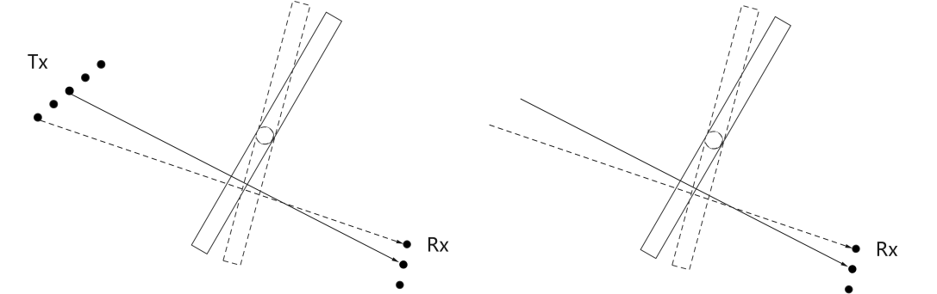

* Figure x. Rotation of the blocker changes with the element pair
* Option 2: A reference antenna element pair is determined so that the arrival direction of the corresponding path is perpendicular to the screen, the blockage conditions of other element pairs can be directly determined under such rotation.

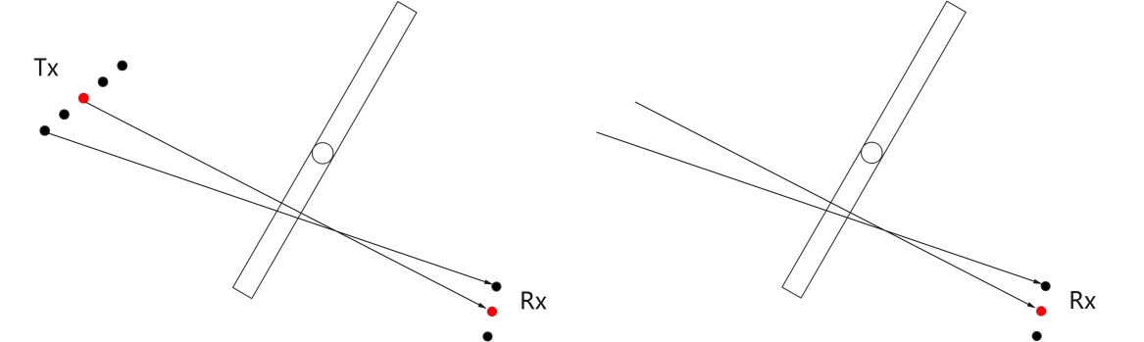

* Figure y. Rotation of the blocker is determined according to reference element pair

With the above options, whether the element pair is blocked can be determined as follows, if the sub-path intersects the screen in both top and side view, the cluster of the element pair can be determined as blocked by the screen, otherwise, the cluster of the element pair can be determined as not blocked by the screen.

Based on companies’ views, the following is proposed:

***Proposal 2-3-2-2****: For the modelling of spatial non-stationarity, if physical blocker is introduced, the existing procedure defined in TR 38.901 can be reused as baseline with following options to determine blockage condition and calculation of the attenuation for ray/cluster:*

* *Option 1: For each ray/clsuter, rotating the blocker to ensure the arrival/departure direction at each Receive/Transmit antenna element is always perpendicular to the screen, respectively.*
* *Option 2: For each ray/clsuter, rotating the blocker to ensure the arrival/departure direction at the reference Receive/Transmit antenna element is perpendicular to the screen. For other antenna elements, the blockage conditions are determined under such rotation.*

Companies are encouraged to share your views.

|  |  |
| --- | --- |
| Companies | Comments and Views |
| QC | Why is it necessary to rotate the blocker? Needs more discussion. |
| InterDigital | Don’t support physical blocker. |

**Consistency**

Considering that if physical blocker is introduced, the consistency across antenna elements and across clusters can be naturally guaranteed, so no need to further discuss this aspect.

### **2.3.3 Channel coefficient generalization**

**2.3.3.1 Company View (Round-1)**

To reflect the above consideration, the updated channel coefficient procedure diagram is proposed by some companies, which can be found in Appendix-B.

From FL’s perspective, the channel generation procedure defined in clause 7.5 in TR 38.901 should be reused as much as possible. Regarding the proposed updates on the diagram, it can be considered for reference and detailed changes can be discussed later once the details of model is stable.

Companies are encouraged to share your views regarding the above content if any.

|  |  |
| --- | --- |
| Companies | Comments and Views |
| CATT | This can be de-prioritized for now |

# Proposals for discussion

# Conclusion

# Reference

R1-2403857 Discussion on Channel Model Extension of TR38.901 for FR3 InterDigital, Inc.

R1-2403908 Discussion on channel modelling adaptation/extension for 7-24GHz LG Electronics

R1-2403926 Considerations on the 7-24GHz channel model extension Huawei, HiSilicon

R1-2403963 Discussion on channel model adaptation/extension Intel Corporation

R1-2403992 Discussion on adaptation and extension of channel model Ericsson

R1-2403997 Discussion on Channel model adaptation/extension of TR38.901 for 7-24GHz Nokia

R1-2404130 Discussion on channel model adaptation/extension of TR38.901 for 7 - 24 GHz Samsung

R1-2404192 Views on channel model adaptation/extension of TR38.901 for 7-24GHz vivo

R1-2404213 Discussion on the channel model adaptation and extension ZTE

R1-2404305 Channel Model Adaptation and Extension of TR38.901 for 7-24 GHz Apple

R1-2404330 Discussion on modeling near-field propagation and spatial non-stationarity in TR38.901 for 7-24GHz BUPT, CMCC, vivo

R1-2404340 Discussion of FR3 channel model Lenovo

R1-2404416 On channel model adaptation/extension of TR38.901 for 7-24GHz CATT

R1-2404437 Discussion on channel modeling for single road bridge (SRB) scenario China Telecom, BJTU

R1-2404544 Channel model adaptation of TR 38901 for 7-24 GHz NVIDIA

R1-2405082 Discussion on channel modelling enhancements for 7-24GHz for NR MediaTek Inc.

R1-2405170 Channel Model Adaptation/Extension of TR38.901 for 7-24GHz Qualcomm Incorporated

R1-2405250 Channel model adaptation/extension of TR38.901 for 7-24 GHz CEWiT

# Appendix-A

Near-field channel coefficient generation

* [InterDigital]:



* [Huawei]: Generate channel coefficients according to formula (1)-(3) and apply pathloss and shadowing.

(1)

$$H_{u,s,1}^{LOS}\left(t\right)={\left[\begin{matrix}F_{rx,u,θ}\left(θ_{LOS,ZOA,u},φ_{LOS,AOA,u}\right) \\ F_{rx,u,ϕ}\left(θ_{LOS,ZOA,u},φ_{LOS,AOA,u}\right)\end{matrix}\right]}^{T}\left[\begin{matrix}1 & 0 \\ 0 & -1\end{matrix}\right]\left[\begin{matrix}F_{tx,s,θ}\left(θ_{LOS,ZOD,s},φ_{LOS,AOD,s}\right) \\ F_{tx,s,ϕ}\left(θ_{LOS,ZOD,s},φ_{LOS,AOD,s}\right)\end{matrix}\right]$$

$$exp\left(-j2π\frac{d_{0,0}}{λ_{0}}\right) exp\left(j2π\frac{{d_{0,0}-d}_{u,s}}{λ_{0}}\right)\exp\left(j2π\frac{{\hat{r}}_{rx,LOS}^{T}.\bar{v}}{λ_{0}}t\right)$$

(2)

$$H_{u,s,n,m}^{NLOS}\left(t\right)=\sqrt{\frac{P_{n}}{M}}{\left[\begin{matrix}F_{rx,u,θ}\left(θ_{n,m,ZOA,u},φ_{n,m,AOA,u}\right) \\ F_{rx,u,φ}\left(θ_{n,m,ZOA,u},φ_{n,m,AOA,u}\right)\end{matrix}\right]}^{T}\left[\begin{matrix}\exp\left(jΦ_{n,m}^{θθ}\right) & \sqrt{{κ_{n,m}}^{-1}}\exp\left(jΦ_{n,m}^{θφ}\right) \\ \sqrt{{κ_{n,m}}^{-1}}\exp\left(jΦ_{n,m}^{φθ}\right) & \exp\left(jΦ_{n,m}^{φφ}\right)\end{matrix}\right]$$

$$\left[\begin{matrix}F_{tx,s,θ}\left(θ_{n,m,ZOD,s},φ_{n,m,AOD,s}\right) \\ F_{tx,s,φ}\left(θ_{n,m,ZOD,s},φ_{n,m,AOD,s}\right)\end{matrix}\right]\exp\left(j2π\frac{{d_{rx,n,m,0}-d}_{rx,n,m,u}}{λ_{0}}\right)\exp\left(j2π\frac{{d_{tx,n,m,0}-d}_{tx,n,m,s}}{λ_{0}}\right)\exp\left(j2π\frac{{\hat{r}}_{rx,n,m}^{T}.\bar{v}}{λ_{0}}t\right)$$

(3)

$$H_{u,s}^{LOS}\left(τ,t\right)=\sqrt{\frac{1}{K_{R}+1}}\sum_{n,m}{H_{u,s,n,m}^{NLOS}\left(t\right)δ\left(τ-τ_{n,m,0,0}\right)}+\sqrt{\frac{K_{R}}{K_{R}+1}}H_{u,s,1}^{LOS}\left(t\right)δ\left(τ-τ_{1}\right)$$

* [Vivo]:

For direct-path:

|  |  |  |
| --- | --- | --- |
| **Parameter** | **TR38.901** | **Modified Formula** |
| Delay | Based on | No modification |
| Amplitude | Based on | No modification |
| Angle | $$θ_{LOS,ZOD},{ϕ_{LOS,AOD},θ_{LOS,ZOA},ϕ}_{LOS,AOA}$$ | $$θ_{LOS ZOD}^{u,s},ϕ_{LOS AOD}^{u,s},θ_{LOS ZOA}^{u,s},ϕ_{LOS AOA}^{u,s}$$ |
| Phase |  |  |
| Doppler shift | $$exp\left(j2π\frac{{\hat{r}}_{rx,LOS}^{T}∙\overline{v}}{λ_{0}}t\right)$$ | $$exp\left(j2π\frac{{\hat{r}}_{rx,LOS,u,s}^{T}∙\overline{v}}{λ_{0}}t\right)$$ |

For non-direct path:

|  |  |  |
| --- | --- | --- |
| **Parameter** | **TR38.901** | **Modified Formula** |
| Delay | Based on | No modification |
| Amplitude | Based on | No modification |
| Angle | $$θ_{n,m,,ZOD},{ϕ_{n,m,,AOD},θ_{n,m,ZOA},ϕ}_{n,m,AOA}$$ | $$θ_{n,m, ZOD}^{s},ϕ_{n,m, AOD}^{s},θ_{n,m, ZOA}^{u},ϕ_{n,m, AOA}^{u}$$ |
| Phase |  |  |
|  |  |
| Doppler shift | $$exp\left(j2π\frac{{\hat{r}}_{rx,n,m}^{T}∙\overline{v}}{λ_{0}}t\right)$$ | $$exp\left(j2π\frac{{\hat{r}}_{rx,n,m,u}^{T}∙\overline{v}}{λ_{0}}t\right)$$ |

* [CATT]:

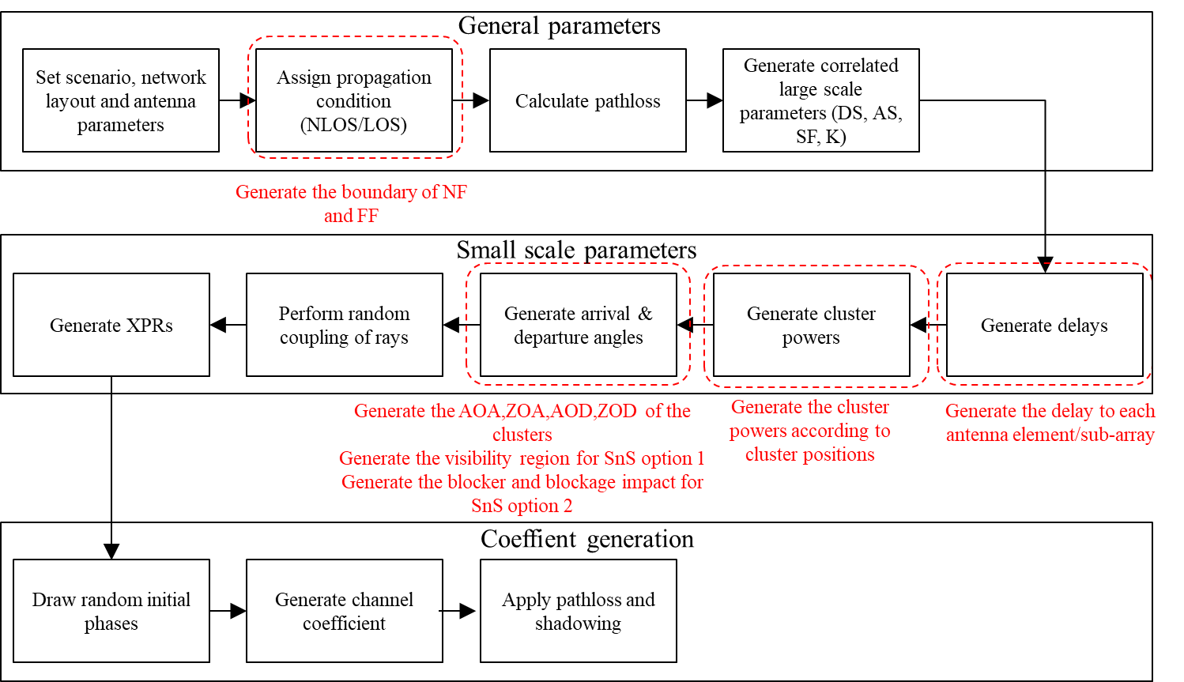

* [CEWiT]:

* [ZTE]:

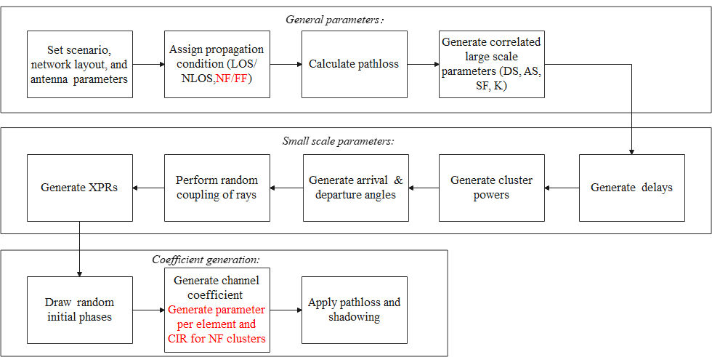

# Appendix-B

## Spatial non-stationarity channel coefficient generation

* [ZTE]: The blockage model B in TR 38.901 can be reused to establish the spatial non-stationary model with the following step-wise channel coefficient generation procedure.

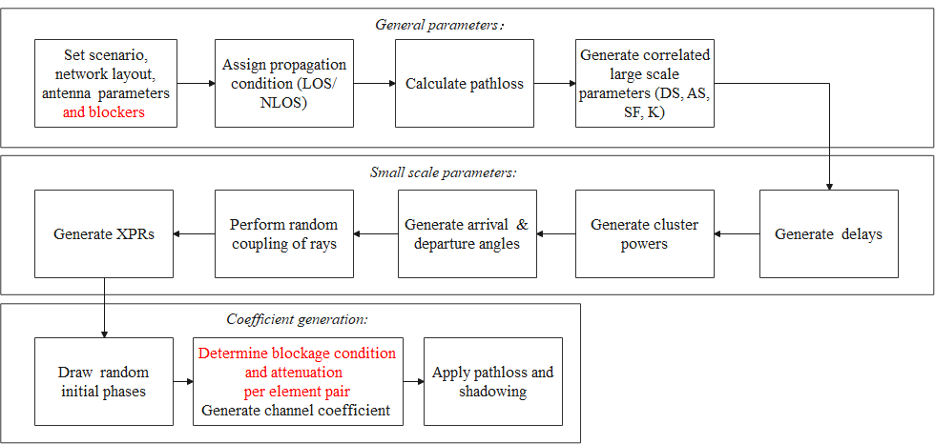

* [Huawei]: Generate channel coefficients according to formula (6)-(7) and apply pathloss and shadowing.

(6)

$$H_{u,s,1}^{LOS}\left(t\right)=α_{s,0,0}{\left[\begin{matrix}F_{rx,u,θ}\left(θ_{LOS,ZOA,u},φ_{LOS,AOA,u}\right) \\ F_{rx,u,ϕ}\left(θ_{LOS,ZOA,u},φ_{LOS,AOA,u}\right)\end{matrix}\right]}^{T}\left[\begin{matrix}1 & 0 \\ 0 & -1\end{matrix}\right]\left[\begin{matrix}F_{tx,s,θ}\left(θ_{LOS,ZOD,s},φ_{LOS,AOD,s}\right) \\ F_{tx,s,ϕ}\left(θ_{LOS,ZOD,s},φ_{LOS,AOD,s}\right)\end{matrix}\right]$$

$$exp\left(-j2π\frac{d_{0,0}}{λ_{0}}\right) exp\left(j2π\frac{{d_{0,0}-d}_{u,s}}{λ_{0}}\right)\exp\left(j2π\frac{{\hat{r}}_{rx,LOS}^{T}.\bar{v}}{λ_{0}}t\right)$$

(7)

$$H_{u,s,n,m}^{NLOS}\left(t\right)=α_{s,n,m}\sqrt{\frac{P_{n}}{M}}{\left[\begin{matrix}F_{rx,u,θ}\left(θ_{n,m,ZOA,u},φ_{n,m,AOA,u}\right) \\ F_{rx,u,φ}\left(θ_{n,m,ZOA,u},φ_{n,m,AOA,u}\right)\end{matrix}\right]}^{T}\left[\begin{matrix}\exp\left(jΦ_{n,m}^{θθ}\right) & \sqrt{{κ_{n,m}}^{-1}}\exp\left(jΦ_{n,m}^{θφ}\right) \\ \sqrt{{κ_{n,m}}^{-1}}\exp\left(jΦ_{n,m}^{φθ}\right) & \exp\left(jΦ_{n,m}^{φφ}\right)\end{matrix}\right]$$

$$\left[\begin{matrix}F_{tx,s,θ}\left(θ_{n,m,ZOD,s},φ_{n,m,AOD,s}\right) \\ F_{tx,s,φ}\left(θ_{n,m,ZOD,s},φ_{n,m,AOD,s}\right)\end{matrix}\right]\exp\left(j2π\frac{{d_{rx,n,m,0}-d}_{rx,n,m,u}}{λ_{0}}\right)\exp\left(j2π\frac{{d_{tx,n,m,0}-d}_{tx,n,m,s}}{λ_{0}}\right)\exp\left(j2π\frac{{\hat{r}}_{rx,n,m}^{T}.\bar{v}}{λ_{0}}t\right)$$

* [Apple]: To support spatial non-stationarity, in the step of “generate cluster power”, a cluster in near-field of base station has reduced cluster power.
* [CATT]: For modelling of spatial non-stationary, the steps of “Generate delay”, “Generate cluster powers” based on TR 38.901 should be modified
  + Generate the location information for each cluster and each antenna element/sub-array in step-5.
  + Generate the visibility region of the antenna array for each cluster in step-7, if option 1 is supported.
  + Generate the blocker and blockage impact in step-7, if option 2 is supported.



* [CEWiT]: According to the current TR 38.901, the channel co-efficient generation procedure comprises of 12 steps. Some of these steps are modified to incorporate the effects of Near-Field Propagation and Spatial Non-Stationarity which are elaborated as follows.

