3GPP TSG-RAN Meeting #104 RP-24xxxx
June 17th ‒ 20th, 2024
Shanghai, CN

Agenda item: 9.1.5
Source: Moderator (RAN4 vice chair, Qualcomm Incorporated)
Title: Moderator's summary for Ku band
Document for: Information

Introduction
This document provides a summary of discussion for initiating a work item to define specifications for a new NR frequency band in the Ku frequency range.

Issues
A proposed work item description was provided in [1]. The objectives are copied below
The objectives are:
Phase 1
- Update coexistence study if needed [RAN4]
- Use the regulation requirements in ITU Regions 1, 2 and 3 to identify relevant adjacent band co-existence scenarios for NTN Ku Band covering the following frequency ranges, considering targeted deployment scenarios [RAN4]:
  - Downlink 10.70 – 12.70/12.75 GHz
  - Uplink 12.75-13.25 GHz (excluding US in region 2) & 13.75-14.5 GHz
- Specify RF requirements for satellite access node and relevant NTN VSAT types considering existing regulations on antenna sizes for certain parts of the Ku band. [RAN4].
- Specify RRM requirements to cover the Ku band. [RAN4]
- In addition to legacy channel bandwidths, support new channel bandwidths to align with typical existing Ku band operational constraints [RAN4]
- Study and specify enablers for half duplex FDD mode [RAN1]
  - Rational: Interference mitigation for uplink 12.70 GHz – 13.25 GHz being adjacent to 10.70 GHz– 12.70 GHz downlink

Phase 2
- Extend the phase 1 normative work to include uplink band 12.70 GHz – 13.25 GHz for the US in Region 2

Coexistence
Is a coexistence study needed in additional to the coexistence study already conducted for Ka band? If additional study is needed, what aspects different from the Ka band study should be considered?
Company | Comment
Charter Comm Inc | From our perspective, we would like to suggest waiting until the FCC rules before approving the WID. There is a current an FCC NOI considering 12.75-13.25 GHz as Mobile Wireless Spectrum. Until this NOI is completed, we should hold off in this work. Furthermore, in RAN3101, Intelsat provided a tdoc, RP231886 which proposed to hold this work until RAN#105 (Sept 2024). In this meeting, there was also a tdoc which was approved, RP232668, RAN4 New Proposals for Rel-19 in which RP231886 was withdrawn.

Proposed way forward:

Regional applicability
Recognizing the ongoing consultation in the US regarding the frequency range 12.70 – 13.25 GHz in the US, the proponents of [1] have suggested to structure the work item in two phases. The first phase of the work item would define requirements only for Region 1 and Region 3 countries as well as Region 2 countries not including the US. The second phase commencing after conclusion from the FCC would potentially extend the 12.70 – 13.25 GHz to the US as well. Yet, other companies preferred to discuss the 12.70 – 13.25 GHz altogether for all regions, only after conclusion from the FCC to allow the possibility of enabling a common band and/or common requirements worldwide.
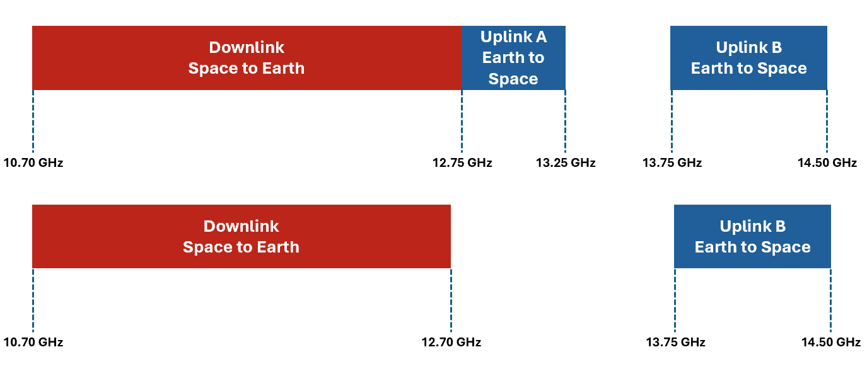
Figure 3. Phase 1: Normative work for ITU regions excluding US

Figure 4. Phase 2: Additional normative work for US

Company | Comment

Proposed way forward:

Channel bandwidths
The WID [1] suggests that new channel bandwidths aligned with typical existing Ku band operational constraints is needed. The addition of new channel bandwidths may require work outside of RAN4 as well as potential additional work inside RAN4. Moreover, the channel bandwidths have not been identified by the proponents.
Company | Comment

Proposed way forward:

Half duplex
The WID [1] proposes an objective to introduce a half duplex FDD mode for NR NTN. It is acknowledged that this would require participation from RAN1 and therefore extends the scope of this work item beyond spectrum.
Company | Comment

Proposed way forward:

Other issues
Any other issues?
Company | Comment

Moderator recommendation

Reference
- RP-240938, “New WID on Introduction of Ku Band for NR NTN,” Intelsat, Eutelsat Group, Thales

