3GPP TSG-RAN WG4 Meeting #113 R4-2419403

Orlando, US, 18th – 22nd November, 2024

**Title:** Discussion on spatial channel model for demodulation requirements

**Source:** Huawei, HiSilicon

**Agenda item:** 7.14.2

**Document for:** Discussion

# Background

In last meeting, a WF on spatial channel for demodulation requirements [1] was approved, this contribution provide our views.

1. Discussions

## Test cases

Following test cases are listed as candidate options for evaluation:

|  |
| --- |
| **Cases for SU-MIMO**  **Agreement:**  Single-User PDSCH:  8Rx: 8 Layer, MCS 13 on both codewords (Table 1) (type I codebook) – PMI Choice (FFS Fixed, Random) *Companies encouraged to bring Fixed PMI choice to next meeting*  (*FFS Whether it is already covered in PMI*) 4Rx: 4 Layer, MCS 13 (Table 1) (type I codebook) – PMI Choice (FFS Fixed, Random) *Companies encouraged to bring Fixed PMI choice to next meeting*  4 CSI-RS Ports (2,1) for 4 Layer  8 CSI-RS Ports (4,1) for 8 Layer  Single-User PMI  4Rx: 4 Layer (type I) – Full Throughput Curves (PMI Follow, PMI Random)  4Rx: 4 Layer (eType II) – Full Throughput Curves (PMI Follow)  4Rx: 2 Layer (type I) – Full Throughput Curves (PMI Follow, PMI Random)  4Rx: 2 Layer (eType II) – Full Throughput Curves (PMI Follow)  *Interested companies can use initially 8 CSI-RS Ports, more ports can be used to identify and show relevant impacts.*  *Note: Several companies would prefer to focus on PDSCH until the modelling is stable*  **Cases for MU-MIMO**  **Agreement:**  Interested companies to bring to RAN4#113 views on the following cases:  PDSCH  2+2 layers with IRC (type I orthogonal and random precoding, to distinguish target and co-scheduled UE)  Interested companies are encouraged to assess 2+2 layers with R-ML / E-IRC (type I orthogonal and random precoding, to distinguish target and co-scheduled UE)  Proponents to highlight the difference between a SCM and TDL for MU-MIMO |

We don’t see any necessity to introduce MU-MIMO cases, performance of the spatial channel can be verified in full layers allocation for SU-MIMO tests (4 layers and 8 layers), no matter the layers are allocated for serving UE or other UEs, the interference is same. Furthermore, Advanced receiver is not usual cases and optional feature. For SU-MIMO test cases, we prefer to use random PMI rather than fixed PMI, we admit that performance difference will be large, but we don’t want to change the typical test setup since our purpose is focus on UE behaviour with no limitation on BS side.

Proposal 1: RAN4 shall preclude MU-MIMO test cases and only focus on SU-MIMO PDSCH and PMI test cases. For PDSCH cases, use random PMI rather than fixed PMI.

It is mentioned that 4 layers and 8 layers are not usual cases for RAN4 demodulation test, which can be used for evaluation but may not be sufficient for simulation alignment. One rationality of a new channel model is that simulation results under such channel model can be aligned. In Rel-15, RAN4 introduced many cases with several MCS, doppler, layers for simulation alignment. Hence RAN4 shall discuss whether to separate the discussion for simulation alignment and comparison.

Proposal 2: RAN4 shall confirm simulation alignment as one of metric to justify the feasibility of new channel model

To compare the channel models, the metric of PDSCH cases could be throughput or condition number, i.e, ratio of the absolute value of the maximum eigenvalue to the absolute value of the minimum eigenvalue of the channel. The metric of PMI cases could be reused from PMI test cases. I.e. Ratio of throughout of follow PMI to throughput of random PMI at SNR@ 90% of max throughput.

Proposal 3: To compare the channel models, the metric of PDSCH cases could be throughput or condition number, i.e, ratio of the absolute value of the maximum eigenvalue to the absolute value of the minimum eigenvalue of the channel. The metric of PMI cases could be reused from PMI test cases.

## TDL Based Methodologies

The big issue for legacy TDL+ correlation channel model is rank deficiency, which is not suitable for high layers requirements definition. To increase the spatial degree of freedom, two kinds of enhanced TDL methodologies are proposed by some companies, one is proposed by [2], the idea of which is to introduce per tap per correlation. The pro is that the model is very typical and proposed by a lot of literatures, and very close to the real MIMO channel model in the real deployment. However, the con is huge computational complexity, which may be unacceptable by some companies. The other one is proposed by [3], the idea of which is to introduce multi-cluster, where each cluster corresponds to one TX-RX beam. The pro is that it’s easy to be implemented by TE, the cons is that each TX-RX beam have same delay, which may be artificial and may not reflect the real channel characterisers. Next we propose a new approach to combine the such two approaches, which is easy to be implemented and can also highly increase the spatial degree of freedom.

Instead of deriving the correlation matrix per tap from formula, we implement multi beams to one TDL channel, where each beam corresponds to some taps and each beam is steering of other beams by using steering matrixes B.2.3.2.3A. The formula is:

$$y=\sum_{n=0}^{N-1}{P_{n}{D_{θ_{k1,k2}}^{\left(rx,n\right)}H}_{n}D_{θ_{k1,k2}}^{\left(n\right)}D_{θ_{k1,k2}}^{\left(tx,n\right)}}Wx+n$$

Where N is number of taps per TDL channel, i.e. 12 for simplified TDL channel used for performance requirements definition. $P_{n}$ normalized power of tap n. $D_{θ_{k1,k2}}^{\left(rx,n\right)}$ and $D_{θ_{k1,k2}}^{\left(tx,n\right)}$ is Rx beam steering matrix and Tx beam steering matrix respectively. And $H_{n}$ is the channel matrix for tap n with initial beam corresponding to correlation matrix defined in clause B.2.3.2.2 in 38.101-4.

- ,is the steering matrix for tap n in first dimension with same polarization for Rx beam and Tx beam respectively

- ,is the steering matrix for tap n in second dimension with same polarization for Rx beam and Tx beam respectively

-  is the number of antenna elements in first dimension with same polarization,

-  is the number of antenna elements in second dimension with same polarization,

- For antenna array with only one direction, number of antenna element in second direction equals 1，

For 1 antenna element of the same polarization in one direction, .

For 2 antenna elements of the same polarization in one direction, .

For 3 antenna elements of the same polarization in one direction,.

For 4 antenna elements of the same polarization in one direction, .

Table 2-1 provides our proposed enhanced TDLC300 channel with 2 TX-RX beams configurations.

Table 2-1: Enhanced TDLC300 channel with 2 TX-RX beams

|  |  |  |  |  |
| --- | --- | --- | --- | --- |
| Tap | Delay(ns) | Power(dB) | Tx-Rx Beam | Beam Power(dB) |
| 1 | 0 | -6.9 | Beam1 $$θ_{k1}=0$$ $$θ_{k2}=0$$ | 0 |
| 2 | 65 | 0 |
| 3 | 70 | -7.7 |
| 4 | 190 | -2.5 |
| 5 | 195 | -2.4 | Beam 2 $$θ_{k1}=π$$ $$θ_{k2}=π$$ | -1.52 |
| 6 | 200 | -9.9 |
| 7 | 240 | -8.0 |
| 8 | 325 | -6.6 |
| 9 | 520 | -7.1 |
| 10 | 1045 | -13.0 |
| 11 | 1510 | -14.2 |
| 12 | 2595 | -16.0 |

Table 2-2 provides our proposed enhanced TDLC300 channel with 3 TX-RX beams configurations.

Table 2-2: Enhanced TDLC300 channel with 3 TX-RX beams

|  |  |  |  |  |
| --- | --- | --- | --- | --- |
| Tap | Delay(ns) | Power | Beam steering | Beam Power(dB) |
| 1 | 0 | -6.9 | Beam1 $$θ_{k1}=0$$ $$θ_{k2}=0$$ | 0 |
| 2 | 65 | 0 |
| 3 | 70 | -7.7 |
| 4 | 190 | -2.5 | Beam2 $$θ_{k1}=2π/3$$ $$θ_{k2}=2π/3$$ | -0.82 |
| 5 | 195 | -2.4 |
| 6 | 200 | -9.9 | Beam3 $$θ_{k1}=4π/3$$ $$θ_{k2}=4π/3$$ | -2.41 |
| 7 | 240 | -8.0 |
| 8 | 325 | -6.6 |
| 9 | 520 | -7.1 |
| 10 | 1045 | -13.0 |
| 11 | 1510 | -14.2 |
| 12 | 2595 | -16.0 |

Table 2-3 provides our proposed enhanced TDLC300 channel with 4 TX-RX beams configurations.

Table 2-3: Enhanced TDLC300 channel with 4 TX-RX beams

|  |  |  |  |  |
| --- | --- | --- | --- | --- |
| Tap | Delay(ns) | Power | Beam steering | Beam Power(dB) |
| 1 | 0 | -6.9 | Beam1 $$θ_{k1}=0$$ $$θ_{k2}=0$$ | 0 |
| 2 | 65 | 0 |
| 3 | 70 | -7.7 | Beam2 $$θ_{k1}=π/2$$ $$θ_{k2}=π/2$$ | -2.16 |
| 4 | 190 | -2.5 |
| 5 | 195 | -2.4 | Beam3 $$θ_{k1}=π$$ $$θ_{k2}=π$$ | -2.50 |
| 6 | 200 | -9.9 |
| 7 | 240 | -8.0 | Beam4 $$θ_{k1}=3π/2$$ $$θ_{k2}=3π/2$$ | -2.45 |
| 8 | 325 | -6.6 |
| 9 | 520 | -7.1 |
| 10 | 1045 | -13.0 |
| 11 | 1510 | -14.2 |
| 12 | 2595 | -16.0 |

Table 2-4 provides our proposed enhanced TDLC300 channel with 6 TX-RX beams configurations.

Table 2-4: Enhanced TDLC300 channel with 6 TX-RX beams

|  |  |  |  |  |
| --- | --- | --- | --- | --- |
| Tap | Delay(ns) | Power | Beam | Beam Power(dB) |
| 1 | 0 | -6.9 | Beam1 $$θ_{k1}=0$$ $$θ_{k2}=0$$ | -7.58 |
| 2 | 65 | 0 | Beam2 $$θ_{k1}= π/3$$ $$θ_{k2}=π/3$$ | 0 |
| 3 | 70 | -7.7 |
| 4 | 190 | -2.5 | Beam3 $$θ_{k1}=2π/3$$ $$θ_{k2}=2π/3$$ | -3.18 |
| 5 | 195 | -2.4 | Beam4 $$θ_{k1}=π$$ $$θ_{k2}=π$$ | -2.37 |
| 6 | 200 | -9.9 |
| 7 | 240 | -8.0 | Beam5 $$θ_{k1}=4π/3$$ $$θ_{k2}=4π/3$$ | -4.91 |
| 8 | 325 | -6.6 |
| 9 | 520 | -7.1 | Beam6 $$θ_{k1}=5π/3$$ $$θ_{k2}=5π/3$$ | -5.79 |
| 10 | 1045 | -13.0 |
| 11 | 1510 | -14.2 |
| 12 | 2595 | -16.0 |

To verify the performance for the our proposed enhanced TDLC channel, we did some simulations for Rank4 and Rank 8 respectively, in the simulation, MCS13 was used, 4T4R for Rank4 and 8T8R for Rank8 were simulated.

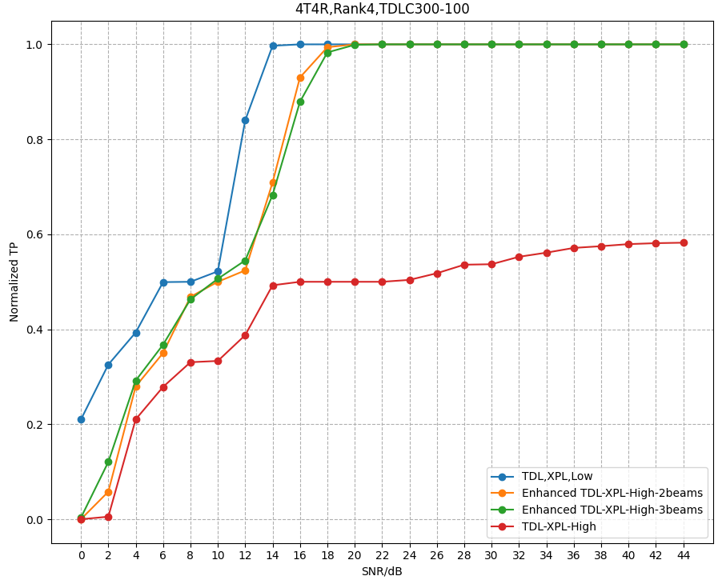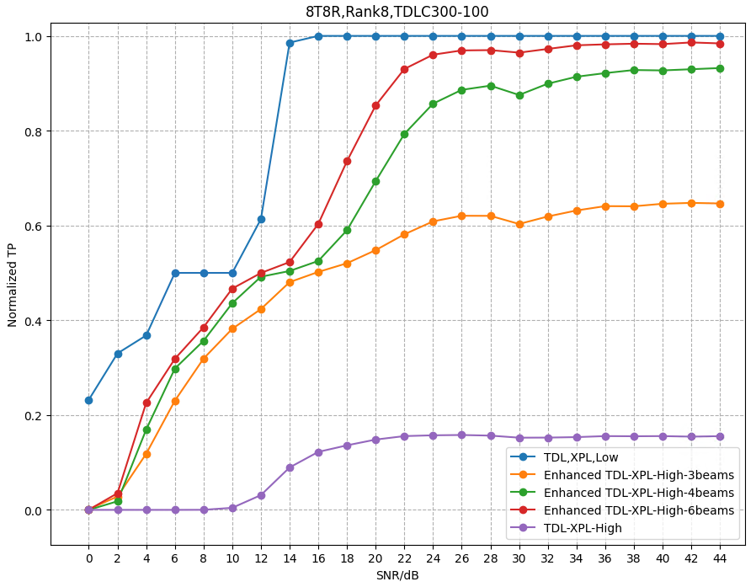

**Figure 2-1: Simulation results for enhanced TDLC channel with multi beams**

For Rank4, we simulated legacy TDLC300-XPL-High, TDLC300-XPL-Low, enhanced TDLC channel with 2beams and 3 beams. It can be observed that for TDLC300-XPL-High, due to the high rank deficiency, 70% of maxTP is unachievable, TDL300-XPL-Low has best performance since low correlation has spatial isotropic characters. Enhanced TDLC channel with 2 beams and 3beams have similar performance and much better performance than TDL300-XPL-High, which means spatial freedom of degree is highly increased when multi-beams are implemented. It can be concluded that for TDLC300, 2 beams enough to check the 4 layers performance under spatial channel model.

For Rank8, we simulated legacy TDLC300-XPL-High, TDLC300-XPL-Low, enhanced TDLC channel with 3beams, 4beams and 6beams. Similar observation as rank4, for TDLC300-XPL-High, due to the high rank deficiency, 70% of maxTP is unachievable, TDL300-XPL-Low has best performance since low correlation has spatial isotropic characters, for enhanced TDLC300 channel, performance will be better when more beams are implemented. We believe that performance will converge on low correlation when more beams are introduced. It can be concluded that for TDLC300, 6 beams enough to check the 8 layers performance under spatial channel model.

Based on the above analysis, the proposed enhanced TDL channel with multi-beams can improve the rank deficiency of legacy TDL+ correlation channel and introduces proper spatial component at the same time. Furthermore, each beam corresponds to different tap(s) with different delay, which will be more practical than the multi-clusters methodology proposed in [3] and easier to be implemented than per-tap per correlation methodology proposed in [2]. Hence, this method should be one of candidate solutions for R19 SCM.

Proposal 4: RAN4 to introduce enhanced TDL channel with multi-beams as one of candidate solutions for R19 SCM.

## CDL Based Methodologies

We summarized the open issues for implementations of CDL channels in Table 2-5:

Table 2-5: Summary of open issues for implementation of CDL channels

|  |  |
| --- | --- |
| CDL channel generation procedure | * Option 1: CDL channel generation procedure defined in 38.901 * Option 2: CDL channel generation procedure defined in 38.827 |
| CDL parameters Table | * Option 1: CDL look up Table defined in 38.827 (CDL-UMa-C) * Option 2: CDL look up Table defined in 38.901 (CDL-C) |
| Port virtualization and beamforming | * Option 1: Fixed Array * (M,N,P,Ms,Ns) = (8,8,2,8,4) for 4Tx CSI-RS Ports * (M,N,P,Ms,Ns) = (8,8,2,8,2) for 8Tx CSI-RS Ports * Option 2: Fixed SubArray * (M,N,P,Ms,Ns) = (8,2,2,8,1) for 4Tx CSI-RS Ports * (M,N,P,Ms,Ns) = (8,4,2,8,1) for 8Tx CSI-RS Ports * Option 3: Without antenna virtualization * [(M,N,P,Ms,Ns) = (1,4,2,1,1) for 8Tx CSI-RS Ports] * [(M,N,P,Ms,Ns) = (1,2,2,1,1) for 4Tx CSI-RS Ports] * Option 4: Full connected * [(M,N,P) = (8,8,2) for 8Tx and 4Tx CSI-RS Ports] |
| Antenna Coordinates, Angles, and other parameters for gNB (for UMa-CDL-C) | * Option 1: For the gNB, use the following parameters for alignment with UMa CDL-C model: * GCS Location Coordinates for the gNB: * Height = 25m (based on UMa); * Azimuth = 0; (placement on the x axis); * GCS to LCS Conversion angles (α,β,γ = bearing, downtilt, slant) for the gNB; * α,β,γ=(0,0,0); * Option 2: * Frequency Fc = 3.5 GHz, height BS = 25m, and D2D = 100m. * BS orientation: (alpha = 0 degrees, beta = 0 degrees, gamma = 0 degrees). Intention is that BS points towards horizon along x-axis. * Other options not precluded |
| Antenna Coordinates, Angles, and other parameters for UE (for UMa-CDL-C) | * Option 1: For the UE, use the following parameters for alignment with UMa CDL-C model: * Height = 25m (same as gNB) * Azimuth = 0; (placement on the x axis); * α,β,γ=(90,0,45); * Option 2: * Frequency Fc = 3.5 GHz, height UE = 1.5m and D2D = 100m. * UE orientation: (alpha = -90 degrees, beta = -13.2 degrees, gamma = 45 degrees). Intention is that UE points towards BS and uses "[+ + ... +]" crosspol elements. * Other options not precluded. |

CDL channel generation procedure

Compared 38.901, CDL channel defined in 38.827 has much less random variables such as initial phases for 2x2 polarization matrices and simper procedures such as rays mapping, which make it easier to align simulation results. Also, it has been implemented by TE during OTA test so testability can be confirmed. Hence RAN4 sho uld use CDL channel generation procedure defined in 38.827.

Proposal 5: RAN4 to use CDL channel generation procedure defined in 38.827.

CDL parameter Table

Based on our simulation results, both CDL-C in 38.901 and CDL-UMa-C in 38.827 channels can show reasonable performance for 4 and 8 layers with proper antenna virtualization methodology. The problem of CDL-UMa-C in 38.827 is that the CDL parameter table is defined as band specific, e,g, parameters in CDL-UMa-C are based on 3.5GHz carrier frequency, which conflicts with the tradition that requirements are defined as band agnostic. We prefer CDL parameter table in 38.901, which is more flexible. And it’s proposed to invite TE vendors to inform if some potential issues exist such as high angular resolution.

Observation 1: CDL-UMa-C in 38.827 is that the CDL parameter table is defined as band specific, e,g, parameters in CDL-UMa-C are based on 3.5GHz carrier frequency, which conflict with the tradition that requirements are defined as band agnostic.

Proposal 6: RAN4 to use CDL parameters table defined in 38.901 for study.

Port virtualization and beamforming

Beamforming is to maximum receiving signal power, however, 38.101-4 defines SNR as ratio of receiving signal power to the noise power, which means noise power is proportional to the receiving signal power at given SNR, so the beamforming gain is not actually reflected during the simulation.

$$SNR=\frac{\sum_{j=1}^{N_{RX}}{E_{s}^{(j)}}}{\sum_{j=1}^{N_{RX}}{N_{oc}^{(j)}}}$$

Observation 2: Beamforming changes receiving signal power but doesn’t change actual SNR since 38.101-4 defines SNR at receiving side.

Also, based on our simulation results, PMI gain is limited if we use beamforming defined in 38.827, So, it’s redundant to implement beamforming in the CDL channel. Additionally, fullconnected with beamforming only support up to 8Tx corresponding to 4 beams according to 38.827, which can’t be applicable for 16 or 32Tx PMI test. Based on observation 3~6 , for PDSCH demodulation cases, it’s enough to use without AAV approach for 4 layers since the target SNR is reasonable, for 8 layers, it’s proposed to use fixed array approach to guarantee the reasonable SNR, hence, we propose the following: For cases with up to 4layers: Use without AAV approach, random PMI. For cases with 8layers: Use FixedArray approach, random PMI.

Proposal 7: RAN4 to use without AAV approach and random PMI for cases with up to 4layers. Use FixedArray approach and random PMI for cases with 8layers.

Antenna Coordinates, Angles, and other parameters

Our understanding is that angular defined in the CDL parameter table are based on GCS, but the antenna radiation pattern is defined based on LCS, so it’s very necessary to specify the parameters of conversion from GCS to LCS. I.e. alpha, Beta and Gama. Besides, it’s also necessary to specify the BS/UE antenna coordinate in the LCS since antenna panel placement have quite different performance.

Proposal 8: RAN4 shall specify the parameters of conversion from GCS to LCS. I.e. alpha, Beta and Gama and BS/UE antenna element coordinate in the LCS.

It is mentioned that 38.827 specifies the assumption of BS and UE height, which not specified by 38.901. Therefore, we propose the following:

If RAN4 agrees to use CDL parameters table defined in 38.901, RAN4 to configure $α=0,$ $β=0,$ $γ=0$ for BS side and $α=180°,$ $β=0,$ $γ=0$ for UE side. I.e. UE and BS are facing to each other with same height.

Proposal 9: If RAN4 agrees to use CDL parameters table defined in 38.901, RAN4 to configure $α=0,$ $β=0,$ $γ=0$ for BS side and $α=180°,$ $β=0,$ $γ=0$ for UE side. I.e. UE and BS are facing to each other with same height.

If RAN4 agree to use CDL parameters table define in 38.827, we propose to configure $α=0,$ $β=13.2°,$ $γ=0$ for BS side and $α=180°,$ $β=0,$ $γ=0$ for UE side. I.e. UE and BS are facing to each other with BS height=25m, UE height=1.5m and D2D=100.

Proposal 10: If RAN4 agrees to use CDL parameters table defined in 38.901, RAN4 to configure $α=0,$ $β=13.2°,$ $γ=0$ for BS side and $α=180°,$ $β=0,$ $γ=0$ for UE side. I.e. UE and BS are facing to each other with BS height=25m, UE height=1.5m and D2D=100.

Time varying Beam direction

Time varying beam direction is necessary for PMI test to make the optimal PMI vary slot by slot. 38.901 defines the procedure of scaling of angles for CDL channel as following:

|  |
| --- |
| The translated and scaled ray angles can be obtained according to the following equation:  (7.7-5)  in which:  is the tabulated CDL ray angle  is the rms angular spread of the tabulated CDL including the offset ray angles, calculated using the angular spread definition in Annex A  is the mean angle of the tabulated CDL, calculated using the definition in Annex A  is the desired mean angle  is the desired rms angular spread  is the resulting scaled ray angle. |

By this procedure, the mean angle and RMS angular spread can be changed to any desired value, time variant CDL channel can be generated by setting desired mean angle changed slot by slot. However, the issue is that if beam direction is time variant, the post SNR will also be changed considering that antenna radiation gain is different in different direction. The SNR at receiving side cannot be converged.

**Proposal 11: RAN4 to generate the time varying beam direction CDL channel by referring the procedure of scaling of angles for CDL channel defined in clause 7.7.5.1 in 38.901, the making the desired mean angle changed slot by slot.**

**Proposal 12: RAN4 to discuss how to handle the changed SNR with the beam direction changed**

1. Simulation results

## PDSCH

Table 3.1-1: Simulation assumptions

|  |  |
| --- | --- |
| Antenna configuration | 4T4R for Rank4,8T8R for Rank8 |
| Channel model | CDL generation procedure defined in 38.827  CDL parameter table: CDL-C in 38.901, CDL-UMa-C in 38.827. RMS delay=363ns  TDLC363ns, Low  TDLC 363ns, Med B |
| Antenna virtualization : | FixedArray, FixedSubArray, WithoutAAV, FullConnected |
| Antenna elements placement | BS antenna panel are placed on YZ plane  UE: antenna array is placed on X axis. |
| UE antenna orientation | $$(α=180, β=0,γ=0)$$ |
| BS antenna orientation | $$(α=0, β=0,γ=0)$$ |
| UE Speed | 30km/h |
| Frequency | 3.5GHz |
| Subcarrier Spacing | $$μ=30kHz$$ |
| Bandwidth | 40MHz |
| Precoder | Type I single panel, randomly selected per PRG bundling size |
| Rank | Rank4, Rank8 |
| MCS | 13 |
| HARQ processes number | 4 |
| Max. number of retransmissions | $$4$$ |
| Detector at the receiver | MMSE-IRC |
| Channel Estimation | Real |

Figure 3-1 shows the performance for CDL-C channel in 38.901, TDLC+ low correlation and TDLC + medium B correlation.

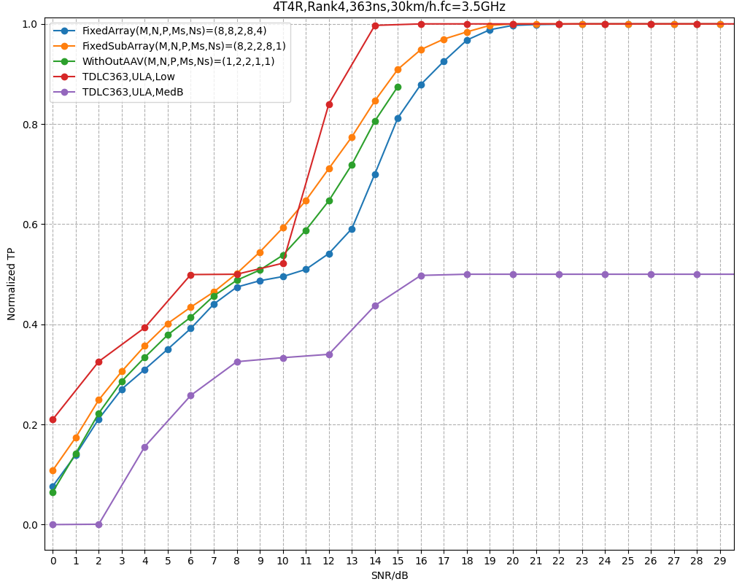 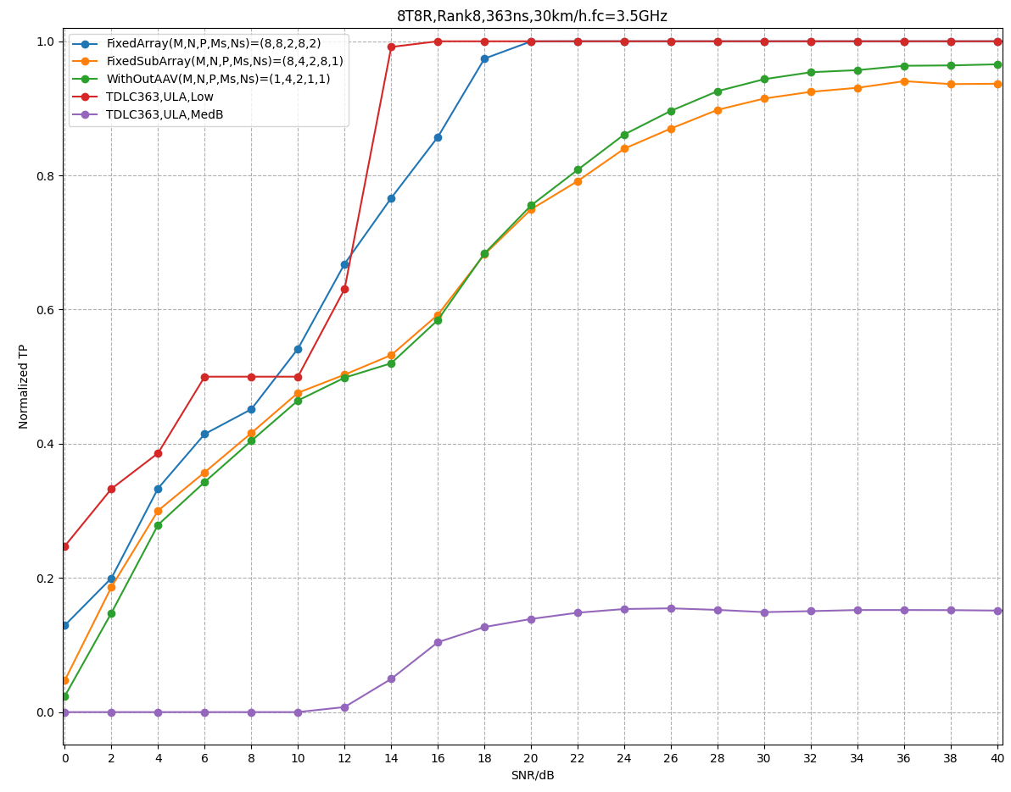

Figure 3.1-1: Simulation results for CDL-C channel defined in 38.901

Table 3-1 summaries the results for CDL-C channel in 38.901, TDLC+ low correlation and TDLC + medium B correlation.

Table 3.1-2: Summary of simulation results for CDL-C channel in 38.901

|  |  |  |
| --- | --- | --- |
| Rank | Channel model and antenna virtualization | SNR(dB)@70% of maxTP |
| Rank 4 | CDL-C, FixedArray (M,N,P,Ms,Ns) = (8,8,2,8,4) | 14.0 |
| CDL-C, FixedSubArray (M,N,P,Ms,Ns) = (8,2,2,8,1) | 11.8 |
| CDL-C, WithoutAAV (M,N,P,Ms,Ns) = (1,4,2,1,1) | 12.7 |
| TDLC363ns, Low | 11.1 |
| TDLC 363ns, Med B | N/A |
| Rank 8 | CDL-C, FixedArray (M,N,P,Ms,Ns) = (8,8,2,8,2) | 12.7 |
| CDL-C, FixedSubArray (M,N,P,Ms,Ns) = (8,4,2,8,1) | 18.5 |
| CDL-C, WithoutAAV (M,N,P,Ms,Ns) = (1,8,2,1,1) | 18.5 |
| TDLC363ns, Low | 12.4 |
| TDLC363ns, Med B | N/A |

We have following observations:

Observation 3: For Rank4, the performance comparison is TDLC+Low>CDL-C with FixedSubArray> CDL-C withoutAAV>CDL-C with FixedArray >TDLC+Med B. Cases with all virtualization approaches have reasonable target SNR.

Observation 4: For Rank8, the performance comparison is TDLC+Low>CDL-C with FixedArray> CDL-C with FixedSubArray=CDL-C withoutAAV>TDLC+Med B. Cases with all virtualization approaches have reasonable target SNR.

Figure 3-2 shows the performance for CDL-UMa-C channel in 38.827.

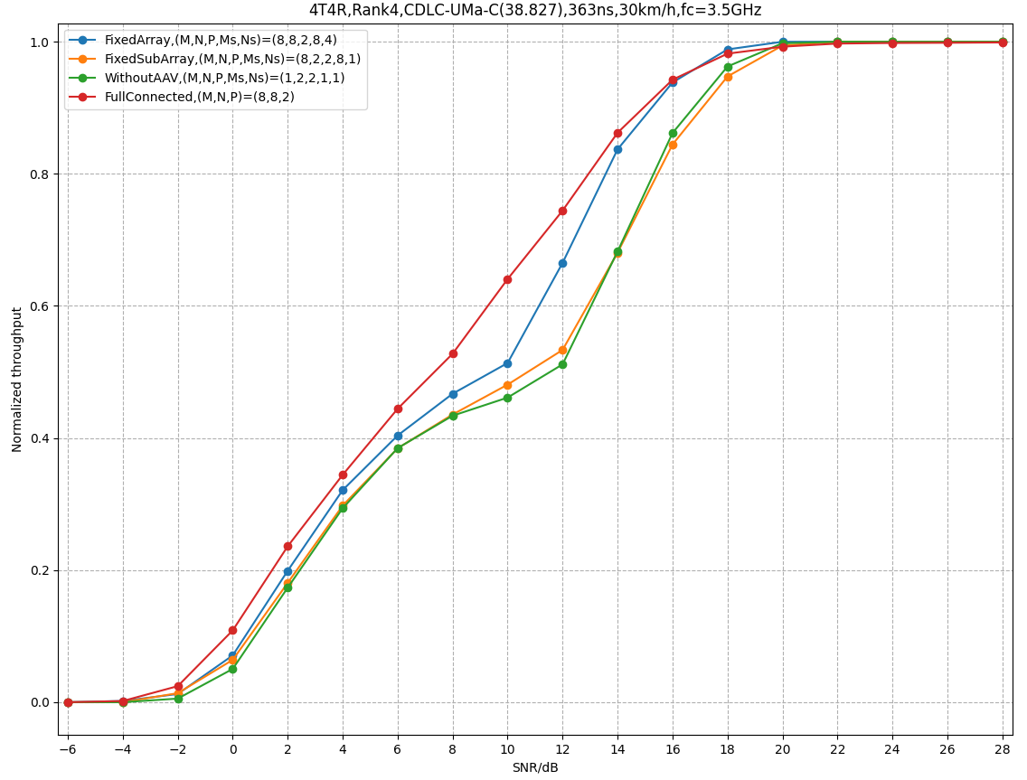 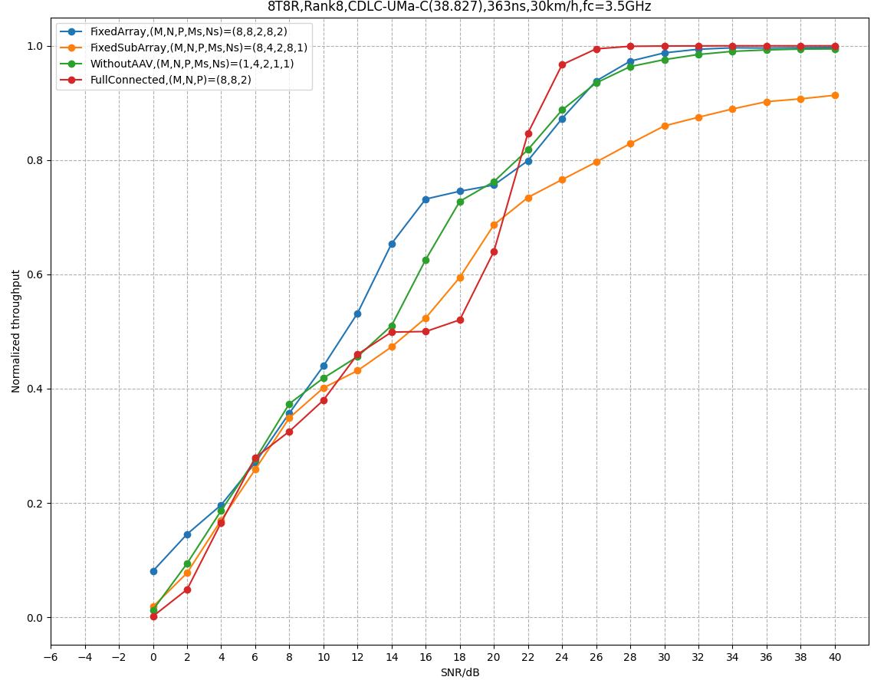

Figure 3.1-2: Simulation results for CDL-C channel defined in 38.827

Table 3-2 summaries the results for CDL-UMa-C channel in 38.827.

Table 3.1-3: Summary of simulation results for CDL-C channel in 38.827

|  |  |  |
| --- | --- | --- |
| Rank | Channel model and antenna virtualization | SNR(dB)@70% of maxTP |
| Rank 4 | CDL-C, FixedArray (M,N,P,Ms,Ns) = (8,8,2,8,4) | 12.4 |
| CDL-C, FixedSubArray (M,N,P,Ms,Ns) = (8,2,2,8,1) | 14.2 |
| CDL-C, WithoutAAV (M,N,P,Ms,Ns) = (1,4,2,1,1) | 14.2 |
| CDL-C, FullConnected (M,N,P,Ms,Ns) = (1,4,2,1,1) | 11.1 |
| TDLC363ns, Low | 11.1 |
| TDLC 363ns, Med B | N/A |
| Rank 8 | CDL-C, FixedArray (M,N,P,Ms,Ns) = (8,8,2,8,2) | 15.2 |
| CDL-C, FixedSubArray (M,N,P,Ms,Ns) = (8,4,2,8,1) | 20.1 |
| CDL-C, WithoutAAV (M,N,P,Ms,Ns) = (1,8,2,1,1) | 17.5 |
| CDL-C, FullConnected (M,N,P,Ms,Ns) = (1,4,2,1,1) | 20.6 |
| TDLC363ns, Low | 12.4 |
| TDLC363ns, Med B | N/A |

Observation 5: For Rank4, the performance comparison is TDLC+Low= CDL-C with FullConnected> CDL-C with FixedArray> CDL-C with FixedSubArray=CDL-C withoutAAV>TDLC+Med B. Cases with all virtualization approaches have reasonable target SNR.

Observation 6: For Rank8, the performance comparison is TDLC+Low>CDL-C with FixedArray> CDL-C withoutAAV >CDL-C with FixedSubArray >TDLC+Med B. The peak throughput of case withoutAAV is unachievable.

## PMI

Table 3.2-1: Simulation assumptions

|  |  |
| --- | --- |
| Antenna configuration | 4T4R for Rank4,8T8R for Rank8 |
| Channel model | CDL generation procedure defined in 38.827  CDL parameter table: CDL-UMa-C in 38.827.  TDLC363-5  Enhanced TDLC363-5 with 2beams |
| Antenna virtualization : | FixedArray, WithoutAAV, FullConnected |
| Antenna elements placement | BS antenna panel are placed on YZ plane  UE: antenna array is placed on X axis. |
| UE antenna orientation | $$(α=180, β=0,γ=0)$$ |
| BS antenna orientation | $$(α=0, β=0,γ=0)$$ |
| UE Speed | 1.5km/h |
| Frequency | 3.5GHz |
| Subcarrier Spacing | $$μ=30kHz$$ |
| Bandwidth | 40MHz |
| Precoder | Type I single panel, randomly selected per PRG bundling size,  Follow PMI |
| Rank | Rank2, Rank4 |
| MCS | 13 |
| HARQ processes number | 4 |
| Max. number of retransmissions | $$4$$ |
| Detector at the receiver | MMSE-IRC |
| Channel Estimation | Real |

Table 3.2-2: Summary of PMI simulation results for CDL-C-UMa channel in 38.827

|  |  |  |
| --- | --- | --- |
| Rank | Channel model and antenna virtualization | Gama (TP of follow PMI/ TP of random PMI) |
| Rank2 | CDL-UMa-C,WithoutAAV (M,N,P,Ms,Ns) = (1,4,2,1,1) | 1.47 |
| CDL-UMa-C, FixedArray (M,N,P,Ms,Ns) = (8,8,2,8,2) | 1.76 |
| CDL-UMa-C, FullConnected (M,N,P,Ms,Ns) = (1,4,2,1,1) | 1.02 |
| Rank4 | CDL-UMa-C,WithoutAAV(M,N,P,Ms,Ns) = (1,4,2,1,1) | 1.80 |
| CDL-UMa-C,FixedArray(M,N,P,Ms,Ns) = (8,8,2,8,2) | 1.80 |
| CDL-UMa-C,FullConnected(M,N,P,Ms,Ns) = (1,4,2,1,1) | 1.60 |
| TDLC363-5 | N/A |
| Enhanced TDLC363-5, 2 beams | 1.86 |

We have following observations:

Observation 7: For Rank 2, digital beamforming gain for CDL channel is not sufficient, which means PMI test is problemtic since Rank2 is always used for legacy PMI test.

Observation 8: For Rank4, the digital beamforming gain is sufficient for CDL channel, legacy TDLC XPL High channel can’t work. However, with enhanced TDLC363-5 with 2beams, the Digital beamforming gain is quite higher than CDL channel.

1. Conclusion

This contribution provides our views on spatial channel model for demodulation requirements definition, the observations and proposals are:

Proposal 1: RAN4 shall preclude MU-MIMO test cases and only focus on SU-MIMO PDSCH and PMI test cases. For PDSCH cases, use random PMI rather than fixed PMI.

Proposal 2: RAN4 shall confirm simulation alignment as one of metric to justify the feasibility of new channel model

Proposal 3: To compare the channel models, the metric of PDSCH cases could be throughput or condition number, i.e, ratio of the absolute value of the maximum eigenvalue to the absolute value of the minimum eigenvalue of the channel. The metric of PMI cases could be reused from PMI test cases.

Proposal 4: RAN4 to introduce enhanced TDL channel with multi-beams as one of candidate solutions for R19 SCM.

Proposal 5: RAN4 to use CDL channel generation procedure defined in 38.827.

Observation 1: CDL-UMa-C in 38.827 is that the CDL parameter table is defined as band specific, e,g, parameters in CDL-UMa-C are based on 3.5GHz carrier frequency, which conflict with the tradition that requirements are defined as band agnostic.

Proposal 6: RAN4 to use CDL parameters table defined in 38.901 for study.

Observation 2: Beamforming changes receiving signal power but doesn’t change actual SNR since 38.101-4 defines SNR at receiving side.

Proposal 7: RAN4 to use without AAV approach and random PMI for cases with up to 4layers. Use FixedArray approach and random PMI for cases with 8layers.

Proposal 8: RAN4 shall specify the parameters of conversion from GCS to LCS. I.e. alpha, Beta and Gama and BS/UE antenna element coordinate in the LCS.

Proposal 9: If RAN4 agrees to use CDL parameters table defined in 38.901, RAN4 to configure $α=0,$ $β=0,$ $γ=0$ for BS side and $α=180°,$ $β=0,$ $γ=0$ for UE side. I.e. UE and BS are facing to each other with same height.

Proposal 10: If RAN4 agrees to use CDL parameters table defined in 38.901, RAN4 to configure $α=0,$ $β=13.2°,$ $γ=0$ for BS side and $α=180°,$ $β=0,$ $γ=0$ for UE side. I.e. UE and BS are facing to each other with BS height=25m, UE height=1.5m and D2D=100.

**Proposal 11: RAN4 to generate the time varying beam direction CDL channel by referring the procedure of scaling of angles for CDL channel defined in clause 7.7.5.1 in 38.901, the making the desired mean angle changed slot by slot.**

**Proposal 12: RAN4 to discuss how to handle the changed SNR with the beam direction changed**

Observation 3: For Rank4, the performance comparison is TDLC+Low>CDL-C with FixedSubArray> CDL-C withoutAAV>CDL-C with FixedArray >TDLC+Med B. Cases with all virtualization approaches have reasonable target SNR.

Observation 4: For Rank8, the performance comparison is TDLC+Low>CDL-C with FixedArray> CDL-C with FixedSubArray=CDL-C withoutAAV>TDLC+Med B. Cases with all virtualization approaches have reasonable target SNR.

Observation 5: For Rank4, the performance comparison is TDLC+Low= CDL-C with FullConnected> CDL-C with FixedArray> CDL-C with FixedSubArray=CDL-C withoutAAV>TDLC+Med B. Cases with all virtualization approaches have reasonable target SNR.

Observation 6: For Rank8, the performance comparison is TDLC+Low>CDL-C with FixedArray> CDL-C withoutAAV >CDL-C with FixedSubArray >TDLC+Med B. The peak throughput of case withoutAAV is unachievable.

Observation 7: For Rank 2, digital beamforming gain for CDL channel is not sufficient, which means PMI test is problemtic since Rank2 is always used for legacy PMI test.

Observation 8: For Rank4, the digital beamforming gain is sufficient for CDL channel, legacy TDLC XPL High channel can’t work. However, with enhanced TDLC363-5 with 2beams, the Digital beamforming gain is quite higher than CDL channel.

1. Reference

[1] R4-2416591 Way Forward Minutes for [112bis][318] NR_SCM