**3GPP TSG-RAN WG4 Meeting #113 R4-2420333**

Orlando, US, 18th – 22nd November, 2024

**Agenda item: 7.3.4**

**Source: OPPO**

**Title:** WF on NR sidlink intra-band NC CA

**Document for:** Approval

# Introduction

This WF captures most the agreements for NR SL intra-band non-contiguous CA.

# WF agreements

### Sub-topic 1-1 A-MPR requirement

#### Issue 1-1-1: A-MPR simulation cases for intra-band NCCA with NS_33

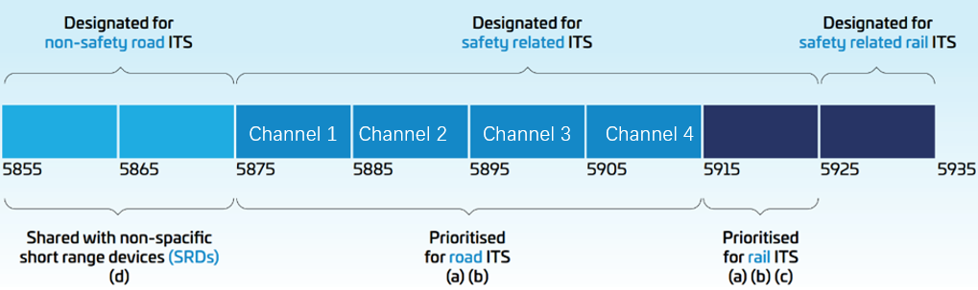

Agreement:

* Evaluate 10+10MHz channel bandwidth combination

WF agreement:

* Use 5855MHz to 5925MHz with 7 channels for A-MPR channel configuration.

#### Issue 1-1-2: A-SEM requirements for intra-band NCCA with NS_33

* Proposals:
  + Proposal 1: For intra-band NCCA, the A-SEM of two non-contiguous 10MHz carriers, the overlapping part of the A-SEM for each carrier will use the higher limit as the combined A-SEM.
  + Proposal 2: For intra-band CCA A-SEM, only consider the A-SEM of one side of the 10MHz carrier.
  + Observation 1: Spectrum mask is defined for 10MHz channel bandwidth only
  + Observation 2: Spectrum mask is only applicable within 5855 to 5925MHz.
* Moderator WF:

Further discuss and agree on the A-SEM for A-MPR simulation

* + Apply the NR NCCA SEM principle

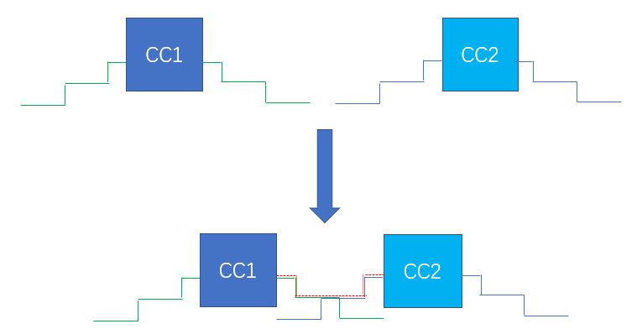

Agreement:

* + Apply the NR NCCA SEM principle



#### Issue 1-1-3: A-SE requirements for intra-band NCCA with NS_33

* Proposals:
  + Observation 1: The out-of-band domain is defined as ±250 % of the channel bandwidth, and then the out-of-band (OOB) domain for the 5 GHz ITS frequency band is 5 835 MHz to 5 855 MHz at the lower part and 5 925 MHz to 5 945 MHz at the higher part of the frequency band.
  + Observation 2: Maximum EIRP power density for UE emissions into the out-of-band domain is -30dBm/MHz.
  + Proposal 1: To use the A-SE limit to derive the derive the A-MPR requirement.

WF agreement:

* The A-SE requirement specified in sub-clause 6.5E.3.4.2 in TS 38.101-1 is used.

### Sub-topic 2-1 PC3 non-contiguou CA MPR

#### Issue 2-1-1: PSSCH/PSCCH with 1x23dBm PA + 1LO

* Proposals
  + Proposal 1 (LGE):

|  |  |  |
| --- | --- | --- |
| B | MPR (dB) for IM3 frequency | |
|  | SEMfreq_-13 | SEfreq_-30 |
| 0 ≤ B < 5.04 | ≤ 10.0 | ≤ 16.5 |
| 5.04 ≤ B < 10.08 | ≤ 9.0 | ≤ 15,5 |
| 10.08 ≤ B |  | ≤ 15.0 |

* + Proposal 2 (OPPO):
    - For -30dBm/MHz IM3:
    - For 1PA 1LO architecture:
    - 3.6≤B＜9 11
    - 9≤B＜13.5 10.5
    - 13.5≤B 8

WF agreement:

|  |  |  |
| --- | --- | --- |
| B | MPR (dB) for IM3 frequency | |
|  | SEMfreq_-13 | SEfreq_-30 |
| 0 ≤ B < 5.04 | ≤ [10.0] | ≤ 16.5 |
| 5.04 ≤ B < 10.08 | ≤ [9.0] | ≤ 15,5 |
| 10.08 ≤ B |  | ≤ 15.0 |

#### Issue 2-1-2: PSSCH/PSCCH with 2x20dBm PA + 1LO

* Proposals
  + Proposal 1 (LGE):

|  |  |  |
| --- | --- | --- |
| B | MPR (dB) for IM3 frequency | |
|  | SEMfreq_-13 | SEfreq_-30 |
| 0 ≤ B < 5.04 | ≤ 10.5 | ≤ 17.0 |
| 5.04 ≤ B < 10.08 | ≤ 9.5 | ≤ 16.0 |
| 10.08 ≤ B |  | ≤ 15.5 |

* + Proposal 2 (OPPO):
    - For -30dBm/MHz IM3:
    - For 2PA 1LO architecture:
* 3.6≤B＜9 13
* 9≤B＜13.5 12
* 13.5≤B 11

WF agreement:

|  |  |  |
| --- | --- | --- |
| B | MPR (dB) for IM3 frequency | |
|  | SEMfreq_-13 | SEfreq_-30 |
| 0 ≤ B < 5.04 | ≤ [10.5] | ≤ 17.0 |
| 5.04 ≤ B < 10.08 | ≤[ 9.5] | ≤ 16.0 |
| 10.08 ≤ B |  | ≤ 15.5 |

#### Issue 2-1-3: PSSCH/PSCCH with 2x20dBm PA + 2LO

* Proposals
  + Proposal 1 (LGE):

|  |  |  |
| --- | --- | --- |
| B | MPR (dB) for IM3 frequency | |
|  | SEMfreq_-13 | SEfreq_-30 |
| 0 ≤ B < 5.04 | ≤ 6.5 | ≤ 13.5 |
| 5.04 ≤ B < 10.08 | ≤ 6.5 | ≤ 12.5 |
| 10.08 ≤ B < 20.16 |  | ≤ 11.5 |
| 20.16 ≤ B |  | ≤ 10.5 |

* + Proposal 2 (OPPO):

For 2PA 2LO architecture:

3.6≤B＜9 11

9≤B＜13.5 10

13.5≤B 8

WF agreement:

|  |  |  |
| --- | --- | --- |
| B | MPR (dB) for IM3 frequency | |
|  | SEMfreq_-13 | SEfreq_-30 |
| 0 ≤ B < 5.04 | ≤ [6.5] | ≤ 13.5 |
| 5.04 ≤ B < 10.08 | ≤ [6.5] | ≤ 12.5 |
| 10.08 ≤ B < 20.16 |  | ≤ 11.5 |
| 20.16 ≤ B |  | ≤ 10.5 |

### Sub-topic 2-2 PC2 non-contiguou CA MPR

#### Issue 2-2-1: PSSCH/PSCCH with 1x26dBm PA + 1LO

* Proposals
  + Proposal 1 (LGE):

|  |  |  |
| --- | --- | --- |
| B | MPR (dB) for IM3 frequency | |
|  | SEMfreq_-13 | SEfreq_-30 |
| 0 ≤ B < 5.04 | ≤ 11.0 | ≤ 18.5 |
| 5.04 ≤ B < 10.08 | ≤ 10.0 | ≤ 17.0 |
| 10.08 ≤ B |  | ≤ 16.0 |

* + Proposal 2 (OPPO):
* **For 1PA 1LO architecture:**
* **3.6≤B＜9 14**
* **9≤B＜13.5 11**
* **13.5≤B 10**

WF agreement:

|  |  |  |
| --- | --- | --- |
| B | MPR (dB) for IM3 frequency | |
|  | SEMfreq_-13 | SEfreq_-30 |
| 0 ≤ B < 5.04 | ≤ [11.0] | ≤ 18.5 |
| 5.04 ≤ B < 10.08 | ≤ [10.0] | ≤ 17.0 |
| 10.08 ≤ B |  | ≤ 16.0 |

#### Issue 2-2-2: PSSCH/PSCCH with 2x23dBm PA + 1LO

* Proposals
  + Proposal 1 (LGE):
* Table 2-11 : PSSCH/PSCCH MPR for SL non-contiguous CA with 2x23dBm PA + 1LO

|  |  |  |
| --- | --- | --- |
| B | MPR (dB) for IM3 frequency | |
|  | SEMfreq_-13 | SEfreq_-30 |
| 0 ≤ B < 5.04 | ≤ 11.5 | ≤ 19.0 |
| 5.04 ≤ B < 10.08 | ≤ 11.0 | ≤ 17.5 |
| 10.08 ≤ B |  | ≤ 16.5 |

* + Proposal 2 (OPPO):
* **For 2PA 1LO architecture:**
* **3.6≤B＜9 16.5**
* **9≤B＜13.5 12.5**
* **13.5≤B 11.5**

WF agreement:

|  |  |  |
| --- | --- | --- |
| B | MPR (dB) for IM3 frequency | |
|  | SEMfreq_-13 | SEfreq_-30 |
| 0 ≤ B < 5.04 | ≤ [11.5] | ≤ 19.0 |
| 5.04 ≤ B < 10.08 | ≤ [11.0] | ≤ 17.5 |
| 10.08 ≤ B |  | ≤ 16.5 |

#### Issue 2-2-3: PSSCH/PSCCH with 2x23dBm PA + 2LO

* Proposals
  + Proposal 1 (LGE):
* Table 2-12 : PSSCH/PSCCH MPR for SL non-contiguous CA with 2x23dBm PA + 2LO

|  |  |  |
| --- | --- | --- |
| B | MPR (dB) for IM3 frequency | |
|  | SEMfreq_-13 | SEfreq_-30 |
| 0 ≤ B < 5.04 | ≤ 7.0 | ≤ 15.0 |
| 5.04 ≤ B < 10.08 |  | ≤ 13.0 |
| 10.08 ≤ B < 20.16 |  | ≤ 12.0 |
| 20.16 ≤ B |  | ≤ 10.0 |

* + Proposal 2 (OPPO):
* **For 2PA 2LO architecture:**
* **3.6≤B＜9 12**
* **9≤B＜13.5 11**
* **13.5≤B 10**

WF agreement:

|  |  |  |
| --- | --- | --- |
| B | MPR (dB) for IM3 frequency | |
|  | SEMfreq_-13 | SEfreq_-30 |
| 0 ≤ B < 5.04 | ≤ [7.0] | ≤ 15.0 |
| 5.04 ≤ B < 10.08 |  | ≤ 13.0 |
| 10.08 ≤ B < 20.16 |  | ≤ 12.0 |
| 20.16 ≤ B |  | ≤ 10.0 |