3GPP RAN WG4 Meeting #113 R4-2420388

Orlando, USA, 18th – 22nd November 2024 (revision of R4-2417742)

Agenda item: 7.2.4.2

Source: Apple, Samsung, MediaTek

Title: TP on general considerations for the UE antenna parameters for the 14800-15350MHz frequency range

WI/SI: FS_NR_IMT_4400_7125_14800MHz

Release: Rel-19

Document for: Discussion

# 1 Introduction

The WRC-23 conference identified three frequency ranges as potential IMT candidates and tasked ITU-R WP5D to conduct the corresponding sharing and compatibility studies. In turn, the ITU-R WP5D sent the LS to a number of bodies, including 3GPP, asking to provide technical parameters for the candidate frequencies [1]. In response to that LS from WP5D and based on the technical input from RAN WG4 [2], the 3GPP RAN#103 meeting approved a new SI [3], purpose of which will be to study and provide the corresponding IMT technical parameters.

During the RAN4#111 meeting an initial discussion took place and RAN WG4 concluded that for this frequency range both FR1- and FR2-like approaches for the UE RF architecture will be studied further. This document presents a text proposal to capture general considerations on the UE antenna design trade-offs based on the input contributions R4-2417742 and R4-2419399.

# 2 Text proposal

-------------------------------------------- TP BEGIN --------------------------------------------

# 6 14800 - 15350 MHz frequency range

## 6.5 Antenna characteristics

### 6.5.1 BS antenna characteristics

#### 6.5.1.1 Antenna model

#### 6.5.1.2 Antenna parameters

### 6.5.2 UE antenna characteristics

#### 6.5.2.1 General considerations

One of the key issues for this range is the UE RF architecture. While existing FR1 system parameters are defined for frequencies up to 7.1GHz, same FR1 principles are already assumed for e.g. 7.1-8.4GHz, which is however below the considered range of 14.8-15.3GHz. At the same time, the lower bound for the FR2 starts at 24.25GHz, which is notably higher than 15.3GHz. A choice for a particular UE RF architecture at these frequency ranges should consider implementation feasibility, e.g. physical constraints in case of handheld devices, and anticipated performance, such as coverage (as highlighted in Figure 6.5.2-1 in TR 38.820). The capabilities of PA technology in the FR2 frequency range motivated 3GPP to consider a UE architecture which relies on panels performing analog beam-forming, which was also considered as a feasible option from the handheld device implementation perspective. In contrast, panels and analog beam-forming are not feasible for lower FR1 frequencies.

In the context of the UE RF architecture, better UL coverage at FR2 frequencies was one of the key driving factors to consider the UE RF design with panels performing analog beam-forming. An FR2-like array antenna system incorporates analog beamforming into the array antenna to increase the coherent EIRP gain, thus helping to reduce the path loss between the UE and the base station. Furthermore, the FR2 array antenna, LNAs, PAs, beamformers, and PMIC are integrated into a single package, small form factor of which was also considered as a feasible option from the handheld device implementation perspective. As for the frequencies around 10-15GHz, previous work in TR 38.820 studied feasibility of FR2 principles in hand-held devices operating in that frequency range. One of the main challenges is the size of potential FR2 panel and, as noted in TR 38.820, *"… we can see that the antenna module doubles in size going from 28 GHz to 20 GHz and further doubles at 14 GHz*". Figure 6.5.2-1 presents an example of the patch width and ground plane extension based on the microstrip patch array design assuming four elements with half-wavelength spacing.

**Figure 6.5.2-1: Patch array dimensions vs. frequency**

For more detailed information on the potential array antenna size operating at the considered frequency of 15GHz, Figure 6.5.2-2 below presents several example cases with different antenna arrangements accounting for the typical spacing between elements of the array antenna of half wavelength. As can be seen from the figure for a typical inter-element antenna spacing, the total antenna array size becomes much larger comparing to the FR2 sizes.

**Figure 6.5.2-2: Estimated antenna size at 15GHz**

Figure 6.5.2-3 below illustrates an example of a survey of the internal area used by four different commercially available 5G devices for FR1 (based on individual company contributions in RAN4). The FR2 area is calculated based a single 4x1 reference design, the configuration used as the basis for current FR2 spherical coverage requirements. Additionally, an estimate of the required 13-15GHz antenna array area is provided for comparison, similarly based on a 4x1 microstrip patch array with half-wavelength spacing. So, assuming dedicated apertures, an estimated 4x1 array at 13-15 GHz would represent an additional area growth on the order of 30-70% relative to antenna area usage currently needed to support FR1.

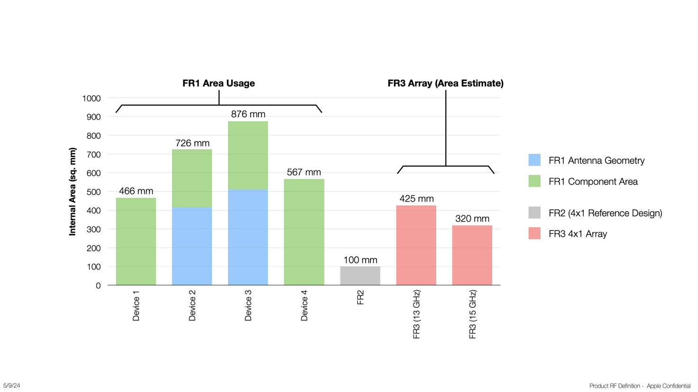

**Figure 6.5.2-3: A survey of internal area usage for FR1, FR2 and estimated 13-15GHz antennas**

In addition, support of analog beamforming in 13-15GHz might impose a substantial growth and volume requirements dedicated for cellular antennas. Furthermore, the nature of such an array might constrain the dimensions leading to implementation challenges in densely integrated consumer devices that can be of different form factors. For instance, Figure 6.5.2-4 shows an example of the PCB of a foldable phone, from which one can see that it might be challenging to mount single patch antennas on four edges or the backside of the smartphone considering the larger array size and the already-packed smartphone space. In other words, it can be difficult for a hand-held to assume that there will be extra space in all required physical dimensions making it challenging, at least from the packing perspective, to put FR2-like panels supporting the 15GHz range.

**Figure 6.5.2-4: Main PCB of a foldable mobile phone.**

-------------------------------------------- TP END --------------------------------------------

# 3 References

1. RP-240024, "LS on Parameters of terrestrial component of IMT for sharing and compatibility studies in the frequency bands 4400-4800 MHz, 7125-8400 MHz and 14.8-15.35 GHz", ITU-R WP5D
2. R4-2102840, "LS on Parameters of terrestrial component of IMT for sharing and compatibility studies in preparation for WRC-23 (6.425 to 10.5 GHz)", RAN WG4.
3. RP-240765, "Study on IMT parameters for 4400 to 4800 MHz, 7125 to 8400 MHz and 14800 to 15350 MHz"
4. 3GPP TR 38.921, "Study on International Mobile Telecommunications (IMT) parameters for 6.425-7.025GHz, 7.025-7.125GHz and 10.0-10.5 GHz", v17.1.0