3GPP TSG-RAN WG4 Meeting # 113 R4-2417540

Orlando, US, 18th – 22nd November 2024

**Agenda Item:** **7.2.5**

**Source: Nokia**

**Title:** **TP to TR 38.922: Summary and conclusion for MIMO modeling aspects**

**Document for:** **Approval**

**1. Introduction**

The SI on IMT parameters for 4400 to 4800 MHz, 7125 to 8400 MHz and 14800 to 15350 MHz was approved at TSG RAN#103 [1]. This study item aims as answering requests from ITU-R WP5D regarding NR in these frequencies for IMT [2]. One of the requests from ITU-R WP5D in [2] is:

|  |
| --- |
| e) Considering the system-level simulation work typically conducted in WP5D for sharing and compatibility studies using 3D modelling of antenna pattern, WP5D is seeking information on whether for implementation of IMT BS multiuser spatial beamforming techniques, such as zero-forcing (ZF) or minimum mean-square error (MMSE) based schemes, would be necessary to improve the assessment of interference and the accuracy of studies. If considered necessary, guidance on the process of deriving the necessary beamforming weights for the IMT AAS BS to compute its radiation pattern is welcomed. |

This topic was discussed at TSG RAN4#112bis and the WF was approved [3].

This contribution provides a text proposal for MIMO modeling aspects in clause 7.3 of TR 38.922 [4] to merge the text proposals in [5-9]. R4-2418397 (Ericsson), R4-2417540 (Nokia), R4-2417545 (Spark), R4-2418608 (Qualcomm), R4-2419238 (Huawei).

**2. Text proposal**

**<Start of text proposal>**

7.3 MIMO modelling

7.3.1 Simulation methodologies

7.3.1.1 Methodology 1

The following simulation methodology was adopted to produce simulation results:

1. For the k-th UE, generate array coefficients, , to reflect the UE angles from the BS antenna array in both azimuth and elevation (NOTE 1):

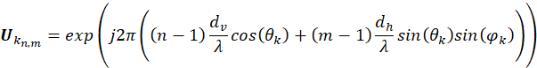

where, for the k-th UE, and are the angles of elevation and azimuth, respectively. The ranges of and are and [-] radians. The size of the matrix is N×M, where N is the number of rows and M is the number of columns of the antenna array.



1. Assess the angular separation between the K UEs in the cell (NOTE 2).
2. For each UE (NOTE 3), if there is at least another UE which with the minimum angular separation requirement is fulfilled, create a concatenated K×MN channel matrix, **Hk** (NOTE 4):  
     
     
     
   where T is the transpose operator and **h**k corresponds to the vectorization of **U**k resulting in a vector of size MN×1 (NOTE 5).



1. For each UE, the zero-forcing beamforming (precoding) matrix **W**k (MNxK) is:  
     
     
     
   where **H**k represents the channel matrix with its number of columns corresponding to the number of RX antennas (i.e., UEs) and its number of rows corresponding to the number of TX antennas (BS antenna ports), and H is the conjugate transpose operator.



1. The entire **W**k matrix can be normalized by diving it by its Frobenius norm, or, doing a column wise normalization by diving each column with its norm (NOTE 6).
2. The actual precoding weights for each UE (**w**k) are obtained by selecting the first column of **W**k. The size of **w**k is MN×1.
3. Obtain the individual Zero Forcing beam pattern: The precoding weights for each beam **w**k of size MNx1 may be used to obtain the k-th zero forcing beam pattern by reordering the column vector **w**k of size MNx1 into a matrix **W**k of size NxM which can be used as element weight in:  
     
     
     
   where wk refers to the entry in the n-th row and m-th column of weighting matrix **W**k and νn,m is the superposition vector. Note that for AAS with sub-arrays, AE(θ,ϕ) is updated by Asub(θ,ϕ):  
     
     
     
   where Asub(θ,ϕ) calculation follows the method defined in the extended AAS modelling supporting vertical sub-array configurations.

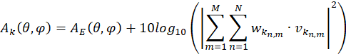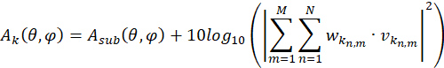

1. The resulting composite ZF beam pattern may be obtained by summing up the individual Zero Forcing beam patterns in linear scale (and transforming them back to dB):

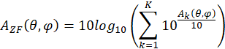

where AZF(θ,ϕ) refers to the composite ZF beam pattern and Ak(θ,ϕ) refers to the k-th individual zero forcing beam pattern.

NOTE 1: For the computation of **U**k, θk and φk are in Local Coordinate System (LCS) which accounts for the mechanical down-tilt.

NOTE 2: The total 3D angular separation should be considered to determine the fulfillment of the minimum angular separation requirement. Additionally, only the azimuth angular separation may be considered in cases where the elevation angle does not significantly contribute to the total 3D angular separation.

NOTE 3: **H**k must be constructed for each UE separately, since in some instances, one UE can be paired with all other UEs while another UE could be paired with only a single other UE. The next figure depicts this situation: UE1 can be paired with UE2 and UE3 since the min. angular separation is fulfilled (as shown in (a)), UE2 can only be paired with UE1 (as shown in (b)), and UE3 can only be paired with UE1 (as shown in (c)).



NOTE 4: **H**k only includes the UEs that fulfill the minimum angular separation requirement depending on the size of the BS antenna, so **H**k may have two or three columns (K=2 or 3) in each Monte Carlo snapshot depending on the geometry of the BS and the UEs. For the UEs that cannot be paired with any other UEs (K=1), **H**k is not constructed, and the current beamforming model is used.

NOTE 5: The vectorization must ensure that the vector of size 1×MN correspond to the concatenation of the rows of **U**k:



NOTE 6: The total power constraint simplifies the design problem and leads to simple and efficient precoders. However, the magnitude of some elements of may be larger than , which can introduce per-antenna port transmit power larger than . In practice, many systems are subject to individual per-antenna port power constraints.



7.3.1.2 Methodology 2

7.3.1.2.1 Beamforming equations

An alternative to a single-user MIMO (a.k.a. point-to-point MIMO) system is MU-MIMO in which an antenna array at the mobile base station simultaneously serves a multiplicity of autonomous user equipments (UEs). These UEs can be single-antenna devices, in which case the multiplexing throughput gains of the MU-MIMO system are shared among the different UEs. A MU-MIMO system is more tolerant of the propagation environments than a single-user MIMO system. For instance, under line-of-sight dominant propagation conditions (implying strong levels of correlation across user channels), the multiplexing gains can disappear for a single-user MIMO system but are retained in the MU-MIMO case provided that the angular separation of the user equipments exceeds the Rayleigh resolution of the array. The co scheduled UEs should lie in uncorrelated or weakly correlated positions. Considering the propagation conditions, , in dominant non-line-of-sight conditions, the multiplexing gains are naturally also retained for the MU-MIMO system. Keeping this in mind, it is worth noting that irrespective of the propagation conditions, the conclusions from standard MU-MIMO techniques like ZF and MMSE to serve multiple user equipments remain consistent. To this end, where necessary, we will assume the existence of a given propagation environment coupled with the appropriate model for generating the propagation channel impulse responses, without specifying or recommending a particular propagation model.

When the mobile base station employs multiuser spatial beamforming techniques like ZF, the antenna array produces spatial nulls in the direction of undesired users. Hence, assuming rank-1 transmission (in 3GPP terminology), if there are K users, then the array forms K analog beams towards the K users where retrieval of the single data streams will occur. Each of the K beams is given by the composite array radiation pattern, as given in Table 7.1.3-1. Yet the separation of users via analog beamforming (BF) alone is not adequate to sufficiently separate the K users signals. To do this, it is preferable to have the users adequately separated say in the azimuth. Spatial beamforming techniques are used in combination with analog beamforming. This will result in nulls in the undesired direction(s).

Consider the simple example below:

Suppose there are say three users communicating with a base station. The three users can be assumed to be located at \phi_{1} = -10 degrees, \phi_{2} = 0 degrees and \phi_{3} = +10 degrees in the azimuthal plane. One can also assume that the base station array (e.g., uniform planar configuration say of size (32x8) is able to steer three independent beams to the three user equipments via the composite radiation patterns generated via the array factor[1] in Table 7.1.3­-1 above, with the azimuth main lobe of each beam pointing towards the azimuth angles of -10, 0, and+10 degrees respectively, observed at a fixed elevation angle cut of, say, 90 degrees[2]. Furthermore, one can assume that the base station can implement a multiuser beamforming technique which allows the base station to form nulls in certain undesired directions relative to a desired direction. Then, when serving the user at \phi_{2} = 0 degrees, the base station will form nulls in the direction of the other users (signifying the undesired directions), at \phi_{1}=-10 degrees and \phi_{3} = +10 degrees respectively.

When extrapolating this logic to the case when the base station is serving a higher number of users, e.g., eight users[3], located in eight different azimuth directions, allowing the base station to generate seven nulls in the direction of other users relative to the desired user in the azimuthal plane.

7.3.1.2.2 ZF and MMSE-based beamforming for Rank-1 MU-MIMO Transmission

When spatial beamforming is used in conjunction with analogue beamforming, the beamforming weights may be estimated as below:

ZF based beamforming

Here, we consider ZF-based beamforming for two users, denoted by UE 1 and UE 2 served by a single base station (BS) within the same time-frequency resource. Large numbers of antennas enable the focussing and steering of energy in desired directions [3]. The BS is assumed to have antenna elements in total configured in a uniform planar array in the plane in the standard three-dimensional (3D) local coordinate system. For the sake of simplicity, perfect channel estimation at both the BS and UEs are assumed.[4] Both UEs are assumed to have a single antenna. UE 1 and UE 2 is assumed to be located at two discrete azimuth angles, and , respectively, with say the same elevation angle, . Considering this, the composite antenna array radiation pattern towards UE 1 and UE 2 can be obtained by following the mathematical expressions given in the Table 7.1.3­-1 above, where the azimuth angles, and , are used Two RF matrices corresponding to UE 1 and 2 as and .[5]respectively are derived. The size of the matrices and is equal to MN x NtRF. where NtRF is the number of RF chains at the base station. If every antenna has a transmitter then the size of the beamforming matrices and is MN x MN respectively.



Even though the UEs may be lying say in one dimension say the azimuth only their impulse response has both an azimuth and elevation component see the impulse response channel matrix in [2].

Note that the exact structure of and depends on the radio propagation conditions at the time of transmission from the BS to both UEs. However, this notation is agnostic to the type of conditions and propagation mechanisms present in the channel responses and hence is preferred for use in this document.



Concatenating the equivalent channel responses into a total equivalent channel matrix of appropriate size stacking the two equivalent user channels, one can write:



(1)



Where and are the two equivalent channels and are in turn equal and respectively.



Now the ZF-based beamforming to null the inter-user interference can be used on . To this end, the ZF beamforming matrix, can be calculated as:



This will ensure that if the BS is transmitting the desired signal in the direction of UE 1, i.e., towards , a null in the radiation pattern of the BS can be formed towards the unintended direction of UE 2, i.e., towards . We note that the ZF beamformer should be normalized to satisfy a total power constraint. There are two different ways to normalize the ZF beamformer, namely via a *vector normalization* or via a *matrix normalization*. Using the example of a vector normalization, the per-user digital beamforming weight vector specific to UE 1 and UE 2 can be written as and forming the two columns of Normalizing these using the vector normalization method yields



and



This implies that for UE 1, multiplying the , while and vice-versa for UE 2. Therefore, a null in the azimuth direction can be formed towards UE 2 while serving UE 1.



The array response vmn ( in the 3GPP AAS model) can be made to provide maxima at given angular directions by an appropriate choice of the angles in wmn which can be viewed as additional phase terms in the array response. It should be noted that pseudo inverse based on concatenated channels in eqn (1) that are in turn based on wmn alone is flawed and will not provide an exact impact of ZF on the complete array response.

##### MMSE based beamforming

In the case of MMSE beamforming, the MMSE beamforming matrix, , is given by



where is the regularisation constant/factor and is the identity matrix of the same dimension as . By maximizing the SINR at the UEs, the optimal regularisation constant/factor was derived in [6] as , where is the operating signal-to-noise ratio (SNR) typically computed by taking the ratio of the EIRP with the noise variance (power spectral density) of the UE. Note that optimal regulariser was only obtained for the case of equal conducted transmit power being split across the K user equipments and only applies to rank-1 transmission.



It is noteworthy that when (holding the value in K as constant), reflecting high SNR scenarios, the MMSE beamforming matrix in (5) reduces to the ZF beamforming matrix in (2) as .



The normalization of the beamforming vectors of the MMSE approach is identical to the ZF and hence the expressions in (3) and (4) apply with and now derived from the MMSE expression in (5).



7.3.2 Simulation results

7.3.2.1 Methodology 1

7.3.2.1.1 Ericsson (R4-2418397)

The parameters values listed in Table 7.3.2.1.1-1 and 7.3.2.1.1-2 is used for the simulation.

**Table 7.3.2.1.1-1: IMT deployment-related parameters**

| **Parameter** | **Macro Urban** |
| --- | --- |
| **Base station** |  |
| Carrier frequency | 6 GHz |
| Channel bandwidth | 100 MHz |
| BS antenna height | 18 m |
| Cell size | 300 m |
| Sectorization | 1 sector 1 |
| Frequency reuse | 1 |
| **User Equipment** |  |
| UE height | 1.5 m |
| UE density for terminal that are transmitting simultaneously | 3 UEs per sector |
| NOTE 1: This study considers only a single-entry scenario. | |

**Table 7.3.2.1.1-2: IMT base station beamforming antenna characteristics for IMT**

| **Parameter** | **Macro Urban** |
| --- | --- |
| Antenna pattern | Refer to Recommendation ITU-R M.2101 Annex 1 |
| Element gain (incl. Ohmic loss) (dBi) | 5.5 |
| Horizontal/vertical 3 dB beamwidth of single element (degree) | 90º for H  90º for V |
| Horizontal/vertical front to back ratio (dB) | 30 for both H/V |
| Antenna polarization | Linear ±45º |
| Antenna array configuration (Row × Column) | 16 × 8 |
| Horizontal/Vertical radiating element spacing | 0.5 of wavelength for H  0.5 of wavelength for V |
| Array Ohmic loss (dB) | 2 |
| Base station maximum coverage angle in the horizontal plane (degrees) | ±60 |
| Base station vertical coverage range (degrees) | 90-120 1 |
| Mechanical down-tilt (degrees) | 10 |
| NOTE 1: The vertical coverage range includes the mechanical down-tilt. A minimum BS-UE distance along the ground of 35 m should be used for urban/suburban and rural macro environments. | |

For the sake of completeness, additional results are provided with an AAS with a subarray configuration. The parameters for this AAS are taken from the WRC-23 studies 5D/1235 and 5D/1461 and are presented in the Table 7.3.2.1.1-3.

**Table 7.3.2.1.1-3: IMT base station beamforming antenna characteristics for IMT with subarray configuration**

| **Parameter** | **Macro Urban** |
| --- | --- |
| Antenna pattern | Refer to the extended AAS model in 5D/716 (Annex 4.4 - WRC23) |
| Element gain (incl. Ohmic loss) (dBi) | 6.4 |
| Horizontal/vertical 3 dB beamwidth of single element (degree) | 90º for H  65º for V |
| Horizontal/vertical front to back ratio (dB) | 30 for both H/V |
| Antenna polarization | Linear ±45º |
| Antenna array configuration (Row × Column) | 16 × 16 |
| Horizontal/Vertical radiating element spacing | 0.5 of wavelength for H  1.4 of wavelength for V |
| Number of element rows in sub-array | 2 |
| Vertical radiating element spacing in sub-array | 0.7 of wavelength |
| Pre-set sub-array down-tilt (degrees) | 3 |
| Array Ohmic loss (dB) | 2 |
| Base station maximum coverage angle in the horizontal plane (degrees) | ±60 |
| Base station vertical coverage range (degrees) | 90-100 1 |
| Mechanical down-tilt (degrees) | 6 |
| NOTE 1: The vertical coverage range includes the mechanical down-tilt. A minimum BS-UE distance along the ground of 35 m should be used for urban/suburban and rural macro environments. | |

The IMT network consists of a single site with a single sector. In each snapshot of the Monte Carlo simulation, 3 UEs are uniformly distributed within the sector, and the BS serves each UE with a dedicated beam. These beams can be generated by both the traditional antenna model and as described in subclause 7.3.1.1, assuming a UE minimum angular separation of 10 degrees.

To assess the interference to possible interfered-with receivers, two scenarios are considered, where these receivers are represented by sample points:

1. Equidistant sample points towards the horizon around the IMT BS (Figure 7.3.2.1.1-1a)
2. Equidistant sample points on a hemisphere above the IMT BS excluding the sample points towards the horizon (Figure 7.3.2.1.1-1b)

It is noted that the angular separation between sample points is approximately 15.5 degrees, with scenario 1 having 23 sample points and scenario 2 having 62 sample points.



**Figure 7.3.2.1.1-1: Equidistant sample points (a) towards the horizon around the BS, and (b) on a hemisphere above the BS**

In this section the Monte Carlo simulations results are presented. For each sample point in the considered scenarios, 10.000 snapshots are simulated. The cumulative distribution functions (CDFs) curves of the IMT BS gain towards the sample points of the different scenarios are shown in Figures 7.3.2.1.1-2 to 7.3.2.1.1-5. The CDF results for scenario 1 using a BS without and with subarrays are shown in Figures 7.3.2.1.1-2 and 7.3.2.1.1-3 respectively. The CDF results for scenario 2 using a BS without and with subarrays are shown in Figures 7.3.2.1.1-4 and 7.3.2.1.1-5 respectively. For instance, since scenario 1 has 23 sample points, Figures 7.3.2.1.1-2a and 7.3.2.1.1-3a show 23 pairs of CDFs.



**Figure** **7.3.2.1.1-2: Scenario 1 (without subarrays) CDFs: BS gain towards (a) each sample point, and (b) all sample points (composite)**



**Figure 7.3.2.1.1-3: Scenario 1 (with subarrays) CDFs: BS gain towards (a) each sample point, and (b) all sample points (composite)**



**Figure 7.3.2.1.1-4: Scenario 2 (without subarrays) CDFs: BS gain towards (a) each sample point, and (b) all sample points (composite)**



**Figure 7.3.2.1.1-5: Scenario 2 (with subarrays) CDFs: BS gain towards (a) each sample point, and (b) all sample points (composite)**

To assess the impact on long- and short-term statistics, the 80th percentile and 99.9th percentile are considered respectively. For Figures 7.3.2.1.1-2a, 7.3.2.1.1-3a, 7.3.2.1.1-4a, and 7.3.2.1.1-5a, Table 7.3.2.1.1-1 contains the summary of the average BS antenna gain difference between traditional beamforming model and ZF beamforming model.

**Table 7.3.2.1.1-1: Average BS antenna gain difference between traditional beamforming model and ZF beamforming**

| **Scenario** | **Long-term (80th percentile)** | **Short-term (99.9th percentile)** |
| --- | --- | --- |
| Scenario 1 (without subarrays) | 0.39 dB | 0.14 dB |
| Scenario 1 (with subarrays) | 0.05 dB | ~0 dB |
| Scenario 2 (without subarrays) | 0.48 dB | 0.06 dB |
| Scenario 2 (with subarrays) | 0.08 dB | ~0 dB |

Furthermore, the BS antenna gain integrated over parts of or the entire angular sphere around the antenna, i.e., the Total Integrated Gain (TIG), is also evaluated to provide a set of more consistent results by considering all angular directions. The TIG is calculated as follows:

(Eq.7.3.2.1.1-1)



where *θ* and *φ* represent the elevation and azimuth angles, respectively, and are the number of samples on elevation and azimuth, respectively, and *G* is the antenna gain in linear units at the spherical coordinates (*θ, φ*).



For this assessment, the BS antenna gain is integrated over the whole sphere and over only the upper hemisphere by limiting the range of *θ*. The integrated gain is calculated for each individual beam for 10000 snapshots, resulting in three values per snapshot. Note that the integrated gain of the upper hemisphere of the AAS, where *θ* = 90 degrees is the AAS boresight direction including down-tilt, is not exactly the integrated above the horizon but includes most of it. This is depicted in Figure 7.3.2.1.1-6.



**Figure 7.3.2.1.1-6: Upper hemisphere: (a) upper hemisphere above horizon, and (b) upper hemisphere considered in this study**

Figures 7.3.2.1.1-7and Figure 7.3.2.1.1-8 show the BS antenna gain integrated over the whole sphere and over only the upper hemisphere (Figure 7.3.2.1.1-6b), including the horizon, for the BS without and with subarrays, respectively. For simplicity, it is noted that for all the presented results, the integrated gain is always normalized by , as indicated in Eq.7.3.2.1.1-1, regardless of the number of samples considered.



**Figure 7.3.2.1.1-7: CDFs of the BS antenna gain without subarrays, integrated over (a) the upper hemisphere, including the horizon, and (b) the entire angular sphere around the antenna**



**Figure 7.3.2.1.1-8: CDFs of the BS antenna gain with subarrays, integrated over (a) the upper hemisphere, including the horizon, and (b) the entire angular sphere around the antenna**

As can be seen, in all cases considered, the TIG difference between the beamforming schemes is negligible.

7.3.2.1.2 Qualcomm (R4-2418608)

BS AAS parameters and configurations that are considered in our Monte-Carlo simulation campaign are provided in Table 7.3.2.1.2-1, Table 7.3.2.1.2-2, and Table 7.3.2.1.2-3, respectively. In terms of scenario/deployment, we consider a single sector where within each snapshot, 3 UEs are randomly deployed within the coverage region of that sector with a given minimum angular/spatial separation of 10 degrees. The location of those UEs is assumed to be known at the BS and a dedicated beam is generated to serve each UE. In order to investigate the impact of BS emissions above the horizon, probing points in the upper hemisphere have been placed, as visualized in Figure 7.3.2.1.2-1. Black points represent the total probing points, while blue points represent the 3 UEs dropped in each snapshot, taking into account the minimum angular separation among those UEs (i.e., 10 degrees as assumed in this contribution). The probing points are equidistantly distributed on a hemisphere above the horizon with angular separation between them approximately 18 degrees. It is worth mentioning that the objective of our study is to investigate the experienced emissions at the different probing points, since they represent possible incumbent services that will suffer from to the IMT BS unwanted emissions above the horizon.

**TABLE 7.3.2.1.2-1 IMT deployment-related parameters**

|  | Urban macro |
| --- | --- |
| **Base station** | |
| Carrier frequency | 6 GHz-band |
| Channel bandwidth | 100 MHz |
| BS Antenna height | 18 m |
| Cell size | 300 m |
| Sectorization | 1 sector |
| Frequency reuse | 1 |
| **User terminal** | |
| UE height | 1.5 m |
| UE density for terminals that are transmitting simultaneously | 3 UEs per sector |

TABLE 7.3.2.1.2-2

IMT base station beamforming antenna characteristics for IMT

|  | **Urban Macro** |
| --- | --- |
| Antenna pattern | Refer to Recommendation [ITU-R M.2101](https://www.itu.int/dms_pubrec/itu-r/rec/m/R-REC-M.2101-0-201702-I!!PDF-E.pdf) Annex 1 |
| Element gain (incl. Ohmic loss) (dBi) | 5.5 |
| Horizontal/vertical 3 dB beamwidth of single element (degree) | 90º for H 90º for V |
| Horizontal/vertical front‑to‑back ratio (dB) | 30 for both H/V |
| Antenna polarization | Linear ±45º |
| Antenna array configuration (Row × Column) | 16 × 8 |
| Horizontal/Vertical radiating element spacing | 0.5 of wavelength for H  0.5 of wavelength for V |
| Array Ohmic loss (dB) | 2 |
| Base station maximum coverage angle in the horizontal plane (degrees) | ±60 |
| Base station vertical coverage range (degrees) | 90-120 (**Note 1**) |
| Mechanical downtilt (degrees) | 10 |
| **Note 1:** The vertical coverage range includes the mechanical downtilt. A minimum BS-UE distance along the ground of 35 m should be used for urban/suburban and rural macro environments. | |

TABLE 7.3.2.1.2-3

IMT base station beamforming antenna characteristics for IMT with subarray configuration

|  | **Urban Macro** |
| --- | --- |
| Antenna pattern | Refer to the extended AAS model in 5D/[716](https://www.itu.int/md/R19-WP5D-C-0716/en) (Annex 4.4 - WRC23) |
| Element gain (incl. Ohmic loss) (dBi) | 6.4 |
| Horizontal/vertical 3 dB beamwidth of single element (degree) | 90º for H 65º for V |
| Horizontal/vertical front‑to‑back ratio (dB) | 30 for both H/V |
| Antenna polarization | Linear ±45º |
| Antenna array configuration (Row × Column) | 16 × 16 |
| Horizontal/Vertical radiating sub-array spacing | 0.5 of wavelength for H  1.4 of wavelength for V |
| Number of element rows in sub-array | 2 |
| Vertical radiating element spacing in sub-array | 0.7 of wavelength |
| Pre-set sub-array downtilt (degrees) | 3 |
| Array Ohmic loss (dB) | 2 |
| Base station maximum coverage angle in the horizontal plane (degrees) | ±60 |
| Base station vertical coverage range (degrees) | 90-100 (**Note 1**) |
| Mechanical downtilt (degrees) | 6 |
| **Note 1:** The vertical coverage range includes the mechanical downtilt. A minimum BS-UE distance along the ground of 35 m should be used for urban/suburban and rural macro environments. | |

.

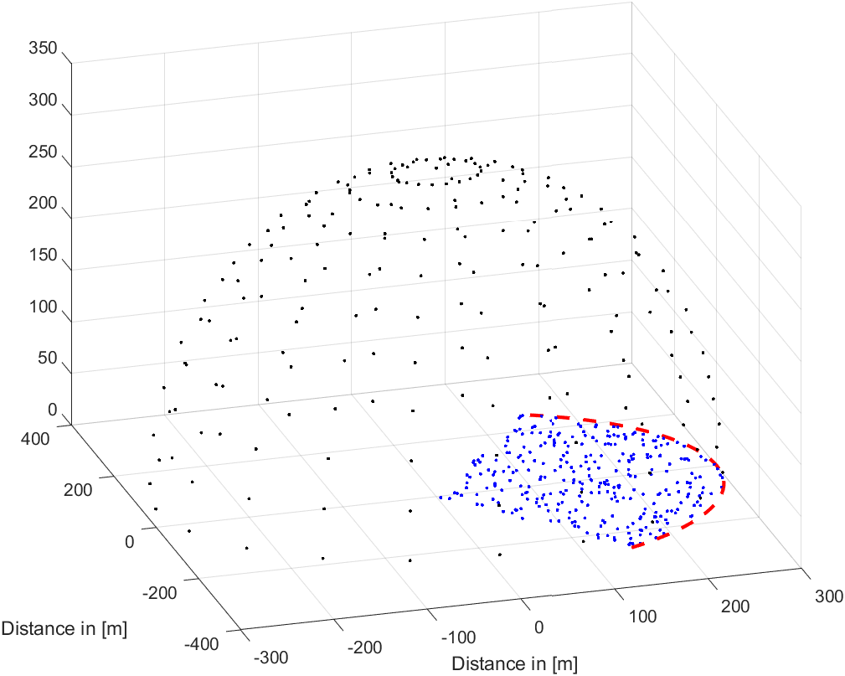

Figure 7.3.2.1.2-1 System layout for a given sector

The CDF curves of the IMT BS gain towards the black probing points are shown in Figure 7.3.2.1.2-2, considering the AAS without subarray structure (left figure) and with subarray structure (right figure). It can be observed the performance degradation observed when ZF is applied is negligible. Such behaviour shows that when considering large number of snapshots in a Monte-Carlo framework, the impact of the spatial beamforming above the horizon has minimal impact on the emissions above the horizon.

|  |  |
| --- | --- |
|  |  |

Figure 7.3.2.1.2-2 Composite AAS gain from IMT BS towards probing points considering AAS with (left) and without subarrays (right)

7.3.2.1.3 Huawei (R4-2419238)

In order to assess the necessity and accuracy of interference comes from IMT systems for ITU-R sharing and compatibility studies, the IMT BS gain towards a number of potential interfered-with receivers located in the upper hemisphere are simulated. The angular separation between sample points is assumed 10 degrees.

Figure 7.3.2.1.3-1

10-degree sample points in the upper hemisphere above the BS

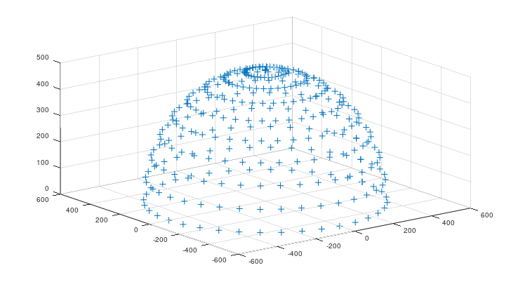

Deployment related parameters of BSs and UEs are based on the agreed technical and operational characteristics in the document 5D/[716](https://www.itu.int/md/R19-WP5D-C-0716/en) (Annex 4.4 - WRC-23), and beamforming antenna characteristics are referred to 3GPP liaison statement on parameters for 4400 to 4800 MHZ of terrestrial component of IMT for sharing and compatibility studies in preparation for WRC-27, see [5D/136](https://www.itu.int/md/R23-WP5D-C-0136/en).

The cumulative distribution functions (CDFs) curves of the IMT BS gain towards the sample points of the different scenarios are shown in Figures 7.3.2.1.3-2 with additional individual per-antenna power constraint. It can be seen that the difference between ITU-R M.2101 and ZF gains are minor.

Figure 7.3.2.1.3-2

BS gain towards all sample points (composite) with individual per-antenna power constraint

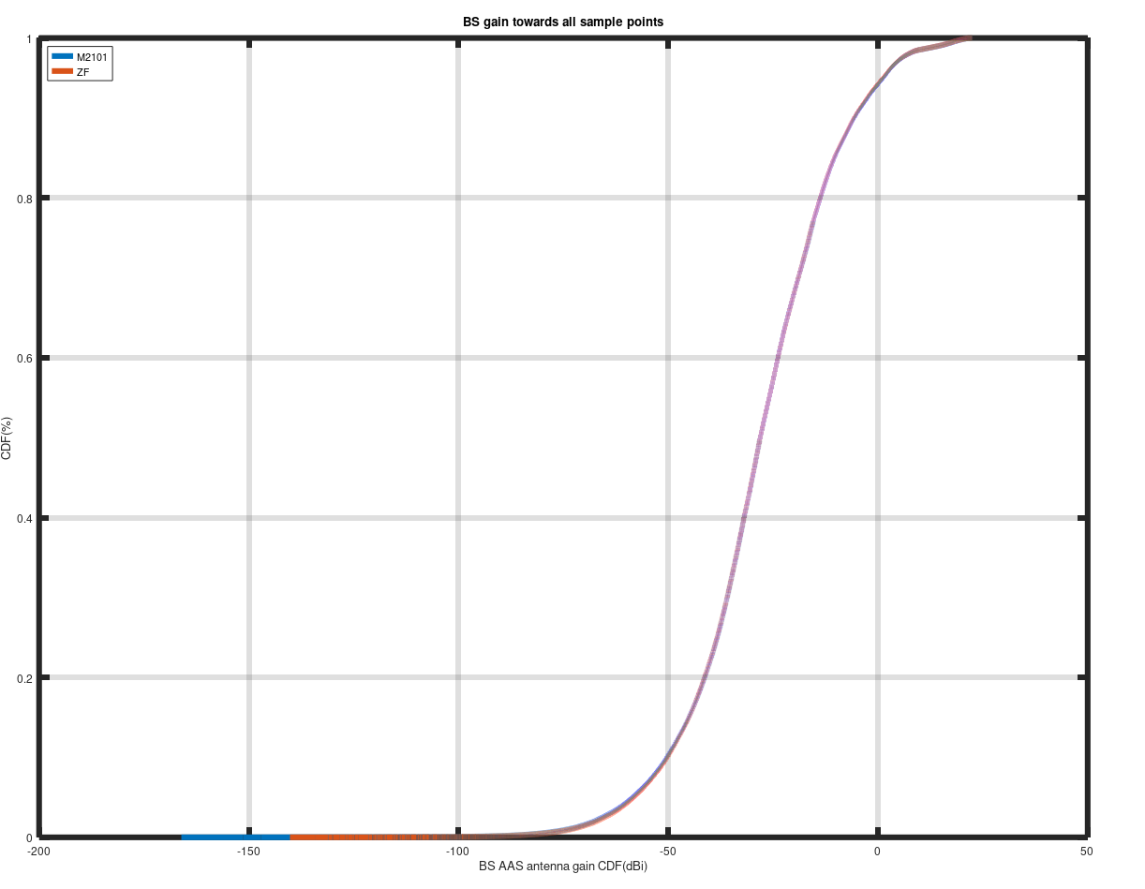

To assess the impact on long- and short-term statistics, the 80th percentile and 99.9th percentile are considered respectively. Table 7.3.2.1.3-1 contains the summary of the BS antenna gain difference between ITU-R M.2101 model and ZF beamforming model with & without additional individual per-antenna power constraint. Additional individual per-antenna power constraint influences the simulation results very little. In addition, it shows that ZF beamforming get slightly less antenna gain than M.2101 towards to the sample points with individual per-antenna power constraint:

TABLE 7.3.2.1.3-1

BS antenna gain difference between ITU-R M.2101 beamforming model and ZF beamforming (Method 1)

| C band Urban (with subarrays)  Scenario | Long-term (80th percentile) | Short-term (99.9th percentile) |
| --- | --- | --- |
| M.2101 | -13.720 | 20.861 |
| ZF without individual per-antenna power constraint | -13.587 | 20.855 |
| ZF with individual per-antenna power constraint | -13.779 | 20.719 |
| M.2101- ZF difference (dB) (without individual per-antenna power constraint) | -0.133 | 0.006 |
| M.2101- ZF difference (dB)  (with individual per-antenna power constraint) | 0.059 | 0.142 |

7.3.2.2 Methodology 2

7.3.2.2.1 Spark (R4-2417545)

We provide below example simulation results for using ZF with two UEs, both are in the azimuth at 0 and 10 degrees respectively and are at the same elevation with a 5 degrees down tilt (angle from the Z axis is 95 degrees). The antenna and other parameters are:

**Table 7.3.2.2.1-1 IMT deployment-related parameters**

| **Parameter** | **Value** |
| --- | --- |
| Environment | Macro Urban |
| Carrier frequency | 6 GHz |
| Sectorization | 1 sector |
| Frequency reuse | 1 |

**Table 7.3.2.2.1-2 IMT base station beamforming antenna characteristics for IMT**

| **Parameter** | **Macro Urban** |
| --- | --- |
| Antenna pattern | Refer to Section 5 of Recommendation ITU-R M.2101 |
| Element gain (incl. Ohmic loss) (dBi) | 5.5 |
| Horizontal/vertical 3 dB beamwidth of single element (degree) | 90º for H  90º for V |
| Horizontal/vertical front to back ratio (dB) | 30 for both H/V |
| Antenna polarization | Linear ±45º |
| Antenna array configuration (Row × Column) | 16 × 8 |
| Horizontal/Vertical radiating element spacing | 0.5 of wavelength for H  0.5 of wavelength for V |
| Array Ohmic loss (dB) | 2 |
| Base station maximum coverage angle in the horizontal plane (degrees) | ±60 |
| Base station vertical coverage range (degrees) | 90-120 |
| Mechanical down-tilt (degrees) | 10 |

The cdf of the array gain of the elevation pattern above the horizon for methodology 2 using ZF MU MIMO is shown below for 1000 simulation runs.

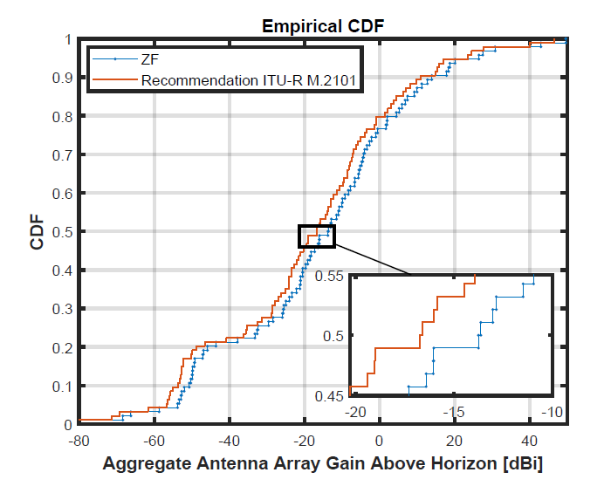

Figure 7.3.2.2.1-1 Aggregate Antenna Array Gain Above Horizon [dBi]

The following observations may be made:

The median gain difference is about 3 dB.

When more UEs are added to the ZF set, the placement of nulls in the azimuth pattern will have a consequential impact on the elevation pattern and will further increase this difference.

The example is for two UEs with a given azimuth placement. The median gain difference will also be sensitive to the actual azimuth angles at which the UEs are placed. The point of this exercise is just to demonstrate the impact of ZF beamforming using the correct formulation of pseudo inverse to accurately assess the aggregate antenna array gain above the horizon. The conclusions presented here can be replicated for a larger number of users in a given sector with the same methodology.

7.3.2.2.2 Huawei (R4-2419238)

The cumulative distribution functions (CDFs) curves of the IMT BS gain towards the target UE are shown in Figure 7.3.2.2.2-1. It can be seen that this method can also get reasonable target antenna gain compared to M.2101.

Figure 7.3.2.2.2-1

BS gain towards to target UEs

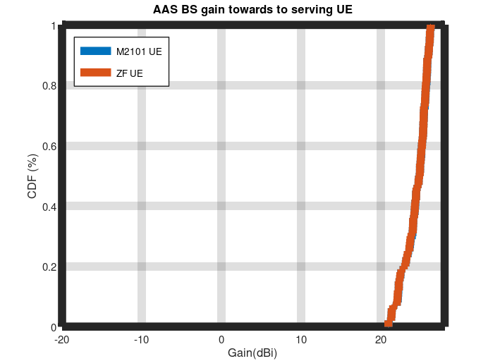

The cumulative distribution functions (CDFs) curves of the IMT BS gain towards the sample points of the different scenarios are shown in Figures 7.3.2.2.2-2 without additional individual per-antenna power constraint. It can be seen that the difference between ITU-R M.2101 and ZF gains are minor.

Figure 7.3.2.2.2-2

BS gain towards all sample points (composite) without individual per-antenna power constraint (Method 2)

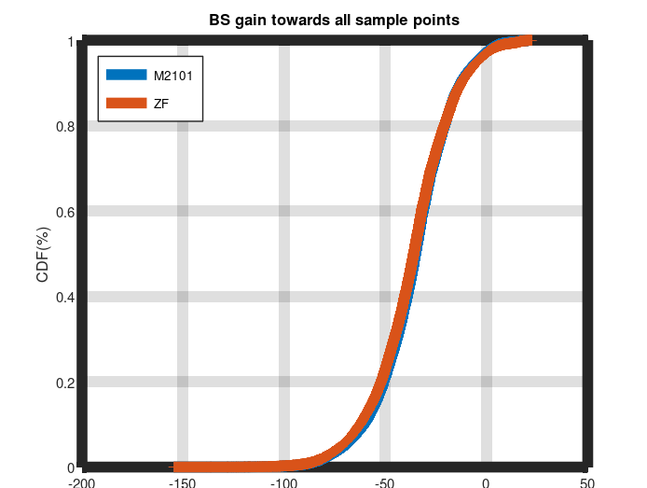

TABLE 7.3.2.2.2-1

BS antenna gain difference between ITU-R M.2101 beamforming model and ZF beamforming (Method 2)

| C band Urban (with subarrays)  Scenario | Long-term (80th percentile) | Short-term (99.9th percentile) |
| --- | --- | --- |
| M.2101 | -20.810 | 19.527 |
| ZF (Method 2) without individual per-antenna power constraint | -20.992 | 19.197 |
| M.2101- ZF (Method 2) difference (dB) (without individual per-antenna power constraint) | 0.182 | 0.33 |

7.3.3 Summary and conclusion

The simulation results in clause 7.2 using the simulation methodologies in clause 7.1 have indicated that MU MIMO based ZF BF does not need to be considered for the pure LOS case, and Rec. ITU-R M.2101 methodology remains valid for performing sharing and compatibility studies in WP5D.

**<End of text proposal>**

**References**

[1] RP-240787, “New SI proposal: Study on IMT parameters for 4400 to 4800 MHz, 7125 to 8400 MHz and 14800 to 15350 MHz”, Ericsson.

[2] R4-2400333, “Parameters of terrestrial component of IMT for sharing and compatibility studies in the frequency bands 4 400-4 800 MHz, 7 125-8 400 MHz and 14.8-15.35 GHz”, ITU-R WP5D.

[3] R4-2417109, “WF on other issues (MIMO)”, Nokia.

[4] R4-2417200, “TR 38.922 version 0.3.0”, Ericsson.

[5] R4-2417540, “TP to TR 38.922: Summary and conclusion for MIMO modeling aspects”, Nokia.

[6] R4-2417545, “TP for other issues (MIMO Beamforming) in TR 38 922”, Spark.

[7] R4-2418397, “TP to TR 38.922: Addition of MIMO modelling simulation results in subclause 7.3”, Ericsson.

[8] R4-2418608, “Views on Additional AAS aspects related to spatial beamforming”, Qualcomm.

[9] R4-2419238, “Simulation methodologies and results of AAS Modelling”, Huawei, HiSilicon.

1. It should be note that the array response is both in the azimuth and elevation.
2. We assume a broadside array. An elevation angle of 90 degrees is when users are in the elevation boresight.
3. Whilst antenna numbers can increase due to advancements in semiconductor technology [3], the numbers of users to be nulled must be less than or equal to the number of RF chains
4. In practice, this is not the case, as *Sounding Reference Signals (SRS)* are used in time-division duplex (TDD) systems, where the UEs would send an uplink SRS signal based on which the BS will estimate the uplink channel and using channel reciprocity, will estimate the downlink channel. In frequency-division duplex (FDD) systems, *Channel State Information-Reference Signal (CSI-RS)* is transmitted from the BS periodically and the UEs will estimate the channel and feedback the channel response via a codebook to the BS [5].
5. *Mathematical notation*: We note that denotes a vector, while denotes a matrix. Furthermore, is denoted as a real scalar value, where as and are used to denote a transpose and a Hermitian transpose operation. Finally, is used to denote the matrix inverse of a square matrix (same number of rows and columns), .

   

  