3GPP TSG RAN WG1 #118bis R1-24xxxxx
Hefei, China, October 14th – 18th, 2024
Source: Moderator (CMCC)
Title: Moderator’s summary on the discussion of common TA in a regenerative payload scenario
Agenda item: 9.11
Document for: Discussion & Decision

Introduction
RAN2 has sent a LS to RAN1 regarding the common TA in a regenerative payload scenario [1]. In RAN2 #127 meeting, the setting of common TA and Kmac for regenerative payload with full gNB on board was discussed. RAN2 brought questions on whether it would be a problem for TA common to stick to 0 as the minimum value or if there is a need to introduce negative values. The content of the LS is listed as below.

In RAN2#127 meeting, the setting of common TA and Kmac for regenerative payload with full gNB on board was discussed, and a question related to the value setting was raised.

Related to this, RAN2 kindly asks RAN1 and RAN4:

Question: Whether in a regenerative payload scenario it would be a problem to stick to 0 as the minimum possible value for TA-Common or whether we should e.g. introduce negative values for ta-Common.

Additionally, RAN2 understands in any case legacy UEs would have to rely on existing signaling and then for legacy UEs, minimum value of Common TA is equal to 0.

Actions:

To RAN1 and RAN4:

RAN2 kindly requests RAN1 and RAN4 to provide feedback on above question.

Discussion

21 contributions [2-22] including both discussion papers and draft replies are submitted in this meeting. Based on the inputs, moderator has the following questions about the issues related to the question from RAN2.

2.1 Issues of uplink reception window at gNB

It was mentioned by companies’ contributions that there would be a performance loss due to the mismatch for the uplink transmission and the reception window at gNB. And the overestimated TA will induce an advanced reception at gNB, which seems the traditional terrestrial gNB never need to deal with.
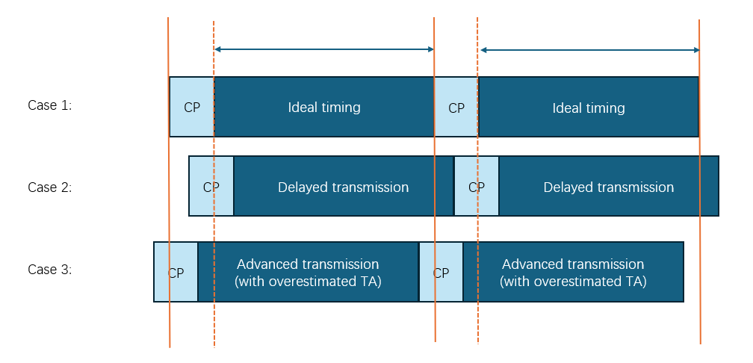
Figure 2 Examples for the uplink reception at gNB

Question 1:
Do companies think that it would impact the uplink reception performance due to the delayed or advanced arrival of uplink transmission?

Company | Yes or No | Detailed answers and other comments
OPPO | No | For TA accuracy error falls in [-Te,+Te] with Te smaller than CP length, gNB implementation can avoid any performance degradation.

Question 2:
Is there any difficulty for the gNB to deal with the advanced reception in uplink?

Company | Yes or No | Detailed answers and other comments
OPPO | No | the gNB can select a FFT window starting from Te after the OFDM symbol boundary for the concerned PRACH reception (also applicable to PUSCH reception as well). With this implementation method, any random accuracy error within [-Te,+Te] won’t suffer from the degradation, as long as the Te is smaller than CP length.  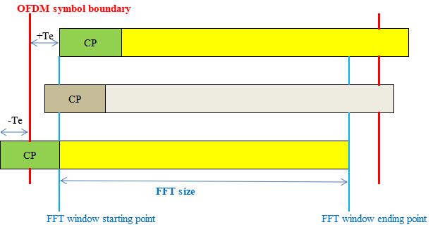

2.2 Backward compatibility issues

Some companies mentioned there would be a backward compatibility issue if negative values are introduced for the common TA. But other companies mentioned that if negative values were introduced for the common TA configuration in Rel-19 for regenerative payload, corresponding new IE would be introduced. With the consideration of that, there would be no backward compatibility issues.

Question 3:
Is there any backward compatibility issue for the legacy UE if negative values were introduced for the configuration of common TA, with the consideration that new Rel-19 IEs with negative values of common TA can be introduced?

Company | Yes or No | Detailed answers and other comments
OPPO | not issue with backward compatibility | The problem is that by introducing negative value for R19, it will make legacy performance worse. While, by NW implementation, both legacy performance and R19 performance can be kept un-impacted.

2.3 Questions on the negative values

Based on the consideration of the above two questions and the answers, it can be further discussed on the questions from RAN2. Though Q4 and Q5 are similar and may point to the same direction for the answers, it may save some efforts for drafting the content of reply LS.

Question 4:
With the consideration of the above two issues, do you think negative values for ta-Common can be introduced to solve the overestimated TA issues and improve the performance of uplink receptions?

Company | Yes or No | Detailed answers and other comments
OPPO | No | it is not meaningful to introduce negative value, it will make the system worse.

Question 5:

Do you think it would be a problem to stick to 0 as minimum possible value for TA common without introducing the negative value for ta-Common?

Company | Yes or No | Detailed answers and other comments
OPPO | No | there is no issue with 0 value common TA as explained in the previous questions.

Conclusion

References
- R1-2407590, LS on common TA in a regenerative payload scenario, 3GPP TSG-RAN WG1 Meeting #118-bis
- R1-2407691 Discussion on LS on common TA in a regenerative payload scenario Spreadtrum Communications
- R1-2407830 Draft reply LS on common TA in a regenerative payload scenario vivo
- R1-2407888 Discussion on the LS on common TA in a regenerative payload scenario CMCC
- R1-2407889 Draft reply LS on common TA in a regenerative payload scenario CMCC
- R1-2407929 Discussion on LS on common TA in a regenerative payload scenario ZTE Corporation, Sanechips
- R1-2408003 Discussion on LS reply on common TA in a regenerative payload CATT
- R1-2408140 Discussion on RAN2 LS about the common TA issue in regenerative payload scenario OPPO
- R1-2408141 Draft LS reply on common TA in regenerative payload scenario OPPO
- R1-2408170 Discussion on the reply of LS on common TA in a regenerative payload scenario Huawei, HiSilicon
- R1-2408171 Draft reply LS on common TA in a regenerative payload scenario Huawei, HiSilicon
- R1-2408226 Discussion on RAN2 LS on common TA in a regenerative payload scenario NEC, TCL
- R1-2408396 Discussion on the LS on common TA in a regenerative payload scenario THALES
- R1-2408397 Draft reply LS on common TA in a regenerative payload scenario THALES
- R1-2408442 Discussion on RAN2 LS on Common TA in a Regenerative Payload Scenario Apple
- R1-2408443 Draft Reply LS to RAN2 on Common TA in a Regenerative Payload Scenario Apple
- R1-2408556 Discussion on common TA in a regenerative payload scenario ETRI
- R1-2408612 Discussion on RAN2 LS on common TA in a regenerative payload scenario Samsung
- R1-2408698 Discussion on reply LS on common TA in regenerative payload in NTN NR MediaTek Inc.
- R1-2408726 Discussion on LS on common TA in a regenerative payload scenario Nokia
- R1-2408772 Discussion on RAN2 LS of common TA for regenerative payload NTT DOCOMO, INC.
- R1-2408906 Discussion on RAN2 LS on common TA in a regenerative payload scenario Ericsson

