3GPP TSG-RAN WG1#119 R1-24abcde
Orlando, FL, USA, Nov 18th-22nd 2024

Agenda Item: 8.1
Source: Moderator (Ericsson)
Title: Draft summary of maintenance for Rel-18 NES cell DTX/DRX (de)activation time
Document for: Discussion

Introduction
This document summarizes the discussion on the draft CR proposed in R1-2410440 to clarify the (de)activation time for cell DRX/DTX in TS38.213.
The relevant coversheet information from the draft CR [1] is shown below.
Reason for change: | The activation/deactivation time for cell DTX/DRX is ambiguous. The specification states that “the UE operates […] according to the indicated cell DTX operation or DRX operation starting from a slot […] that is not before the beginning of slot m+d”. Since there are multiple slots that are not before the beginning of slot m+d, it is unclear which slot (as illustrated by the green slots x+1,…,x+4 in the figure below) that is referred by “a slot”. Further, it is unclear if a slot is before a point in time or not, if the slot overlaps that point in time (illustrated by the yellow slot x in the figure below).  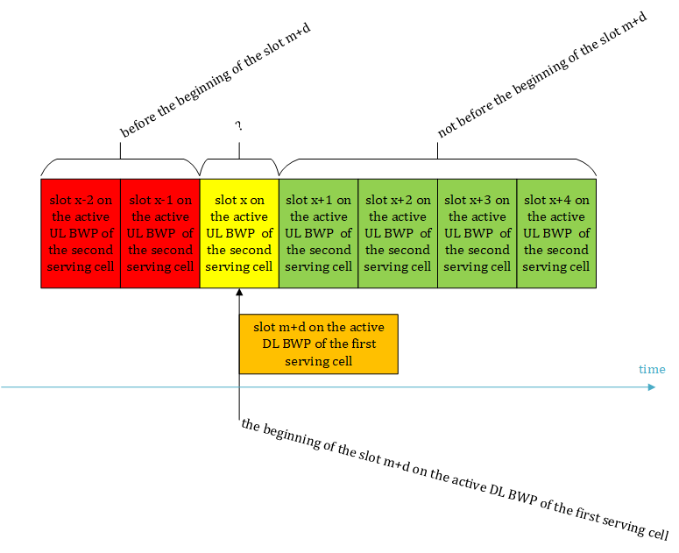
Summary of change: | Reflect that the activation/deactivation of cell DTX/DRX starts from the first slot that does not begin before the beginning of the slot m+d.
Consequences if not approved: | Incorrect specification since UE and NW may have different understanding of when a change in activation or deactivation of cell DTX/DRX applies.
Clauses affected: | 11.5

The proposed update from the draft CR [1] is shown below (for subclause 11.5 of TS38.213).
A UE does not expect to monitor PDCCH for detection of DCI format 2_9 on more than one serving cells of one cell group.
When a UE not provided with cellSpecificKoffset receives in slot $m$ on the active DL BWP of a first serving cell a PDCCH providing DCI format 2_9 that indicates a change in activation or deactivation of a current cell DTX operation or cell DRX operation for a second serving cell, the UE operates on the second serving cell according to the indicated cell DTX operation or cell DRX operation starting from the first slot on the active DL BWP or on the active UL BWP of the second serving cell, respectively, that does not begin before the beginning of the slot $m+d$ on the active DL BWP of the first serving cell where $d$ is a number of slots for the SCS of the active DL BWP of the first serving cell in Table 11.5-1.
When a UE provided with cellSpecificKoffset receives in slot $m$ on the active DL BWP of a serving cell a PDCCH providing DCI format 2_9 that indicates a change in activation or deactivation of a current cell DTX operation for the serving cell, the UE operates on the serving cell according to the indicated cell DTX operation starting from the first slot on the active DL BWP that does not begin before the beginning of the slot $m+d$ on the active DL BWP of the serving cell, where $d$ is a number of slots for the SCS of the active DL BWP of the serving cell in Table 11.5-1, , μ is the SCS configuration of the active DL BWP of the serving cell.
When a UE provided with cellSpecificKoffset receives in slot $m$ on the active DL BWP of a serving cell a PDCCH providing DCI format 2_9 that indicates a change in activation or deactivation of a current cell DRX operation for the serving cell, the UE operates on the serving cell according to the indicated cell DRX operation starting from slot $\left\lfloor (m+d)⋅\frac{2^{μ_{UL}}}{2^{μ_{DL}}}\right\rfloor +K_{cell,offset}⋅2^{μ_{UL}}$ on the active UL BWP where $d$ is a number of slots for the SCS of the active DL BWP of the cell in Table 11.5-1, $K_{cell,offset}$is the cellSpecificKoffset, $μ_{DL}$ and $μ_{UL}$are the SCS configurations of the active DL BWP and the active UL BWP of the cell, respectively.

Discussion
Companies are invited to provide inputs to the following questions.

Q1: Do you agree with the reason for change in R1-2410440 [1], i.e. that the activation/deactivation time for cell DTX/DRX should be clarified as the first slot that does not begin before the beginning of the slot m+d?
Company | Support (Y/N) | Comments

Q2: Do you agree with the changes proposed in the draft CR for 38.213 in R1-2410440 [1]?
Company | Support (Y/N) | Comments

Conclusion

Reference
[1] R1-2410440, Ericsson, Draft CR on clarification of activation and deactivation time for cell DRX and DTX, RAN1#119, Orlando, FL, USA, Nov 18th-22nd 2024.

