DRAFT Report of PCG Group to Study Transposition Improvements

# Introduction and Objective

This report covers a study of the current process used to perform transpositions of 3GPP specifications. The study had the following goals:

* To Identify and describe the specific inefficiencies and problems that OPs may experience with the current transposition process and information flow (e.g. file formats) between the MCC and the OPs.
* Identify potential solutions to the above problems and evaluate their complexity, resource impacts and other pros and cons.
* Recommend solutions for further elaboration and adoption to improve the efficiency of the transposition process.

# Current Transposition Process in OPs

This clause captures at a high-level information received from OPs during the study on how they currently perform transpositions.

## 2.1. ARIB

Currently, ARIB publishes transposed documents as PDFs containing the complete content of the 3GPP specification. ARIB is considering changing to the method described in clause 4.5 where the transposition contains a link to the 3GPP document (similar to TTC).

The following diagram shows the current overall process used by ARIB for transposition. Specs are converted to PDF and a cover sheet added, but there is no customization of Word files.

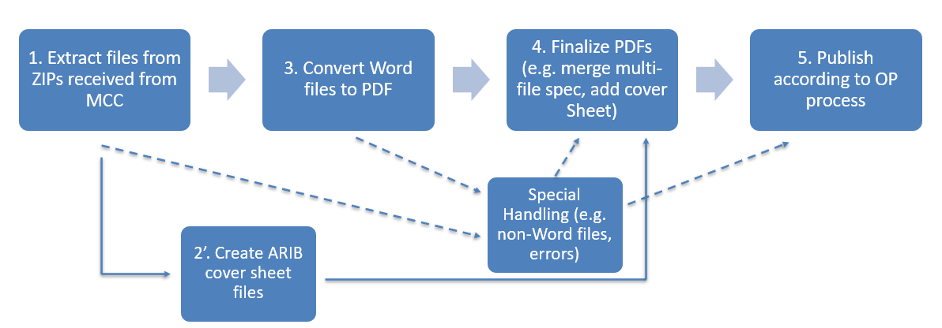

**ARIB Transposition Process**

## 2.2 ATIS

ATIS publishes transposed documents as PDFs containing the complete content of the 3GPP specification.

The following diagram shows the overall process used in ATIS. Word files are customized to change information on the cover pages and on the page headers and then converted to PDF.

A Visual Basic for Applications (VBA) script is used to perform the Word customization and PDF conversion, but this script does not work in all situations and manual intervention is often required. Specifications that contain multiple Word files are one case that the ATIS script does not automatically handle.

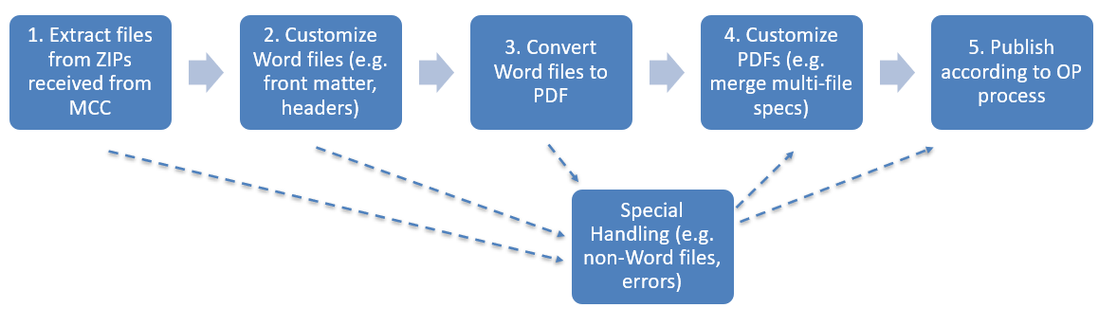

**ATIS Transposition Process**

## 2.3 CCSA

CCSA publishes transposed documents as customized Word files containing the complete content of the 3GPP specification.

## 2.4 ETSI

ETSI publishes transposed documents as PDFs containing the complete content of the 3GPP specification.

The following diagram shows the overall process used in ETSI. Word files are customized to change information on the cover pages and on the page headers. VBA macros are used to perform most of the steps. The Word files are then converted to PDF.

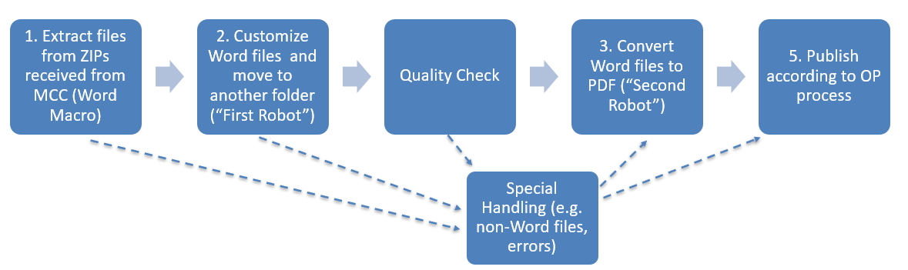

**ETSI Transposition Process**

## 2.5. TSDSI

TSDSI publishes transposed documents as PDFs containing the complete content of the 3GPP specification.

The following diagram shows the overall process used in TSDSI. Specification Word files are customized to change information on the cover pages and on the page headers and then converted to PDF.

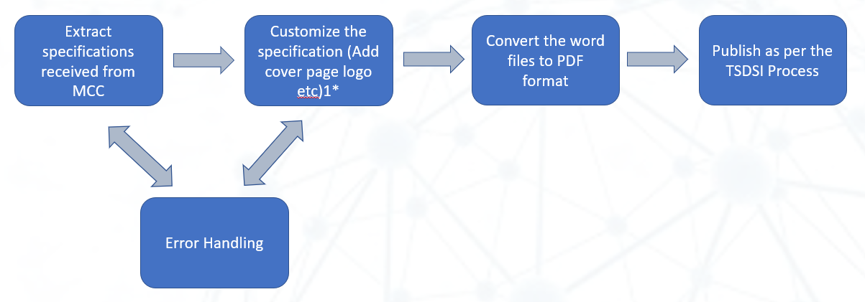

**TSDSI Transposition Process**

## 2.6. TTA

TTA publishes transposed documents as PDFs containing the complete content of the 3GPP specification.

The following diagram shows the overall process used by TTA for transposition. Specs are converted to PDF and a cover sheet added, but there is no customization of Word files.

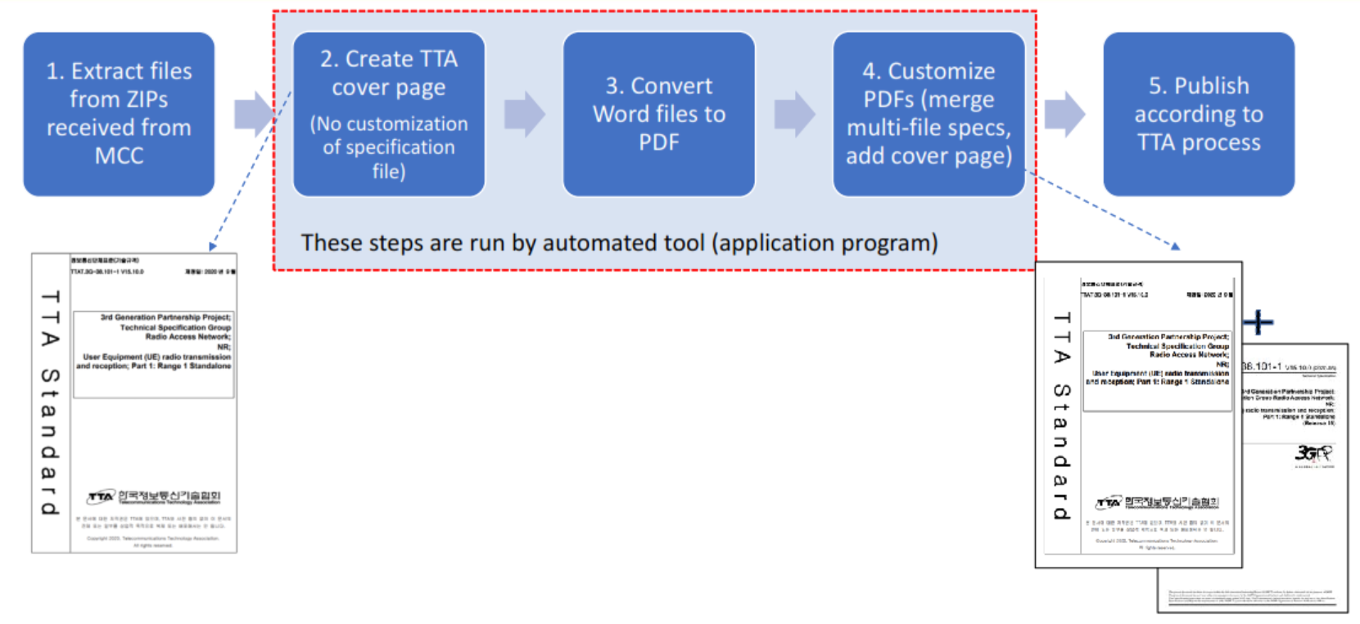

**TTA Transposition Process**

## 2.7. TTC

TTC does not publish the whole content of transposed 3GPP specifications in their standards. Instead, they produce short (2 page) “cover sheet” documents that contain a link to the corresponding 3GPP specification on the 3GPP web site.



**TTC Transposition Process**

## 2.8 Summary of Transposition Formats and Processes

There are three main formats in which OPs currently published transposed documents:

* PDF files containing the complete text of 3GPP specifications
* Word files containing the complete text of 3GPP specifications
* PDF “cover page” containing a link to the 3GPP specification

For those OPs that publish PDF files containing the complete text there are two main processes used to create the files. Some OPs convert the 3GPP Word files to PDF without modification and then add their own cover pages to the PDF. Other OPs customize the 3GPP Word files prior to converting to PDF.

The following table summarizes the transposition deliverable format and process for different OPs:

|  |  |
| --- | --- |
| **Transposition Deliverable Format** | **OPs Using This Format** |
| PDF files containing the complete text of 3GPP specifications | OPs that customize the 3GPP Word file:   * ATIS * ETSI * TSDSI   OPs that do not customize the 3GPP Word file:   * ARIB * TTA |
| Word files containing the complete text of 3GPP specifications | CCSA |
| PDF “cover page” containing a link to the 3GPP specification | TTC |

# Transposition Steps and Problem Areas

This section introduces some of the steps the OPs use during the transposition process that can cause particular problems.

## 3.1 Customization of specification Word files

Some OPs customize the specification Word files received from 3GPP to format them according to their own style and requirements. Currently, four OPs do perform customizations on the Word files and three OPs do not. The following table shows which OPs currently do customizations on the specification Word Files:

|  |  |  |
| --- | --- | --- |
| **OP** | **Customize specification Word Files during transposition?** | **Notes** |
| ARIB | No | Transpositions include unmodified 3GPP specification files  ARIB is considering changing to the method described in clause 4.5 (similar to TTC). |
| ATIS | Yes | A Word Visual Basic for Applications (VBA) app is used to automatically make the customizations. |
| CCSA | Yes |  |
| ETSI | Yes | A Word Visual Basic for Applications (VBA) app is used to automatically make the customizations. |
| TSDSI | Yes |  |
| TTA | No | A cover sheet is added on top of the unmodified 3GPP specification |
| TTC | No | TTC generates short “cover page” documents that contain a link to the complete 3GPP specification file. |

Word file customizations could include:

* Modification of document numbers in the file;
* Replacing logos on the cover page;
* Modifying copyright statements or other front matter;
* Modifying headers or other parts of the body page template.

This process can be time consuming because of:

* the large number of documents;
* the need to handle exceptions such as multi-file documents;
* the use of large Word files in 3GPP which can make operations slow (particularly if they involve repagination).

Customizing Word files is not the only way to create OP-specific content in transposed documents. Using the right tools it is possible to perform some customization on PDF files. PDF tools allow pages to be added, removed or rearranged. Some OPs use this capability to add custom cover pages to unmodified 3GPP specifications.

## 3.2 Conversion of specification Word files, and other 3GPP files, to PDF

Some OPs currently convert specification Word files in to PDF as shown in the following table. Currently five OPs generate PDFs of complete 3GPP specifications and two OPs do not.

|  |  |  |
| --- | --- | --- |
| **OP** | **Convert specification Word files to PDF during transposition?** | **Notes** |
| ARIB | Yes | ARIB is considering changing to the method described in clause 4.5 (similar to TTC). |
| ATIS | Yes | A Word Visual Basic for Applications (VBA) app is used to automatically do PDF conversion. |
| CCSA | No | Publish transpositions as Word files |
| ETSI | Yes | A Word Visual Basic for Applications (VBA) app is used to automatically do PDF conversion. |
| TSDSI | Yes |  |
| TTA | Yes |  |
| TTC | No | Only the TTC cover page documents are converted to PDF. |

This process can cause problems for some OPs due to:

* Many large documents and slow generation of PDF using some tools;
* Errors causing conversion failures on some tools;
* Need to use special handling for some cases, e.g.:
  + Specifications split in to multiple Word files
  + Specifications that include non-Word files in the Zip

## 3.3 Multiple Word Files for One Specification

Some specifications have become so large that it has become practically essential to split them in to multiple Word files. These are practically stored as Zip files containing different word files for each section (example below).

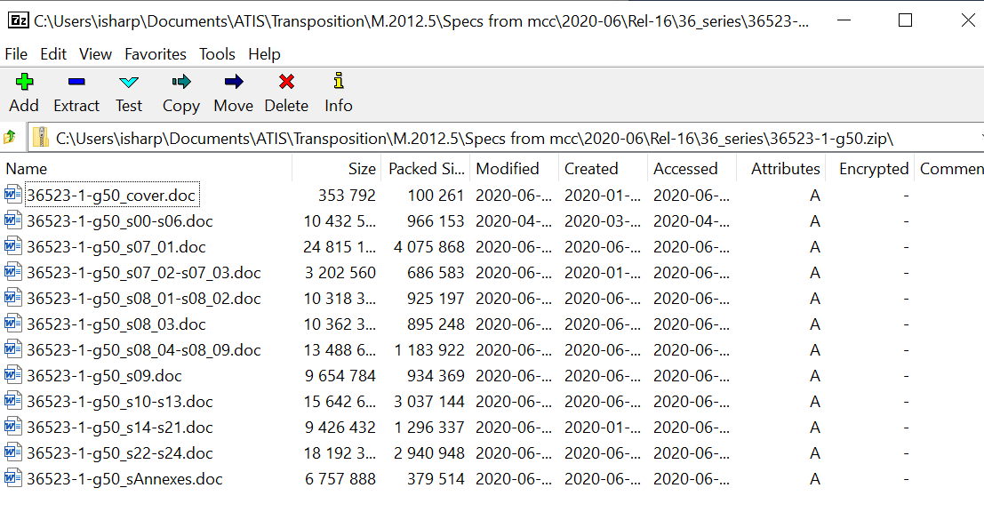

**Example of Multiple Word Files For One Specification**

Several OPs that produce PDFs of specifications have commented that multi-file specifications create particular problems. For example:

* Creating a single PDF for the multi-file case is complicated as each individual file needs to be converted to PDF and then the individual PDFs joined together;
* Where OPs have automated tools, they may not support the multi-file spec case and therefore manual intervention is needed;
* Different parts of the multi-file may require different treatment to format according to OP requirements (e.g., the cover pages should be treated differently from other sections);
* Any reformatting of one file in the multi-file can cause changes to page numbering in all other files so there is manual corrections needed.

The MCC has confirmed that file naming in all multiple Word file specifications should follow the structure similar to the example shown above. This implies that an alphanumeric sort of the file names should arrange the files in the right order. If specifications are found not to follow this structure then they may be reported to the MCC for correction.

## 3.4 Non-Word Files in Zip

Some specifications contain additional files that are not Word documents. Typically, these may be software code or other information that is not convenient to capture in Word. See the example below.

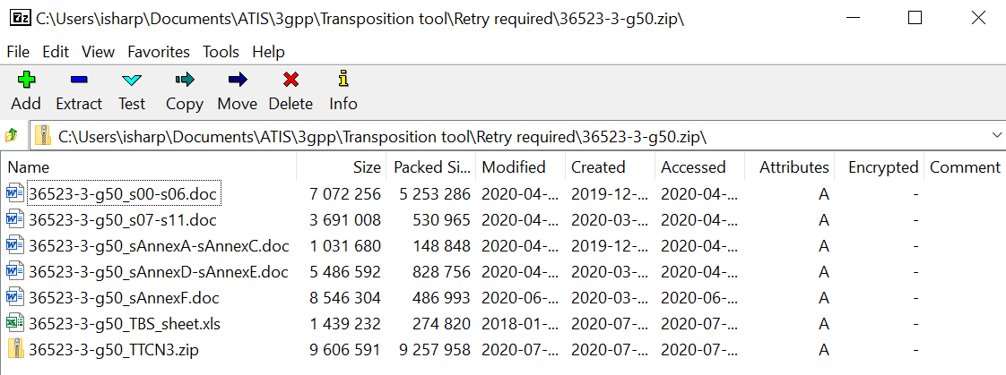

**Example of Specification Zip Containing Excel Information and TTCN (in Another Zip)**

Several OPs have commented that specifications that contain additional file types require special handling during transposition.

If an OP creates transpositions by processing Word files then it will be required that non-Word files are first separated from the Word files before the Word files are processed. OPs may also want to recombine the non-Word files in to the transposed package (e.g. a Zip) as they contain valuable information related to the specification.

Not all automatic tooling used by OPs will successfully handle specifications that contain non-Word files and thus manual intervention may be required.

Over time it has become more common for 3GPP specifications to include non-Word files. This trend will likely continue in the future, and OPs should allow for this when designing their transposition processes.

# Process Improvement Ideas

This section contains ideas generated by the group for ways the steps could be improved.

## 4.1 Change 3GPP Specification Template to Simplify Customizations

This idea aims to simplify or eliminate the step of doing customizations on specification Word files for those OPs that currently perform this step. There are two ways this might be done:

* To change the specification template to make it easier for OPs to process customizations – e.g. by using “Field Codes” in Word for information (e.g., the Copyright notice) that OPs customize
* To change the content or presentation of the template so that it is more “generic” and can be published by OPs with less customization (e.g., include the logos of all OPs on the cover page)

Note that changes to the template should be carefully considered because:

* Some OPs use the 3GPP specification files without modification and therefore any changes will directly appear in their outputs,
* Some OPs have automated tools that are tied to the current template and these tools will need updates if the template is changed.

## 4.2 OPs consider not customizing 3GPP specification Word Files

Some OPs do not do any customization of the 3GPP specification Word files. OPs that currently do customizations could consider changing their process to avoid this step.

## 4.3 Experiment with different PDF conversion tools

OPs that convert 3GPP specification Word files to PDF can experience problems with the speed of this process and errors leading to failures on some specifications.

Experiences from some OPs and experimentation indicates that different tools can vary a lot in terms of their performance and reliability for doing PDF conversions of 3GPP specification Word files. By changing to different tools, OPs may be able to improve the problems.

## 4.4 Collaboration between MCC and OPs to identify and fix Word files with technical problems

Some specification Word files seem to contain content that causes repeat failures on some PDF conversion tools (even though the files may appear correct on screen or convert successfully using other tools). By collaboration between the MCC and OPs it may be possible to identify the files that cause problems and correct the problematic content.

Some OPs already have this collaboration with MCC, but the possibility could be made better known.

## 4.5 OPs consider not doing PDF conversions of specification Word files

Some OPs do not do PDF conversions of specification Word files and instead either:

* Link directly to 3GPP source files in the transposition, or
* Publish their transpositions in the source file format (e.g., Word)

OPs that currently do PDF file conversions could consider changing their process to avoid this step.

## 4.6 MCC delivers OPs PDFs for specifications

Several OPs already use PDFs of unmodified 3GPP specification Word files in their transposition outputs. If there was sufficient interest among OPs to use this format, then it may be more efficient for the MCC (or another single organization) to create PDFs of the 3GPP specification Word files to avoid duplicate effort among OPs.

## 4.7 Remove page numbers from table of contents in 3GPP specifications

Updating the Table of Contents (ToC) specification can be very time consuming due to the pagination slowness in Word. Removing the numbers from the ToC (not the documents) results in a much faster update.

Removing page numbers from the ToC may improve the performance of transposition tools used by OPs. It also offers a significant time saving to the MCC as reduces the time required to update the ToC of each specification after incorporating all the CRs in to specifications, possibly be a factor of more than 100x in some scenarios.

Most people work with the electronic format of the documents and to access the content of a clause, they may click on the link in the ToC rather than scrolling down to the page using the number from the ToC. However, some OPs have indicated that some people do use printed versions of specifications and for these people not including page numbers in the ToC may be a significant disadvantage.

# 5. Evaluation of Process Improvement Ideas

## 5.1 Individual and Collective Impacts

Clause 4 contains a number of ideas for improvement of transposition processes. These ideas can be grouped in to two categories:

• Ideas that an individual OP may decide to use as part of their process. These ideas only impact individual OPs. For these ideas, individual OPs may perform their own evaluation and take independent decisions. Because these ideas only impact individual OPs, we do not evaluate them further in this report. These ideas are:

* OPs consider not customizing 3GPP specification Word Files (Clause 4.2);
* Experiment with different PDF conversion tools (Clause 4.3); and
* OPs consider not doing PDF conversions of specification Word files (Clause 4.5)

• Ideas that impact elements of the process that are shared by multiple OPs, or that impact the MCC. These ideas would need agreement between the impacted parties prior to implementation. The evaluation of these ideas is contained in subsequent subclauses.

## 5.2 Evaluation of Change 3GPP Specification Template to Simplify Customizations

## 5.3 Evaluation of Collaboration between MCC and OPs to identify and fix Word files with technical problems

## 5.4 Evaluation of MCC delivers OPs PDFs for specifications

## 5.5 Evaluation of Remove page numbers from table of contents in 3GPP specifications

# 6. Conclusions

# Appendix A – Detailed Examples of Current Processes (Informative)

This appendix gives more information about the transposition process used by OPs and examples of the output format. For a high-level view on the transposition process please refer to clause 2.

## A.1 ARIB

The following diagram shows an example of the ARIB cover sheet in the current process.

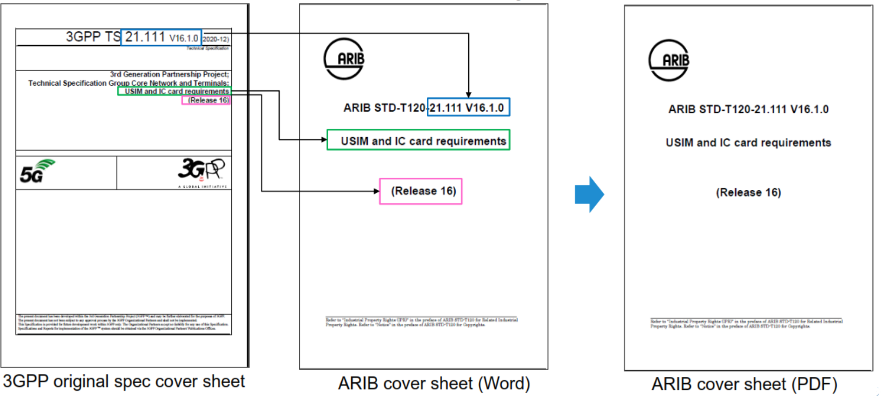

**Example of ARIB Cover Sheet**

## A.2 ATIS

The following diagram shows examples of how ATIS customizes different pages of the Word specification files. Information that is based on data extracted from the original files has been highlighted with red boxes.

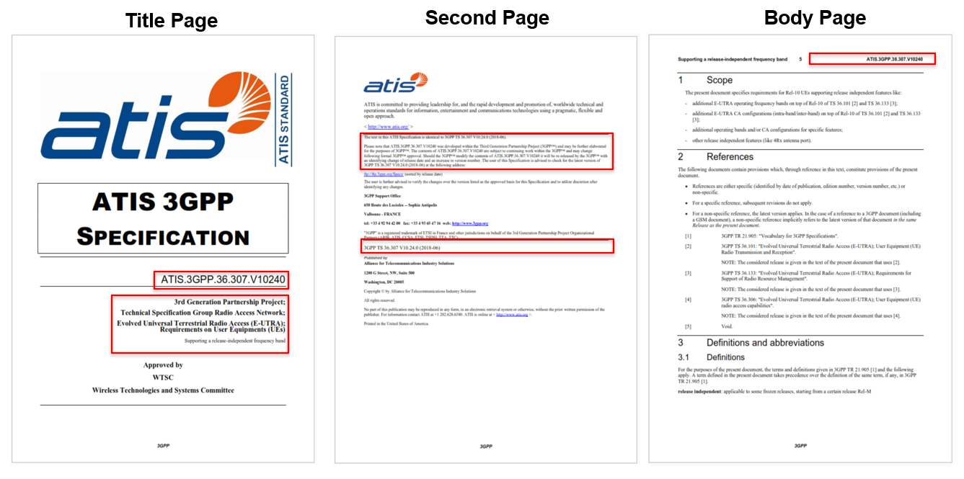

**Example of ATIS Standard Format**

## A.3 CCSA

The following diagram shows an example of a CCSA specification file.

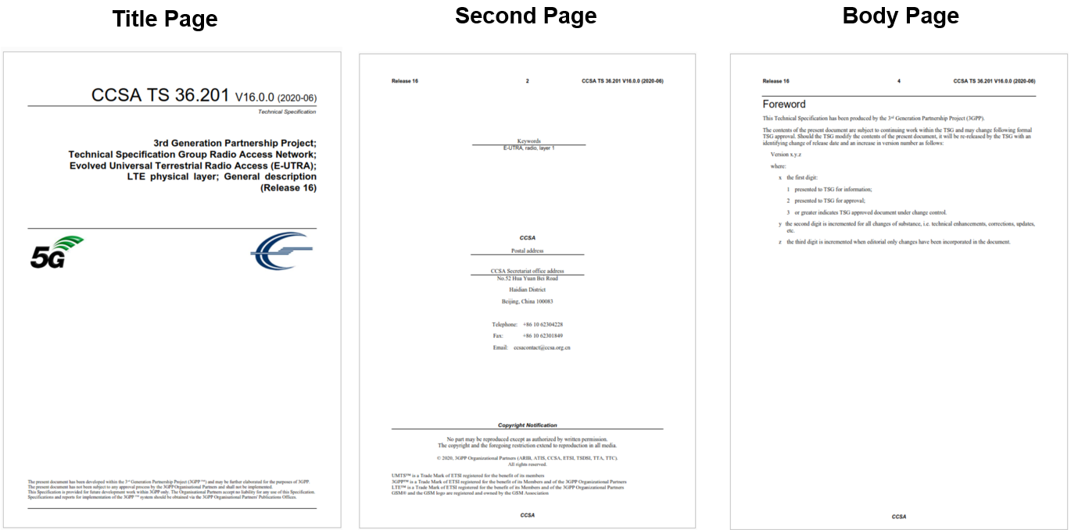

**Example of CCSA Standard Format**

## A.4 ETSI

The following text and diagrams explain the ETSI process. The “1st ETSI Robot” customizes the Word specification files as shown in the diagram below. The robot uses a VBA script.

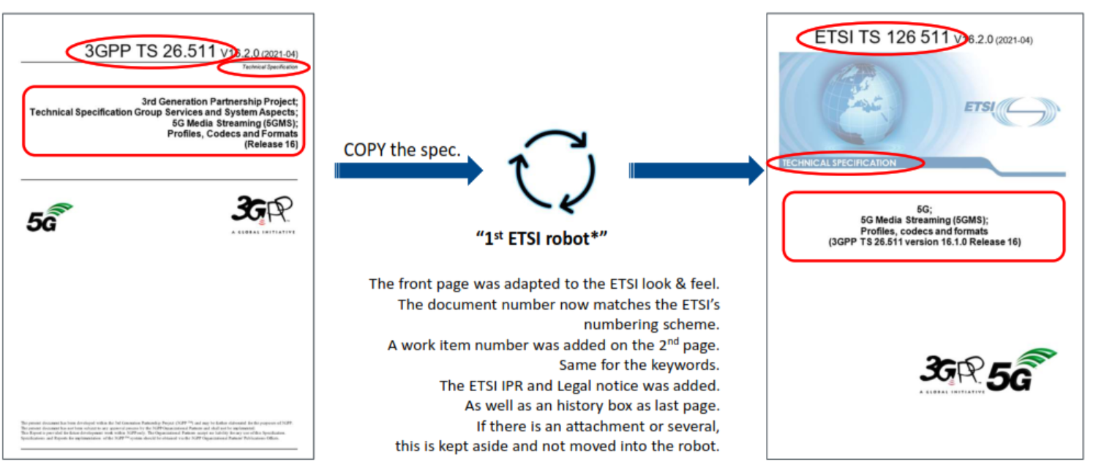

**Customization of Word files by the “1st ETSI Robot”**

Special handling is applied for non-Word files contained in the package. This is shown in the diagram below.

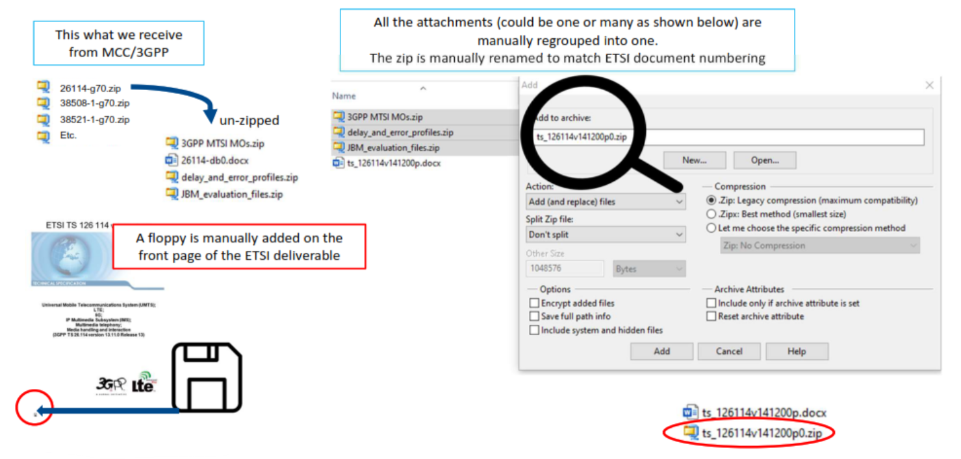

**Special Handling for non-Word files in ETSI**

The “2nd ETSI Robot” creates PDFs from the Word files and shown below. These are combined with attachments containing non-Word files to create the final package.

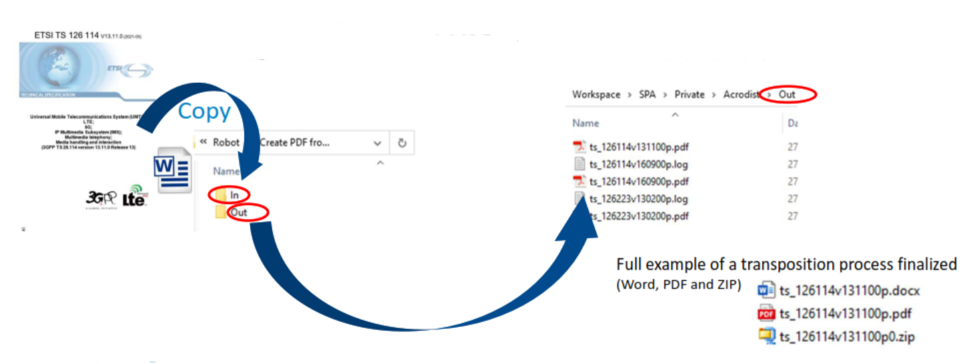

**2nd ETSI Robot**

## A.5 TSDSI

The following diagram shows examples of how TSDSI customizes the cover page.

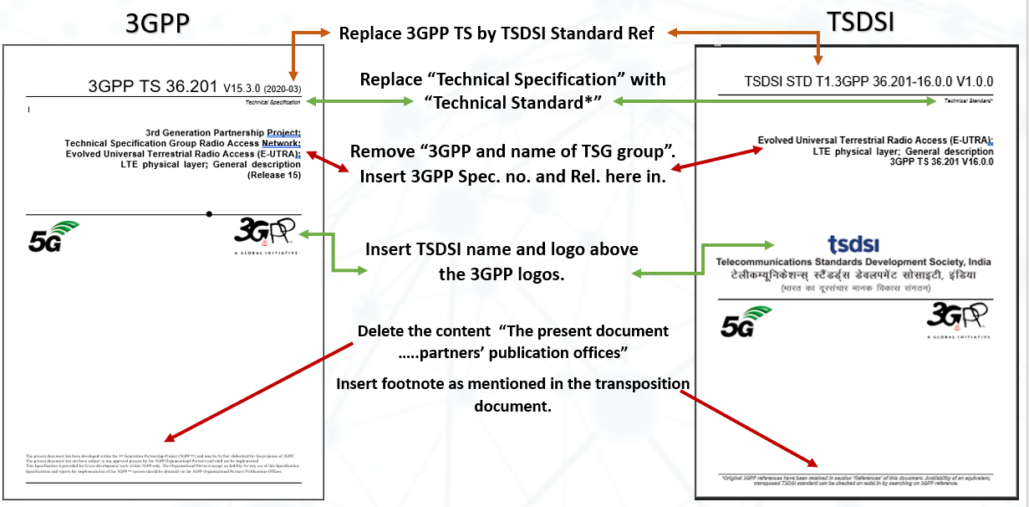

**Example of TSDSI Cover Page Format**

Other pages are also customized. The following diagram shows examples of the second page and the Forward page.

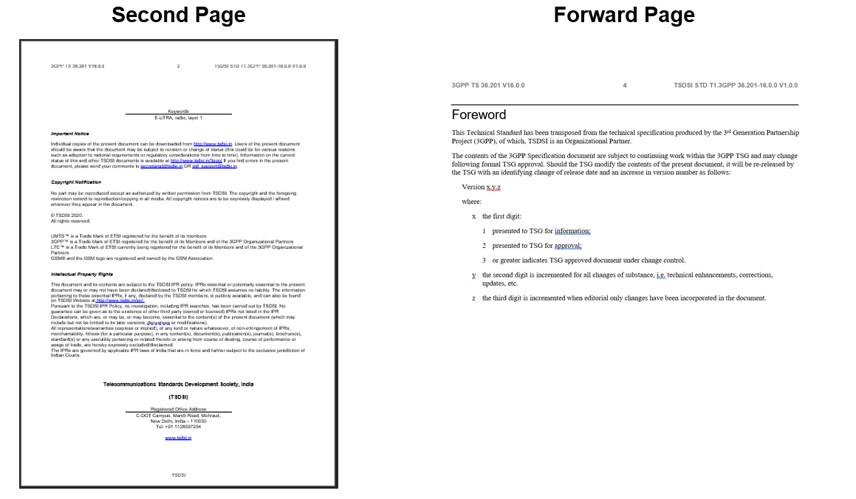

**Example of TSDSI Standard Format for Subsequent Front Matter Pages**

TSDSI also performs the following steps:

* The Specification number of both 3GPP and TSDSI is mentioned on each page of the document. 3GPP specification number is on the left side of the page and TSDSI Standard number is on the right side of the page.
* In case of the multiple Word file documents, each part is saved as “PART 1, PART 2….”. After transposing all the parts are combined in a zip file.
* The font type and size are predefined for each change in the document.
* After the transposition of the specifications is complete, the documents are converted into PDF format.

A particular problem encountered by TSDSI is that page numbering can change in one part of multiple Word file document which necessitates manual intervention to align page numbers throughout the whole set of files.

## A.6. TTA

The following diagram shows an example of the TTA cover sheet.

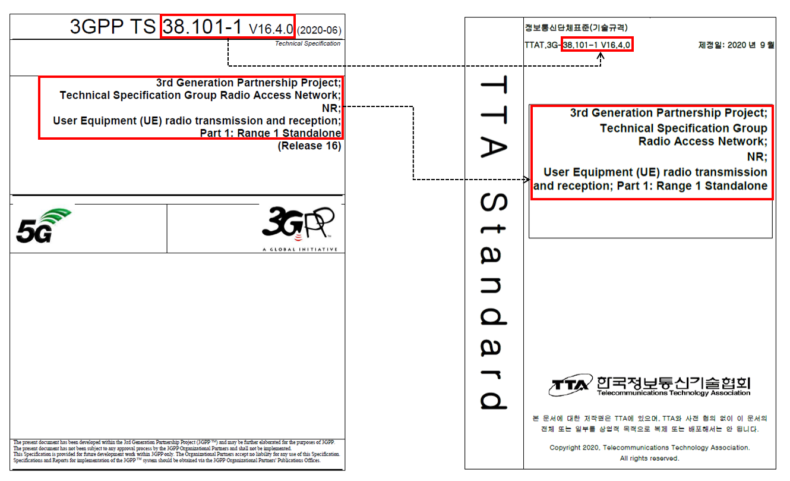

**Example of TTA Cover Sheet**

# A.7 TTC

The following diagram shows an example of the TTC “cover sheet document”. Note that the technical content is only included by reference to the URL of the 3GPP specification.

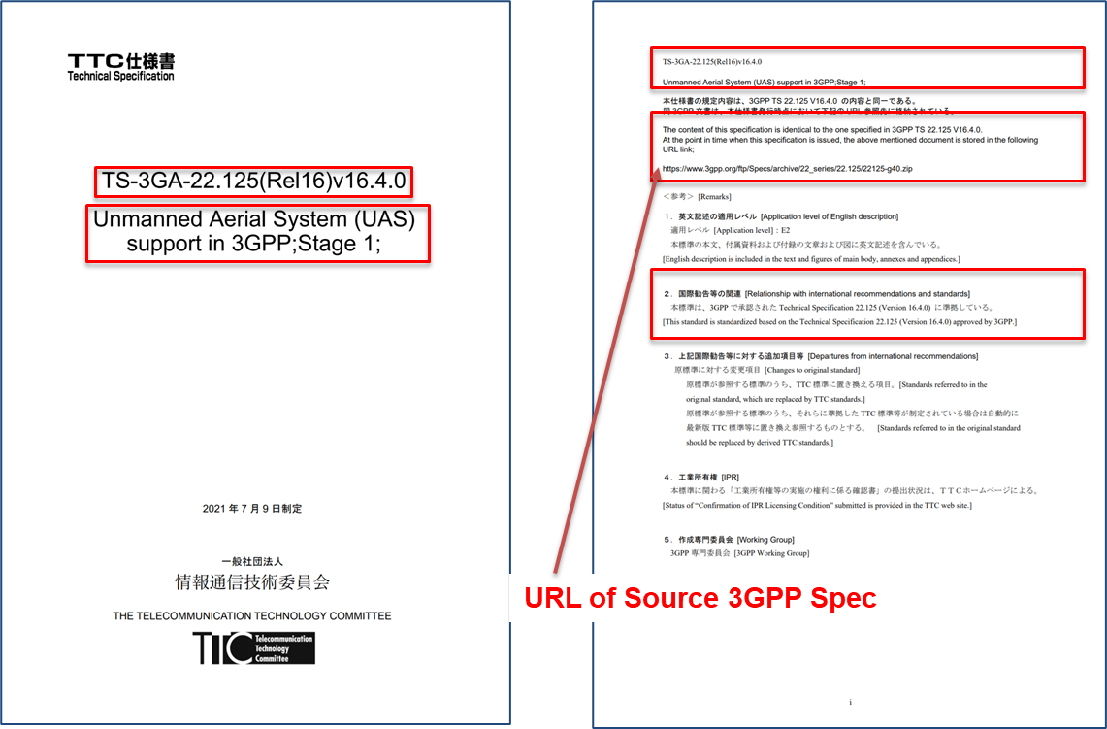

**Example of TTC Document**